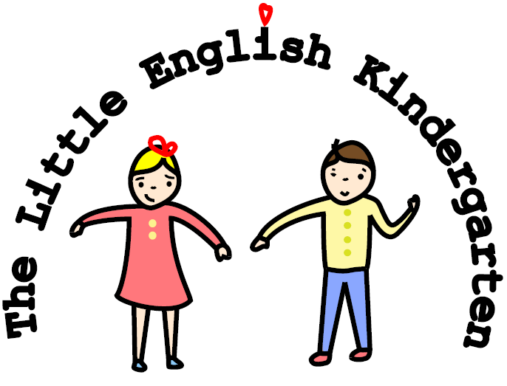
Photo of child
ease attach passport-size photo here

Application of Admission
Child’s Information
Which kindergarten are you applying for? | Kallio Haaga | Desired start date
Full name |  | Has your child previously been in a day care? No Yes  Name of day care
Gender | Male Female | Citizenship(s)
Social Security No/(DOB)
Place of birth |  | Any siblings
Mother’s Native Language
Fathers Native Language
Languages spoken at home
How would you rate your child’s spoken English? | Good Fair None
Does your child have any physical or learning difficulties? | No Yes If yes, please explain
Has your child received any learning support? | No Yes If yes, please explain
Does your child require a nap during the day? | No Yes
Parent Information
Mother’s Name and Citizenship: | Biological Mother Step Mother  Legal Guardian
Mother’s Occupation: | Company Name:
Mother’s Work Address: | Telephone Number:
Does the Mother speak English? Yes Fair None
Father’s Name and Citizenship: | Biological Father Step Father  Legal Guardian
Father’s Occupation: | Company Name:
Father’s Work Address: | Telephone Number:
Does the Father speak English? Yes Fair None
Home Address:
Home Telephone: | Emergency Telephone: (Relative or Friend)
Mobile Number: | e-Mail Address:
Signatures

Date Date
Signature of Mother (or legal guardian) Signature of Father (or legal guardian)
06/10/2014

