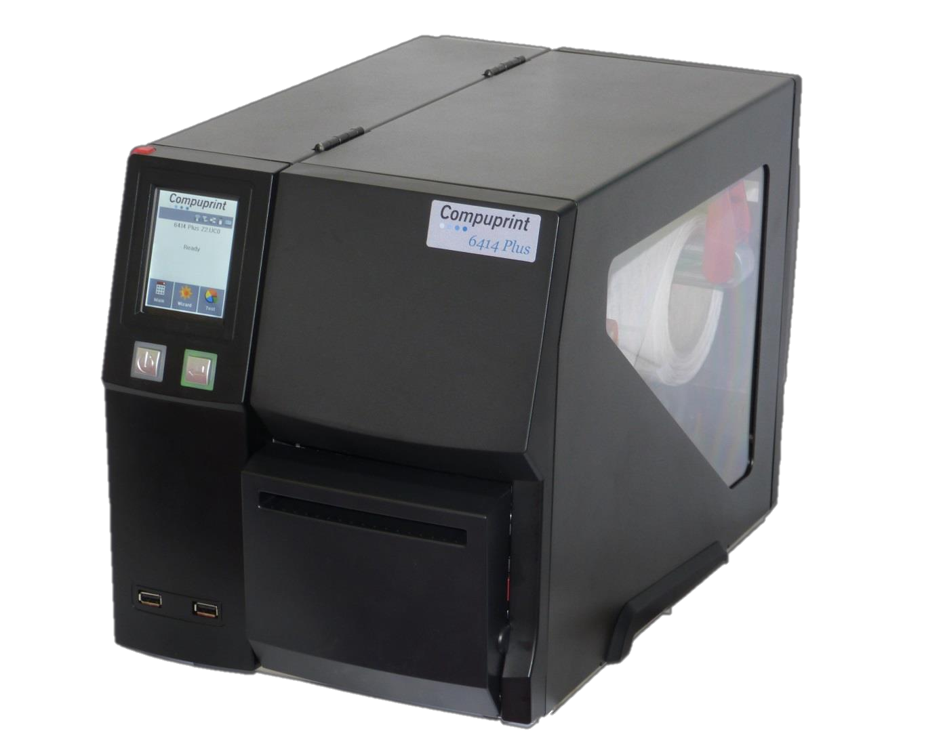
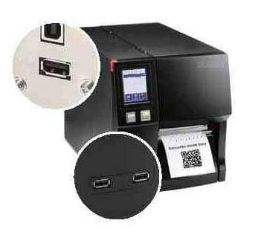
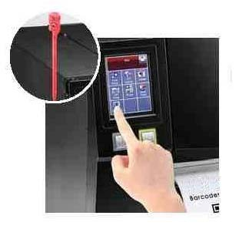
Thermal Printers
6414 Plus
Compuprint
Printing and scanning Solutions
High connectivity:
+ USB 2.0
+ 3 USB-Hosts
+ Ethernet 10/100 Base-T
+ serial RS232
+ par. Centronics (opt.)
+ WiFi (opt.)
The control center:
The 3,2” touch screen can be handled both by your fingertip and the attached orange pen
Barcode label printers for industrial and retail environments

The Compuprint 6414 Plus is the mid range model of our new thermal product line which has been developped to meet the needs of the markets. A wide connectivity including both Ethernet and USB give the user all the flexibility he needs to get his data printed. And if there is no host available to connect is, WiFi is an option as well.
The large interactive touch screen panel is desigend for easy and intuitive operations. And if the user is forced to wear gloves, the attached orange pen makes life easy to him.
The compact and robust metal frame in combination with its printspeed of up to 10 inch per second makes the 6414 Plus the ideal label printer in cooling houses, warehouses, shipping departments and production lines.

6414 Plus

Model Name | PRODUCT  PRT6414 | SPECIFICATIONS  PRT6414-H
Print Method | Thermal Transfer / Direct Thermal
Resolution | 203 dpi (8 dots/mm) | 300 dpi (12 dots/mm)
Print Speed | Up to 10 IPS (254 mm/s) | Up to 7 IPS (177 mm/s)
Print Width | 4.09” (104 mm) Up to (108mm) | 4.09” (104 mm) Up to (105.7mm)

Processor 32-bit MPU
Print Length
Min. 0.16” (4 mm)** – Max. 180” (4572 Min. 0.16” (4 mm)** – Max. 85” (2159
mm)mm)

Memory Flash 128 MB Flash (60 MB for user storage)
SDRAM 32 MB

Sensor Type Adjustable reflective sensor and transmissive sensor, left aligned

Type Continuous form, gap labels, black mark sensing, and punched hole; label length set by auto sensing or programming

Tear : Min. 1” (25.4 mm) – Max. 4.64” (118 mm)

Media
Width
Cutter : Max. 4.61” (117 mm)
Dispenser / Rewind : Max. 4.64” (118 mm)

Ribbon

Software

Thickness Min. 0.003” (0.06 mm) – Max. 0.01” (0.25 mm)

Label roll diameter Max. 8” (203.2 mm)

Core diameter Min. 1.5" (38.1 mm) – Max. 3" (76.2 mm)
Types Wax, wax/resin, resin

Length Max. 1476’ (450 m)

Width Min. 1.18” (30 mm) – Max. 4.33” (110 mm)

Ribbon roll diameter 3” (76.2 mm)

Core diameter 1” (25.4 mm)
Printer Language CEL , CZL auto switch - CEL (Compuprint Eltron Language) CZL (Compuprint Zebra Language)
Label design software CPLabel

Driver Windows XP, Vista, Win7, Win8, Server 2003 & 2008

DLL Windows XP, Vista, Win7, Server 2003 & 2008
6, 8, 10, 12, 14, 18, 24, 30, 16X26 and OCR A&B

Resident Fonts Bitmap Fonts
Bitmap fonts 90°, 180°, 270° rotatable, single characters 90°, 180°, 270° rotatable Bitmap fonts 8 times expandable in horizontal and vertical directions

Download Fonts

Scalable Fonts 90°, 180°, 270° rotatable
Bitmap Fonts Bitmap fonts 90°, 180°, 270° rotatable, single characters 90°, 180°, 270° rotatable

Asian Fonts Asian fonts 90°, 180°, 270° rotatable and 8 times expandable in horizontal and vertical directions

Scalable Fonts Scalable fonts 90°, 180°, 270° rotatable
Code 39, Code 93, EAN 8 / 13 (add on 2 & 5), UPC A / E (add on 2 & 5), I 2 of 5 & I 2 of 5 with Shipping Bearer Bars,

Barcodes 1-D Bar Codes
Codabar, Code 128 (Subset A, B, C), EAN 128, RPS 128, UCC 128, UCC / EAN-128 K-Mart, Random Weight, Post NET, ITF 14, China Postal Code, HIBC, MSI, Plessey, Telepen, FIM, GS1 DataBar

  - Bar Codes PDF417, Micro PDF417, Datamatrix code, Maxicode, QR code, Micro QR code and Aztec code Codepage 437, 850, 851, 852, 855, 857, 860, 861, 862, 863, 865, 866, 869, 737

Code Pages
Windows 1250, 1251, 1252, 1253, 1254, 1255, 1257
Unicode (UTF8、UTF16)

Graphics Resident graphic file types are BMP and PCX, other graphic formats are downloadable from the software

    - USB 2.0 (B-Type)

Interfaces

Control Panel
- S erial port: RS-232 (DB-9)
- IEEE 802.3 10/100 Base-Tx Ethernet port (RJ-45)
- 3 USB Host (A-Type). 2 ports at the front panel, 1 port at the rear panel
- Ba cklight 3.2” touch screen LCD
- 1 Power on/off button with green color LED backlight
- 1 Control key : FEED / PAUSE / CANCEL with dual color LED backlight: Ready (Green); Error (Red)
- 1 Calibration button at rear panel

Real Time Clock Standard

Power Auto Switching 100-240V AC, 50-60Hz

Environment Operation temperature 41°F to 104°F (5°C to 40°C) Storage temperature -4°F to 140°F (-20°C to 60°C)

Humidity Operation 20-85%, non-condensing
Storage 10-90%, non-condensing
Agency Approvals CE (EMC)、FCC Class A、CB、cUL、CCC、GOST-R、KC

Length 18.30” (465 mm)

Dimension

Height 10.35” (263 mm)

Width 12” (305 mm)
Weight 30 lbs (13.6 Kg), excluding consumables Cutter module
Parallel port adaptor module (Centronic female 36-pin) Bluetooth module
WiFi print server module (IEEE 802.11b/g/n)

Options
Applicator Interface (DSUB female 15-pin)
External label roll holder for 10” (250 mm) O.D. label rolls External label rewinder
Label Dispenser+ Internal Rewinder (factory install) 1” Ribbon winder module (factory install)
RFID R/W module (project option)

Compuprint S.r.l.
Via Cottolengo, 75/77/79 10072 Caselle T.se (To) – Italy Sales Contact
Tel. +39 011 9892 141 – Fax +39 011 9974432
sales@compuprint.com
www.compuprint.com

Copyright ® 2013 Compuprint Srl The information contained in this document are subject to change without notice. All company and product names mentioned herein are trademarks or registered trademarks of their respective owners.

