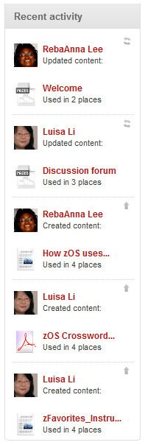

**Marist College  
*Academic Community Cloud***

Love Fashion? Check out our lecture series streamed [LIVE from New York Fashion Week](http://www.test.com)!

Interested in being part of Fashion Week? [Complete our application](http://www.test.com) to volunteer and enter a chance to win a hotel stay in NYC

Our Mission is to open the Marist Academic Community to the World as means to collaborate in the generation of new knowledge and learning experiences.

Join our **Enterprise Computing Community Cloud**

Join our  
 **Fashion Community Cloud**

Join our **Leadership Community Cloud**