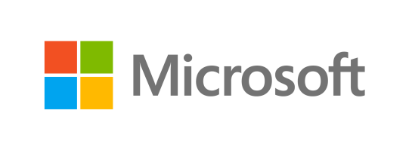

Microsoft Dynamics is a line of integrated, adaptable business management solutions that enables you and your people to make business decisions with greater confidence. Microsoft Dynamics works like and with familiar Microsoft software, automating and streamlining financial, customer relationship and supply chain processes in a way that helps you drive business success.

U.S. and Canada Toll Free 1-888-477-7989

Worldwide +1-701-281-6500

[www.microsoft.com/dynamics](http://www.microsoft.com/dynamics)

This is a preliminary document and may be changed substantially prior to final release.

The information contained in this document represents the current view of Microsoft Corporation on the issues discussed as of the date of publication. Because Microsoft must respond to changing market conditions, it should not be interpreted to be a commitment on the part of Microsoft, and Microsoft cannot guarantee the accuracy of any information presented after the date of publication.

This white paper is for informational purposes only. Microsoft makes no warranties, express or implied, in this document.

Complying with all applicable copyright laws is the responsibility of the user. Without limiting the rights under copyright, no part of this document may be reproduced, stored in, or introduced into a retrieval system, or transmitted in any form or by any means (electronic, mechanical, photocopying, recording, or otherwise), or for any purpose, without the express written permission of Microsoft Corporation.

Microsoft may have patents, patent applications, trademarks, copyrights, or other intellectual property rights covering subject matter in this document. Except as expressly provided in any written license agreement from Microsoft, the furnishing of this document does not give you any license to these patents, trademarks, copyrights, or other intellectual property.

© 2013 Microsoft Corporation. All rights reserved.

Microsoft, Active Directory, Excel, FRx, Hyper-V, Microsoft Dynamics, SharePoint, SQL Server, Windows, Windows Azure and Windows Server are either registered trademarks or trademarks of Microsoft Corporation in the United States and/or other countries.