Create a Subscription
You will create one or more subscriptions for the Windows Azure account. A subscription is a grouping of Windows Azure services and applications, including the virtual machines discussed earlier. The subscription provides a way to control the access to and the use of the Windows Azure subscribed service. On the account billing, the resource usage of Windows Azure services for each subscription is reported separately. In a situation where you will have multiple Microsoft Dynamics GP deployments, you may decide to use a separate subscription for each deployment in order to track expenses related to each deployment. All of the Microsoft Dynamics GP components for a single deployment need to be deployed to the same subscription however. You can set up different administrators for each subscription as required. See Overview of Subscription Management for additional information.
Use the following steps to create a subscription.

- Sign in to the Azure account management portal.
- Click Account Center to manage the account.
- Click to add a subscription.

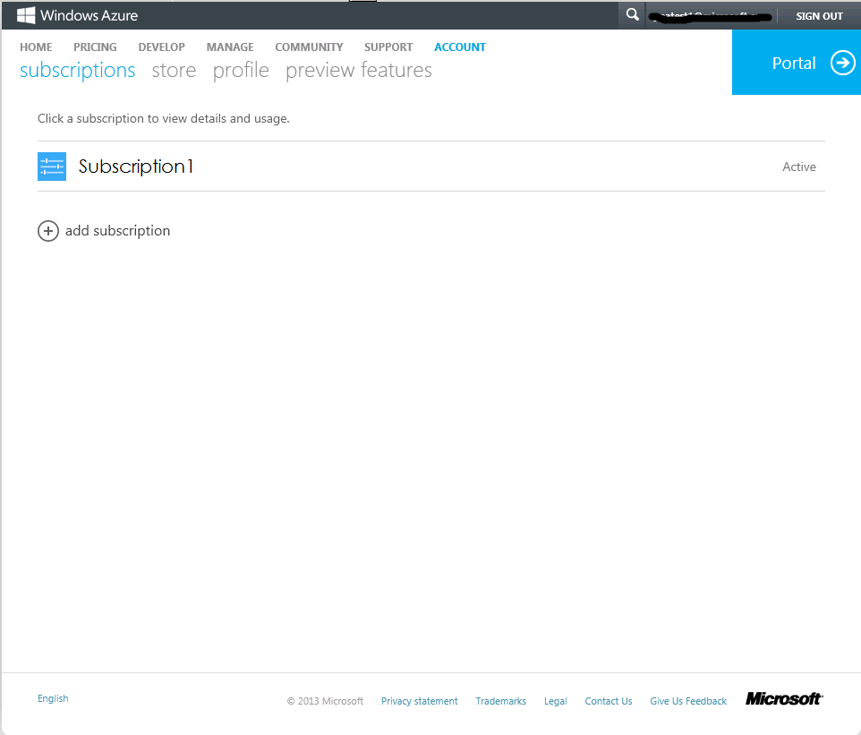

- Click a subscription offer from the available list to create the subscription.

Note: You can rename the subscription after it has been created.

http://msdn.microsoft.com/en-us/library/windowsazure/hh531793.aspx
https://account.windowsazure.com/Home/Index

