Practical – Algometry Testing - PPT

Position of the patient:

Seated comfortably in an upright position, feet flat on the floor. Arms should be resting on the armrests of the chair, or a pillow on the lap. The shoulder girdle should be in a neutral position, neither elevated nor depressed.

Position of the therapist:

For the Upper Trapezius:
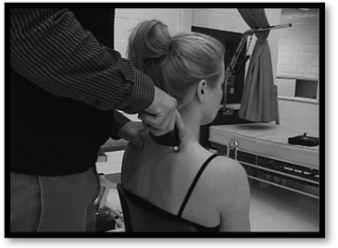
The therapist stands such that the therapist’s dominant hand can hold the algometer and apply the pressure to the angle of the upper trapezius muscle. The angle of the trapezius is most commonly at the level of the 7th cervical or 1st thoracic vertebrae.

For the Tibialis Anterior:

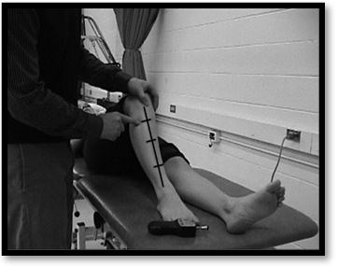
The therapist should position him/herself in such a way as to allow for several pounds of pressure to be applied to the belly of the tibialis anterior, 1 to 1 ½ inches distal to the lateral femoral condyle and ½ to 1 inch lateral to the anterior ridge of the tibia.

Instructions to the patient:

“I am going to press down on your muscle using this device. This device (digital algometer) measures pressure. I will start to push down slowly. I want you to tell me as soon as the sensation you feel changes from one of pressure to one of pain or discomfort. I will stop immediately when you feel pain”

Scoring:

Record the readings for each of the left and right upper trapezius and tibialis anterior.
Be sure to indicate which is the symptomatic side.

Walton D. Assessment Manual Prognosis following acute WAD: Development and Initial Validation of a New Clinical Tool January 2008

