How the western frontiers were won with the help of geophysics

J. G. Smith1 and H. K. Weston2,*

[1]{Institute for Historical Geophysics, Houston, Texas}

[2]{School for Military Advances, London, United Kingdom}

[*]{now at: Playa del Ingles, Gran Canaria}

Correspondence to: J. G. Smith (jgsmith@coldmail.com)

Abstract

To date, very little has been written about the very important role played by the magnetosphere during the conquest of the Western Hemisphere. This paper tries to fill this gap by drawing on historical documents from the years 1492 to 1888, the most vital years for this development. Almost no conclusions are drawn as the influence appears to approach absolute zero.

# Introduction

With the discovery of America (Columbus, 1492) a new continent was opened up. However its full exploitation by Europeans and their offspring was not fully complete until many centuries later, as reported by James et al. (1776).

During this interval, known as the Winning of the West (Smith and Weston, 1954), a major role in the development of the continent was played by the lowly revolver (e.g. Green et al., 1900). Recently, Phillips (1999) suggested that the magnetosphere could have played an even more significant role. In order to pursue this conjecture, the authors of this work have carried out a historical survey and have found startlingly little evidence for such a claim.

# The discovery

America was discovered by Columbus (1492), as illustrated in Fig. 2.Without the use of the compass, this would never have been possible. In fact, this could be considered the most important (and only) contribution of the geomagnetism to the development of the American continent. A painting of Christopher Columbus is shown in Fig. 1.

The subsequent taming of the West took place with considerable quantities of lead, but since this metal is non-magnetic, there are no geomagnetic variances attributed to it.

# The next five centuries

In Sect. 1, the discovery of America was described. Here we will outline the subsequent history until the present. This is best summarized in Table 1.

As can be seen from Table 1, there is almost no mention of geomagnetism or the magnetosphere at all. This sorry situation is discussed further and explained away in Sect. 4.

## The mathematics of development

The complete mathematical description is beyond the scope of this report, but can be found in Smith and Weston (1954). The basic equation is

. (1)

In addition to Eq. (1), we also have

, (2)

, (3)

. (4)

Equations (1) and (2) together describe the entire time development of the history of America. Again no geomagnetic term enters.

### **Pseudo-mathematics**

In addition to the true mathematics mentioned above, there are a number of pseudo-mathematical theories, but these cannot be seriously considered by reputable scientists.

## The chemistry of development

An important equation in the chemistry of the development is

C8H18 + 12.5 O2 → 8 CO2 + 9 H2O. (5)

Moreover, it is necessary to consider photochemistry:

O3 + *hν* → O2 + O. (6)

# Conclusions

Considering Fig. 2 and Table 1 we see that the influence of the geomagnetic and magnetospheric terms is negligible. Furthermore, Eqs. (1) and (2) add no insight to the problem. We must therefore conclude that Phillips (1999) incorrectly supposed such a connection to exist.

In spite of this negative result, research will continue on this highly interesting question. For if it were to prove correct, then the consequences would be enormous to say the least.

Appendix A: Mathematical background

Apart from the following equation there is not very much to say about mathematical background to this topic.

(A1)



Acknowledgements

The authors thank their colleagues for continuing support and discussion around the coffee breaks. The editor thanks X. Y. Furore and another referee for assisting in evaluating this paper.

References

Columbus, C.: How I Discovered America. Hispanic Press, Barcelona, 1492.

Green, R. J., Fred, U. P., and Norbert, W. P.: Things that go bump in the night, Psych. Today, 46, 345-678, 1900.

James, K., Harris, Jr., G., and Wollops, W.: American independence and magnetism, Revol. Tracts, 32, 34-55, 1776.

Phillips, T. P.: Possible influence of the magnetosphere on American history, [www.sma-london.ac.uk/~phillips/magnet_infl.htm](http://www.sma-london.ac.uk/~phillips/magnet_infl.htm), 1999.

Smith, J. G. and Weston, H. K.: Nothing particular in this year's history, J. Oddball Res., 2, 14-15, 1954.

Table 1. The History of America from Discovery to Present.

|  |  |  |
| --- | --- | --- |
| Date | Event | Ref. |
| 1492 | Discovery | Columbus (1492) |
| 1776 | Independence | James et al. (1776) |
| 1954 | Nothing much | Smith and Weston (1954) |
| 1999 | Present | Phillips (1999) |

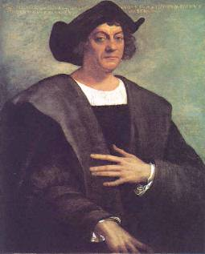

Figure 1.Sebastiano del Piombo painted this portrait thirteen years after Columbus’s death (from the Columbus Navigation Homepage).

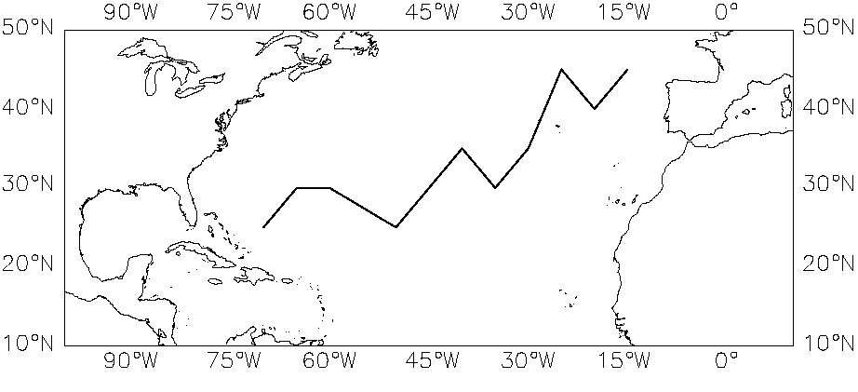

Figure 2. Columbus’s voyage to the New World (a rough approximation).