TMA Marking | Peter Thomson 2013  I have inserted a page break at the start of the document and added this page to indicate my marking techniques to the student and monitor
 | The following symbols and methods are used to indicate the feedback on your assignment. If you cannot easily read these comments please get in touch.
 | On the left you should see a large blue tick. This uses windings font. It indicates that the section of your answer is appropriate, and a good answer.
This is text styled to be in blue  25/25 | On the left is an example of an inline comment used to provide feedback and section marks. It is designed to stand out from your own text. Again, if this colour doesn't suit you let me know.
Comment in a callout | On the left is an example of a comment in a callout, used when I want to point to a specific point.  I can also easily add pro-forma grades and comments using Word
LibreOffice is an excellent, free office suite that runs on most desktop computer systems, and can be used for TMAs- save work as doc files | If you have specific needs, for example you need to use a screen reader, or you cannot read blue text, and prefer e.g. comments in red, please include a message at the top of every TMA
You can view marked TMAs using a web browser if you upload them to Google Docs

Criterion | Grade | Tutor’s comment
1 Does the wiki page meet the brief? | E | You have an excellent focus on the material in the block and have done some research for new material to bring it up to date.  You developed your work on the wiki and updated it after receiving feedback.  You have referenced the block materials, as well as including citations, but you haven't used a quotation
2 Is the content factually accurate? | E | Your report shows good understanding of the topic
3 Is the structure appropriate for the audience, purpose and medium? | E | This report uses clear and appropriate structure, with suitable introduction and conclusion, and well ordered sequence of topics.
4 Is the style appropriate for the audience, purpose and medium? | E | You use a clear and appropriate style
Sample TMA for Electronic Marking. Prepared by Peter Thomson. June 2013
This TMA is marked with Word using macros on the toolbar

Plain text
This wide margin was added using a macro
Praesent consectetur, velit eget gravida interdum, libero dolor sollicitudin felis, id luctus magna metus et lectus. Curabitur eu bibendum orci, a tempus leo. Nam dignissim dolor eget risus sollicitudin convallis. Nunc dapibus odio in nunc lobortis eleifend. Etiam id ante dignissim libero semper elementum ac vel augue. Quisque turpis diam, elementum at elit a, convallis vehicula risus. Suspendisse lacus justo, vulputate vitae erat at, pulvinar ultrices diam. In hac habitasse platea dictumst. Curabitur lobortis fringilla nibh, posuere imperdiet purus porta dapibus. Nullam quis urna adipiscing orci interdum sollicitudin ac ut diam.

One click on the document to locate the pointer, second click selects macro callout.
Pointer may need moving
Nunc orci lacus, egestas sit amet velit vitae, accumsan elementum quam. In sed mollis sem. Pellentesque habitant morbi tristique senectus et netus et malesuada fames ac turpis egestas. Nulla feugiat dolor quis enim pretium, vel condimentum diam venenatis. Lorem ipsum dolor sit amet, consectetur adipiscing elit. Nullam gravida mi semper felis vestibulum rutrum. Integer non tortor eget nisl viverra luctus id nec ipsum. Phasellus sit amet laoreet neque, ut cursus sapien. Nunc consectetur erat nec bibendum consequat. Fusce tristique lectus vel congue eleifend. Quisque quis sapien non justo vestibulum vestibulum quis in augue. Aliquam vehicula interdum neque non molestie. Aliquam a tempus dui.


Highlighting and strikethrough quick and easy
Cras lorem turpis, molestie eget dignissim ac, commodo eu felis. Ut sed turpis congue, volutpat mi id, porta arcu. Nullam a accumsan leo. Morbi et commodo lacus, nec ultricies nulla. Vestibulum ante ipsum primis in faucibus orci luctus et ultrices posuere cubilia Curae; Nullam faucibus turpis erat, sed vulputate odio hendrerit vel. Morbi id adipiscing massa, at accumsan neque. Mauris ut molestie turpis. In convallis libero quis tincidunt dictum. Nulla vitae leo fringilla lectus convallis elementum. Nulla hendrerit fermentum viverra. Vestibulum lectus augue, viverra vel purus in, posuere gravida urna.

floating ticks easy in Word

Bullet points and lists
- Curabitur pharetra ut ante condimentum tristique. Cras volutpat urna in urna condimentum bibendum. Nullam lectus libero, vulputate vitae ligula ac,
inline ticks break formatting
- tristique rutrum lectus. Aliquam quis
- quam molestie,
Bullet points and lists are very easy to disrupt when you add comments in Word, but they don't get modified in a pdf. No problem if you use callouts
- placerat est et, vehicula nisl. Nullam facilisis

- venenatis elit vitae pellentesque.
- Pellentesque
s
^
- aliquam ligula at quam elementum cursus non vel arcu. Pellentesque facilisis odio quis porttitor mollis.
callouts without borders used here
- Sed nec porttitor nunc.
- Nunc massa diam,
- tincidunt condimentum ante vitae,
- fermentum dapibus tortor. Cras id lectus pellentesque, dignissim est laoreet, lacinia arcu. Quisque scelerisque ipsum id tristique laoreet.

Images

I can also type over the image

The following images are from http://commons.wikimedia.org

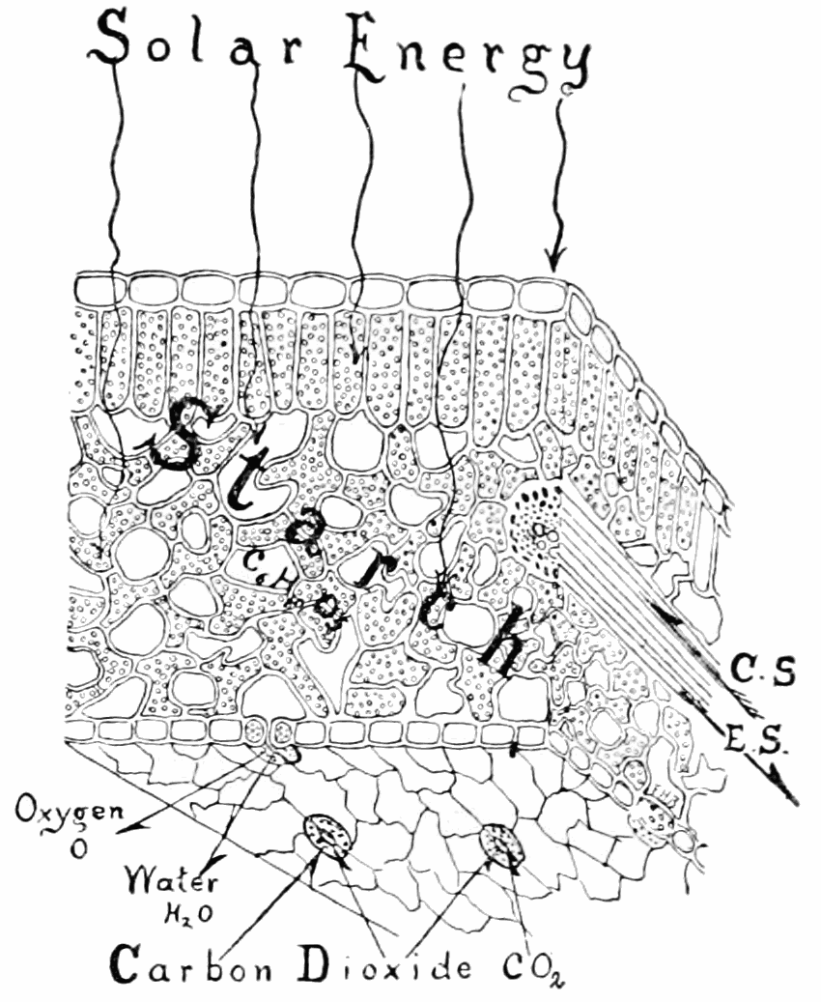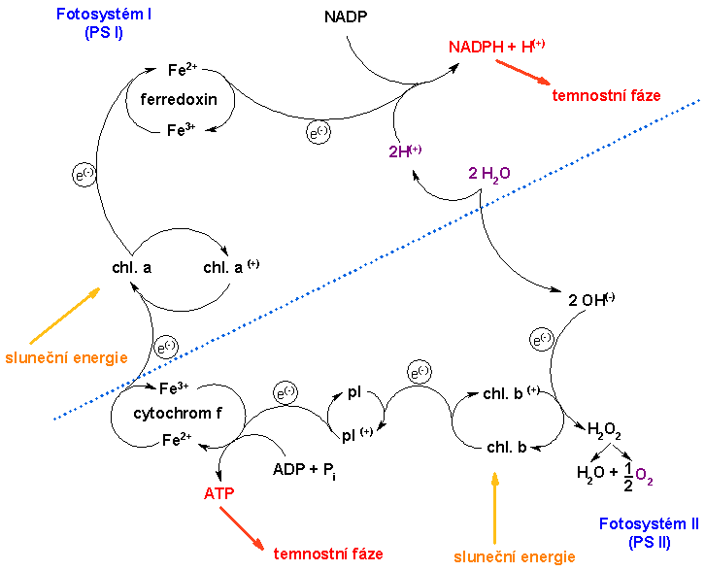
I have used a macro to add a transparent text pane over the image so I can click anywhere to add a comment
I have dragged the corners of the image to enlarge it rather than use zoom

Note here

I can overtype an image

so what do we call this stage?

lines can be drawn over images

But you may need to drag callout and pointer to the correct location
Comments can be placed anywhere
But I prefer to use callouts over an image

Too Small ?
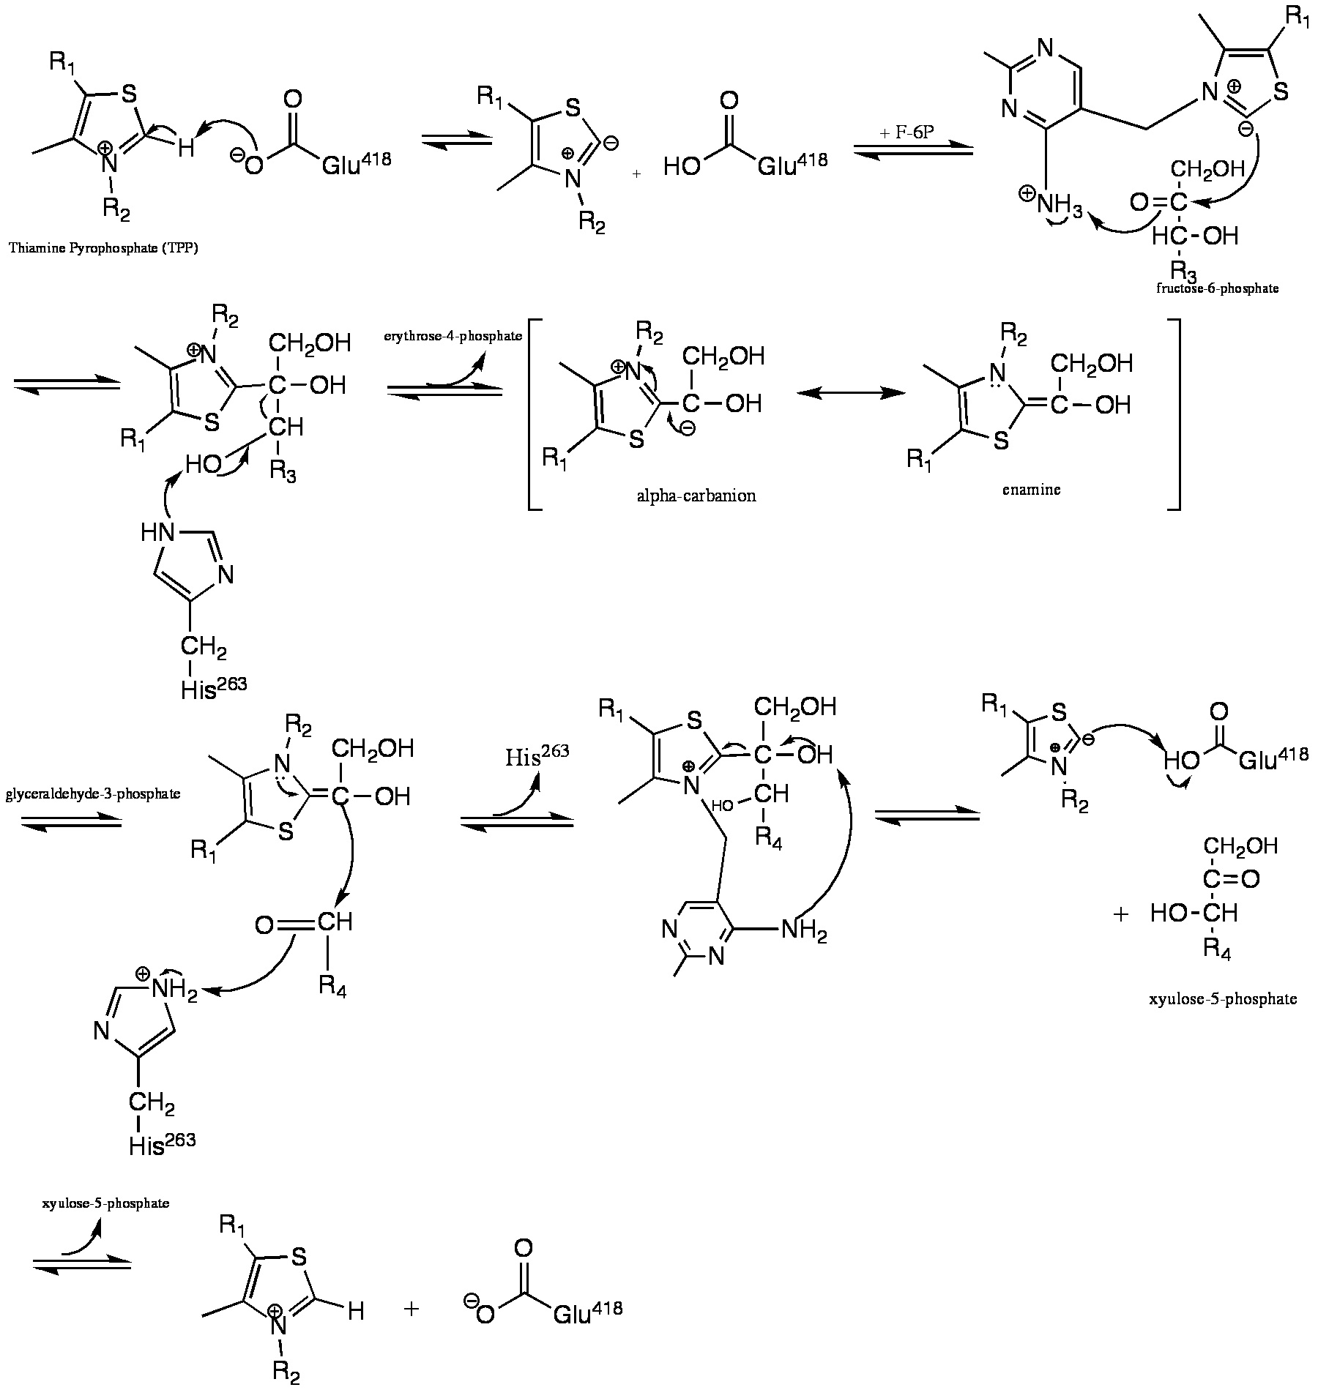
Here is a clip from a specimen answer I prepared earlier. Much simpler to add this using Word!
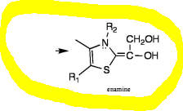
Again this image was too small to add my comments, so I have resized the image
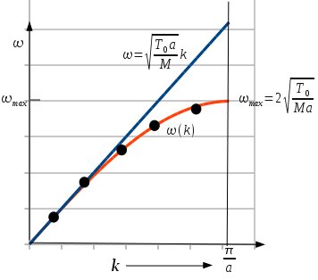
groups of symbols in floating boxes can be dragged into any relationship. http://math.typeit.org/
μνξπρ
ΔΞΦΨ
√
Lines can be drawn over the page
But enlarging the previous image has changed the page formatting - this might be important if diagrams are closely related to each other. I could add a page break here to restore subsequent formatting
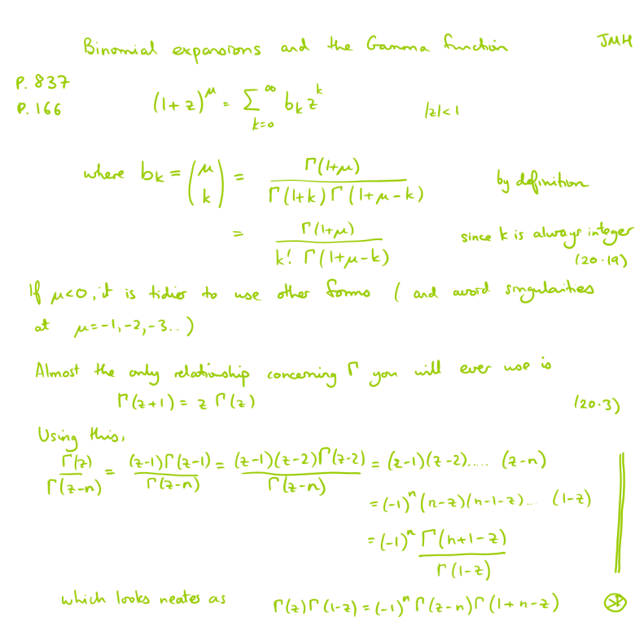
freeform lines easy to add over image
Single lines are easy to type in
α = β² + γ³
Image clips from pre-prepared answer much faster than typing more than a little.
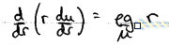
d r du = eg r
dr dr μ
( )
Image supplied by a maths tutor

Block diagrams with separate components.
E
D
C
B
A

Use callouts to avoid disrupting diagrams built from separate components, or place the clear pane over the top using a macro

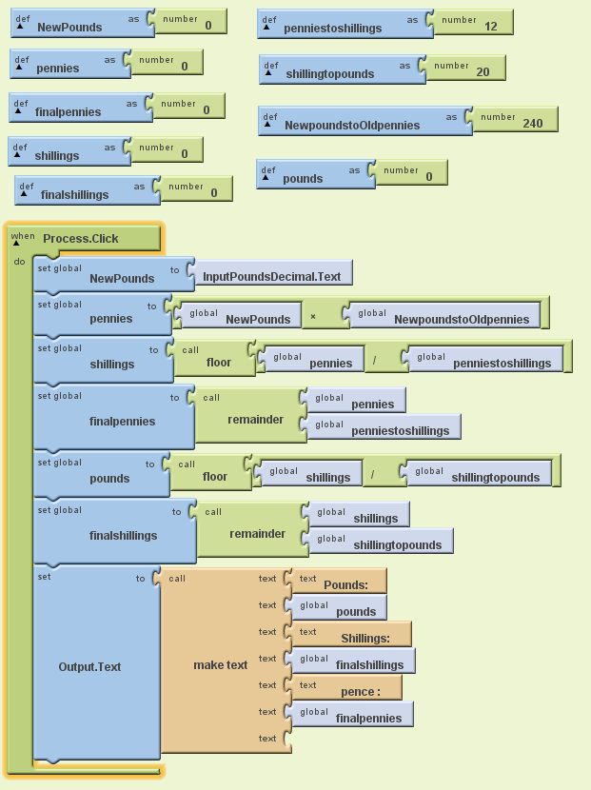
^
^
use meaningful variable names
Sometimes I want to draw attention to specific points

And in word I can add pre-prepared comments and they will keep the formatting !

