A document with mixed png, jpg and gif.

First 4 gifs

The document now contains:

image1.GIF 5,096
image2.GIF 41,335
image3.GIF 26,656
image4.GIF 35,175

Then 4 pngs

The document now includes:

image1.png 6,949
image2.png 47,027
image3.png 54,367
image4.png 67,784

Finally 4 Jpegs

When opened in Libreoffice it .....

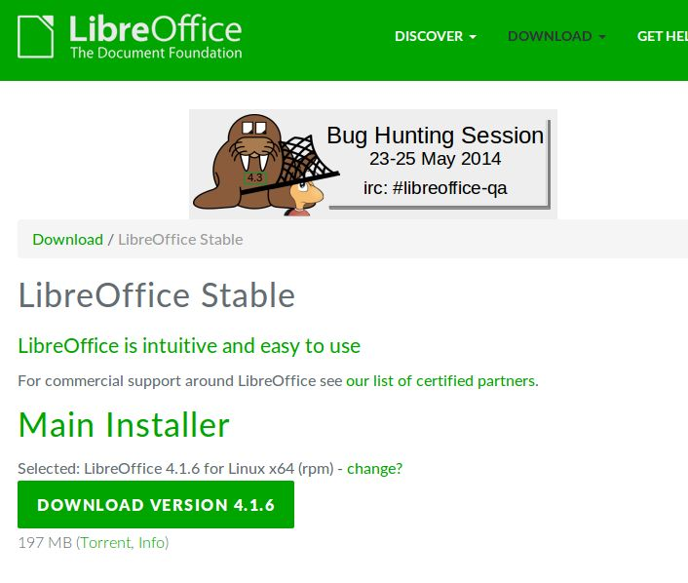

The docx includes:
image1.jpeg 4,394
image2.jpeg 31,438
image3.jpeg 35,458
image4.jpeg 49,022

The three documents copied and pasted into one results in:

A docx document with 4 Jpegs

When opened in Libreoffice it .....

The docx includes:
image1.GIF 5,096
image2.GIF 41,335
image3.GIF 26,656
image4.GIF 35,175
image10.jpeg 31,438
image11.jpeg 35,458
image12.jpeg 49,022
image9.jpeg 4,394
image5.png 6,949
image6.png 47,027
image7.png 54,367
image8.png 67,784

And evrything is visible in Libreoffice when the document is opened.
After saving as docx from Libreoffice however:

image9.png 4,249
image20 0
image19 0
image18 0
image17 0
image16.png 67,784
image15.png 54,367
image14.png 47,027
image13.png 6,949
image12.png 31,413
image11.png 23,718
image10.png 38,428

So, Libreoffice has destroyed the 4 jpegs and rendered their size 0
Libreoffice has also changed the filetypes from gif to png and saved those without any warning.

If we look atthe rels document in the docx (tells docx the relationships between its internal links) we can tell that it has destroyed the file extensions/types there too.

<?xml version="1.0" encoding="UTF-8"?>
<Relationships xmlns="http://schemas.openxmlformats.org/package/2006/relationships"><Relationship Id="rId1" Type="http://schemas.openxmlformats.org/officeDocument/2006/relationships/styles" Target="styles.xml"/><Relationship Id="rId2" Type="http://schemas.openxmlformats.org/officeDocument/2006/relationships/image" Target="media/image9.png"/><Relationship Id="rId3" Type="http://schemas.openxmlformats.org/officeDocument/2006/relationships/image" Target="media/image10.png"/><Relationship Id="rId4" Type="http://schemas.openxmlformats.org/officeDocument/2006/relationships/image" Target="media/image11.png"/><Relationship Id="rId5" Type="http://schemas.openxmlformats.org/officeDocument/2006/relationships/image" Target="media/image12.png"/><Relationship Id="rId6" Type="http://schemas.openxmlformats.org/officeDocument/2006/relationships/image" Target="media/image13.png"/><Relationship Id="rId7" Type="http://schemas.openxmlformats.org/officeDocument/2006/relationships/image" Target="media/image14.png"/><Relationship Id="rId8" Type="http://schemas.openxmlformats.org/officeDocument/2006/relationships/image" Target="media/image15.png"/><Relationship Id="rId9" Type="http://schemas.openxmlformats.org/officeDocument/2006/relationships/image" Target="media/image16.png"/><Relationship Id="rId10" Type="http://schemas.openxmlformats.org/officeDocument/2006/relationships/image" Target="media/image17"/><Relationship Id="rId11" Type="http://schemas.openxmlformats.org/officeDocument/2006/relationships/image" Target="media/image18"/><Relationship Id="rId12" Type="http://schemas.openxmlformats.org/officeDocument/2006/relationships/image" Target="media/image19"/><Relationship Id="rId13" Type="http://schemas.openxmlformats.org/officeDocument/2006/relationships/image" Target="media/image20"/><Relationship Id="rId14" Type="http://schemas.openxmlformats.org/officeDocument/2006/relationships/fontTable" Target="fontTable.xml"/><Relationship Id="rId15" Type="http://schemas.openxmlformats.org/officeDocument/2006/relationships/settings" Target="settings.xml"/>
</Relationships>

A document with 4 gifs.docx 117,339
A document with 4 gifslo.docx 100,857 gifs converted to png
A document with 4 pngs.docx 180,416
A document with 4 pngslo.docx 176,358
A docx document with 4 Jpegs.docx 112,653
A docx document with 4 Jpegslo.docx 5,535 Clearly destroyed the four jpgs
A document with mixed png_jpg_gif.docx 392,578
A document with mixed png_jpg_giflo.docx 273,203
So the mixed document had gifs converted to png and destroyed all jpg

Conclusion:
A. Libreoffice has a serious problem because many users will use the jpg/jpeg format to insert graphics into their documents, but when libreoffice is used to edit the document as docx, it will destroy the graphics when saved.

B. Libreoffice will enforce png conversion from other formats. There is no need for that and it does nto ask anything to the user about this.

