Factsheet ENT-1

September 2012

Biology and Pest Management of Spiraling Whitefly
Deanna Chin¹, Haidee Brown¹, Lanni Zhang, Michael Neal¹, Brian Thistleton¹ and Stuart Smith²
Entomology, Plant Industries¹, Biosecurity and Product Integrity²

Background and Distribution
Spiraling whitefly, Aleurodicus dispersus is native to the Caribbean region and Central America. The pest is also found in the USA (southern Florida), West Indies, South America, Africa, the Canary Islands, Hawaii, Samoa, the Maldives, Cook Islands, Fiji, Guam, Micronesia, Nauru, Taiwan, India, Sri Lanka, Papua New Guinea, South East Asia and Torres Strait. In Australia, the pest is established in coastal Queensland from Mackay to Cape York was first detected in Darwin in March 2006. Spiraling whitefly has now been recorded from many localities in Darwin, Palmerston, Darwin rural including, Howard Springs, Virginia, Bees Creek, Noonamah, Humpty Doo, Girraween, Berry Springs, Wagait Beach (Cox Peninsula), Adelaide River, Batchelor, Pine Creek, Jabiru and Katherine. It has not been detected from Nhulunbuy or Alice Springs.

Appearance
Spiraling whitefly is a small sap sucking insect which is related to mealybugs and aphids. To the naked eye, the adults look like a very small moth and have a body length of about 2 mm. The wings of the adults are plain white or occasionally have pale or dark spots on the forewings. Eggs are elliptical and yellow to tan in colour, 0.3 mm long and are laid singly at right angles to the leaf veins and associated with irregularly spiraling deposits of white flocculent wax. This spiraling effect is usually on the undersides of leaves but in heavy infestations the spirals may also be seen on the upper surface of leaves as well as fruit and non plant material. The first stage of the larva is mobile but the later immature stages are sedentary and have an oval disc shaped soft body that is light green in colour. The final immature stage is the pupa and is about 1 mm in length. The sedentary larvae have characteristic waxy tufts and the final larval stage (pupa) has glass like rods of wax along the sides of the body.
The coconut whitefly, Aleurodicus destructor is a local species that resembles the spiraling whitefly. Differences between the two species cannot be seen with the naked eye and requires identification by a specialist.
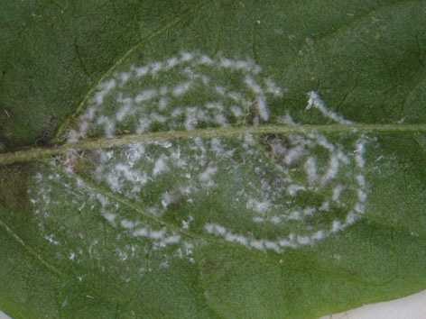
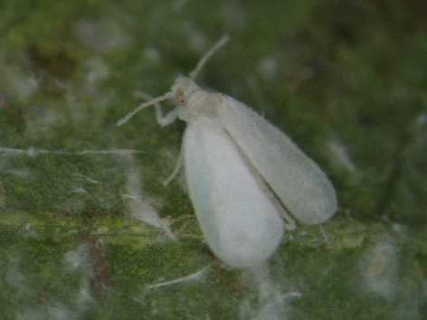

Spiraling whitefly adult Spiral pattern formed during egg laying

Life Cycle
In the temperature range of 20°C to 39°C development from egg to adult takes 34 to 38 days (eggs 9-11 days, 1st instar (stage) larvae 6-7 days, 2nd instar 4-5 days, 3rd instar 5-7 days and 4th instar larva (pupa) 10-11 days). Under laboratory conditions the adult can live for up to 39 days.

Symptoms and Damage
Spiraling whitefly attacks a large range of plants including vegetables, fruit trees, ornamentals, native plants and weeds. Some common hosts that it has been found on in the Darwin area are acalypha, a local weed called Euphorbia heterophylla (sometimes referred to as “milkweed”), chillies, capsicum, bauhinia, sweet potato, guava, pawpaw, poinsettia, banana, tomato, heliconia, eggplant, mulberry, frangipanni and ground orchids. Spiraling whitefly will also deposit eggs on non hosts.
These whiteflies produce honeydew and this may provide a substrate for the growth of sooty mould which interferes with photosynthesis. In heavy infestations, feeding damage may cause leaf drop or reduced yield in crops. The wet season weather is less favourable to the whiteflies and they will generally be in low populations. Higher populations are more common during the favourable weather conditions of the dry season.
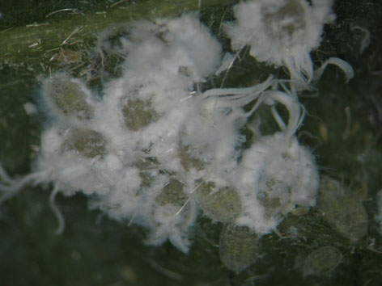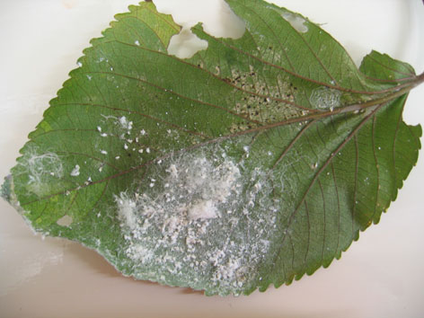
Spiraling whitefly larvae Spiraling whitefly on an acalypha leaf

Pest management
The whitefly is able to build up a resistance to most chemical pesticides and should not be treated with these. Spraying with chemicals also destroys natural enemies or biological control agents that have been released. Potassium soap such as Natrasoap or Neemtech potassium soap with added spray oil may assist in managing populations on host plants. (Note that other potassium soap products may also be effective).
Examples of spray oils include: Eco oil, DC tron plus, Spraytech oil, Synertrol Hort oil or any other suitable horticultural spray oil. For home garden situations, cooking oils such as canola oil or a vegetable oil are also suitable. It is important to spray both sides of the leaves and spray to runoff and repeat every 3 days (until controlled). This spray solution may cause leaf burn to sensitive plants. The best time to apply sprays is in the early morning or late afternoon.
Suggested spray rates are: Natrasoap 20ml/L + spray oil 2ml/L or Neemtech 30ml/L + spray oil 2ml/L
(The recommended rate of oil listed is for canola oil and vegetable cooking oil. If you have a horticultural spray oil use the rate shown on the product label.)

Biological control with Encarsia wasp parasite
Shortly after the detection of spiraling whitefly in March 2006, DPIF introduced a microscopic wasp parasite called Encarsia sp. (which was sent from Cairns by QDPI) to assist in the management of spiraling whitefly. The wasp parasite is 0.1 mm long and is harmless to humans. Encarsia is now established in many localities in Darwin, Palmerston and the rural area and has been observed to reduce the population of spiraling whitefly in several areas. The Department has continued to monitor and promote the establishment of Encarsia in all major suburbs and rural areas where it has been detected. The wasp will spread naturally to nearby areas after it has been released and will take between 1-6 months to establish at a new site depending on the suitability of the vegetation and how well the garden is maintained. In general, Encarsia are more likely to establish quicker and take control of the spiraling whitefly infestation if the garden is well maintained and has plenty of shade.

As of August 2008, the spiraling whitefly has been detected from the following areas:
- Darwin area: Alawa, Anula, Berrimah, Brinkin, Coconut Grove, Darwin City, Fannie Bay, Karama, Jingili, Knuckey's Lagoon, Leanyer (and Woodleigh Gardens), Malak, Nakara, Nightcliff, Northlakes, Parap, Stuart Park, Wagaman, Wanguri, Wulagi, Tiwi and 11 Mile
- Palmerston area: Bakewell, Driver, Durack, Gray, Gunn, Marlow Lagoon, Moulden, Woodroffe and Roseberry
- Rural area: Bees Creek, Howard Springs, Humpty Doo, McMinns Lagoon, Virginia, Wagait Beach Cox Peninsula, Batchelor, Adelaide River, Pine Creek, Jabiru and Katherine.

The Encarsia wasp parasite has been released in many sites in the Darwin, Palmerston and rural areas and it is now spreading naturally. Encarsia has now established at the following areas (94 sites as of August 2008):
- Darwin area: Alawa (3 sites), Anula (8 sites), Berrimah (3 sites), Brinkin (1 site), Darwin City (1 site), Coconut Grove (1 site), Fannie Bay (1 site), Jingili (2 sites), Karama (7 sites), Knuckeys Lagoon (1 site), Leanyer (5 sites), Malak (1 site), Moil (3 sites), Nakara (3 sites), Northlakes (1 site), Rapid Creek (2 sites), Stuart Park (2 sites), Wagaman (6 sites), Wanguri (6 sites), Wulagi (4 sites), Tiwi (2 sites)
- Palmerston area: Bakewell (3 sites), Driver (1 site), Gray (4 sites), Marlow Lagoon (4 sites), Moulden (2 sites), Woodroffe (2 sites), Roseberry (1 site)
- Rural area: Bees Creek (1 site), Howard Springs (4 sites), Humpty Doo (7 sites), Pine Creek (Pine Creek) and Adelaide River (1 sites).

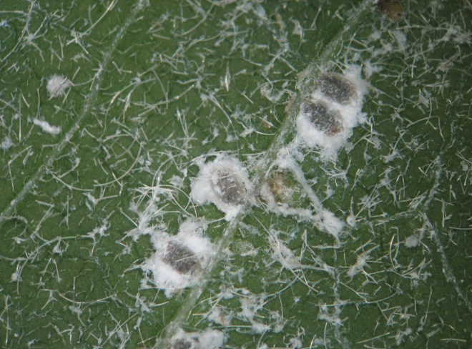
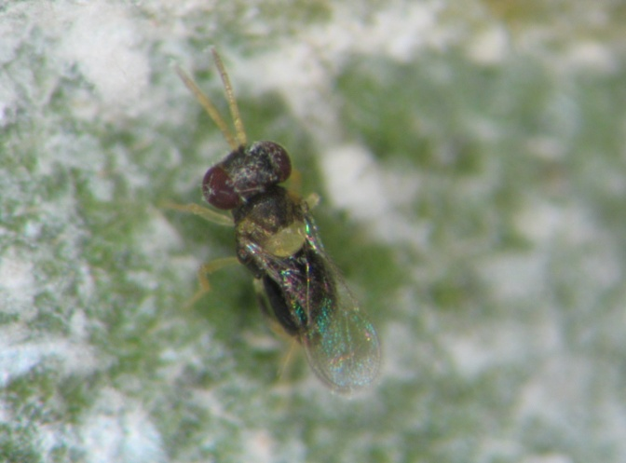

Encarsia wasp parasite (0.1 mm in length)
Spiraling whitefly larvae parasitised by Encarsia

The Department will only supply Encarsia to new detection sites and all commercial horticultural properties affected but not to Darwin and Palmerston suburbs where the wasp has already been released and is spreading naturally.

If you have noticed the spiraling whitefly in areas south of Humpty Doo please contact Entomology DPIF on telephone number 08 8999 2258, or deliver a sample to Entomology, Berrimah Agricultural Laboratories (BAL) Building at Berrimah Farm, Makagon Road, Berrimah. For residents outside the Darwin area, please deliver samples to your local DPIF office or quarantine officer in your region.

Quarantine Restrictions
Plants and fruit produce exported interstate may require specific treatments as well as an inspection from a Quarantine inspector to comply with the 'Interstate Certification Assurance' (ICA) agreements. Similarly, plants moving within the Territory from an infested to an uninfested area may need treatment to prevent the spread of the pest. Further information is available from DPIF NT Quarantine. New legislation is currently being developed which reinforces the responsibility of the public to prevent the spread of plant pests and diseases.
For further information on this leaflet contact Entomology at insectinfo.dor@nt.gov.au. Agnotes or factsheets on other pests are available from www.entomology.nt.gov.au or www.primaryindustry.nt.gov.au.

References
Botha, J., Hardie, D. and Power, G. (2000). Spiraling Whitefly Factsheet No. 18/2000, Agriculture Western Australia.
Lambkin, T. (2004). Emerging plant pests spiraling whitefly. Department of Primary Industries and Fisheries. DPI&F Note.
Waterhouse, D.F. and Norris, K.R. (1989). Biological Control Pacific Prospects- Supplement 1. Australian Centre for International Agricultural Research Canberra. pp. 13-22.
www.cabicompendium.org
Department of Primary Industry and Fisheries
© Northern Territory Government
Disclaimer: While all care has been taken to ensure that information contained in this Factsheet is true and correct at the time of publication, the Northern Territory of Australia gives no warranty or assurance, and makes no representation as to the accuracy of any information or advice contained in this publication, or that it is suitable for your intended use. No serious, business or investment decisions should be made in reliance on this information without obtaining independent/or professional advice in relation to your particular situation.

