A Mobile application to interact with a Mesh billing system

By

Zine Tshaka

A project document submitted in partial fulfillment of the requirements for the degree of

BSc Honours (Computer Science)

University of The Western Cape

2013

Date: February 28, 2013

University Of The Western Cape

Abstract

A Mobile application to interact with a Mesh billing system

By

Zine Tshaka

Supervisory: Professor I.M Venter

Co-Supervisor: Professor WD Tucker

Mentor: Carlos Rey-Moreno

Department of Computer science

ABSTRACT

The cost of making a call and sending a text message in most parts of Eastern Cape is extremely high. The mesh potato network aims to help people from rural areas to make calls for free (or almost free). Due to the fact that material needs to be maintained, it was decided by the authorities that maintenance fee must be paid to keep the system going. Therefore a nominal fee must be paid. The mesh billing system will be used to collect money for the maintenance of the network. The aim of this project is to create an interface between the billing system and the users so that monthly statements can be received via Short Message Service or queried using USSD. The mesh billing system will specify the number of calls a person can make for a certain fee before having to recharge again. To collect the requirements of the system, seven people from the Delft community originally from Eastern Cape were interviewed. From what I have discovered from the people new system needs to be developed. That brings us to the discussion of the mobile application to interact with the mesh billing system.

Table of Contents

Table of Contents 1

list of figures 2

list of tables 3

Chapter 1 5

user REQUIREMENTs DOCUMENT 5

Background 5

User’s view of the problem 5

Brief description of the problem domain 6

What is expected from the software 6

What is not expected from a software solution 6

Chapter summary 6

Chapter 2 7

Requirement Analysis Document 7

Chapter introduction 7

Designers interpretation of the user’s requirements 7

Requirements 7

Solutions 7

Breaking down the problem into high level constituent parts 8

Identify existing solutions 9

Technologies to be used 9

Devise ways to test the solution 9

Chapter summary 10

Appendices 11

Appendix A 11

APPENDIX B 12

Bibliography 14

Index 15

list of figures

Figure 1 How USSD works for many users 8

Figure 2(How USSD works) 9

list of tables

Table 1 Project Plan for Term 1 13

Glossary

SMS- Short message service is a system that allows one to send and receive a text message in a cell phone (Li, Zhi Wu, et al. "Extension of Elementary Siphons in a Class of Generalized Petri Nets." Applied Mechanics and Materials 284 (2013): 2238-2243.)

USSD -Unstructured Supplementary Service Data is a protocol used by GSM based mobile phones to communicate with the network operator's compute (http://searchnetworking.techtarget.com/definition/USSD)

GSMG **-** Global System for Mobile communications (<http://cellphones.about.com/od/phoneglossary/g/gsm.htm>)

MSC - the mobile service center, a switching center for mobile device

Chapter 1

user REQUIREMENTs DOCUMENT

# ****Back****ground

A mesh potato is a device that provides low-cost telephony and Internet services in areas where alternative access doesn’t exist or is too expensive. A mesh potato system was implemented in the Mankosi district (a rural area in Eastern Cape) to overcome the communication problems that are faced by the people of Mankosi. A mesh billing system will be implemented to collect money for the maintenance of the mesh network. The system that is proposed will allow the people of Mankosi to easily access their mesh potato network bills/status.

Currently to see how much they owe, they will have to go the place where the mesh potato is situated and ask for a bill. The proposed system will allow the Mankosi community easy access to their bills whenever they want to do so. In this chapter the requirements of such a system are described as elicited and described by the users. The proposed application will be used to interact with the mesh billing system as well as the administrator of the system.

# User’s view of the problem

To get to know the user’s view of the problem, people from Delft (originally from Eastern Cape) were interviewed using a list of probes (see Appendix A). Most of these cell phones users seem to have experienced the same problems with their cell phones: they do not know exactly when to recharge and they do not have easy access to the status of their “pre-paid bills”. Some indicated that they would not like to cover long distances just to recharge their credit for phoning. If it cannot be done remotely they would have to walk to the mesh potato office in order to view their monthly bills or update their credit on the phone. They were concerned that a new system might not be easy for them to understand and suggested that the new system should be clear and easy to use.

# Brief description of the problem domain

If the people from Mankosi village using the mesh potato network can only access their account or recharge their mesh network access by physically going to the place where the mesh network office is located – it will be inconvenient. If there is no-one at the office they will not be able to view their bill-status or update their “air-time”.

# What is expected from the software

The system is expected to be able to accurately send information to the user when the user requests it via USSD. The system is expected to accommodate everyone, even those who do not use a “smart” phone

# What is not expected from a software solution

1. This system will not be able to send the bill more than once in 30 days unless requested to do so.
2. The system will not be expected to keep all the previous bills. After 30 days the system will no longer have records of the previous month.

# Chapter summary

In this chapter the problem is stated and the user’s requirements for the billing of a mesh system (to be implemented) are stated. In the next chapter the user’s requirements will be analyzed in terms of what is possible with the technologies available and the time allocated for the project.

Chapter 2

Requirement Analysis Document

# Chapter introduction

In the previous chapter the user’s requirements and the problems of a mobile phone application that can interact with a mesh billing system, were identified and explained. In this chapter the requirements will be analyzed and solutions to the problems will be posed.

# Designers interpretation of the user’s requirements

In the previous chapter the problem and the user’s requirements for the system was briefly described. The requirements are now revisited and possible solutions for each requirement are stated below

## Requirements

1. Users specified that the system must not require a specific phone; a user must be able to use the system even on a non-smart phone.
2. The system must not require some passwords in order to access it
3. System must not involve long and complicated processes
4. System must be safe and secured

## Solutions

Solutions to all of these requirements are:

1. An automatic monthly statement will be sent to all users
2. And USSD will be used the query the bills during the month,

The system will be free to all the users; a user could use the system even if their airtime credit is “0” on their cell phone account. The user must register once with the system, the system must be able to retrieve the user’s information for the registered user.

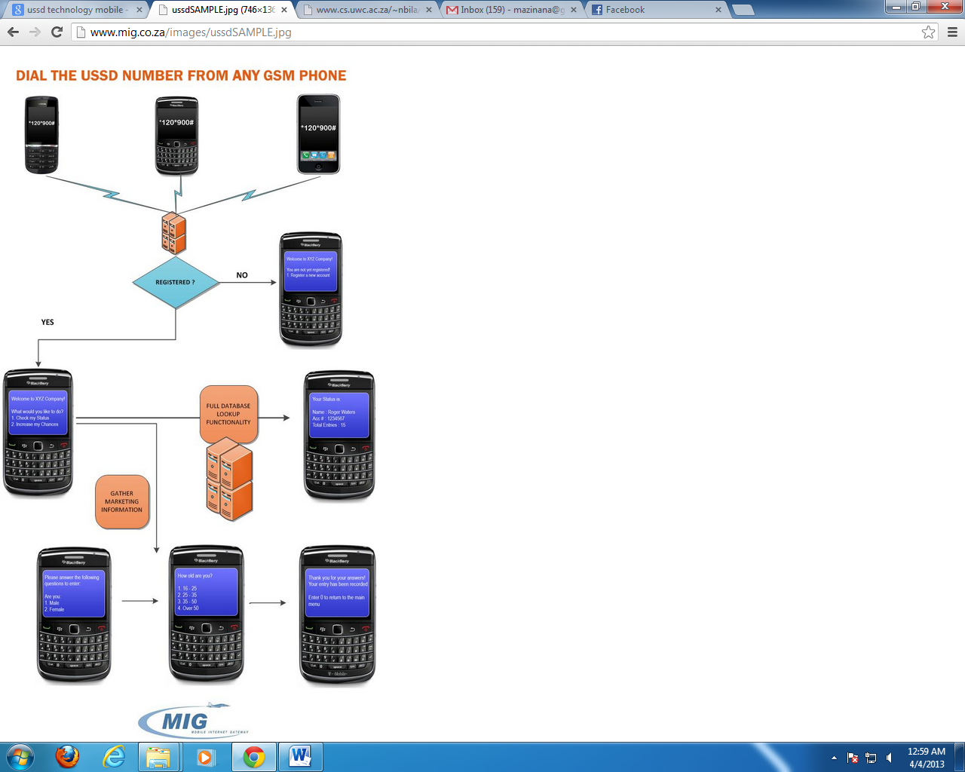

Figure 1 How USSD works for many users

# Breaking down the problem into high level constituent parts

The user interacts with the system using a mobile phone using a certain USSD code to check his or her mesh network bills. The following is the breakdown of how the system works:

A user sends USSD code to the server. The server receives a request from the user and a communication between a user and a network is created. The server checks the user’s bill from the database and sends the current status to the user. 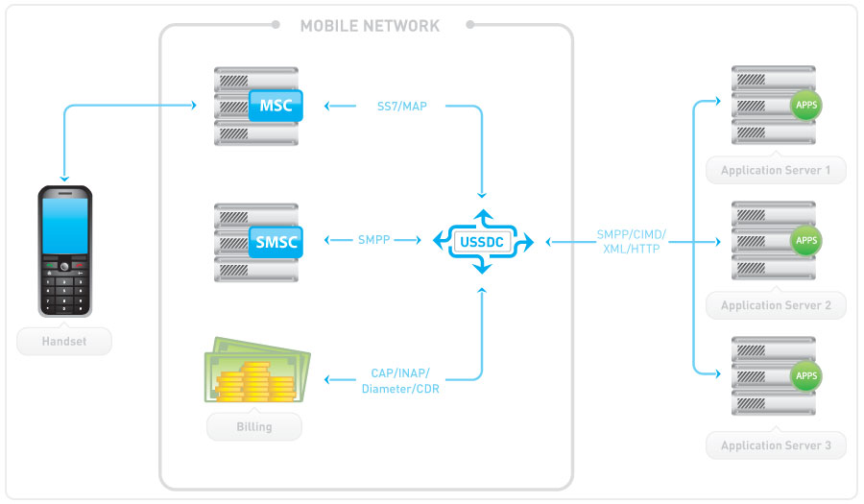

Figure 2(How USSD works)

# Identify existing solutions

The mesh billing system could be a solution to the communication problem that the Mankosi community is experiencing. Most of existing USSD system is used to check airtime and other requests, there are very few USSD systems that are used to check the accounts of phones.

# Technologies to be used

[NetBeans Java](http://netbeans.org/projects/java)

MyQsl for database installations

Bulk SMS portal for smsing to a group of people

NET, PHP, Java for connecting applications to the mobile world

# Devise ways to test the solution

An evaluation of a system’s functionality will be done by testing it on a group of users. The users that initially gave the requirements (the people from Delft) will be asked to evaluate the system. When testing system users will be asked to interact with the system using a mobile phone to determine whether the system produces the expected results or performs in the desired manner and see what must be improved from the system.

# Chapter summary

This chapter gives a brief description of designer’s view of the problem, the possible solutions to the problem; ways in which the system will be tested and Breaking down the problem into high level constituent parts

Appendices

# Appendix A

**A mobile application to interact with a mesh billing system**

Project description

This project aims to help people from rural areas where the mesh network is implemented. This project focuses on helping them get their mesh network bills without any difficulties.

1). Do you think such a system will be helpful to the people of Mankosi? How?

2). what would you like a system to do?

3). what is it that you do not want from the new implementation?

4). Can you please describe the way you would like the system work like

# APPENDIX B

**Consent form**

University of the Western Cape

Faculty of Science

Department of Computer Science

Title of the research project:

A mobile application to interact with a mesh billing system

Department:

sddaaaaafdfdfdsfs

Telephone:

Email:

Name of participant:

• I agree to participate in this research project

• I have read this consent form and the information it contains and had the opportunity to ask questions about them.

• I agree to my responses being used for education and research on condition my privacy is respected, subject to the following.

- I understand that my personal details may be included in the research/ will be used in aggregation form only, so that I will not be personally identifiable.

• I understand that I am under no obligation to take part in this project.

• I understand I have the right to withdraw from this project at any stage.

Signature of Participant:

………………………………….

Name of participant:

……………………………………………………

Table 1 Project Plan for Term 1



# Bibliography

*A Mesh Network Implementation In Mankosi, South Africa*. (n.d.). Retrieved 03 26, 2013, from Marie Josée: http://www.cs.uwc.ac.za/~mufitamahoro/project.html

*http://www.logossolvo.com/news.php?start_from=48&ucat=&archive=&subaction=&id=&*. Retrieved 03 10, 2013

*https://groups.google.com/forum/?fromgroups=#!topic/village-telco-dev/95vOPMpXg2I*. Retrieved 03 10, 2013

*MIG*. Retrieved 04 03, 2013, from http://www.mig.co.za/images/ussdSAMPLE.jpg

nbila. *mobile banking banking theb unbanked*. Retrieved 10 03, 2013, from http://www.cs.uwc.ac.za/~nbila/thesis.pdf

*send mode*. Retrieved 04 05, 2013, from http://www.sendmode.co.za/sms-gateway

stephen, m. a. The Village Telco project: a reliable and practical wireless mesh telephony infrastructure.

*village telco*.. Retrieved 03 26, 2013, from villa telco: http://villagetelco.org/mesh-potato/

# Index

A

air-time, 6

B

Bulk SMS portal, 9

C

call, i

M

Mankosi, 5, 6, 9, 11

mesh potato, i, 5, 6

mobile phone, 7, 8, 9

MyQsl, 9

N

NetBeans Java, 9

R

requirements, 1, i, 5, 6, 7, 9

rural area, 5

S

SMS, 4

U

USSD, i, 4, 6, 7, 8, 9