Locating EV Charging Stations
A growing EV charging infrastructure exists in the metropolitan Washington region as a result of stimulus funding through state governments and private investment. To facilitate EV deployment in the region, investment in EV charging stations should to address the needs of EV owners, or the investments made will go unused and EV ownership will continue to be a small minority of vehicles on the road.

Information about driving behavior in the region and EV ownership are important factors in making decisions about investing in EVSE equipment. Experience in regions having developed EV infrastructure indicates that most EV charging is done at home. The next most frequent location for charging is at major places of employment.

Information about household travel demand data has potential and EV ownership in the region will be important to deciding where and how many charging stations to locate at places of major employment, retail, public facilities and entertainment destinations. Some of this data is presented in this report but more analysis is needed.

The Stakeholder group addressed the questions of where EV infrastructure should be located and considered the challenges of providing destination charging and providing access to charging for residents of multi-unit buildings. This section presents baseline information on EV ownership outlook and siting along with general site location recommendations. Deployment planning strategies are presented with a preliminary regional needs analysis with best practices and examples to improve the network going forward.

EV Ownership

Outlook for EV Markets
As Corporate Average Fuel Economy (CAFE) standards increase, automobile original equipment manufacturers (OEMs) are investing more in electric vehicles. In July 2011, President Obama announced that vehicle manufacturers would be required to meet a fleet-wide average fuel economy of 55 miles per gallon by 2025. In order to meet a 35.5 mpg in 2016, manufacturers are responding by releasing more high-efficiency vehicles. Since 2009, the number of and subcompact vehicles rated at least 30 mpg has tripled, and large increases have also been seen in the mid-size and crossover categories as well. Electric vehicles, which offer ratings of 75 to over 100 miles per gallon equivalent (MPGe), will play an increasingly important role in auto manufacturers’ fleets as they seek to meet the ambitious 2025 goal.
Summary: Factors Affecting EV Demand
Global: Gasoline Prices
National: Federal Grants, CAFÉ Standards, Tax Credits
Regional: Electricity Prices
State & Local: Incentives and Requirements
Consumer/Purchaser: Cost, Range, Availability of EV models and availability of charging infrastructure

While interest in electric vehicles is growing, the EV market share has not grown significantly over the past five years. Since 2007, the yearly proportion of EVs out of all vehicles sold has hovered between two and three percent. In that time, 1.3 million electric drive vehicles have been sold, including hybrid, plug-in hybrid, extended-range, battery, and fuel cell vehicles.

Industry experts suspect that constraints on the availability of the most popular models, the Nissan Leaf EV and the Chevrolet Volt PHEV, have held back growth in the electric vehicle segment in recent years. In 2011, the Leaf was only available in 30 states, and all cars produced that year had been claimed by pre-orders from 2010. This left only a few unclaimed pre-orders available to car shoppers that year. Chevrolet also did not begin offering the Volt nationally until fall 2011. As the roll-out progressed, sales have increased. Both companies have announced higher production for 2012, which is expected to open the market to additional growth.

Additionally, limited vehicle selection is attributed to low growth rates in this sector. Compared to the wide array of model types in the internal combustion sector, there are currently only two EV models available nationally. A number of new vehicle models are expected for national rollout in 2013 and 2014, however, which should further open the market. See Appendix ___ for a detailed description of OEM vehicle offerings.
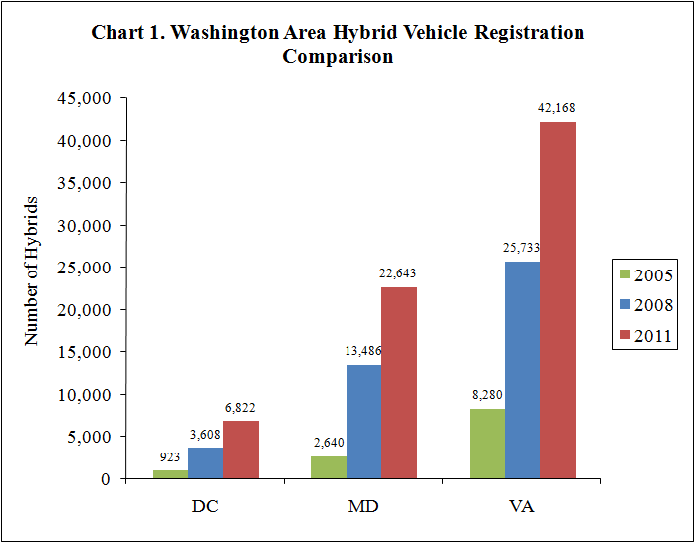

OEMs are also currently offering the Leaf and Chevy Volt in the metropolitan Washington region. To date, based on vehicle registration data, it is estimated that there are _____ EVs operating in region. Plug-in hybrid electric vehicles (PHEVs) such as the Toyota Prius are also being sold in the region. Fitzgerald Toyota in Gaithersburg Maryland offers a service to convert the standard Prius to a PHEV. Starting in April, Toyota also began to offer PHEV Prius at the point of sale.

Regional Forecast for EV ownership
There is no way to accurately predict the exact number of EV that will be operating in the region in the next 2, 5, or 10 years or where to site EVSE to best accommodate potential future charging needs. Currently, there are an estimated less than 500 EVs registered in the metropolitan Washington region. As of 2009, there were believed to be approximately 57,000 EVs in operation nationwide. The US DOE projects that there could be 1.2 million EVs on the road by 2015.
Number of Hybrid Vehicles per Household
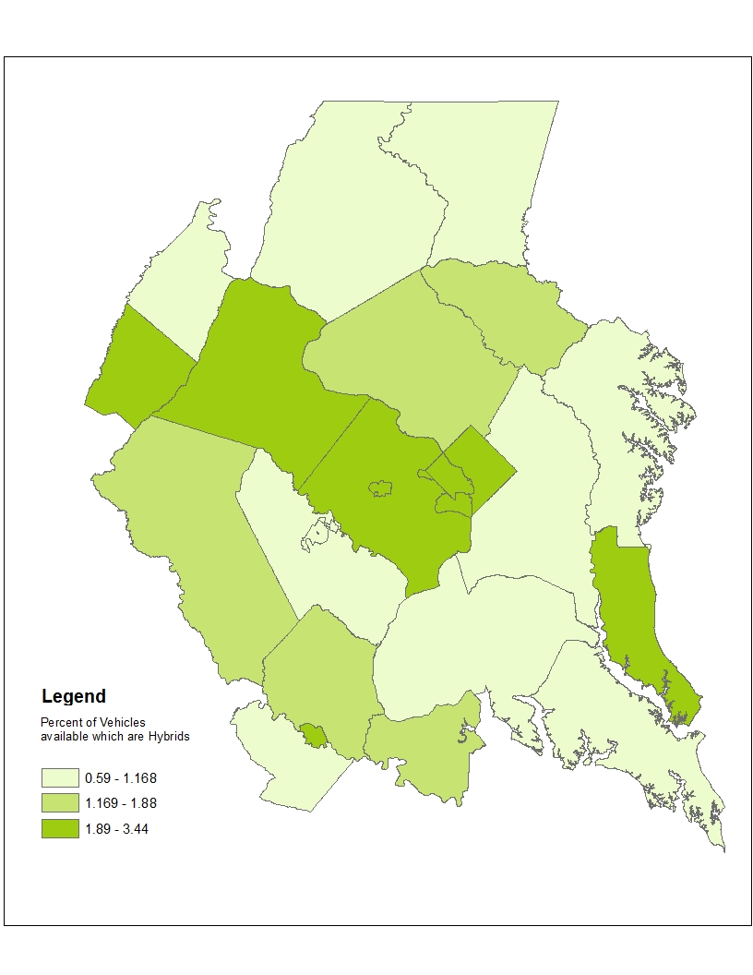
Source: COG Department of Transportation Planning ( 2011)

One approach to predicting future EV demand is to analyze the experience of hybrid vehicles and the early adopters. COG staff analyzed registration data available from the Transportation Planning Board (TPB) from 2005-2011. In just six years, the number of registered hybrid vehicles grew by more than 600 percent. However, total registered hybrid vehicles in the region still represent approximately 1.5 percent of all vehicle registrations.

COG staff was also able to document generally where the early adopters of hybrid vehicles are located. If EV market adoption in the region resembles anything like the growth in hybrids the region could experience the following trends:
- Early adopters may be found in clusters, with potentially higher concentrations in Fairfax, Arlington, Alexandria, and DC.
- There was a heavy concentration in the outer suburbs in Virginia.
- As a low estimate, by 2015/2020, the region could have 1,500 to 3,000 EVs operating on the roadways.
- As a high estimate, if EVs are adopted as rapidly as hybrids, the region could see anywhere from 50,000 to 75,000 EVs operating on the roadways by 2020.

Factors Impacting EV Adoption and Location

Predicting potential ownership of electric vehicle, and understanding common planning guidelines for number of charging stations typically needed per vehicle, could assist in identifying needs for charging station deployment. Some of the factors that may impact adoption of EVs, the location of EVs, and the potential need for public/private charging infrastructure siting in the metropolitan Washington region could include:
- Jurisdiction Location, with respect to the central core
- Number of Vehicles per Household
- Number of Trips
- Number of Trips by Destination
- Trip Length
- Household Income Level
- Length of Commute Trips
- Desire to lower fuel costs through higher fuel efficiency
- HOV exemptions for EVs (only applicable in Virginia through Special Clean Fuel plate)

Summary of Vehicle Ownership and Travel Patterns for Metropolitan Washington
Electric vehicles have the potential to be effectively deployed to meet the transportation needs of the population in the region. Using information from the COG Household Travel Survey and Travel Demand Model, in the region data indicate that most trips are relatively short, and are associated with destinations that would be good candidates for charging solutions - workplace, shopping, schools, recreational sites. For most daily commutes and other trip purposes, the relatively short length of the trips would not cause significant range anxiety. In the near term, the region may experience higher adoption rates in the inner suburbs and core, and in areas with relatively higher household income and in households with multiple cars.

[placeholder for information from COG DTP staff on trip types/lengths, etc]

Small Area Case Study: Highway 270 and Democracy Boulevard in Maryland

COG Transportation Staff conducted a sample siting analysis for electric vehicle infrastructure for illustrative purposes, using data from the 2007/2008 Household Travel Survey. Transportation Analysis Zones (TAZ) with the highest number of home to work trips made by car were identified. The zone in the region with the greatest number of these trips that was not a major military installation was found to be north of Bethesda in Montgomery County. Zone 702, shown below, exhibits several factors that indicate potential for charging station demand.

Figure 1. Breakdown of Where Workers of TAZ 702 Live. 77% of workers who drive live within the 20 mile EV range of TAZ 702.

This area is difficult to access other than in a private vehicle and it contains major employers with whom local governments could partner to encourage EV usage. Additionally most workers live within 20 miles, about the current electric vehicle range (see Figure XX). If commuters had access to charging stations at this location, even workers that did not have access to a private driveway or private garage could potentially commute via electric vehicle. Currently, there is just one publicly accessible charging station in the area located at the Sun Trust Bank at Democracy Boulevard and Old Georgetown road, with three Level 2 chargers. Areas with these characteristics could be targeted with policies to encourage installation of additional stations, while not inducing proportionally more vehicle trips.

Figure. Transportation Analysis Zone 702. Source: googlemaps.com

EVSE Site Locations
As part of their Park and Charge Pilot Program, the District of Columbia installed the first public curbside electric vehicle charging station in the United States at the intersection of 14th & U St. NW in 2010 in partnership with ChargePoint America and Pepco and partially supported by federal grants. Between installation and April 2012, the station was utilized for 135 charging sessions. The District plans to open at least two more stations at the Washington Canal Park in May, 2012.
http://ddot.dc.gov/DC/DDOT/Services/Parking+Services/View+All/Park+and+Charge+Pilot
For PEV owners, most charging will likely occur at home, with workplace charging a close second. Multi-family and urban dwellers without a dedicated garage or driveway will require innovative charging solutions. Public charging should be provided in strategic locations based upon driver lifestyle destinations—shopping, theater, hairdresser, park & ride and so forth. EV car sharing and rental programs provide additional opportunities for non-PEV owners.

This section identifies considerations and recommendations for deploying electric vehicle charging stations, or EV infrastructure in specific site types. Many sources recommend taking an adaptive approach—laying the groundwork in new development and redeveloping areas for future infrastructure capability.

Considerations and Opportunities by Site Type

1) Homes (Vehicle spends 8 – 12 hours parked) will see the highest demand for charging.

Figure. Housing Type by Jurisdiction. A majority of residents in DC and Alexandria life in multifamily or single family attached housing, while single family home ownership is common in other jurisdictions. Source: 2007/2008 Household Travel Survey.

Single family homes which have garages or driveways are the most straight-forward locations.
As shown in the Figure, single family home ownership is common in many regional jurisdictions. A local permit may be required if a EV charging unit is installed.

Town Homes without garages or driveways will have special charging station location needs.

Apartments/Condos and other multiple unit dwellings have particularly difficult challenges due to limited and/or shared parking and lack of access to electrical conduits. Multifamily residential units vary in their needs regarding EV infrastructure implementation. Home Owner Associations (HOAs) may need to be educated about electric vehicle charging stations, their requirements and how to locate them.
Charging Location Guidelines by Charging Level Type
--adapted from EV Project

Level 1 Locations – Full charge up to 24 hours
Residential Locations
- Lightly traveled BEVs, PHEVs
- All night charging available
Workplace Locations
- All day charging available
Emergency Use
- Carry converter in trunk for backup use with any compatible electric socket

AC Level 2 Locations - Full charge 4 to 6 hours
Destination Locations
- Where people shop, play, gather
- Target is 1 to 3 hour stays
- Expand effective operating range
- Higher turnover
Workplace Locations
Parking Garages

DC Fast Charging – Full charge 20-30 minutes
(None yet available in Washington area)
Destination Locations
- Short stops: convenience stores, fast food, rest stops
- Target is 15-30 minute stays
- “Safety Net” Locations
- Serve “Garageless” EV Owners
Freeway Corridors
Typically High Traffic Areas

2) Work (Vehicle spends typically 6 – 10 hours parked) may be the second most used approach to charge EVs, behind home charging. Workplace charging provides opportunities to attract high quality employees and present an innovative image.

Workplace destinations include office parks, hotels (business trips), institutions and universities, convention centers, hospitals, fleet depots and motorpools, non-profits, and park & ride lots. Stakeholders found that many building owners and operations are uninformed about EV charging station installation requirements. Some workplaces may have limited parking. Building owners may need to consider permitting, parking lot management, and turnover of charging parking spaces. Surface parking lots and garages have different site-level issues, addressed in other sections of this report.

3) Amenities and Recreation Destinations (Vehicle spends typically 1+ hours) are the third most used location.
Amenities Destinations include Surface Parking Lots or Garages, Shopping Malls or other Retail locations, Cultural Centers, Restaurants, Sporting Venues, Universities, Curbside in cities, Parks and Recreation areas, Airports, Gas stations or rest stops. When locating EV charging stations, issues include permitting, training and education on technical installation practices, and some parking space turnover management (less applicable than for workplaces). Gas stations and rest stops are feasible only if adjacent to other uses or designed for long stays, such as mixed use locations. Electric vehicle dealerships are also advantageous locations for charging stations.

4) Public Facilities (Vehicle spends 1+ hours) that are publicly accessible can be positioned to complement existing privately-financed stations.
Public Facilities that could support charging stations include City Halls, Libraries, Courthouses, town squares, and other public institutions. Beyond serving their employees, charging stations that serve customers in public facilities can educate vehicle owners and reduce range anxiety, assisting in kick-starting the market. Public facilities charging stations can demonstrate feasibility and highlight air quality benefits of Electric Vehicles. Charging stations serving on-street parking in the right-of-way is a special case that poses significant cost barriers and site-survey needs in order to access the power source and meet the requirement for second utility meter. (see Municipal policy section)

5) Car Rental and Car Sharing (Vehicle spends varying amount of time parked) can provide unique educational opportunities and space-efficient solutions for travelers and urban dwellers.
Rental and Car Sharing charging stations could be located in car share parking spots (i.e. Zip Car), rental car depots, tourist or business destinations, and area hotels.
EV car rental and EV car sharing are well-suited for shorter travel and errands. The Stakeholders see a potential business model for a network of EV charging stations for business travelers and tourists. This system would require special agreement between rental car operators, hotels, and attractions.
Car sharing can help meet the needs of multifamily dwelling residents without increasing needed parking spaces. Car sharing and car rental can perform an additional benefit of allowing drivers to experience an electric vehicle and how it operates, serving as a stepping stone for future EV use.

Summary of Opportunities and Issues by Site Type
Location | Opportunities | Barriers/Limitations
Single Family Home (with driveway or garage) | - Highest charging demand | - Many potential owners may not live in SFHs or have private driveway/garages  - Knowledge  - Permitting process
Multifamily Residential | - Potentially high demand  - Many contain parking facilities  - Opportunity for car-sharing | - Some may have limited parking spaces  - Property owners information gap  - Permitting process  - Technical capability  - Turnover management  - Parking lot management
Workplace | - Second highest charging demand behind residential | - Knowledge  - Permitting process  - Technical capability  - Charging turnover management  - Parking lot management
Amenities and Recreation | - Third highest charging demand | - Knowledge  - Permitting process  - Technical capability  - Turnover management  - Parking lot management
Rentals | - Capitalize on tourism market  - Stepping stone to ownership | - Need network with rental companies, hotels and destination parking
EV Car sharing | - Regular car sharing already exists  - Zipcar planning to offer a few EVs | - Permitting/technical
Public Facilities | - Could help kick-start market  - Demonstrate environmental responsibility  - Improved air quality | - Knowledge  - Permitting process  - Technical capability  - Charging turnover management  - Parking lot management  - On-street - special case

Regional Projects and EVSE Inventory

Several federally stimulated initiatives are currently siting public and residential EV infrastructure in parts of the metropolitan Washington region. They include Coulomb’s ChargePoint America Program, Maryland Electric Vehicle Infrastructure Program (EVIP)/BEVI (Baltimore-Washington Electric Vehicle Initiative), and ECOtality’s The EV Project. Private efforts are underway in Northern Virginia for additional stations in Arlington Potomac Regional Park, the Virginia Center for Innovative Technology, in Fairfax County, and at Loudoun County park and ride lots.

Some COG member jurisdictions are taking actions to support EV deployment. Fairfax County has submitted a proposal to the U.S. DOE to use a portion of their EECBG funding for the purchase and installation of 10 Level 2 electric-vehicle charging stations at County facilities. The County is also focusing on putting electric vehicle charging stations in the Tyson’s Corner area; plans include guidance on anticipated needs for the future and site design elements. Fairfax County is looking for direction from EV Coalition to establish some model practices across the region.

The District of Columbia’s Climate Action Plan provides for a substantial incorporation of electric vehicles into the government fleet. The DC Water and Sewer Authority plans to replace 79 utility vehicles with electric vehicles. The Action Plan aspires to convert 65% of the District Columbia’s utility vehicles to electric vehicles by 2012; 200 replacements by 2020; and 350 replacements by 2050. The Action Plan also calls for expansion of public and private infrastructure to support electric vehicle charging stations around the city.

Inventory of EV Charging Stations, Publicly Accessible
COG staff developed an inventory of electric vehicle charging stations for the Washington region. A robust network of charging stations is beginning to take shape in the region. (Maps 1 and 2) Altogether, the inventory identified 332 chargers in 133 charging station locations, 11 of which are planned stations. The District of Columbia has the most charging stations among COG jurisdictions (36), followed by Arlington County (15), Fairfax County (18), and Charles County (11); DC and Arlington have the highest number of chargers (85 and 62). About 40% of the chargers are Level 1 and the remaining 60% are Level 2. No fast chargers were installed when the inventory was developed. The inventory indicates EVSEs are being installed by building managers in a variety of land uses.

EVSE Stations by location type, Metro. Washington
 | Stations | Chargers
Office | 45 | 110
Shopping | 20 | 48
Dealership | 17 | 20
Government | 11 | 27
University | 10 | 25
Mixed Use | 10 | 38
Multifamily Dwelling Unit | 7 | 11
Recreation | 5 | 26
Hotel | 3 | 6
Transportation Hub | 2 | 4
Airport | 2 | 16
Restaurant | 1 | 1
Total | 133 | 332

Home charging stations are not represented in the inventory, except for multifamily dwelling units. Although there are many electric vehicle infrastructure development programs occurring in the region that involve installation of home charging stations, published data on these stations is incomplete for several reasons:
- Stations are not published on EVSE provider websites or on the Alternative Fuels Data Center since they are not available for public use
- Many individuals choose not to voluntarily share their location information with Plugshare, a crowd-source EV station website
- Local governments issue general electrical permits for residential electrical work.

Regional EVSE Infrastructure Maps
Map 1 depicts published charging station location of existing, planned, public, and private stations. Since charging stations may have more than one charger present, Map 2 depicts the number of actual chargers at each location by the size of the symbol. The maps also depict the location of ‘Regional Activity Clusters’ as defined by Region Forward and major highways. Most stations are located along major highways or in Activity Clusters. Sources for the inventory included DOE’s Alternative Fuels Data Center, a COG survey of local jurisdictions, and several EVSE websites including ChargePoint America, SemaCharge, 350Green, Blink, and Car Charging, Inc. In addition, Plugshare, Google Maps, Clean Technica, and property websites assisted in identifying charging station location information. Some property managers were contacted to collect additional information.

Stakeholder Recommendations and Findings Summary
Facilitating charging station implementation through investments, incentives, guidelines, and requirements can reduce range anxiety, promote innovation and environmental sustainability, and help to overcome market barriers to region-wide deployment. The main barriers to all location types are cost of installation, access to power source, parking space turnover management, need for streamlined permitting and inspections, and lack of information and training resources.

The recommendations below were ranked low to medium cost and were med-high on facilitation EV deployment. Most are recommended to be implemented in the near term (0 to 2 years).

Recommendation 1:Promote EVSE siting in strategic locations and monitor EV use and EVSE installation
- Charging will take place primarily at home, secondarily at the workplace, and third at other destinations. Taking that into account, charging station siting should be driven by the market and consumer needs. EV owners with garages or driveways can benefit from streamlining of permitting and educational resources. Multifamily housing and urban dwellers are a special case due to lack of owner garage access or access to an electrical outlet.
- Many workplace locations with parking are feasible locations for charging stations since vehicles are parked for 6-10 hours, such as office parks, surface parking lots, hotels, convention centers, hospitals, airports, fleet depots, and park and ride facilities.
- Other destination parking includes shopping centers, and transportation hubs. For recreational destinations, suggested charging locations include surface parking lots or garages, shopping malls or other retail locations, cultural centers, restaurants, sporting venues, universities, curbside in cities, parks and recreation areas, airports and gas stations located at rest stops.
- City halls, libraries and on-street are places where public charging could be located.
- EV car sharing and rental programs provide additional opportunities for charging locations.
- Benchmark EV sales and use in Washington region and compare to other cities to identify additional needs or barriers

Recommendation 2:Equip new commercial, multifamily residential, and major public construction and redevelopment in advance with a feasible level of inexpensive technology-enabling infrastructure to reduce future installation expense
  - Provide the physical space for transformer capacity to allow the future installation of full-lot electrification.
  - The electrical room should have physical space to allow future installation of a switchboard and capacity for sub-metering.
  - Parking area construction should include conduit bank and conduit between the facility’s electrical room and the spaces needed for future electrification.

Recommendation 3: Address Multifamily Residential EV Charging Challenges
- Follow best practices and heed lessons learned in pilot programs from other U.S. cities.
- Connect property owners and managers, HOAs and Condo associations with educational resources relating to EVSE implementation.
- Requirements should depend upon whether or not the units have or manage a parking facility.
- Managers could incorporate EV into the parking ratio.
- Car-sharing and charger-sharing can help meet the needs of multifamily building residents.

Recommendation 4: Facilitate Workplace Charging
- Identify prime workplace charging locations based on commuting patterns, survey of fleet needs and EV charger installation plans
- Through COG Commuter Connections, AOBA, and other associations, connect employers and property managers with EVSE installation procedures and resources.
- Develop partnerships between corporate offices and EV dealerships/ service providers to deploy fleet EVs and charging stations.

Recommendation 5: Tourist Market Opportunity
- Work with rental car companies, hotels, public on-street parking locations close to tourist destinations to set up a mini-rental infrastructure

Recommendation 6: Public EV Infrastructure Investment
- Offer a variety of incentives, such as tax credits, access to HOV lanes, fast-tracking permitting processes and/or free parking benefits to consumers who purchase and drive an electric car.
- Municipalities should lay down a conduit for future on-street EV parking during right-of-way redevelopment.
- Companies could sponsor charging stations.
- Governments can grant special use permits for parking spaces. Develop guidance for non-governmental entities seeking permitting of on-street charging.
- Certify a meter in the charging station itself instead of including a separate utility meter.

Recommendation 7: Access to public charging stations for Levels 1 and 2
- EV owners suggest municipalities issue EV Charging Passes at low monthly charge that allows EV owners to use a network of simple 110V charging outlets.
- Level 1 should be located in low-turnover locations such as home or workplace. Level 2 stations should be in locations with high turnover, or with valet service or with one load control for multiple spots.
- For level 2, allow owners the ability to control turnover, such as raising the rate after 2 hours.

http://www.nrdc.org/energy/files/relieving-pain-at-the-pump.pdf
http://www.fueleconomy.gov/feg/evsbs.shtml
http://electricdrive.org/index.php?ht=d/sp/i/20952/pid/20952
http://electricdrive.org/index.php?ht=d/sp/i/20952/pid/20952
http://www.edmunds.com/industry-center/commentary/upcoming-revenge-of-the-electric-car.html
EIA's Alternatives to Traditional Transportation Fuels, Table V1. Available at http://www.eia.gov/renewable/
http://www1.eere.energy.gov/vehiclesandfuels/pdfs/1_million_electric_vehicles_rpt.pdf
COG DTP, 2009. Presentation of Some Initial Findings by Robert E. Griffiths, Technical Services Director to the National Capital Region Transportation Planning Board, Metropolitan Washington Council of Governments, January 28, 2009.
Recreation includes parks, arts centers, and recreation centers. Mixed Use describes sites that have a mix of retail, offices, and housing. Multi-Family Dwelling Units consist of condominiums or apartments. Government stations were located at facilities such as libraries, town halls, and government offices.
Other regions that the EV Project is operating in report that 80 to 99% of Level 2 charging stations are installed at home locations
Maps do not include single family home stations.
Locations such as Park and Ride and Airports may necessitate EVSE valet service since cars are parked for longer periods of time.

