LEGEND Below Target 0 - 69 mg/dL Target 70 - 180 mg/dL Above Target 181 - 600 mg/dL

Before Meal After Meal Logbook Manual Entry Control Reading Deleted Reading Comments

Report:Logbook from July 4, 2009 to August 11, 2012

Morning

12:00 AM - 8:00 AM

Date No Mark

Midday

8:00 AM - 4:00 PM

No Mark

Evening

4:00 PM - 12:00 AM

No Mark

HbA1c (%)

Comments

Saturday

Jul 4, 2009
230

7:43 PM

1 DAYS WITHOUT TESTS NOT DISPLAYED

Monday

Jul 6, 2009
162

10:42 PM

55 DAYS WITHOUT TESTS NOT DISPLAYED

Monday

Aug 31, 2009
129

9:04 PM

Tuesday Sep 1, 2009
93

4:56 PM

LEGEND Below Target 0 - 69 mg/dL Target 70 - 180 mg/dL Above Target 181 - 600 mg/dL

Before Meal After Meal Logbook Manual Entry Control Reading Deleted Reading Comments

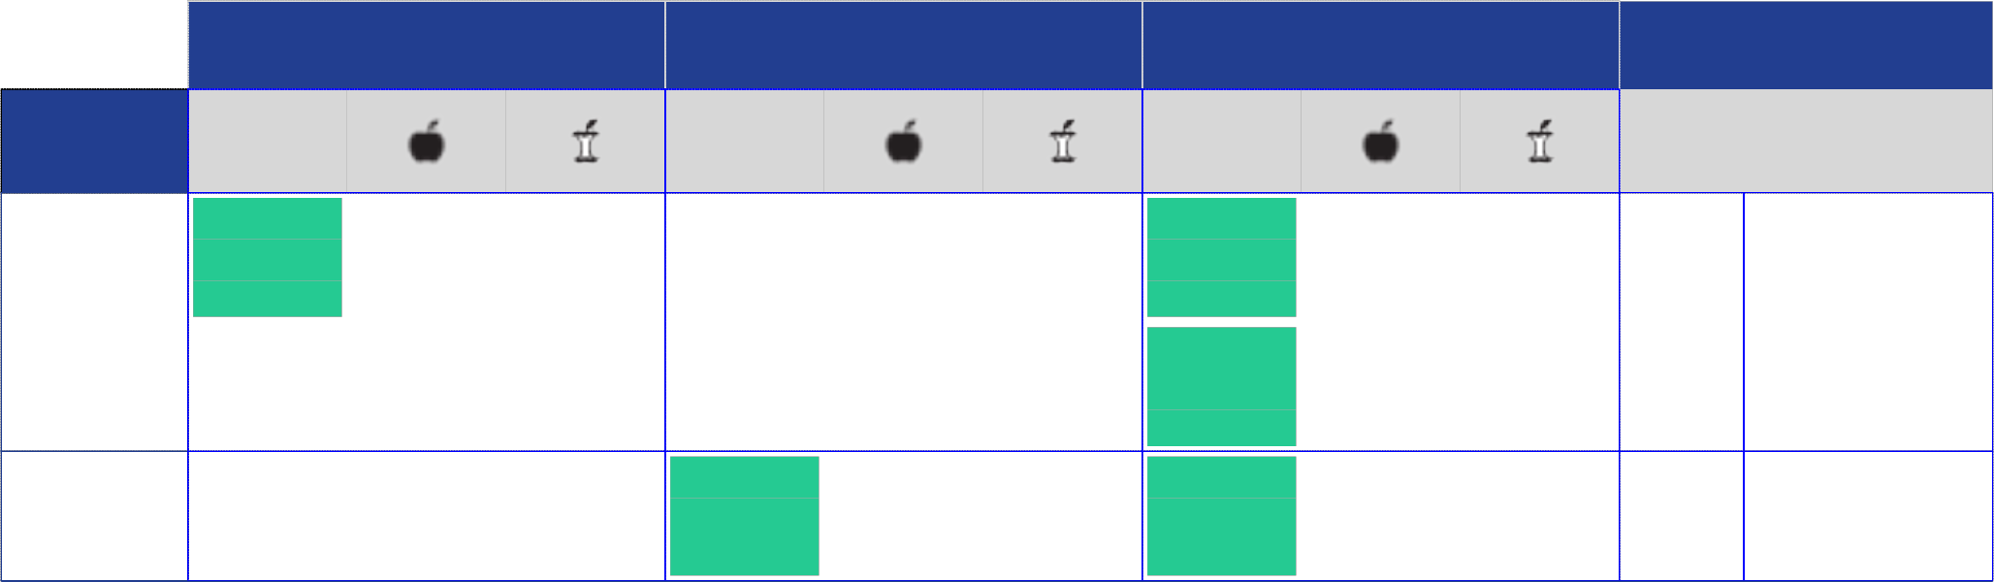Report:Logbook from July 4, 2009 to August 11, 2012

Morning

12:00 AM - 8:00 AM

Date No Mark

Midday

8:00 AM - 4:00 PM

No Mark

Evening

4:00 PM - 12:00 AM

No Mark

HbA1c (%)

Comments

Wednesday Sep 2, 2009
93

12:10 AM
81

10:36 PM

119

10:38 PM

Thursday

Sep 3, 2009
125

2:09 PM
93

9:45 PM

4 DAYS WITHOUT TESTS NOT DISPLAYED

Tuesday

Sep 8, 2009
113

8:03 PM

Wednesday

Sep 9, 2009
167

12:27 PM

Thursday

Sep 10, 2009
113

8:44 PM

LEGEND Below Target 0 - 69 mg/dL Target 70 - 180 mg/dL Above Target 181 - 600 mg/dL

Before Meal After Meal Logbook Manual Entry Control Reading Deleted Reading Comments

Report:Logbook from July 4, 2009 to August 11, 2012

Morning

12:00 AM - 8:00 AM

Date No Mark

Midday

8:00 AM - 4:00 PM

No Mark

Evening

4:00 PM - 12:00 AM

No Mark

HbA1c (%)

Comments

1 DAYS WITHOUT TESTS NOT DISPLAYED

Saturday

Sep 12, 2009
150

1:39 PM
132

8:13 PM

184

10:49 PM

Sunday

Sep 13, 2009
114

10:54 PM

Monday

Sep 14, 2009
111

12:53 PM

Tuesday

Sep 15, 2009
155

12:14 PM

12 DAYS WITHOUT TESTS NOT DISPLAYED

LEGEND Below Target 0 - 69 mg/dL Target 70 - 180 mg/dL Above Target 181 - 600 mg/dL

Before Meal After Meal Logbook Manual Entry Control Reading Deleted Reading Comments

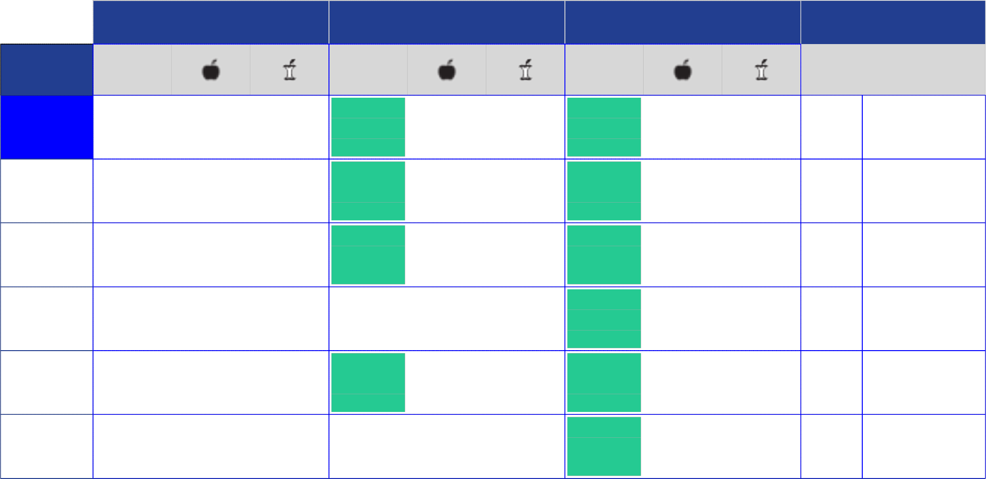Report:Logbook from July 4, 2009 to August 11, 2012

Morning

12:00 AM - 8:00 AM

Date No Mark

Midday

8:00 AM - 4:00 PM

No Mark

Evening

4:00 PM - 12:00 AM

No Mark

HbA1c (%)

Comments

Monday

Sep 28, 2009
143

1:16 PM
116

10:48 PM

Tuesday

Sep 29, 2009
149

11:51 AM
148

9:35 PM

Wednesday

Sep 30, 2009
147

12:03 PM
110

10:26 PM

Thursday

Oct 1, 2009
97

4:34 PM

Friday

Oct 2, 2009
133

1:11 PM
92

11:06 PM

