Barloworld Logistics

10
MyMarket Interface
Finance Department
Carol Bettini

Contents
Background 3
Proposed Solution for Travel 3
1. File Layout 3
2. File Import Process 5
2.1 Errors during Validation 5
2.2 Successful Validation: 5
3. Creditors Transactions 6
3.1 Self Billing 6
3.2 Supplier Invoice Exceptions 7
4. Creditors Payments 8
Functional Specification 9
5. Supplier Cross Reference 9
6. Company Cross Reference & Allocation 9
7. Import Session 10
Proposed Solution for eProcurement 15
1. File Layout 15
2. File Import Process 16
2.3 Errors during Validation 16
2.4 Successful Validation: 16
3. Creditors Transactions 17
3.3 Self Billing 17
3.4 Supplier Invoice Exceptions 18
4. Creditors Payments 19
Functional Specification 20
5. Import Session 20

Background

At present Barloworld make use of the MyMarket portal to procure Accommodation, Flights and Car Hire for the various business units within the organisation. Through the portal a relationship also exists with a Travel Management company, namely CWT, who charge a service fee for assisting with the booking of the above services.

Together with the current relationship, a new relationship for the Electronic Procurement (eProcurement) of goods and services from pre defined suppliers/vendors is being setup. This functionality will allow for users to electronically requisition the procurement of goods or services, obtain the necessary pricing from the portal, and then submit the requisition for electronic approval. Once approved a purchase order will electronically be submitted to the supplier/vendor, who will then supply the required goods or service.

The requirement has therefore been raised by the business to facilitate importing the relevant information supplied by MyMarket into Baan, to assist with the allocation of the expenses, and the payment of the various third parties involved with the delivery of the goods or services.

Proposed Solution for Travel

File Layout

The current file supplied by MyMarket will need to be modified to supply the following information:

Field | Description
Customer Name | Name of Barloworld Company
Debtor Number | Debtors Code with MyMarket
Passenger | Name of Barloworld Employee (Traveller)
Order Number | MyMarket Order Number
Third Party * | The End Supplier of the Goods
Account Allocation * | The Type of Purchase being undertaken, i.e.  - Local Flight  - International Flight  - Local Car Hire  - International Car Hire  - Local Accommodation  - International Accommodation  - Service Fee  - eProcurement
Cost Centre | The Barloworld cost centre to be charged for the services
Billable | Indicator to determine if the charge should be processed
Trip Description | The text that has been captured to indicate the purpose of the services rendered
TVK Number | The MyMarket reference
Invoice Amount | The total amount of the services rendered (inclusive of VAT)
Invoice Date | Date that service delivered
CC Description | Barloworld cost centre description, as contained in MyMarket
Trip Name | Trip details, as captured in MyMarket
Trip Type | The type of trip undertaken, i.e.  - DOM – Domestic  - REG – Regional  - INT – International
Route | Information about the route undertaken by the Barloworld employee
Nett | The net amount of the transaction (ex VAT)
VAT | The VAT portion of the transaction
Airport Tax | The Airport Tax value of the transaction
Division | The Barloworld division’s description
* Indicates new fields required in file

File Import Process

File Saved on Users Local Machine

MyMarket Supplies Data File

Import Program Run to Create Purchase Orders based on MyMarket Data

Purchase Order(s) generated with Account Allocations

The file will be obtained from MyMarket in the specified format, and will then be saved on the user’s local machine, i.e. the c:\ drive.

The user will then open a new session which will have an option to validate the data contained in the file to determine if there are any potential errors.

Errors during Validation

If errors are encountered during validation a report will be generated indicating the line number which has a problem, as well as what the issue is.

These transactions will need to be rectified before the file is imported. Therefore the import is based on all lines being successfully validated; if one line is erroneous then none of the lines are imported.

This measure is put in place, so as to avoid a duplicate upload of the same data, as one could forget to remove already processed lines out of a file, once the errors are rectified.

Successful Validation:

Once the validation is successful the user will then import the file into the system, with the following actions occurring:

- Purchase order(s) generated per supplier of the service
- Purchase order(s) receipted to initiate the allocation of the expense to the relevant ledger account and dimension combinations, and the generation of the accrual in the Order Receipt/GRINYA account:

Overseas Travel
100.00
Orders Received
100.00

Please note that this transaction will not have any VAT implications, and the Packslip field will be filled with the MyMarket Order number.

Creditors Transactions

Self Billing

For self billing the supplier master will be configured to indicate that self billing will be applicable for the specified supplier:

The user will then run the Generate Self Billed Purchase Invoices session:

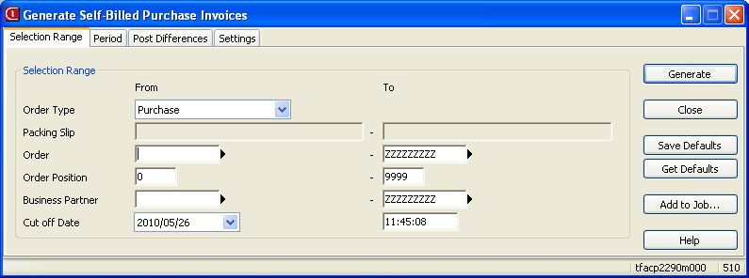

Whereby the system will then generate system invoices for the purchase orders that have been receipted up until the specified Cut Off Date and time.

This process will therefore generate the following transactions:

- Acknowledge the invoice against the creditor’s account, with the necessary updates to VAT Input, and the acknowledgement of the registration of the invoice
- Approve the invoice for payment, which will then transfer the acknowledgement of the registration of the invoice to the order receipt account, to clear out the accrual created during the purchase order receipt process

Invoice Received
100.00
Creditors Control
114.00
VAT Input
14.00
Orders Received
100.00
100.00
a
a
a
b
b

Supplier Invoice Exceptions

There are going to be instances where a supplier’s invoice does not match up with what has gone through MyMarket, these instances will need to be investigate to determine why there are differences, and then the necessary corrective action needs to be taken, i.e. if the costs are valid, a sundry invoice needs to be processed against the suppliers account and allocated to the necessary account and dimensions:

Local Travel
100.00
Creditors Control
114.00
VAT Input
14.00

If the charge is not valid, a query needs to be logged with the supplier, with an indication that the amount will not be paid.

Creditors Payments

Open up Open Entries of the relevant supplier, and make sure the supplier’s invoice number is equal the actual invoice number.

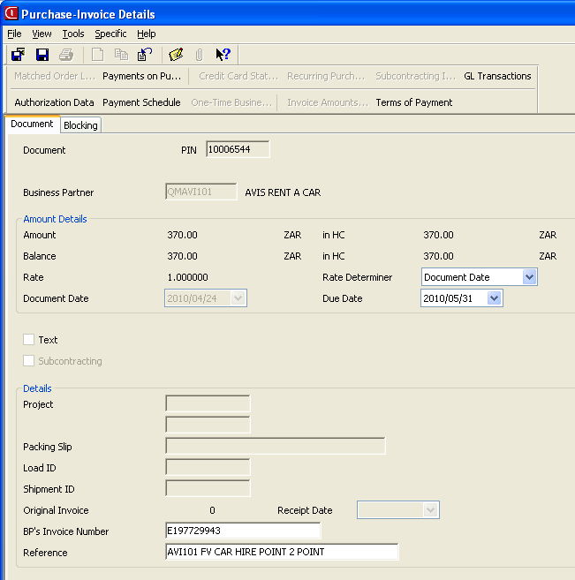

During this update process the user will need to validate that the VAT amount reflected against the Self Billed invoice(s) is equal to the VAT amount on the actual invoice. If differences are found, a manual journal needs to be processed to bring the VAT amount in line with what is actually on the invoice. This journal will refer to the suppliers invoice number with an indication that VAT is being rectified, e.g. VAT differs by R2.00 in that the invoice is higher than the VAT on the Self Billed invoice:

Local Travel
2.00
VAT Input
2.00

Once the necessary updates have been done the user will then follow the standard select invoices for payment procedure, with the necessary reconciliation to the supplier’s statement.

Functional Specification

Supplier Cross Reference

The MyMarket supplier code will be captured in a new table with a link to the Baan supplier code. This cross reference table will be used during the import of the MyMarket file to determine the supplier code to be used on the purchase order.

Field | Description
comp | Company
Borg | Buying Organisation
msup | MyMarket Supplier Code (Third Party Code)
bpid | Baan Supplier Code  (This field will be validated back to tcibd120)

A session will also be created to facilitate a user maintaining this to facilitate future changes or additions to the MyMarket relationships.

Company Cross Reference & Allocation

The MyMarket company code will be captured in a new table with a link to the Baan company, account and where necessary the relevant dimension codes. This cross reference table will be used during the import of the MyMarket file to determine the company in which to import the data.

Field | Description
Mmcp | MyMarket field indicating which company the file relates to (Debtor Number)
Borg | Buying Organisation
Type | eProcurement or Travel indicator
Comp | The related Baan company number
Seri | Order Series
Cofc | Purchase Office
Acca | MyMarket field indicating what type of service was delivered (Account Allocation)
Item | Cost Item
Leac | For the relevant Baan company the related ledger account to book the costs to
dim1 | Dimension 1
dim2 | Dimension 2
dim3 | Dimension 3
dim4 | Dimension 4
dim5 | Dimension 5

A session will be created to facilitate the users updating the necessary information.

Import Session

A new session will be created to facilitate the user importing the MyMarket file into the system

MyMarket Travel Import
File: __________________________________________
(File is on local machine of user)

Order Type: ___________

Update: Yes/No (Default is No)

The user will have the option to import the data, or just verify that the data is correct. If the Update field is set to No the system will just read the file to determine if there are any issues with the data contained in the file, i.e. there is a new company number, and the master data does not indicate where to place the data, or there is a new cost centre, and again the master data does not indicate where to place the transaction. If the users selects Yes the session will import the data contained into the file into a new MyMarket table in Baan:

Field | Description
pass | Name of Barloworld Employee (Traveller)
mmor | MyMarket Order Number
bpid | The End Supplier of the Goods
acca | The Type of Purchase being undertaken, i.e.  - Local Flight  - International Flight  - Local Car Hire  - International Car Hire  - Local Accommodation  - International Accommodation  - Service Fee  - eProcurement
dimx | The Barloworld cost centre to be charged for the services
bill | Indicator to determine if the charge should be processed (Yes/No)
desc | The text that has been captured to indicate the purpose of the services rendered
tvkn | The MyMarket reference
amnt | The total amount of the services rendered (inclusive of VAT)
date | Date that service delivered
ccde | Barloworld cost centre description, as contained in MyMarket
trpn | Trip details, as captured in MyMarket
trpt | The type of trip undertaken, i.e.  - DOM – Domestic  - REG – Regional  - INT – International
rout | Information about the route undertaken by the Barloworld employee
amth | The net amount of the transaction (ex VAT)
vamt | The VAT portion of the transaction
airt | The Airport Tax value of the transaction
divi | The Barloworld division’s description
stat | The transaction status:  - Successfully Imported  - Imported with Errors  - Errors In Creating Purchase Order  - Purchase Order Created
leac | Account Code
dim1 | Dimension 1
dim2 | Dimension 2
dim3 | Dimension 3
dim4 | Dimension 4
dim5 | Dimension 5
ptyp | Purchase Order Type
erro | Error message details
orno | Purchase Order Number

The import process will additionally insert the relevant ledger codes with the related dimension combinations, the business partner code to be used on the purchase order, and a review session will be created where the user will be able to view all records with a status of Successfully Imported, Imported with Errors or Errors in Creating Purchase Order. The user will not be able to modify certain fields, but will be able to modify the ledger account code, and related dimension combinations. Any changes will be logged with the user’s login code and date and time, through the use of standard auditing on the new table.

Company | Supplier | MyMarket Order Number | Amount | VAT | Total Amount | Account | Dim 1 | Dim 2 | Dim 3 | Dim 4 | Dim 5 | Allocation | Passenger | Trip Description/Purchase Reference
510 | Avis | 33-11 | 1,000.00 | 140.00 | 1,140.00 | 35240 | B20130 |  |  |  |  | Local Car Hire | A.N Other | Attend Retirement Fund Road Show plus General Road Show
510 | Diners | 33-11 | 3,000.00 | 420.00 | 3,420.00 | 35220 | B20510 |  |  |  |  | Local Flight | John Smith | Attend Retirement Fund Road Show
Example of session the user will make use of:

Provided all the data is setup correctly there should be no transactions without any allocations, but just in case a new allocation is done in MyMarket before the master data is updated the necessary allocations can be inserted, and once the user is happy that all the data is correctly assigned, they can then process the data through and generate the purchase orders.

When the user opts to generate the purchase order the following information is taken from the MyMarket table(s) and transferred over to the purchase order:

- Supplier is the Business Partner to be used on the purchase order
- MyMarket Order Number is to be placed in the Buy-From BP Order No field on the purchase order
- Order Type
- Purchase Office (BORG in MyMarket)
- Order Series
- Item
- Amount
- The following information will be combined and inserted as the text related to the specific transaction:
  - Passenger
  - Trip Description
  - TVK Number
  - Trip Name

Once the purchase order has been generated the order number will be written back to the MyMarket table as a cross reference.

The creation process will therefore complete the following steps:

- Create the purchase order
- Provided the purchase order type is a Collect Order, the receipting of the order will be done, with the packslip number being set to be equal to the MyMarket Order Number

Proposed Solution for eProcurement

File Layout

An file will be supplied with the current information:

Field | Description
Borg | Buying Organisation  This field will relate to the purchase office that exists in Baan
Supplier | The supplier who provided the goods or service.  The Baan supplier code will be stored in MyMarket against each BORG, and this Baan supplier code will be sent through in the file
Account | The ledger code that is to have the costs allocated to it
Date | The date the receipt was done
Quantity | The number of units that were receipted
Price | The unit cost of the goods or service
Reference | The item description or any text recorded during the creation of the requisition
Receipt details | The name of the user who did the receipt in MyMarket
GRV Number | The unique MyMarket GRV number
Invoice Number | Suppliers Invoice Number
Order Number | MyMarket Order Number

File Import Process

File Saved on Users Local Machine

MyMarket Supplies Data File

Import Program Run to Create Purchase Orders based on MyMarket Data

Purchase Order(s) generated with Account Allocations

The file will be obtained from MyMarket in the specified format and with the necessary date and time stamp, and will then be saved on the user’s local machine, i.e. the c:\ drive.

The user will then open a new session which will have an option to validate the data contained in the file to determine if there are any potential errors.

Errors during Validation

If errors are encountered during validation a report will be generated indicating the line number which has a problem, as well as what the issue is.

These transactions will need to be rectified before the file is imported. Therefore the import is based on all lines being successfully validated; if one line is erroneous then none of the lines are imported.

This measure is put in place, so as to avoid a duplicate upload of the same data, as one could forget to remove already processed lines out of a file, once the errors are rectified.

Successful Validation:

Once the validation is successful the user will then import the file into the system, with the following actions occurring:

- Purchase order(s) generated per supplier of the service
- Purchase order(s) receipted to initiate the allocation of the expense to the relevant ledger account and dimension combinations, and the generation of the accrual in the Order Receipt/GRINYA account:

Stationery
700.00
Orders Received
700.00

Please note that this transaction will not have any VAT implications, and the Packslip field will be filled with the MyMarket Invoice number.

Creditors Transactions

Self Billing

With the use of self billing the supplier master will be configured to indicate that self billing will be applicable for the specified supplier:

The user will then run the Generate Self Billed Purchase Invoices session:

Whereby the system will then generate system invoices for the purchase orders that have been receipted up until the specified Cut Off Date and time.

This process will therefore generate the following transactions:

- Acknowledge the invoice against the creditor’s account, with the necessary updates to VAT Input, and the acknowledgement of the registration of the invoice
- The Packslip Number will be entered as the supplier’s invoice number
- Approve the invoice for payment, which will then transfer the acknowledgement of the registration of the invoice to the order receipt account, to clear out the accrual created during the purchase order receipt process

Invoice Received
700.00
Creditors Control
798.00
VAT Input
98.00
Orders Received
700.00
700.00
a
a
a
b
b

Supplier Invoice Exceptions

There are going to be instances where a supplier’s invoice does not match up with what has gone through MyMarket, these instances will need to be investigate to determine why there are differences, and then the necessary corrective action needs to be taken, i.e. if the costs are valid, a sundry invoice needs to be processed against the suppliers account and allocated to the necessary account and dimensions:

Stationery
700.00
Creditors Control
798.00
VAT Input
98.00

If the charge is not valid, a query needs to be logged with the supplier, with an indication that the amount will not be paid.

Creditors Payments

A reconciliation will be done for the supplier to make sure the suppliers invoice numbers are the same, and that the VAT against the suppliers system invoice is the same.

The user will therefore need to validate that the VAT amount reflected against the Self Billed invoice(s) is equal to the VAT amount on the actual invoice. If differences are found, a manual journal needs to be processed to bring the VAT amount in line with what is actually on the invoice. This journal will refer to the suppliers invoice number with an indication that VAT is being rectified, e.g. VAT differs by R10.00 in that the invoice is higher than the VAT on the Self Billed invoice:

Stationery
10.00
VAT Input
10.00
Once the necessary updates have been done the user will then follow the standard select invoices for payment procedure, with the necessary reconciliation to the supplier’s statement.

Functional Specification

Import Session

A new session will be created to facilitate the user importing the MyMarket file into the system

MyMarket eProcurement Import
File: __________________________________________
(File is on local machine of user)

Order Type: ___________

Update: Yes/No (Default is No)

The user will have the option to import the data, or just verify that the data is correct. If the Update field is set to No the system will just read the file to determine if there are any issues with the data contained in the file, i.e. is a ledger account blocked, does the purchase office exist. If the users selects Yes the session will import the data contained into the file into a new MyMarket table in Baan:

Field | Description
Borg | Buying Organisation  This field will relate to the purchase office that exists in Baan
Supplier | The supplier who provided the goods or service.  The Baan supplier code will be stored in MyMarket against each BORG, and this Baan supplier code will be sent through in the file
Account | The ledger code that is to have the costs allocated to it
Dim_1 | Dimension 1
Dim_2 | Dimension 2
Dim_3 | Dimension 3
Dim_4 | Dimension 4
Dim_5 | Dimension 5
Date | The date the receipt was done
Quantity | The number of units that were receipted
Price | The unit cost of the goods or service
Reference | The item description or any text recorded during the creation of the requisition
Receipt details | The name of the user who did the receipt in MyMarket
GRV Number | The unique MyMarket GRV number
Invoice Number | Suppliers Invoice Number
Order Number | MyMarket Order Number

The import process will additionally insert the relevant dimension combinations as setup in integration. A review session will be created where the user will be able to view all records with a status of Successfully Imported, Imported with Errors or Errors in Creating Purchase Order. The user will not be able to modify certain fields, but will be able to modify the ledger account code, and related dimension combinations. Any changes will be logged with the user’s login code and date and time, through the use of standard auditing on the new table.

Purchase Office | Supplier | MyMarket Order Number | Amount | VAT | Total Amount | Account | Dim 1 | Dim 2 | Dim 3 | Dim 4 | Dim 5 | Allocation | Received By | Purchase Reference | Supplier Invoice Number
PUR510 | Waltons | 99-123 | 1,000.00 | 140.00 | 1,140.00 | 12345 | B20140 |  |  |  |  | Stationery | A.N Other | A4 Paper | 9578
PUR510 | Waltons | 99-124 | 3,000.00 | 420.00 | 3,420.00 | 35220 | B20510 |  |  |  |  | Printing | John Smith | 6 Toner Cartridges | 9579
Example of session the user will make use of:

Provided all the data is setup correctly there should be no transactions without any allocations, but just in case a new allocation is done in MyMarket before the master data is updated the necessary allocations can be inserted, and once the user is happy that all the data is correctly assigned, they can then process the data through and generate the purchase orders.

When the user opts to generate the purchase order the following information is taken from the MyMarket table(s) and transferred over to the purchase order:

- Supplier is the Business Partner to be used on the purchase order
- MyMarket Order Number is to be placed in the Buy-From BP Order No field on the purchase order
- Order Type
- Purchase Office (BORG in MyMarket)
- Order Series
- Item
- Amount
- The following information will be combined and inserted as the text related to the specific transaction:
  - Purchase Reference
  - Received By
  - Receipt Date
  - MyMarket GRV Number

Once the purchase order has been generated the order number will be written back to the MyMarket table as a cross reference.

The creation process will therefore complete the following steps:

- Create the purchase order
- Provided the purchase order type is a Collect Order, the receipting of the order will be done, with the packslip number being set to be equal to the MyMarket Order Number

