Inter-Surface Mapping
John Schreiner | Arul Asirvatham | Emil Praun | Hugues Hoppe
University of Utah | University of Utah | University of Utah | Microsoft Research
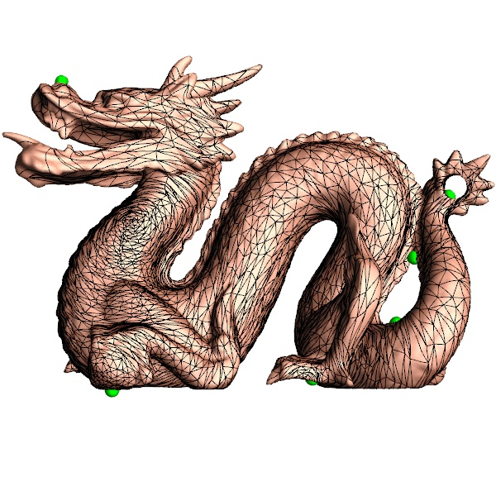 | 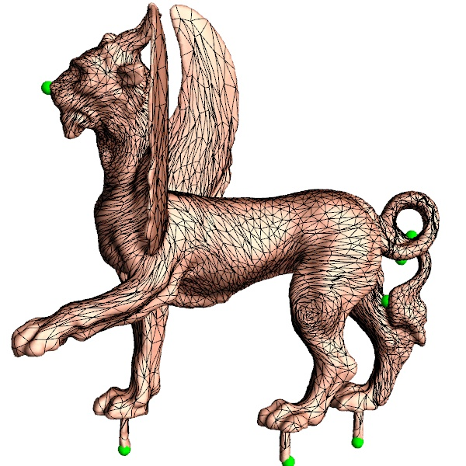 | 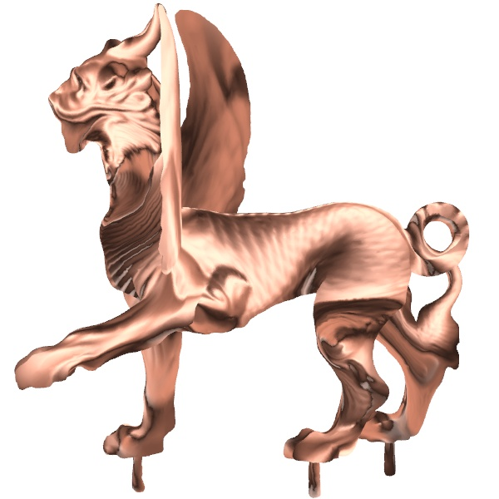 | 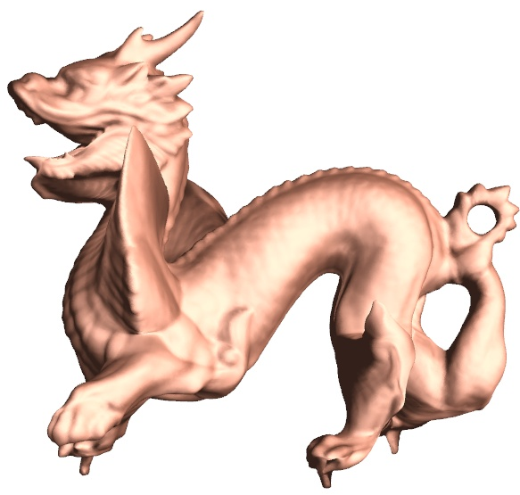
(a) Surface $M^{1}$ with edges from $M^{2}$  (notice density of edges from left wing) | (b) Surface $M^{2}$ with edges from $M^{1}$  (see spike flattened on rear left knee) | (c) $M^{1}$ normals mapped onto $M^{2}$  (lit using 2 antipodal light sources) | (d) 50% morph
Figure 1: Inter-surface map for two objects of genus 2, initialized with 8 user-specified feature points. (Symmetric stretch efficiency 0.311).

Abstract
We consider the problem of creating a map between two arbitrary triangle meshes. Whereas previous approaches compose parametrizations over a simpler intermediate domain, we directly create and optimize a continuous map between the meshes. Map distortion is measured with a new symmetric metric, and is minimized during interleaved coarse-to-fine refinement of both meshes. By explicitly favoring low inter-surface distortion, we obtain maps that naturally align corresponding shape elements. Typically, the user need only specify a handful of feature correspondences for initial registration, and even these constraints can be removed during optimization. Our method robustly satisfies hard constraints if desired. Inter-surface mapping is shown using geometric and attribute morphs. Our general framework can also be applied to parametrize surfaces onto simplicial domains, such as coarse meshes (for semi-regular remeshing), and octahedron and toroidal domains (for geometry image remeshing). In these settings, we obtain better parametrizations than with previous specialized techniques, thanks to our fine-grain optimization.
Keywords: surface parametrization, shape morphing, remeshing.

v  ~  u  w  ~  ~  M¹ |  |  | M²  v  u  w
(a) $N\left(\tilde{v}\right)⊂M^{1}$; initial $\tilde{v}$ |  |  | (b) $N\left(v\right)⊂M^{2}$
v  ^  u  w  ^  ^  R²  I  old v  ^ |  |  | v  ~  u  w  ~  ~  M¹
(c) $N\left(\hat{v}\right)⊂R^{2}$ |  |  | (d) $N\left(\tilde{v}\right)⊂M^{1}$; new $\tilde{v}$
Figure 3: Illustration of neighborhoods in vertex optimization.
 | v  ^  u  w  ^  ^  R² | v  ~  ~  ~  u  w  M¹
Figure 4. A kink vertex (red, right) is required since a direct segment along $\tilde{v}\tilde{w}$ (dotted) goes on the wrong side of $\tilde{u}$.

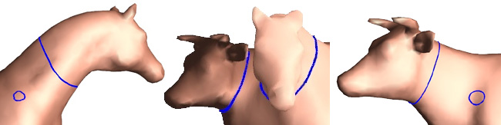
Figure 5. Use of a conformal metric results in a poor inter-surface map.

Applications and results

Inter-surface mapping

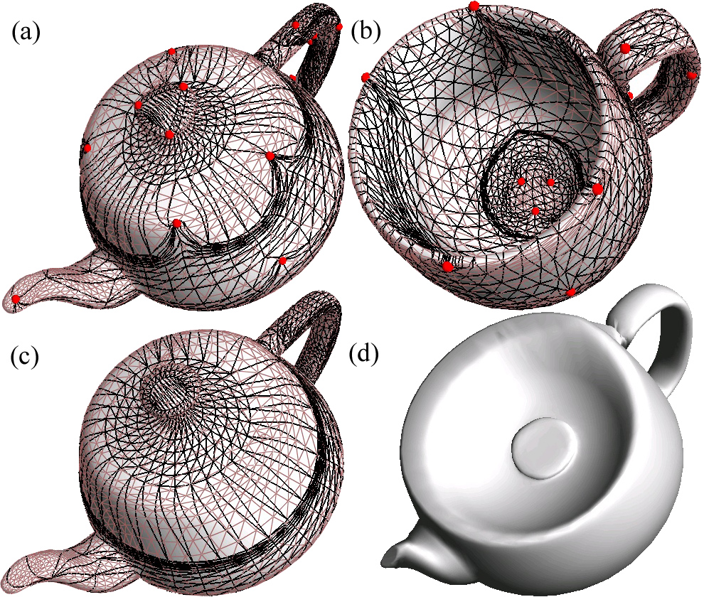
Figure 6. Inter-surface map between two genus-1 objects.
(a,b) use fixed constraints while (c,d) drop the constraints after initialization. (a,c) cup edges on teapot. (b) teapot edges on cup. (d) 50% morph. (Sym. stretch efficiencies: (a,b) 0.471, (c,d) 0.598).
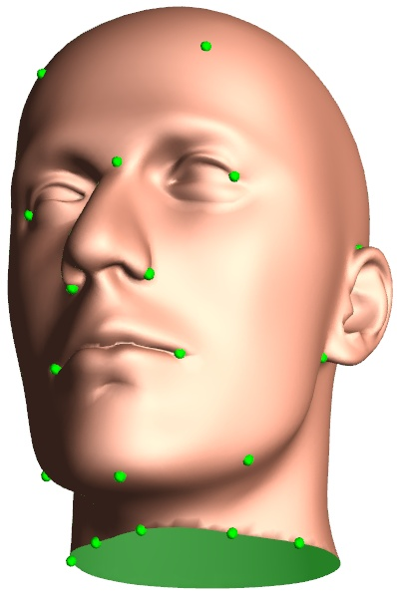 | 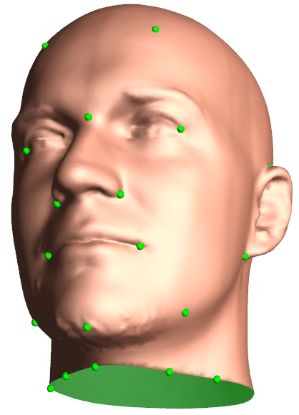 | 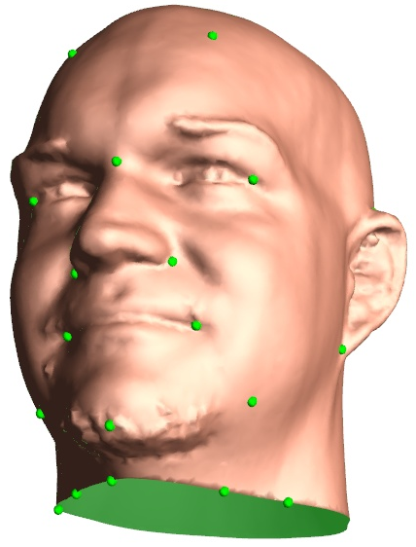 | 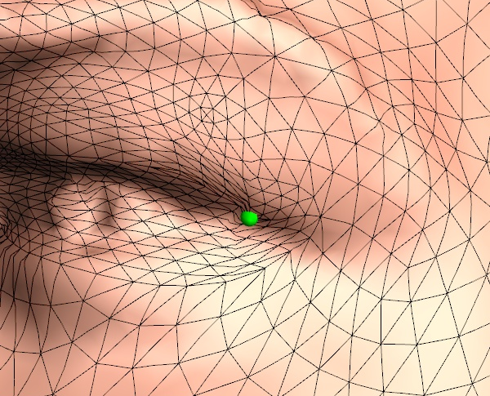
$$M^{1}$$ | 50% morph | $$M^{2}$$ | Close-up
Figure 7. Map between two meshes with boundaries. The close-up on the eye shows low distortion around the feature point ($M^{1}$ edges over $M^{2}$ geometry). (Symmetric stretch efficiency 0.967).

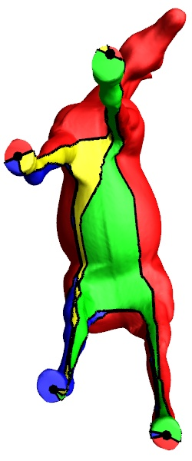 | 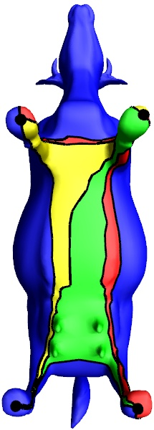 | 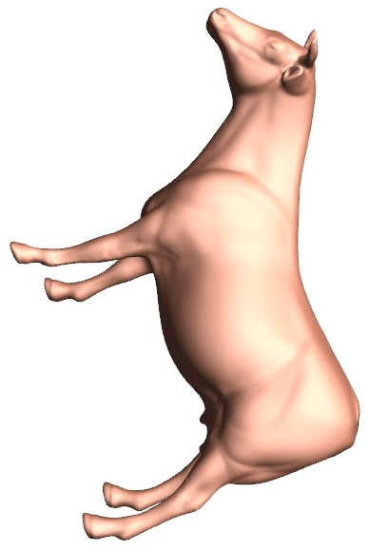
horse base | cow base | 50% morph
Figure 8: Cow-horse inter-surface map using only 4 features.
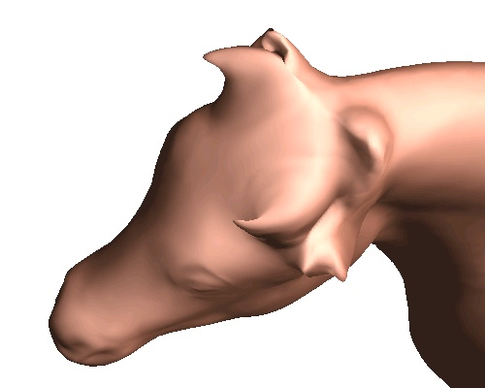 | 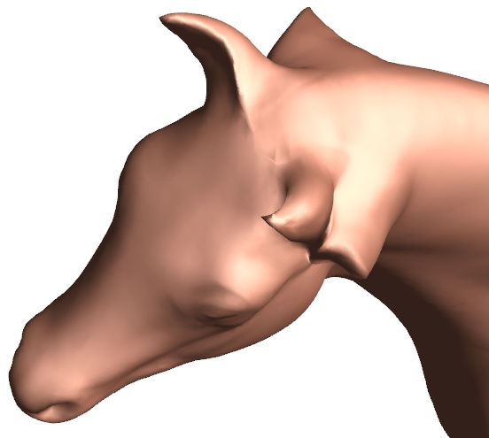
(a) composition of 2 simplicial maps | (b) direct inter-surface map
Figure 9. The inter-surface map automatically favors shape correspondence, unlike the composition of two separate simplicial parametrizations, as shown in these morphs. (The simplicial map uses the 17 feature points shown in Figure 2.) (Symmetric stretch efficiencies: (a) 0.416, (b) 0.442).

Simplicial parametrization
In this scenario, $M^{1}$ is an abstract domain whose triangle faces are conceptually all equilateral. Although such a domain lacks an isometric embedding in $R^{3}$, this is not a problem for the algorithm. During the construction of the local neighborhood $N\left(\hat{v}\right)$ in Section 5.1, the faces in $N\left(\tilde{v}\right)$ are simply taken to be equilateral.
Among previous simplicial parametrization methods, the most advanced is the Globally Smooth Parametrization (GSP) work of Khodakovsky et al [2003], which attains smoothness across domain edges. However, it compresses the parametrization in the vicinity of low-valence irregular vertices, and stretches it near high-valence irregular vertices. As Figure 10 shows, our maps are visually smooth everywhere, and the extraordinary domain vertices have much less influence on the parametrization uniformity.
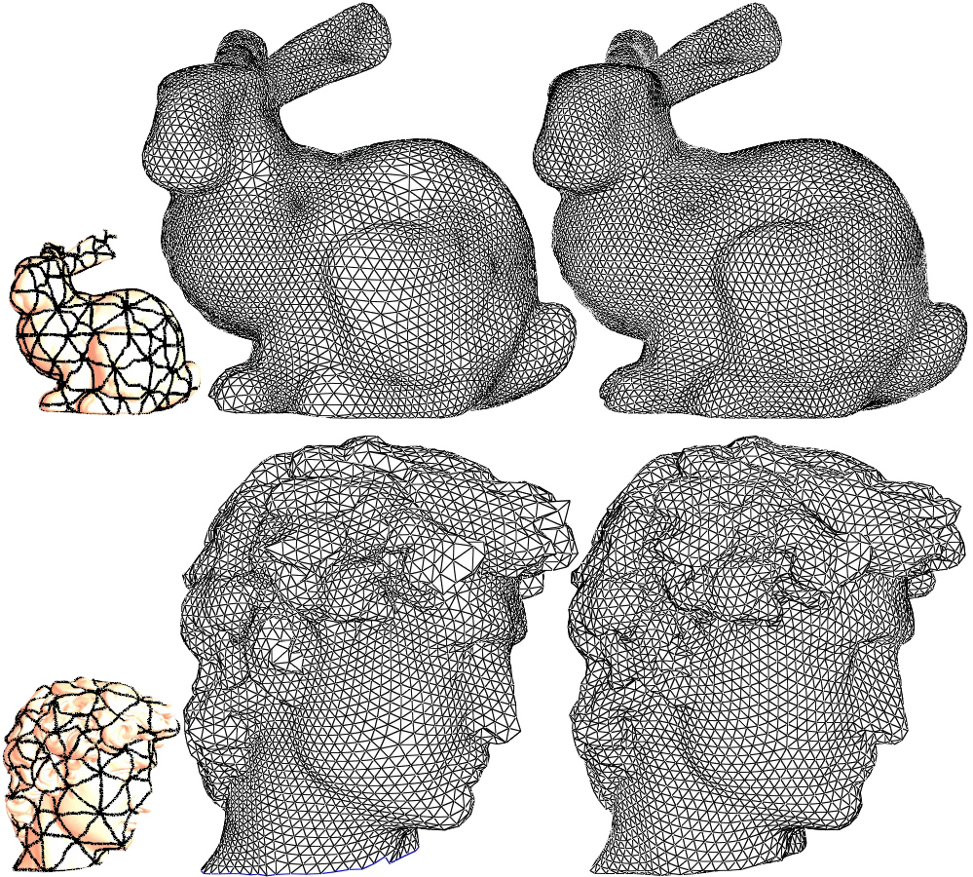
Figure 10. Comparison of semi-regular remeshing using GSP (middle) and our method (right), using the same set of base domain patches (left). (One-way stretch efficiencies: bunny 0.800, 0.915; David 0.761, 0.902).

Octahedral parametrization
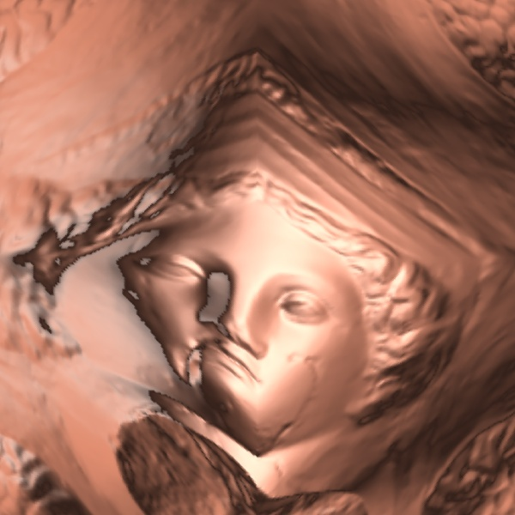
Praun and Hoppe [2003] use a sphere as an intermediate domain to parametrize a surface onto an octahedron, for subsequent geometry image remeshing. By directly optimizing the octahedron-to-surface map, we obtain improved results. The inset figure shows the Venus head as a geometry image obtained by unfolding an octahedral parametrization. As shown in Table 1, the parametrization stretch efficiency is improved in all cases, and the geometric accuracy of the remeshes (as measured with PSNR) is also improved for models with many extremities.
Model | One-way  $L^{2}$ stretch efficiency |  | Remesh PSNR  (dB)
 | $$D\text{→}S\text{→}M^{2}$$ | $$\text{D→}M^{2}$$ | $$D\text{→}S\text{→}M^{2}$$ | $$\text{D→}M^{2}$$
Venus | 0.943 | 0.947 | 83.4 | 83.2
Bunny | 0.706 | 0.717 | 80.0 | 79.9
Gargoyle | 0.643 | 0.679 | 79.2 | 79.3
Armadillo | 0.454 | 0.528 | 72.0 | 73.0
Horse | 0.363 | 0.398 | 76.9 | 77.7
Cow | 0.405 | 0.440 | 74.9 | 77.0
tyrannosaurus | 0.360 | 0.418 | 73.6 | 74.5
Table 1. Comparison of octahedral remeshing using spherical parametrization ($D→S→M^{2}$) [Praun and Hoppe 2003], and using our direct map onto octahedron domain $D$.

Toroidal parametrization
A natural domain for genus-1 surfaces is the toroidal unit square. It is formed by identifying the square’s boundaries left-to-right and top-to-bottom. To apply our framework to this scenario, we let the toroidal domain be represented by a mesh $M^{1}$ with 9 vertices and 18 triangles. As in simplicial parametrization, the domain $M^{1}$ does not have a global isometric embedding in $R^{3}$, but again we can use the local geometry of the domain when constructing the neighborhoods $N\left(\tilde{v}\right)$ and $N\left(\hat{v}\right)$ in Section 5.1. In this case, the triangles in $N\left(\tilde{v}\right)$ are always right isosceles triangles, and their configuration is such that $N\left(\tilde{v}\right)$ is planar. Thus, the local map $N\left(\tilde{v}\right)→N\left(\hat{v}\right)$ is always an isometry.
Toroidal domain
tessellation
To initialize the parametrization, the user specifies 9 feature points on the input mesh $M^{2}$, to correspond with the domain mesh vertices. To allow maximum freedom for the map, these feature points do not act as constraints during coarse-to-fine optimization. Figure 11 shows some example results.
There has been little work on toroidal parametrizations of arbitrary genus-1 surfaces, which is surprising since the domain is the most “Euclidean” of all closed surface topologies. Gu and Yau [2003] demonstrate their global conformal approach on genus-1 surfaces. Compared to their results, ours exhibit less scale-distortion due to the use of a stretch functional.
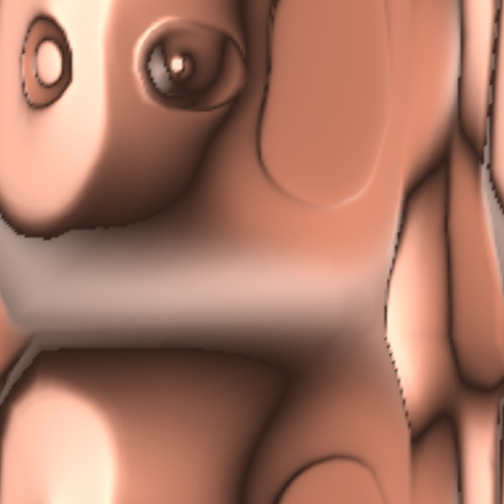 | 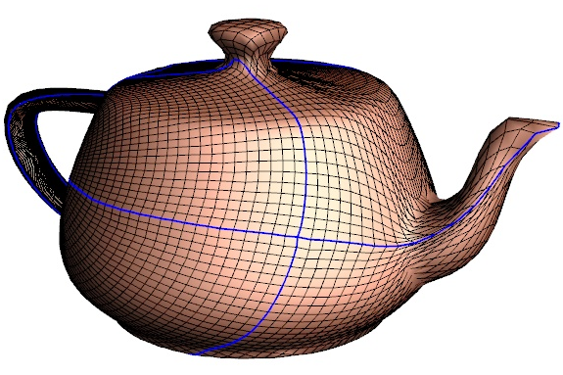
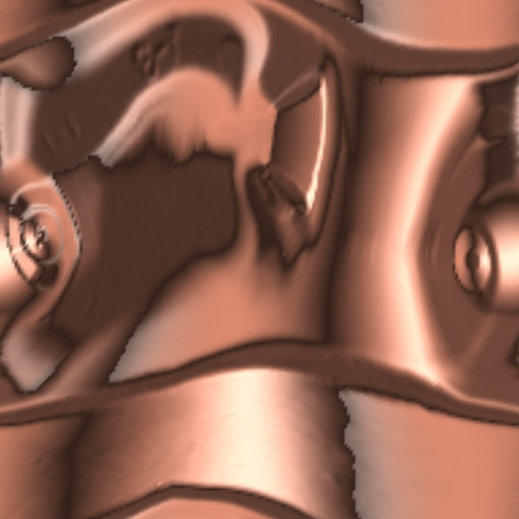 | 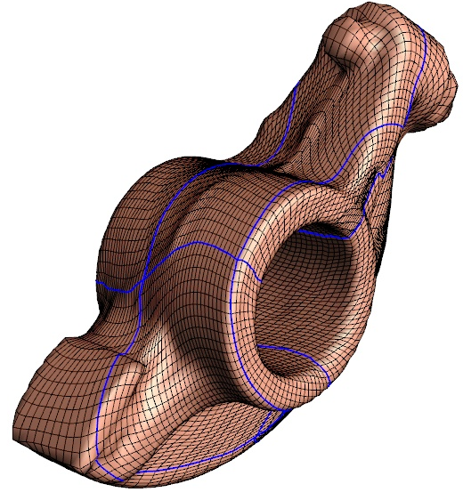
Surfaces mapped into toroidal domain (with 2-sided lighting) | Remeshed surfaces  (all vertices have valence exactly 4)
Figure 11. Examples of toroidal parametrization and remeshing.
(One-way stretch efficiencies: teapot 0.458, rocker arm 0.582).
t.

Future work
There are several avenues for future work. To improve speed we envision using fine-to-coarse propagation of information [Sander et al 2002] to obtain better configurations at low resolutions. Huge meshes could be handled using a hybrid strategy; after running our ISM algorithm to create a good mid-resolution map, we could define the finer map using simplicial map composition, since the simplicial pieces may be small and flat enough to avoid numerical problems and geometric detail mismatch.
One exciting application is the use of inter-surface maps to automatically transfer geometric texture between models. This may allow surface texture synthesis using other surfaces as exemplars.
An interesting open question is how to extend our method to handle multiple models. Simultaneously optimizing an all-to-all map would not scale, while using one model as domain would lose some benefits of directly optimizing inter-surface maps.
Another area of future work is computing maps with singularities to allow correspondences between objects with different topologies. User input may be required to associate topological features and introduce singularities on some of the meshes.

Acknowledgements
We thank Cyberware and the Digital Michelangelo Project at Stanford University for the 3D models, and Andrei Khodakovsky for sharing his Globally Smooth Parametrization data.

References
Aksoylu, B., Khodakovsky, A., and Schröder, P. 2003. Multilevel solvers for unstructured surface meshes. SIAM J. Sci. Comput.
Alexa, M. 2002.Alexa 20022002 Recent advances in mesh morphing. Computer Graphics Forum, 21(2), 173-196.
Desbrun, M., Meyer, M., and Alliez, P. 2002. Intrinsic parameterizations of surface meshes. Computer Graphics Forum, 17(2), 167-174.
Eck et al. 19951995Eck, M., DeRose, T., Duchamp, T., Hoppe, H., Lounsbery, M., and Stuetzle, W. 1995. Multiresolution analysis of arbitrary meshes. ACM SIGGRAPH, 173-182.
Floater, M. 2003. Mean value coordinates. CAGD, 20(1), 19-27.Floater 19971997
Floater, M., and Hormann, K. 2003. Floater 19971997 Recent advances in surface parameterization. Multiresolution in Geometric Modeling Workshop.
Gotsman, C., Gu, X., and Sheffer, A. 2003. Gotsman et al. 20032003 Fundamentals of spherical parameterization for 3D meshes. ACM SIGGRAPH, 358-363.
Gu, X., Gortler, S. J., Hoppe, H. 2002. Geometry images. ACM SIGGRAPH, 355-361.
Gu, X., Yau, S. 2003. Global conformal surface parameterization. Symposium on Geometry Processing, 127-137.
Guskov, I., Vidimče, K., Sweldens, W., and Schröder, P. 2000. Guskov et al. 20002000 Normal meshes. ACM SIGGRAPH, 95-102.
Haker et al. 20002000Haker, S., Angenent, S., Tannenbaum, S., Kikinis, R., Sapiro, G., and Halle, M. 2000. Conformal surface parametrization for texture mapping. IEEE TVCG, 6(2), 181-189.
Hoppe, H. 1996. Hoppe 19961996 Progressive meshes. ACM SIGGRAPH, 99-108.
Hormann, K., and Greiner, G. 1999a. MIPS: An efficient global parametrization method. Curve and Surface Design, 153-162.
Hormann, K., Greiner, G., and Campagna, S. 1999b. Hormann et al. 19991999 Hierarchical parametrization of triangulated surfaces. Vision, Modeling, and Visualization, 219-226.
Khodakovsky, A., Litke, N., and Schröder, P. 2003. Globally smooth parameterizations with low distortion. ACM SIGGRAPH, 350-357.
Kraevoy, V., Sheffer, A., and Gotsman, C. 2003. Matchmaker: constructing constrained texture maps. ACM SIGGRAPH, 326-333.
Kraevoy, V., and Sheffer, A. 2004. Sheffer et al. 2003 2003 Cross-parameterization and compatible remeshing of 3D models. ACM SIGGRAPH.
Lazarus, F., Pocchiola, M., Vegter, G., and Verroust, A. 2001. Computing a canonical polygonal schema of an orientable triangulated surface. ACM Symposium on Computational Geometry, 80-89.
Lee et al. 19981998Lee, A., Sweldens, W., Schröder, P., Cowsar, L., and Dobkin, D. 1998. MAPS: Multiresolution adaptive parametrization of surfaces. ACM SIGGRAPH, 95-104.
Lee, A., Dobkin, D., Sweldens, W., and Schröder, P. 1999. Multiresolution mesh morphing. ACM SIGGRAPH, 343-350.
Lévy, B., Petitjean, S., Ray, N., and Maillot, J. 2002. Lévy et al. 20022002 Least squares conformal maps for automatic texture atlas generation. ACM SIGGRAPH, 362-371.
Maillot, J., Yahia, H., and Verroust, A. 1993 Maillot et al. 19931993. Interactive texture mapping. ACM SIGGRAPH, 27-34.
Praun, E., Sweldens, W., and Schröder, P. 2001. Praun et al. 20012001 Consistent mesh parametrizations. ACM SIGGRAPH, 179-184.
Praun, E., and Hoppe, H. 2003. Praun et al. 20012001Spherical parametrization and remeshing. ACM SIGGRAPH, 340-349.
Sander, P., Snyder, J., Gortler, S., and Hoppe, H. 2001. Sander et al. 20012001 Texture mapping progressive meshes. ACM SIGGRAPH, 409-416.
Sander, P., Gortler, S., Snyder, J., and Hoppe, H. 2002. Sander et al. 20022002 Signal-specialized parametrization. Eurographics Workshop on Rendering, 87-100.
Sheffer, A., and Hart, J. 2002. Sheffer and Hart 20022002 Seamster: Inconspicuous low-distortion texture seam layout. IEEE Visualization, 291-298.
Sorkine et al. 20022002Sorkine, O., Cohen-Or, D., Goldenthal, R., and Lischinski, D. 2002. Bounded-distortion piecewise mesh parametrization. IEEE Visualization, 355-362.
Turk, G. 1992. Re-tiling polygonal surfaces. ACM SIGGRAPH, 55-64.

