4 Levels of Formatting with MS WORD

By Character

Each a, b, c, 1, 2, 3, ?, >, ……

Bold, Italic, Underline, Superscript, Subscript…

By Paragraph

Paragraphs are defined by hitting the ENTER Key

Alignment, Line Spacing, Indents, Tabs

By Section

To Change in Page Orientation, Change in Margins…

Headers and Footers, Column Settings

By Document

As .Txt .Htm (Html) .Wpd .Doc

**Before doing anything we need to define the Normal Style**

In the **Home** Tab, Right-Click on the Normal Style

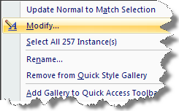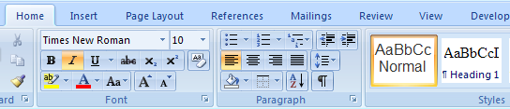

Next, Click on **Modify**

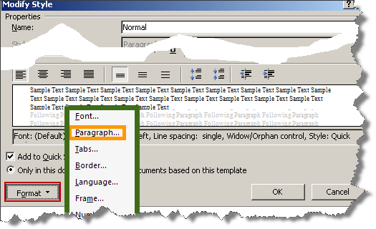

Next, Click

**Format**

Paragraph

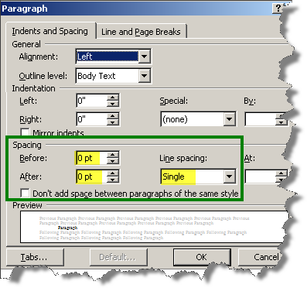

Finally,

In the **Spacing** area of

the **Paragraph** Dialog Box,  
put a Zero in the **Before** and

**After** boxes  
and **Single** in the **Line Spacing**

Click OK.

This will change the paragraph

Formatting for your documents

Jim T. Great

123 Happy Lane

Tacoma, WA 98503

How to Note: - Office Button- Word Options – Proofing – AutoCorrect Options.

Dear John,

I am fine.

Hope you are fine.

How are you?

Your pal,

Jim



**Formatting by Section – Multiple Columns**

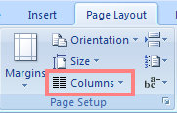In single column, here we have the first, lead-in paragraph. This is just a bunch of text. This is just a bunch of text. This is just a bunch of text. This is just a bunch of text.   
Column Tool is located under the Layout Ribbon.  
 This is just a bunch of text. This is just a bunch of text. This is just text. This is just a bunch of text. This is just a bunch of text wrapped around a graphic.

Then we go to 2 Columns with this text. This is just a bunch of text. This is just a bunch of text. This is just a bunch of text. This is just a bunch of text. This is just a bunch of text. This is just a bunch of text. This is just a bunch of text. This is just a bunch of text. This is just a bunch of text. This is just text.

Then we go to 2 Columns with this text. This is just a bunch of text. This is just a bunch of text. This is just a bunch of text. This is just a bunch of text. This is just a bunch of text. This is just a bunch of text. This is just a bunch of text. This is just a bunch of text. This is just a bunch of text. This is just text.

Then we go to 2 Columns with this text. This is just a bunch of text. This is just a bunch of text. This is just a bunch of text. This is just a bunch of text. This is just a bunch of text. This is just a bunch of text. This is just a bunch of text. This is just a bunch of text. This is just a bunch of text. This is just text.

Then we go to 2 Columns with this text. This is just a bunch of text. This is just a bunch of text. This is just a bunch of text. This is just a bunch of text. This is just a bunch of text. This is just a bunch of text. This is just a bunch of text. This is just a bunch of text. This is just a bunch of text. This is just text.

Going back to single column, here we have the final paragraph in this portion of the document. This is just a bunch of text. This is just a bunch of text. This is just a bunch of text. This is just a bunch of text. This is just a bunch of text. This is just a bunch of text. This is just a bunch of text. This is just a bunch of text. This is just a bunch of text. This is just a bunch of text. This is just text.

## LetterHead Here

To: Zooka Pfadooka

###### 911 Lucky Lane

###### Tacoma, WA 98404

Subject: Writing Tips ( Demo First Line, and Full Indent )

I thought you might be able to use the following writing tips. Please consider them as you prepare documents at you place of employment. They are very concise and to the point. Please use them…you need to!

(Note: have the computer **number the following (1 – 15)**, place **6 points of additional spacing between these paragraphs**, **indent the list by ½ inch**, and give it a **light gray shading**.)

Avoid clichés like the plague.

Proofread carefully and you won’t any words out.

Who needs rhetorical questions?

No one-word sentences. Ever!

The passive voice is to be avoided.

If any word is improper at the end of a sentence, a linking verb is.

Be specific, more or less.

Never overuse exclamation marks!!!!

Never, never, never use repetitive redundancies…never.

Verbs has to agree with their subjects in number.

Prepositions are not used to end sentences with.

Avoid un-necessary hyphens.

I hope you find these tips helpful.

Sincerely,

Jim

LETTERHEAD HERE

## **R E S U M E**

**Objective**: This is just a bunch of text. This is just a bunch of text. This is just a bunch of text. This is just a bunch of text. This is just a bunch of text. This is just a bunch of text. This is just a bunch of text. This is just a bunch of text.

**Experience**: This is just a bunch of text. This is just a bunch of crazy text. This is just a bunch of text. This is just a great bunch of text. This is just a bunch of text. This is just a bunch of text. This is just a bunch of text nice. This is just a great bunch of Weird text. This is just a bunch of text. This is just a bunch of text. This is just a bunch of text. This is just text.

Education: This is just a bunch of text. This is just a bunch of crazy text. This is just a bunch of text. This is just a great bunch of text. This is just a bunch of text. This is just a bunch of text. This is just a bunch of text nice. This is just a great bunch of Weird text. This is just a bunch of text. This is just a bunch of text. This is just a bunch of text. This is just text. This is just a bunch of text.

**Personal**: This is just a bunch of text. This is just a bunch of crazy text. This is just a bunch of text. This is just a great bunch of text. This is just a bunch of text. This is just a bunch of text. This is just a bunch of text nice. This is just a great bunch of Weird text. This is just a bunch of text. This is just a bunch of text. This is just a bunch of text.

**Selecting an Irregular Area on a Page (Alt-Use)**

## Make just the Para Head (A, B, C, Etc. ) Bold and Red using Alt Method

A. This is just a bunch of text. And of course, this is just a great bunch of text. This is just a bunch of text. And of course, this is just a great bunch of text. This is just a bunch of text.

B. This is just a great bunch of text. This is just a bunch of text. This is just a great bunch of text. This is just a great bunch of text. This is just a bunch of text. This is just a bunch of text.

C. This is just a great bunch of text. This is just a bunch of text. This is just a great bunch of text. This is just a great bunch of text.

### D. This is just a great bunch of text. This is just a bunch of text. This is just a great bunch of text. This is just a great bunch of text. This is just a great bunch of text. This is just a bunch of text. This is just a great bunch of text. This is just a great bunch of text.

### How to Turn Text Sideways

### 

### First, you need to create a Textbox,

### Select INSERT – Shapes - Text Box

### Type your text. Then Click and drag the Text Box To where you want the text box

### to be located on the page.

### Once you have created the text box and have typed in the text, you can flip it.

### Select the text box (NOT the text) itself.

### The Format Tab will become active so you can…

### Click to Select TEXT DIRECTION

### Table of Contents

#### Chapter 1 3

Chapter 2 17

Chapter 3 39

#### Chapter 4 57

Chapter 5 79

##### Chapter 6 101

#### Chapter 7 133

Chapter 8 157

Chapter 9 199

**Note WordArt**

**C O M M E N T S H E E T**

**WRONG WAY (To understand, select 3 rows below and change Point Size)**

#### Name _______________________________________ Phone ______________

Address__________________________________________________________

Comments _______________________________________________________

**Right WAY**

* No problem Changing Point Sizes when we set Tabs.
* Demo how hitting the Enter Key carries formatting of Previous Paragraph to the Next Paragraph (Enter-Tab-Enter-Tab-Enter…)

#### Name Phone

Address

Comments

Filling a Shape with a Graphic, Clipart or Picture

**How can I change…**



This and This To This?

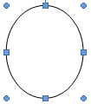

**Insert** the desired **Shape.** **With the shape selected** select **Format**

AND select **the Shape Fill Tool**

**Then select Picture**

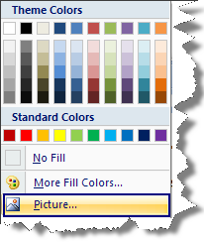

Browse to find the desired picture.

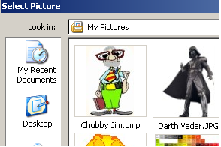

Next, double click on your desired picture. That picture will then fill the inside of the shape.

How to identify if your cow has

Mad Cow Disease

 

**If your cow sounds like this, If your cow sounds like this, then**

**then fire up the barbecue. May we suggest the fish.**

 **(Double Click)**  **(Double Click)**

NOTE: Use **Insert Object** to Insert a Sound Object

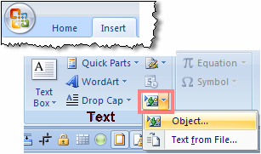

**Note that the Object Insert Tool is on the TEXT Group of the Insert Ribbon**



**Making a TABLE**

The data below has a Tab between each item

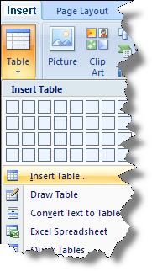

Jan Feb Mar Apr May June

Jim 44 66 88 100 89 93

Bob 40 50 77 66 75 80

Sue 25 60 80 90 87 77

Highlight the Data. Then,   
From the Insert Ribbon

Insert Table Button

You also need to be able to Insert and Delete Rows and Columns

|  |  |  |  |  |  |  |
| --- | --- | --- | --- | --- | --- | --- |
|  | Jan | Feb | Mar | Apr | May | June |
| Jim | 44 | 66 | 88 | 100 | 89 | 93 |
| Bob | 40 | 50 | 77 | 66 | 75 | 80 |
| Sue | 25 | 60 | 80 | 90 | 87 | 77 |

Just select a Column or Row, then

Right-Mouse-Click to get a context Menu

To delete a specific Cell or Cells, Select them, Right Mouse-Click

And select **Insert** >

Or **Delete** **Cells**