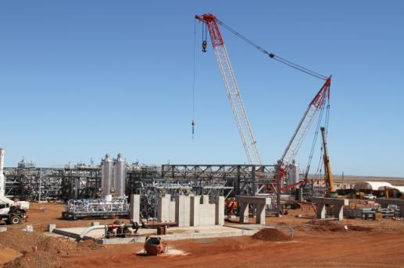

Prepared For:
Devil Creek Development Project (DCDP)
Prepared By:
John Holland Pty Ltd
Date:
Xx August 2010

Distribution List Internal Report
Name | Position
Adam Brunner | Commercial Manager – DCDP
Adam Harry | General Manager – WA
Adrian Claridge | Project Controls – E&R
Andy Rankine | Project Manager - DCDP
Brendan Petersen | General Manager – E&R
David Grenfell | Operations Manager – Western – E&R
Hennie Engelbrecht | Project Services Manager – E&R
John Davis | Operations Manager – WA
Michelle Agioritis | Commercial Manager – E&R
Paul MacFarlane | Regional Manager - Western
Ravi Syam | National Manager – Energy
Stu Owen | Construction Manager - DCDP

