An introduction to MS Word

When you first start some of the programs in 2007 **Microsoft Office** system, you will see that the Office 2007 windows are organized with **Ribbons**, T**abs, Groups and Buttons**.

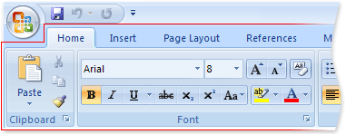

**Tabs**

**Buttons**

**Groups**

**The Ribbon** is designed to help you quickly find the commands that you need to complete a task. Commands are organized in logical **groups**, which are collected together under **tabs**. Each tab relates to a type of activity, such as writing or laying out a page. To reduce clutter, some tabs are shown only when needed. For example, the **Picture Tools** tab is shown only when a picture is selected.

The MS Office Quick Access Toolbar (is a Customizable Toolbar)

1. The **Quick Assess Toolbar** is first located in the   
   upper-left corner next to the **Microsoft Office Button**   
   (its default location)



**OR**

**2.** It can be moved to **Below** the Ribbon

Be aware that, when the Toolbar is below the Ribbon, it slightly reduces the usable work area on a page. Therefore, if you want to maximize the work area, you may want to keep the Quick Access Toolbar in its default location.  
However, if you locate the Toolbar in it’s default location above the Ribbon and you have lots of buttons on the Toolbar, it will mask the Title Bar and you will not see the Name of your Document

**Moving the Quick Access Toolbar**

1. To move the Toolbar, select **Show Below the Ribbon** or **Show Above the Ribbon** In the list.

**2**. On the Drop-Down List, select: **Customize Quick Access Toolbar** .



1. To add items to the toolbar ,select **More Commands**. It’s all that simple !

Need Help Finding Buttons and Commands?

The Link below will take you to an area where you can compare the location of previous MS Office 2003 commands to the location of those same commands in MS Office 2007.

<http://office.microsoft.com/assistance/asstvid.aspx?assetid=XT100766331033&vwidth=1044&vheight=788&type=flash&CTT=11&Origin=HA100744321033>

Working with **Indents**

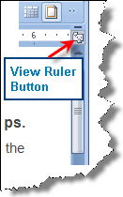

**- - The Indent Tools - -**

The **Indent Tools** are located on the Ruler**. Note**  If you don't see the **horizontal ruler** that runs along the top of the document, click the **View Ruler** **Button** at the top of the vertical scroll bar.

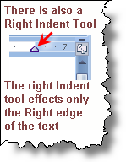

**There are 3 parts to the Left Indent Tool:**

1. **First Line Indent**



**Tab  
Tool**

1. **Hanging Indent**

*(Think of it as affecting the second and subsequent lines of a Paragraph)*

1. **Full Left Indent** *(It indents the whole Paragraph)*

- - - - - - - - - - - - - - - - - - - - - - - - - - - - - - - - - - - - - - - - - - - - - - -



**This is a First Line Indent.** **Note that only the first line of the paragraph is indented.** This is a First Line Indent. This is a First Line Indent This is a First Line Indent. This is a First Line Indent. This is a First Line Indent. This is a First Line Indent This is a First Line Indent. This is a First Line Indent.

- - - - - - - - - - - - - - - - - - - - - - - - - - - - - - - - - - - - - - - - - - - - - - -



**Starts Here** **This is a Hanging Indent**. **Note that the First Line starts way to the left, and the second and subsequent lines all line up…indented to the right.** This is a Hanging Indent. This is a Hanging Indent. This is a Hanging Indent. This is a Hanging Indent. This is a Hanging Indent.

- - - - - - - - - - - - - - - - - - - - - - - - - - - - - - - - - - - - - - - - - - - - - - -

**Full Left Indent**



**This is a Full Indent.** **Note that both the first, second and subsequent lines are all indented away from the right margin area.** This is a Full Indent. This is a Full Indent. This is a Full Indent. This is a Full Indent. This is a Full Indent.

**This text is Indented away from the Right Margin by using the Right Indent Tool**

**This is a Right Indent.** **Note that the entire paragraph is indented from the right margin area.** This is a Right Indent. This is a Right Indent. This is a Right Indent. This is a Right Indent. This is a Right Indent.

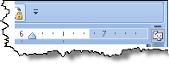

**Setting Tabs and Tab Leaders**



**The easiest way to set Tabs is to use the Ruler to manually set the  
tab stops.  Note**  If you don't see the horizontal ruler that runs along the top  
of the document, click the **View Ruler** button at the top of the vertical scroll bar.



You can quickly set tabs by **clicking the Tab Selector** at the left end of the ruler until it displays the type of tab that you want and **then click on the ruler** where you want the Tab set. But which type of tab stop should you use?

|  |  |
| --- | --- |
|  | A **Left Tab** stop sets the start position of text that will then run to the right as you type. |
|  | A **Center Tab** stop sets the position of the middle of the text. The text centers on this position as you type. |
|  | A **Right Tab** stop sets the right end of the text. As you type, the text moves to the left. |
|  | A **Decimal Tab** stop aligns numbers around a decimal point. Independent of the number of digits, the decimal point will be in the same position |
|  | A **Bar Tab** It only inserts a vertical bar on your page at the tab position. |

If you want your tab stops at precise positions that you can't get by clicking the ruler, or if you want to insert a specific character (leader) before the tab, you can use the **Tabs** dialog box. **To display the Tabs Dialog Box, double-click any tab stop on the ruler.**

**About using the horizontal ruler to set tab stops**

* **By default, there are default left Tabs every ½ inch.** If you set no Tabs, Office will use those default Tabs
* You can **remove a tab stop** that had been set. Just drag it (up or down- - stripping it) off the ruler. When you release the mouse button, the tab stop disappears.
* You can also drag existing tab stops left or right along the ruler to relocate it to a different position.
* When multiple paragraphs are selected, only the tabs from the first paragraph will show on the ruler.

**Change the spacing between the default tab stops**

If you set manual tab stops, the default tab stops are interrupted by the manual tab stops that you set. **Manual tab stops that are set on the ruler override the default tab stop settings**.

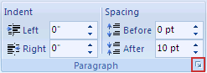

1. On the **Page Layout** tab, click the **Paragraph** Dialog Box Launcher. In the resulting **Paragraph** dialog box, click **Tabs**.

That will result in the **Tabs Dialog box**

1. In the **Default tab stops** box, enter the amount of spacing that you want between the default tab stops.

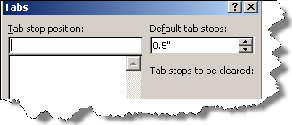

1. Then, when working with your document, and you press the TAB key, your tab will stop across the page at the distance that you specified.

Accessing the Tabs Dialog Box and Setting Tab Leaders

**The Easiest Way to access the Tabs Dialog Box is to Double-click on any Tab on the Ruler.**



**Or**

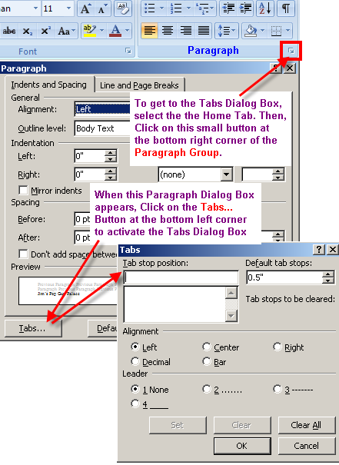

**You can also set Tabs Via the Tabs Dialog Box.**

**See Instructions at LEFT.  
  
The Tabs Dialog Box also offers the ability to set Tab Leaders.**

**See/read graphics at left.**

Regardless of how you accessed it, this is what the **Tabs Dialog Box** looks like

Select the kind of leader you want from the Leader portion of the Tabs Dialog Box

**TAB LEADERS**

**These are Examples of what  
Tab Leader s look like.**

Chapter 1 Page 1

Chapter 2 Page 9

Chapter 3 Page 21

Chapter 4 Page 33

Chapter 5 Page 41

Chapter 6 Page 55

**Page Setup (MS Word)**

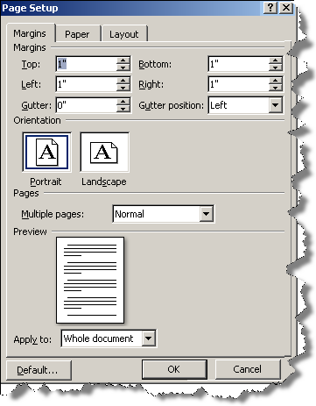

To access the **Page Setup**

Dialog Box just double-click

**HERE**. To left of ruler.

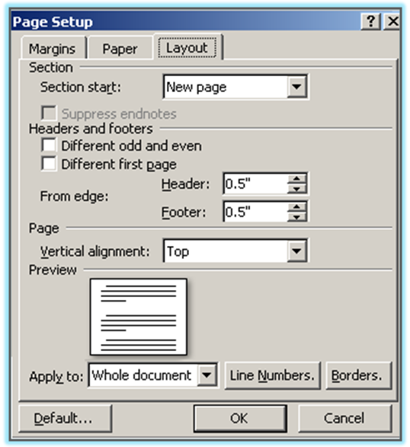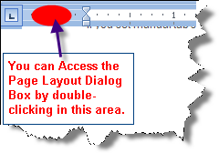

Setting Page Borders

Access tools for setting Page Borders via The Page Layout Ribbon

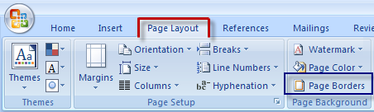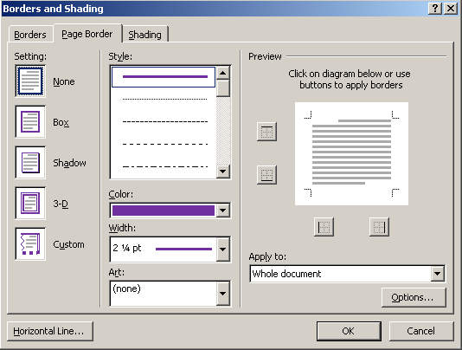

# How to Anchor a Graphic, a Shape or a Text Box to the Page

**To anchor a graphic or a shape to the page so it will not move down the page as you type or hit the enter key:**

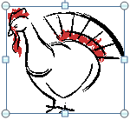

If a **Graphic**…**Right-click** on the graphic

Then select **Text Wrapping,** andthen **More Layout Options**

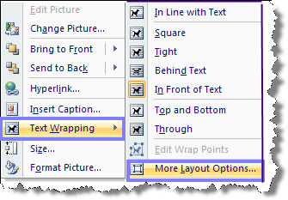

**OR, Right-Click on Text Box**

Right-Click on **Line**

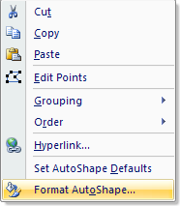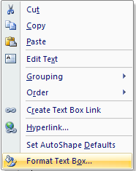

***Text Box***

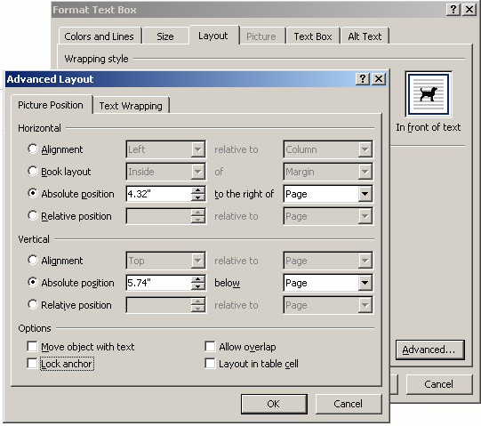

In resulting window, select **LAYOUT**

**Then Select**

**Advanced**

In the **Advanced Layout**

**Dialog Box, Options area,** you need to make sure that **ONLY** the **Lock Anchor Box** is checked. Then click **OK**.

Be sure to Select PAGE in both of these Boxes

**Now your graphic element will stay where you put it, even as you type and/or hit the enter key.**

**X**

# How to Create and Rotate a Text Box

This is a really great, long, sweet Text Box

At the right of the  
 **Insert Tab**,   
you will find the  
**Text Box** Button.

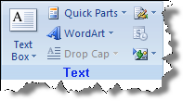

Click on the **Text Box** button, define the textbox and Type in your Text. *(See sample text Box with text Below.)*

This is a really great, long, sweet Text Box

Once you have created/Typed your Text into the Text Box, **Select it**.

Then, at the Left Edge of the Format Tab,   
you will see the **Text Direction** Button

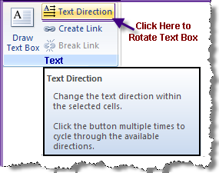

Click on the **Text Direction** Button as many times as needed to rotate the text as desired. You will also need to **resize** and **reshape** the text Box to accommodate what you had typed in it.

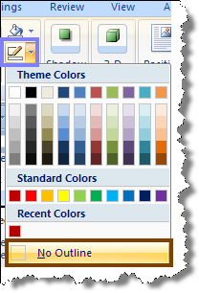

See a possible result at left edge of this page.

If you don’t want the Border around the Text Box,   
go to the **FORMAT** Tab and select **Outline** **Shape**,  
then **No Outline**

**______________________________**

**Be sure to Anchor the Text Box so it doesn’t   
slide down the page as you type.  
Don’t know how to Anchor things? See the  
File: “How to Anchor a Graphic to the Page.docx”**

**It’s a tutorial provided along with this page.**

**Using the AutoCorrect Feature**

Let’s say you want to create a Letterhead, and then be able to insert it with just a couple of key strokes. You can do it with an MS Word feature called **AutoCorrect**.

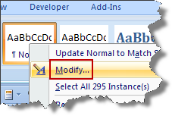

**FIRST:** You must reset/Modify the **Normal Style**

At the **Home** Ribbon,

Right Click on **Normal**,

select **Modify**

**Then…Click on Format, then Paragraph**

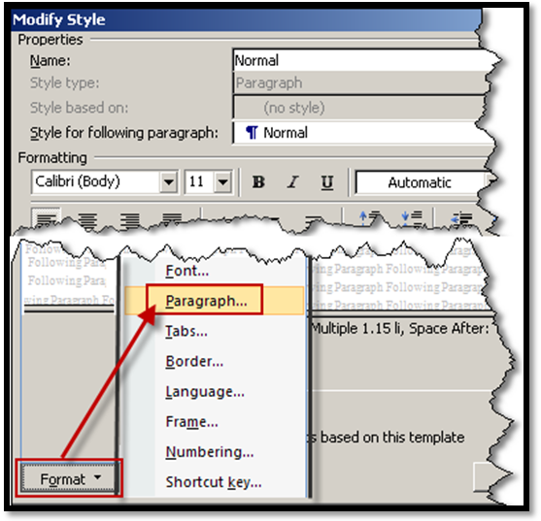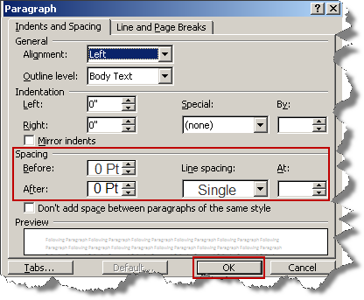

**In the Spacing area, set Before  
and After to 0 Pt** (Zero Points)  
and **Line Spacing to Single.**

**Then, Click OK**

**NEXT: Create an example of the letterhead you will want to use over and over.***(See example of a basic Letterhead below.)*

**RRBooks**

Ph: (123) BR-549  
E-Mail: CoolGuy@MyISP.COM



123 Happy Lane

MyTown USA 98765

**Once you have created the desired letterhead, Highlight/Select and Copy it.**

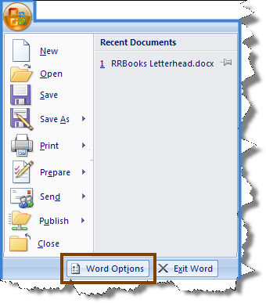

The next step is to click on

the **Microsoft Office Button**  
and then click **Word Options**.



Next, Click **Proofing**.

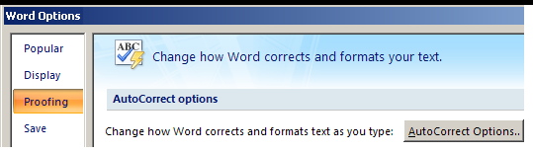

Then, Click on  
**AutoCorrect Options**.

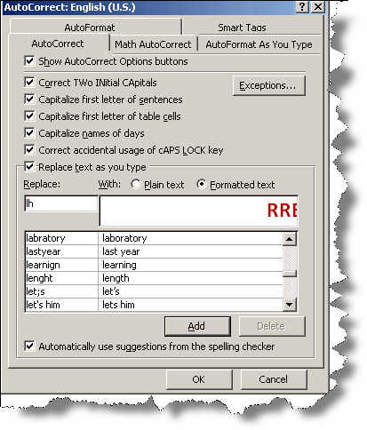

That will produce the

**AutoCorrect** Dialog Box

You must type in the text characters  
You will use to trigger the AutoCorrect  
insertion of your letterhead onto a page.  
Note that I typed in lh (as in letter-head).

This tells Word to insert my letterhead  
anytime I Simply type lh and hit the space  
bar or Enter key

Next, Click on the **Add** Button

Then Click **OK**

On your Keyboard, type ***Ctrl –N*** (That will give you a new, blank MS Word Document).

Test your AutoCorrect feature by typing **lh**, and hitting the spacebar or Enter key.

How to Fill a Shape with a Graphic, Clipart, or Picture

**How can I change…**



This and This To This?

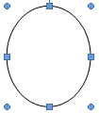

Create the desired Shape **With the shape selected** access the

**Drawing Tools – Format**- **Shape Fill**

AND select **Picture**

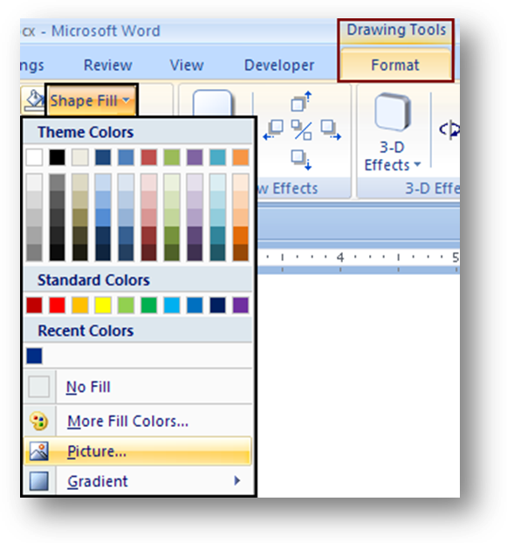

Browse to find the desired picture.

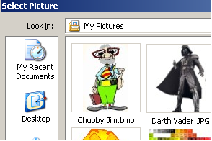

**You are going to Fill the Shape with a Picture.**

When you double click on your desired picture, it will fill the inside of the shape.