Ceiling Layout

|

Front of Stage

Front Light Bar

Balcony

4” x 4”
4 outlet
Electrical
Black
1 – DMX FM
1 – DMX M
1 – Ethernet

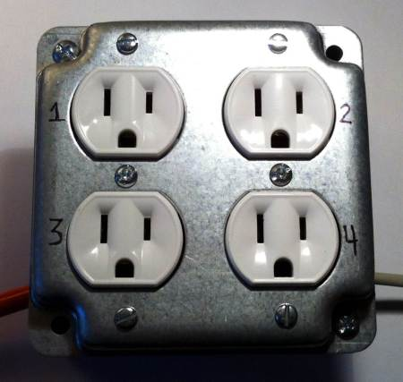
1 x 2 – I
1 x 2 - L
Electric

Video Feed
1 BNC cable to
Tech Suite

