- http://news.bbc.co.uk/1/hi/8243226.stm

Page last updated at 13:35 GMT, Tuesday, 8 September 2009 14:35 UK

T-Mobile and Orange in UK merger
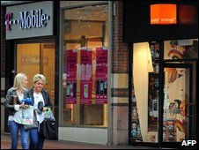
If completed, shop closures and job losses are seen as inevitable
T-Mobile and Orange plan to merge their UK businesses, creating a mobile phone giant with 28.4 million customers.
If completed, a deal between Deutsche Telekom's T-Mobile and Orange owner France Telecom would see a firm with sales of 9.4bn euros (£8.2bn; $13.5bn).
It would be the UK's largest provider, overtaking Telefonica's O2, with about 37% of the mobile market.
It is the second large corporate action in two days, after Kraft Food's £10.2bn takeover proposal for Cadbury.
Orange CEO Tom Alexander: The move means 'better value and better coverage' Orange and T-Mobile said their deal - due to be signed by November - would "bring substantial benefits to UK customers", and promised expanded network coverage, better network quality and improved customer services.
However, it is likely that competition authorities in the UK and EU will probe the deal.
'Efficiencies' Both brands would remain separate for the first 18 months after the deal was completed while branding options were reviewed.
Orange chief executive Tom Alexander would lead the new company, with T-Mobile's UK boss Richard Moat as chief operating officer.
Orange employs 12,500 people in the UK, while T-Mobile has a UK workforce of 6,500.
A spokeswoman confirmed there would be "efficiencies" that could be made across both businesses - but said it was too early to give details of any impact on staff.
Integrating the businesses would cost between £600m and £800m, the firms said. This bill would include decommissioning mobile phone masts, cutting back the network of stores and streamlining other operations.
Over time, savings should reach about £3.5bn, they added.
Pricey renewal UK mobile phone operators would welcome consolidation in the sector said lawyer Chris Watson, of CMS McKenna, adding firms saw the current levels of competition as "ruinous" because of how low they had to keep prices to win customers.
There was very little prospect of the deal being approved by regulators without some alterations, he added, and said "alarm bells will be ringing" about price increases.
Customers on existing contracts would not see their tariffs changed, he said.
"But when your contract comes up for renewal you may well find the price is more expensive."
Mobile phone analyst Nigel Hawkins told the BBC that it was not unprecedented for a firm to have more than a third of a European country's mobile phone market.
"If the deal goes ahead, then this merged firm, along with O2 and Vodafone will have more than 90% of the UK market and there will be concern that there remains plenty of competition and that this position is not abused."
Avoiding writedowns Deutsche Telekom said earlier this year that it was considering its options for its UK business - which has struggled to win customers in the highly competitive market - which sees five operators and several smaller players compete.
DEAL IN NUMBERS
28.4m customers
37% UK market share
£8.2bn sales (in 2008)
Source: Deutsche Telekom
Observers say that a joint venture would allow the German firm to avoid the write downs it could face if forced to sell T-Mobile UK for less than it hoped.
Meanwhile, for France Telecom, the deal is a way to strengthen its position in the UK market without paying cash or taking on vastly more debt.
T-Mobile is currently the fourth-largest mobile operator in the UK, with a 15% share of the market. O2 has a 27% share, followed by Vodafone (25%) and Orange (22%).
ANALYSIS
Simon Atkinson, Business reporter, BBC News
This deal - if it goes ahead - will shake up the UK mobile market.
Both brands would stay for a while - but the Orange name is tipped to remain long-term.
Being market leader would give it clout when it came to the handsets available. Neither Orange or T-Mobile offer "must have" phones such as the iPhone and Blackberry Storm - but this could change.
And the firms promise customers will get better network coverage - and there's potential for investing in better, faster 3G networks and data access through mobiles.
But not everyone will be happy. The range of tariffs offered by the two companies is likely to be scaled back.
Meanwhile, just three major players in the UK mobile market would mean less consumer choice.
Which? surveys suggest Orange and T-Mobile have worse customer service than their rivals - and meshing company databases together will bring another challenge.
What will it mean for customers?
Read Robert Peston's blog
Return of the deal?

- http://web.orange.co.uk/article/news/hanged_man_is_french_firm_s_25th_suicide

- 16 October 2009, 10:50

Hanged Man Is French Firm's 25th Suicide
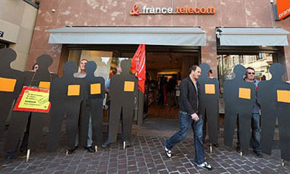
A man who hanged himself at his Brittany home has become the 25th victim of a 'suicide spiral' at France Telecom.
The former state-run company said the man was an engineer at its research and development centre in Lannion.
The employee, who was married with children, had been on sick leave for a month.
France Telecom's under-fire chief executive Didier Lombard paid a visit to the town after learning that the 48-year-old man had killed himself.
The death came two days after a France Telecom employee in Marseille was saved at the last minute from taking his life.
Unions say a drive to restructure the company in the face of the global recession is behind the deaths.
They have called for protests on October 20 to press for better work conditions.
The former-state run company laid off 22,000 workers between 2006 and 2008, while staff say changing working practices and poor management have placed intolerable pressure on workers.
The deaths include a woman who jumped from her office window in the summer, while another man survived stabbing himself in the stomach during a work meeting.
France Telecom employs around 100,000 people in France and insists the number of suicides is in line with the national average.
Mr Lombard has described the suicides as an "infernal spiral" which needed to be stopped.
The company has also blamed "copycat behaviour" for some of the deaths.
3.

T-Mobile and Orange: the winners and losers
Section: NEWS ANALYSIS
TELECOMS
It is too soon to say who will benefit most if Deutsche Telekom and France Telecom win approval to combine the T-Mobile UK and Orange UK mobile network operations, writes Ian Grant.
The proposed 50:50 joint venture company, worth some £3.5bn, would have about 37% market share in the UK.
The deal would solve a problem for De utsche Telekom, which has been seeking a buyer for underperforming T-Mobile UK for months. The latest figures from communications regulator Ofcom show that T-Mobile UK's average revenue per user is £38.50 per month — less than Vodafone (£55.50), O2 (£51.50) and Orange (£47.90).
Katja Ruud, a telecoms analyst at Gartner, says the deal would benefit T-Mobile users most as it would deliver certainty and market clou t following T-Mobile's relatively poor performance. But she warns that stronger rivals could respond by cutting their prices further. This would let them grab market share while the Orange and T-Mobile operations are rationalised and bedded down.
Hamadoun Toureé, secretary general of the International Telecommunications Union (ITU), says the merger will create a strong competitor that will force innovation in the market. The result will be more choice in mobile services and flexibility in pricing.
The deal is bad news for equipment suppliers. The telcos say they will decommission mobile sites, rationalise their retail stores and streamline operations.
It is also bad news for the UK's largest mobile network operators, Vodafone and O2. Each reportedly offered around £3.5bn for T-Mobile UK, or £210 per subscriber.
Orange and T-Mobile to merge
computerweekly.com/237599.htm

- http://www.theinquirer.net/inquirer/news/1558334/t-mobile-orange-merger-doubt

T-Mobile and Orange merger is in doubt
Antitrust scrutiny
By Rosalie Marshall
Tuesday, 13 October 2009, 08:56
UK REGULATORY AUTHORITIES might stop the deal between Orange and T-Mobile going ahead because of the dominance it would give the two firms in the mobile phone market.
According to a report in the Guardian, which cites no sources, the government is working with five of the UK’s main wireless network providers to impose limits on the amount of spectrum each operator can own.
The Office of Fair Trading will probably have to ask the EU if it can investigate the deal because Deutsche Telekom owns T-Mobile, while France Telecom owns Orange.
The report said the OFT will be given responsibility for deciding how much spectrum the networks are each allowed.
The UK mobile phone market is currently dominated by O2, which has 27 per cent of the market, followed by Vodafone with 25 per cent, and Orange with 22 per cent.
If Orange and T-Mobile merge, the partners will hold 37 per cent of the market. The government believes this percentage is too large for the competition, and that the operators may have to sell network spectrum, the report said.
Orange and T-Mobile could not immediately be reached for comment. µ

- http://www.guardian.co.uk/business/2009/sep/08/orange-tmobile-merger

Orange and T-Mobile to create UK's largest mobile phone company
• Deal expected to lead to significant job losses
• Venture will operate under one name by 2012
• 5,000 fewer mobile phone masts needed
- Comments (99)
- Buzz up!
- Digg it
- Richard Wray, communications editor
- guardian.co.uk, Tuesday 8 September 2009 12.49 BST
- Article history
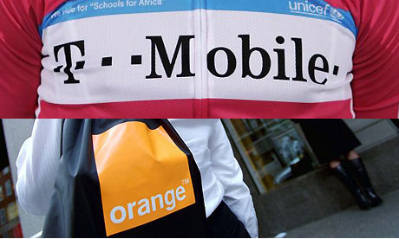
Orange and T-Mobile are currently the third and fourth-largest mobile phone operators in the UK market. Photograph: Getty Images and Newscast
Orange and T-Mobile are merging their UK operations to create the country's largest mobile phone operator, with 28.4 million customers or 37% of the market, leapfrogging rivals O2 and Vodafone.
But the deal is expected to lead to significant job losses among the combined workforce of 19,000 as the two companies rationalise their networks, axe call centre staff and close high street retail stores in pursuit of £3.5bn worth of cost savings. T-Mobile UK employs 6,400 and Orange 12,000.
It should, however, lead to a reduction in mobile phone masts, as the new venture will need at least 5,000 fewer than the two companies operate today.
'In the long-term it will push up the cost of calls'. Link to this audio
By 2012, the venture will also be operating under a single name with either Orange, owned by France Telecom, or T-Mobile, owned by Deutsche Telekom, resigned to the dustbin of British brand history. No decision will be taken on which brand is jettisoned until the merger gets clearance from European regulators, which is likely to take several months. The venture also has about a million residential broadband customers.
France Telecom's chief financial officer Gervais Pellissier said the deal would "on the one hand fundamentally change our respective positions in the UK and on the other hand bring substantial benefits to consumers in the UK". His opposite number at Deutsche Telekom, Timotheus Höttges, added that the merger was "the first step towards creating the new mobile champion in the UK".

Tough decisions
Analysts, however, remain to be convinced that the structure of the deal – in which both parents will have a 50% share – will not leave the company unable to make tough decisions if its board is split down Orange and T-Mobile lines. The two parent companies have picked board members, with Orange UK boss Tom Alexander taking the chief executive's post and new T-Mobile UK head Richard Moat becoming chief operating officer. Deutsche Telekom will pick a finance chief and a chairman – who does not get a casting vote in meetings – with France Telecom picking the venture's human resources director. Both parent companies are locked into the joint venture for at least three years.
The deal gives Deutsche Telekom a solution to its problems in the UK, where T-Mobile lags in fourth place and has consistently underperformed its rivals. It also allows Orange to improve its margins by pooling its wireless network assets with T-Mobile, having been jilted by its original network partner Vodafone in favour of O2 in March.
The deal should also cut the number of mobile phone masts in the country. Orange has 13,000 current generation – or 2G - masts and 7,000 that carry mobile-broadband – or 3G – signals. T-Mobile has 10,000 2G masts and 7,000 3G. After the deal the combined group expects to have 14,000 to 16,000 of both sorts of mast, giving it up to 32,000, or at least 5,000 fewer than today.
T-Mobile is currently sharing its 3G network with the UK's fifth-placed mobile operator 3, and that deal will be included in the joint venture. Orange, meanwhile, already provides coverage for 3's basic 2G service and Alexander explained "we are very excited about the [deal] because the specific synergies with T-Mobile and 3 are very strong". However a deal still needs to be struck with 3's owner, Hong Kong-based conglomerate Hutchison Whampoa.
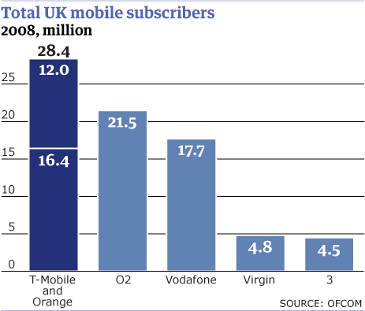Mobile_Subscribers.gif
T-Mobile also carries traffic for Virgin Mobile, which has 4.8 million customers and used to be run by Alexander, and Moat said "we have their support" for the merger. Including the Virgin Mobile customers in the figures for the merged group would give it more than 33 million customers or more than 40% of the market.

Overtures
Orange has made several overtures to Deutsche Telekom about merging with T-Mobile over the past year, all of which were rebuffed. But more recently Deutsche Telekom's management has been looking at all options for its UK operation. Last week it received highly conditional cash offers from O2 and Vodafone but the price – at about £3.5bn – was lower than chief executive Rene Obermann had hoped.
Höttges said: "We have to think about what is the best solution for the difficult UK market that we are in … we came to the conclusion that the best value for our shareholders in the short term and the long term is going to be created by this joint venture."
Some analysts wondered whether either O2 or Vodafone might return with a sweetened offer. Vodafone, however, is understood to have ruled out making a new bid and its shares rose in the morning on relief that it was not going spend its cash bailing out T-Mobile.
To create the new joint venture, Deutsche Telekom will contribute T-Mobile UK on a cash-free, debt-free basis, including T-Mobile UK's 50% holding in its 3G network joint venture with Hutchison and gross tax losses carried forward of at least £1.5bn. France Telecom will contribute the whole of Orange UK, including £1.25bn of intra-group net debt. After the deal is done, Deutsche Telekom will grant a £625m shareholder loan to the joint venture, which will be used to simultaneously reimburse £625m to France Telecom. As a result, the joint venture will have indebtedness of £1.25bn, represented by two shareholder loans of £625m. The two shareholders will receive 90% of the cash created by the venture.
The combined business would have made revenues of €9.4bn (£7.7bn) last year and profits before financial charges of €2.1bn. The merger should create annual operating cost savings of more than £445m from 2014 as a result of network and IT cuts, store closures and job cuts.
"Of course, realising the synergies there are going to be some job losses," admitted Alexander, while Moat added: "We believe there are opportunities to optimise our current workforce."
The programme of store closures and job reductions, however, will cost £600m to £800m between next year and 2014. The company will also be able to reduce its capital expenditure, not least because the two firms will need fewer new mast sites. The two companies reckon they can save £620m between 2010 and 2014, and £100m a year from 2015 onwards. Some of the cost cuts could also come from reduced need for new wireless spectrum.

Digital vision
But the deal will present some problems for the government's vision of creating a Digital Britain. That plan, released in June by then communications minister Lord Carter, included giving mobile broadband an important part to play in getting broadband services to everyone in the country by 2012. To do that, however, required the mobile phone companies to share some of their existing spectrum ahead of the sale of the old analogue TV signal and some new spectrum that is perfect for super-fast broadband over the next two years. The five networks have been locked in talks for months and the government had demanded a deal by the end of the month. Those negotiations, however, were based on their being five networks, not four, and the combined Orange/T-Mobile would break the caps on the amount of spectrum any one network can hold that were being proposed.
The deal, however, may give Orange and T-Mobile an advantage as they try to wrest Apple's iconic iPhone away from its exclusive UK network O2. Both companies have been trying to persuade Apple to expand the number of operators that can stock the phone, when O2's deal reaches its second anniversary in November.
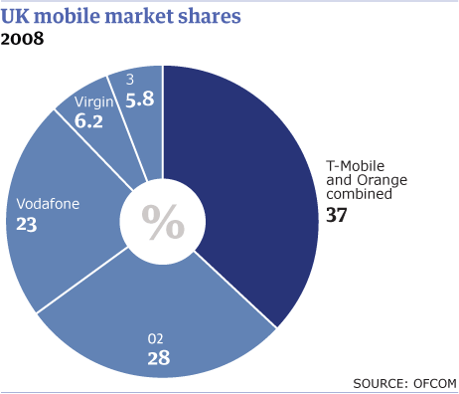Mobile_Shares.gif
France Telecom's chief financial officer Gervais Pellissier said "we are both very good partners of Apple in our domestic markets and [the merger means] we have a very good chance to be a strong partner here in the UK".

- http://wf2dnvr1.webfeat.org/7KdzM1935/url=http://web.ebscohost.com/ehost/pdf?vid=2&hid=102&sid=f0791992-16b7-4e25-9707-8e0cfc39cd77%40sessionmgr10
justin.pearse@nma.co.uk
Orange and T-Mobile merger should benefit (nearly) all
It will be at least
two years before
customers see an
impact of the
Orange and
T-Mobile merser
First Microhoo, now. T-Orange. This year is turning out to be the year of the mega-merger.
Orange and T-Mobile s tie up was certainly far less tortuous than the deal between Microsoft
and Yahoo but the T-Mobile acquisition rumour mill has been rumbling for a while now.
So what does this week's merger mean for UK consumers and for the development of the
mobile content and services market? It's unlikely to run into too many regulatory
issues. The new entity will have less than the 40% market share that would worry Ofcom
and is operating in a country long praised by European regulators for its healthy
competition. Even the loss of one mobile operator would leave the UK comparing
favourably with other territories. With the merger set to be finalised in
November and an 18-month review planned, it will be at least two years before customers see
an impact. However, it does appear to be a healthy development for the market. Both
operators were sold to heavily indebted télécoms companies - Orange to France
Telecom and 0ne20ne to Deutsche Telekom, which rebranded it T-Mobile - and this hurt
their ability to invest in new services. The creation of the new, as yet unnamed, venture
could mean an injection of capital as costs are dramatically cut thanks to operational and
technological efficiencies. The scale achieved will also help in making
deals with content giants, such as the record labels and film studios. This will be true of
negotiating handset deals with the likes of Apple, RIM and Palm too, which have become
more important for attracting subscribers and increasing the take-up of data services.
The jump in position in the UK mobile market will also give the Orange brand - which, as the
dominant UK brand of the two, surely has to win out - a better chance at a truly converged
service. Of the two, only Orange has made real strides towards a converged mobile and fixedline
content service. The one potential disaster is the vulnerable position it could leave 3 in, an
operator whose innovation in mobile date belies the influence of its small subscriber base.

7.
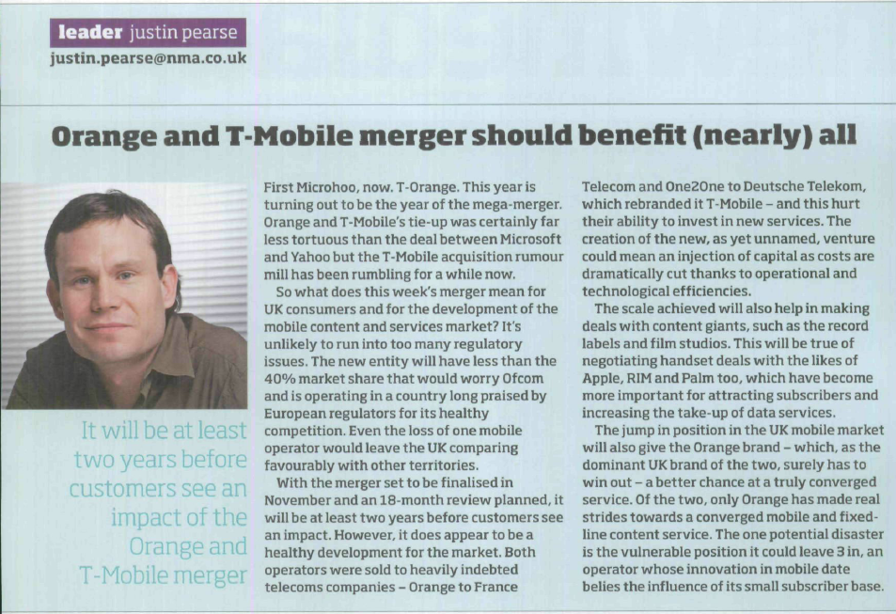

8.
T- Mobile - Group strategy.
Successful implementation of the "Focus, fix and grow" strategy continues.
Deutsche Telekom's aim is to become a global market leader for connected life and work. The company has positioned itself with this vision in the growth areas of those markets that benefit particularly from key modern-day trends: digitization affecting more and more aspects of people's daily lives, the fragmentation of daily life and the world of work and the corre­sponding personalization of services, growing mobility as well as increasing globalization and international value creation.
The continual expansion of Deutsche Telekom's powerful infrastructure, the portfolio of innovative products based on this infrastructure, consistent customer orientation and further internationalization have enabled the Group to benefit from these growth areas. To specifically meet the different requirements in the various regional and product markets, Deutsche Telekom's strategy continues to focus on four key strategic areas of action:
- Improve competitiveness in Germany and in Central and Eastern Europe
- Grow abroad with mobile communications
- Mobilize the Internet
- Roll out network-centric ICT

Improving competitiveness
In Germany as well as the Central and Eastern European markets, Deutsche Telekom is still exposed to high competitive pressure. The Group has risen to these challenges with determination, with the future firmly in mind and with a great deal of success. One example is the broadband fixed-network market. Deutsche Telekom signed up its 10 millionth DSL cus­tomer in Germany in the third quarter of 2008. The Group has acquired the highest number of new customers in the Ger­man broadband business for eight quarters running.
To deliver the same kind of success in future, Deutsche Telekom is working intensively on expanding next-generation net­works. In the fixed network, the Group is providing a growing number of towns and cities with ADSL2+ and the even faster VDSL. At the same time, Deutsche Telekom is improving its broadband mobile communications networks. "Entertain" is one of the particularly compelling products that Deutsche Telekom offers over its high-speed network. It bundles telephony, Internet and television with interactive television-based services, thus providing further differentiation from the competition. Since this summer, Deutsche Telekom has also been offering all matches of the top two German soccer leagues live via Entertain to provide a highly appealing content lineup.

In addition, Deutsche Telekom attaches a great deal of importance to improving service. After surveying almost 30,000 customers, the German Technical Inspection Association (TÜV) awarded the Telekom Shops the "TÜV Service tested" seal. The Telekom Shops scored 1.74 for overall customer satisfaction with service. In order to meet the increasing service requirements in the call centers as well, the Group intends to pool these centers throughout Germany over the next two years, additionally applying an extensive EUR 70 million modernization package.

Besides taking advantage of economic opportunities, maintaining costs at a competitive level is an ongoing task. This is the goal Deutsche Telekom is pursuing with its Save for Service program launched in 2006. There is potential for savings of between at least EUR 4.2 and EUR 4.7 billion each year by 2010. Cumulative savings of EUR 3.5 billion had already been generated by September 30,
Net revenue
Deutsche Telekom generated revenue of EUR 45.6 billion in the first nine months of 2008, a decrease of EUR 1.2 billion or 2.5 percent year-on-year. Revenue was negatively affected by exchange rate effects totaling EUR 1.5 billion. These were primarily the result of the translation of U.S. dollars and pounds sterling. Revenue growth in the Mobile Communications USA operating segment on a U.S. dollar basis was offset by negative effects from the translation into euros. Changes in the composition of the Group had a positive effect of EUR 0.7 billion, primarily resulting from the consolidation of Orange Nederland and SunCom. These positive effects were partially offset by effects of the deconsolidation of Media&Broadcast, T-Online France and T-Online Spain, which totaled EUR 0.4 billion.
The Mobile Communications Europe operating segment recorded revenue growth of 1.1 percent year-on-year in the first nine months of 2008. Changes in the composition of the Group due to the inclusion of Orange Nederland had a positive effect on the revenue development of the operating segment, offset by negative exchange rate effects as well as persis­tently fierce price competition and the resulting decline in voice revenues.
Revenue in the Mobile Communications USA operating segment was up slightly compared with the previous year. Measured in U.S. dollars, the revenue generated by Mobile Communications USA grew by 13.7 percent, primarily due to the continued increase in customer numbers in addition to the effect of the inclusion of SunCom. Negative exchange rate effects from the translation U.S. dollars into euros impacted segment revenue, however.
Revenue in the Broadband/Fixed Network operating segment decreased year-on-year by 6.6 percent, mainly due to continuing line losses and the growing popularity of complete packages and flat rate components. The revenue decline was not fully offset by growth in the number of DSL lines and leased unbundled local loop lines, also due to the reduction in prices in the broadband market.

Revenue in the Business Customers operating segment also declined. In addition to existing price and competitive pres­sure in the telecommunications services business, the deconsolidation of Media&Broadcast and the reassignment of ActiveBilling within the Group had a negative impact on revenue.

 |  |  |  |  | Third quarter of 2008 |  |  |  |  |  | First three quarters of 2008
 | Q1  2008  M€ |  | Q2  2008  M€ |  | Q3  2008  M€ |  | Q3  2007  M€ |  | Change  % |  | Q1 -Q3  2008  M€ |  | Q1 -Q3  2007  M€ |  | Change  % | FY  2007  M€
ªTotal revenue (including revenue between operating segments).
^{b}Elimination of revenue between operating segments.
Net revenue |  | 14,978 |  | 15,125 |  | 15,454 |  | 15,693 |  | (1.5) |  | 45,557 | 46,721 | (2.5) |  | 62,516
Mobile  Com Europeª |  | 4,992 |  | 5,187 |  | 5,381 |  | 5,325 |  | 1.1 |  | 15,560 | 15,388 | 1.1 |  | 20,713
Mobile  ComUSAª |  | 3,461 |  | 3,498 |  | 3,657 |  | 3,562 |  | 2.7 |  | 10,616 | 10,575 | 0.4 |  | 14,075
Broadband/  Fixed Networkª |  | 5,382 |  | 5,291 |  | 5,314 |  | 5,626 |  | (5.5) |  | 15,987 | 17,113 | (6.6) |  | 22,690
Business  Customersª |  | 2,603 |  | 2,667 |  | 2,716 |  | 2,917 |  | (6.9) |  | 7,986 | 8,785 | (9.1) |  | 11,987
Group HQs &  Shared  Servicesª |  | 884 |  | 915 |  | 928 |  | 966 |  | (3.9) |  | 2,727 | 2,906 | (6.2) |  | 3,868
Intersegment  revenue^{b} |  | (2,344) |  | (2,433) |  | (2,542) |  | (2,703) |  | 6.0 |  | (7,319) | (8,046) | 9.0 |  | (10,817)
Contribution of the operating segments to net revenue (after elimination of revenue between segments)
 | Q1 – Q3  2008  M € | Proportion  of net  revenue  % | Q1 – Q3  2007  M€ | Proportion  of net  revenue % | Change  millions of € | Change  % | FY  2007  M€
Net revenue | 45,557 | 100.0 | 46,721 | 100.0 | (1,164) | (2.5) | 62,516
Mobile Comm. Europe | 15,047 | 33.0 | 14,856 | 31.8 | 191 | 1.3 | 20,000
Mobile Comm. USA | 10,606 | 23.3 | 10,556 | 22.6 | 50 | 0.5 | 14,050
Broadband/  Fixed Network | 13,285 | 29.2 | 14,409 | 30.8 | (1,124) | (7.8) | 19,072
Business Customers | 6,151 | 13.5 | 6,606 | 14.1 | (455) | (6.9) | 8,971
Group Headquarters & Shared Services | 468 | 1.0 | 294 | 0.7 | 174 | 59.2 | 423
With 33.0 percent, the Mobile Communications Europe operating segment provided the largest contribution to the net revenue of the Group. While the Mobile Communications Europe and Mobile Communications USA operating segments increased their contribution to net revenue year-on-year, the contributions by the Broadband/Fixed Network and Business Customers operating segments decreased.
Breakdown of revenue by regions
The proportion of net revenue generated outside Germany in the first nine months of 2008 increased by 1.9 percentage points compared with the prior-year period to reach 52.6 percent. The reason was the decrease in domestic revenue, pri­marily in the Broadband/Fixed Network and Business Customers operating segments.

 |  |  |  |  | Third quarter of 2008 |  |  | First three quarters of 2008
 | Q1  2008  M€ |  | Q2  2008  M€ |  | Q3  2008  M € | Q3  2007  M€ | Change  % | Q1 -Q3  2008  M€ | Q1 -Q3  2007  M € | Change  % | FY  2007  M€
Net  revenue |  | 14,978 |  | 15,125 | 15,454 | 15,693 | (1.5) | 45,557 | 46,721 | (2.5) | 62,516
Domestic |  | 7,254 |  | 7,184 | 7,158 | 7,609 | (5.9) | 21,596 | 23,026 | (6.2) | 30,694
International |  | 7,724 |  | 7,941 | 8,296 | 8,084 | 2.6 | 23,961 | 23,695 | 1.1 | 31,822
Proportion  generated  internationally % |  | 51.6 |  | 52.5 | 53.7 | 51.5 |  | 52.6 | 50.7 |  | 50,9
Europe  (excl. Germany) |  | 4,144 |  | 4,318 | 4,510 | 4,383 | 2.9 | 12,972 | 12,761 | 1.7 | 17,264
North America |  | 3,460 |  | 3,497 | 3,642 | 3,597 | 1.3 | 10,599 | 10,636 | (0.3) | 14,159
Other |  | 120 |  | 126 | 144 | 104 | 38.5 | 390 | 298 | 30.9 | 399

Overall economic situation/ industry situation.
Global economic development
The global economy has been witnessing a substantial slowdown since early 2008. The downturn gained momentum glo­bally in the third quarter of 2008. This was caused by the inflationary push fuelled by commodity prices and the extensive corrections in the housing and financial markets. The current deterioration of the financial market crisis has also worsened the economic outlook. In their "Joint Economic Forecast Fall 2008" the leading German economic research institutes cut their expected 2008 growth figure for gross domestic product in Germany to 1.8 percent. The International Monetary Fund (IMF) has cut its forecast for global economic growth this year to 3.9 percent.
Overall economic risks
Inflationary pressures have eased off over the past few months thanks to a sharp decline in commodity prices. The main risk facing the global economy is the extent and duration of the financial market crisis and the scale of the impact on the real economy, along with the willingness of consumers to buy and businesses to invest.
Outlook
The economy may move into a phase of recession in the majority of industrialized nations. Most economic indicators point to a downturn in the United States. The leading eurozone indicators have also fallen sharply over the past few months; con­sumer and investment sentiment is at its lowest level for many years. The "Joint Economic Forecast Fall 2008" pegs growth at just 0.2 percent for German gross domestic product in 2009. The IMF forecasts a further slowdown in growth in the glo­bal economy to 3.0 percent for 2009. Both studies assume the global economy could gradually recover from mid-2009, with the banking sector stabilizing as a result of the joint rescue packages adopted by the industrialized nations.
Telecommunications market
The price index for telecommunications services in Germany issued by the Federal Statistical Office also points to a further reduction in consumer prices in the third quarter of 2008. The consumer price index for fixed network and Internet decreased to 94.5 in September 2008, compared with 98.6 in September 2007. The consumer price index for mobile communications decreased from 89.0 in September 2007 to 86.9 (base 100 in 2005).
According to a study carried out by the Association of Telecommunications and Value-Added Service Providers (VATM) on the telecommunications market in 2008, revenue from telecommunications services in Germany will total some EUR 60.6 billion in 2008, a year-on-year decrease of 4.1 percent, which is essentially due to prices being reduced by competition both in the fixed and mobile networks. The VATM currently believes the financial market crisis will not impact the telecom­munications sector. Based on a recent survey (October 2008), Bitkom also expects the financial market crisis to have hardly any impact on the German IT and telecommunications market.

Regulatory situation
Reform of the EU regulatory framework (EU Review).
At a first reading on September 24, 2008, the European Parliament discussed a whole range of reform proposals relating to the telecommunications regulatory framework. The idea is to promote investment in new superfast fiber-optic access net­workswhile ensuring competition based on unrestricted third-party access to new infrastructures. The European Parliament has made proposals on promoting investment in fiber-optic lines. However, these proposals do not include any clear state­ments on the distribution of the digital dividend. This issue is largely regarded as falling within the competency of national governments. The Commission's proposals are currently being reviewed by the Council.
Geographic differentiation.
Following the model adopted by other European regulatory authorities, the Federal Network Agency is looking at easing existing nationwide regulation of IP bitstream. In regions with intense competition from local-loop operators and cable-TV providers, regulation of IP bitstream could then be pared back. The relevant regulatory process is currently underway. A decision from the Federal Network Agency is expected in January/February 2009.
Charges approved for carrier leased lines at the end of September 2008.
In a resolution dated September 30, 2008, the Federal Network Agency re-approved the charges for carrier leased lines. The charges remain unchanged, with one exception. The Federal Network Agency has reduced the charges for carrier leased lines with a transmission bandwidth of 2 Mbit/s by 11 percent across the board. All charges have been approved for six months through March 31, 2009. Further proceedings regarding carrier leased line charges are currently pending, the outcome of which will also be felt beyond March 31, 2009. The rate ruling for carrier leased lines was received on Oc­tober 31, 2008. The approval applies from January 1, 2009 until Oktober 31, 2010. This supersedes the decision of the Federal Networks Agency of September 30, 2008 and reduces the period of Validity of the approval from six months to three months, i.e., from October 1, 2008 to December 31, 2008. The ruling of October 31, 2008 is currently being analyzed.
Legal situation
Ruling by the Federal Administrative Court on charges for the provision of subscriber data strengthens Deutsche Telekom's position.
Deutsche Telekom AG is permitted to impose charges for the provision of so-called additional data of Deutsche Telekom AG's telephone customers and for third-party data. As before, Deutsche Telekom can still only charge for transport costs for the basic data of is own customers. In the reasons for its ruling, the Court stated that the standard upon which the ruling was based, whereby the recipients of the data could only be charged for the costs for the pure transportation of the data, only applied to the basic data (name, address and telephone number) of Deutsche Telekom AG's own customers. This stan­dard does not apply, however, to charges for the provision of additional data relating to Deutsche Telekom AG's telephone customers and to subscriber data of other network operators.
Deutsche Telekom intends to introduce a new price model on the basis of the ruling. In addition, Deutsche Telekom AG in­tends to orient the prices that will be charged retroactively from August 2005 towards the principles set out by the Federal Administrative Court in the reasons for its ruling. Comprehensive analyses are still necessary.

Mobile Communications Europe
T-Mobile UK exclusively launches the Google Android cell phone T-Mobile G1.
On October 30, 2008 T-Mobile UK became the first European T-Mobile company to exclusively market the state-of-the-art and much-coveted Google Android cell phone T-Mobile G1. Approximately 25,000 customers had placed advanced orders before marketing even began. This handset takes T-Mobile on a whole new course in mobile communications. The T-Mobile G1 combines high-speed access to the mobile Internet with the Android open source mobile software which gives customers unrestricted access to applications and free software developed by third parties. It will be launched from the first quarter of 2009 in other European countries including Germany, Austria, the Czech Republic and the Netherlands.
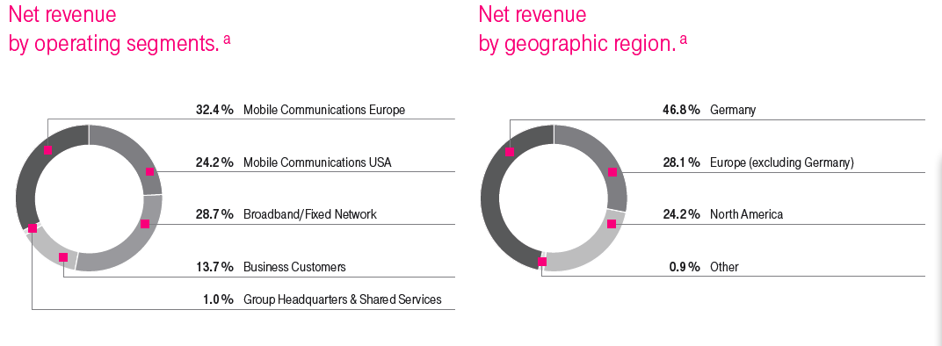
Group Headquarters & Shared Services.
Group Headquarters & Shared Services performs strategic and shared management functions for the Deutsche Telekom Group and is responsible for operating activities that are not directly related to the core business of the Group. The Shared Services unit mainly consists of Real Estate Services, DeTeFleetServices GmbH – a full-service provider of fleet management and mobility services – and Vivento. Vivento is responsible for providing employees with new employment opportunities as part of the workforce restructuring program.

(http://www.interimreport.telekom.de/site0308/en/kb/konzernstrategie/index.php)

9.

ORANGE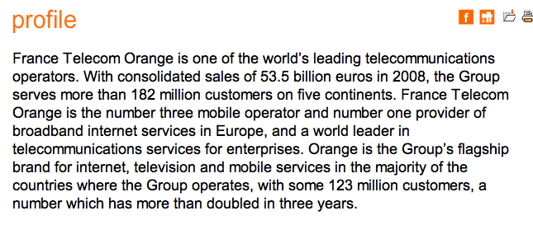

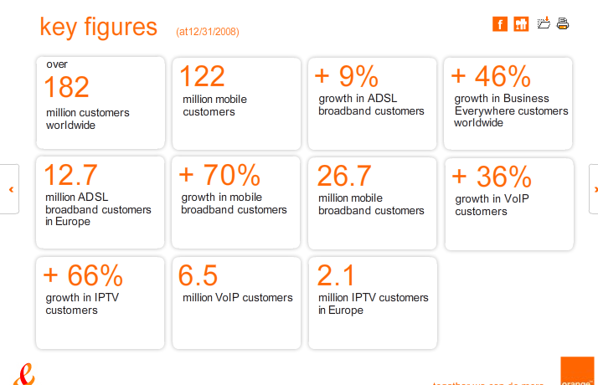

UK: Fixed, Mobile & internet

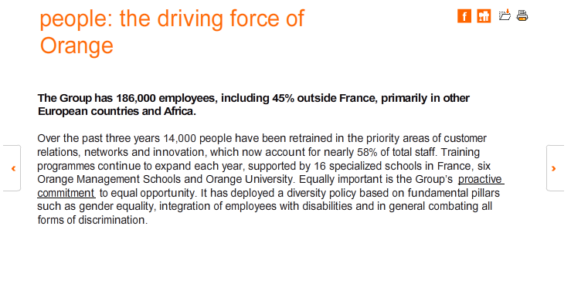

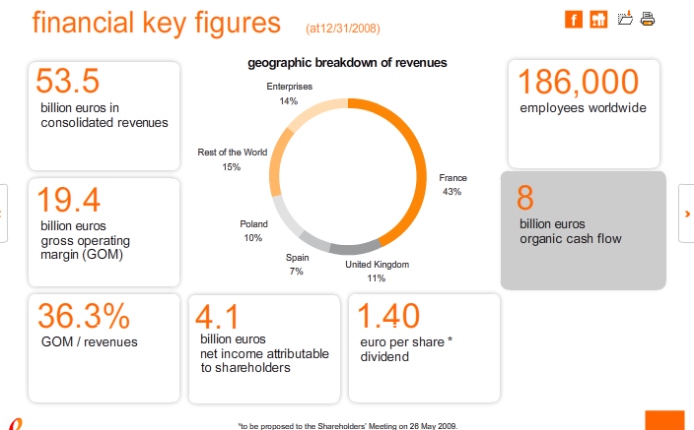

10.
T-Mobile finds a new way to satisfy customers: redesigning their bills

The issue
Two years ago, T-Mobile realised it had a serious problem. Customer satisfaction surveys ranked its phone bills worst in the industry and bill-related queries were clogging up the company’s helpline.
T-Mobile’s situation wasn’t unique – but its solution was. Few sectors have witnessed so many radical changes as quickly as the mobile phone industry. Just a decade ago, mobiles were used only for calls, but with the huge increase in available functions (roaming, texting, 3G) billing has become more complex, while understanding charge breakdowns has become increasingly challenging for customers.
The solution
T-Mobile gave direct marketing agency Tullo Marshall Warren and information design specialists Boag Associates a simple brief – make the bill design as clear as possible to ensure customers can understand information quickly and properly.
It wasn’t the first time a mobile phone company had sought salvation in improved information design. In 2005, Vodafone revamped its bills, which led to vastly improved customer satisfaction and a 35% reduction in paper use. Information design has also been employed successfully by Royal Mail and various energy suppliers. Andrew Boag, director of Boag Associates, didn’t underestimate the magnitude of the task. “We knew the biggest challenge would be achieving a solution that would be colourful and an excellent manifestation of the brand – while working within the constraints of black-only print.”
Fortunately, T-Mobile had already conducted research that identified a number of customer needs and Boag says it soon became clear which design tools could meet them. What he proposed was revolutionary for the telecoms sector. The new bills would include visual snapshots of usage in the graphical form of pie charts and graphs. Boag says: “While there are examples of graphs being used on bills in other countries, ours were the first to be used on a mainstream mobile phone bill in the UK.”
Further changes included better signposting, improved space utilisation, layout and information delivery, as well as “bringing the T-Mobile brand experience to life on the bill” by being “honest and straightforward” and “dynamic” in its look and feel.
The outcome
The new bill was launched in November 2006 and it proved an instant hit. Bill-clarity satisfaction increased by the target 10% over 12 months and unnecessary bill-related helpline calls fell substantially, with those from new customers decreasing from 31% to 22%. The new bill’s clarity meant customer service representatives dealt with calls much more rapidly and 28 staff were redeployed elsewhere in the business.
T-Mobile’s product manager of billing, Paul Harrison, believes the company’s new bills exceed the level reached by Vodafone: “The new bills are highly user-friendly and make it significantly easier for customers. The use of graphs helps T-Mobile explain what would otherwise be a complex system for customers to understand.”
Boag says many companies still underestimate the role documents play in a customer’s brand experience: “Well-designed information documents are a manifestation of a brand that is straightforward, transparent and clear. Information documents that are not well-considered represent the brand as disorganised and uninterested in its customers.”

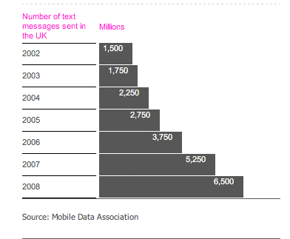

11.

T-Mobile corporate headquarters, BonnT-Mobile is a subsidiary of Deutsche Telekom and belongs to the FreeMove Business alliance.
T-Mobile is a group of mobile phone corporate subsidiaries (all under the ownership of Deutsche Telekom) that operate GSM and UMTS networks in Europe and the United States. The T stands for Telekom. T-Mobile also has financial stakes in mobile operators in Central and Eastern Europe. Globally, T-Mobile has some 150 million subscribers [1], making it the world's eighth largest mobile phone service provider by subscribers and the third largest multinational after the United Kingdom's Vodafone and Spain's Telefónica. T-Mobile USA is the fourth largest wireless telecommunications network in the U.S. market with 33.5 million customers after Verizon Wireless, AT&T Mobility, and Sprint Nextel. T-Mobile International has a substantial presence in eleven European countries (Austria, Croatia, Czech Republic, Germany, Hungary, Macedonia, Montenegro, the Netherlands, Poland, Slovakia, and the United Kingdom) as well as in the United States.
In late 2005, Deutsche Telekom attempted to acquire rival mobile network operator O2, but was beaten out by Spain's Telefónica[2].
In March 2008, the company announced they planned to acquire Siemens Wireless Modules (now known as Cinterion Wireless Modules) as part of the JOMA consortium. The Siemens Wireless Modules spin off to Cinterion Wireless Modules was concluded on May 1, 2008.
The T-D1 logo and brand used in Germany beginning in the mid-1990s for Telekom's GSM network, known in Germany as the D-Netz.

Initial 1984 logo of the analog C-Netz, the first-generation analog mobile phone system that was the predecessor of DeTeMobil and T-Mobile
In Germany, its home market, T-Mobile is the largest mobile phone operator with almost 36 million subscribers (As of January 2008), closely followed by its primary rival, Vodafone. The highly profitable GSM network in Germany is scheduled to be supplemented and ultimately replaced by UMTS, for which T-Mobile spent EUR 8.2 billion in August 2000 to acquire one of the six licenses for Germany.
On July 1, 1989, West Germany's state-owned postal monopoly, Deutsche Bundespost (DBP) was reorganized, with telecommunications consolidated in a new Deutsche Bundespost Telekom unit; this was renamed Deutsche Telekom in 1995, and began to be privatized in 1996.
The analog first-generation C-Netz ("C Network", marketed as C-Tel) was Germany's first true mobile phone network (the A and B networks, also owned by the post office, had been previous radiotelephone systems), and was introduced in 1985. Following German reunification in 1990, it was extended to the former East Germany.
On July 1, 1992, the Deutsche Bundespost Telekom began to operate Germany's first GSM network, along with the C-Netz, as its DeTeMobil subsidiary. The GSM 900 MHz frequency band was referred to as the "D-Netz", and Telekom named its service D1; the private consortium awarded the second license (formerly Mannesmann, now Vodafone) chose the equally imaginative name D2. In 1996, as Deutsche Telekom began to brand its subsidiaries with the T- prefix, the network was renamed T-D1 and DeTeMobil became T-Mobil; the C-Netz, in the process of being wound down, was not rebranded, and was shut down in 2000. In 2002, as Deutsche Telekom consolidated its international operations, it anglicized the T-Mobil name as T-Mobile, although sometimes also using the name T-D1 within Germany. It is still common for Germans to refer to T-Mobile and Vodafone as D1 and D2.
D1 introduced short message service (SMS) services in 1994 and began a prepaid service, Xtra, in 1997.[3]
Austria, Croatia, Czech Republic, Hungary, Macedonia, Montenegro, Netherlands, Poland, Slovakia, United States,
United KingdomFormer One2One
T-Mobile UK started life as Mercury One2One, a GSM mobile network operated by the now-defunct Mercury Communications.[10] Later known simply as One 2 One, it was the world's first GSM 1800 network[11] when it was launched in September 1993. In its final days it was operated as a joint venture between Cable and Wireless and American cable provider Mediaone Group, which had a number of investments in Britain dating back to its days as the US West Media Group. One 2 One was purchased by Deutsche Telekom in 1999[12] and rebranded as T-Mobile in 2002.[13]
T-Mobile offers both pay-as-you-go and pay-monthly contract phones. The pay-monthly contracts are branded as 'Flext', which gives the consumer a monetary allowance to use each month, and 'Combi', which works as many other contracts in giving the consumer a fixed amount of minutes and SMS messages. The network also offers other contract options for off-peak users and customers who call within network predominantly, together with 'boosters', which can be added on to a contract to save each consumer money depending on how they use their phone. T-Mobile launched their 3G UMTS services in the Autumn of 2003.
On 12 December 2007, it was confirmed that a merger of the high-speed 3G and HSDPA networks operated by T-Mobile UK and 3 (UK) was to take place starting January 2008. This will leave T-Mobile and 3 with the largest HSDPA mobile phone network in the country, with a theoretical maximum speed of 6.5 Mb/s, rising to 7.2 Mb/s over the course of the year.
On September 8, 2009 France Telecom's Orange and T-Mobile parent Deutsche Telekom announced they were in advanced talks to merge their UK operations to create the largest mobile operator with 37% of the market. It is unclear the long-term future of either brand when such deal is completed in November, although both brands will be maintained for the first eighteen months at least. [14]

In addition to mobile phone service, T-Mobile also operates WiFi hotspots in the United States and Europe. In the USA alone, it operates over 8,000 (as of December 22, 2006) T-Mobile HotSpot locations for Internet access, including such locations as airports, airline clubs, Starbucks coffeehouses (see below), Kinko's, Borders Books and Music, Hyatt, and Red Roof Inn Hotels. The U.S. WiFi infrastructure was completely replaced when T-Mobile bought the Wireless ISP MobileStar. In addition, Sony Computer Entertainment on behalf of T-Mobile introduced a HotSpot Locator and HotSpot Promotional Period (6 months from activation) for the Sony PSP system and Sony Mylo system. Both promotions are separate, and, by combining the total time allotted for each system, users can have up to one year free access, by using six months on the Mylo, and six months on the PlayStation Portable.
Beginning the second quarter of 2008, T-Mobile will no longer be the provider of Wi-Fi access for Starbucks coffeehouses, which ended its 2001 deal, switching to AT&T.[18] However, through a roaming agreement with AT&T, T-Mobile HotSpot subscribers will still be able to use the AT&T Starbucks wireless networks for a limited time.[19]
Statistics of Deutsche Telekom's GSM networks
[clarification needed]
- All T-Mobile networks (including affiliates and minority owned): 148.4 million (as of March 2009)[20]
[edit]
T-Mobile branded networks (March 31, 2009)
Location | Subscribers
Austria | 3.3 million
Croatia | 2.8 million
Czech Republic | 5.4 million
Germany | 39.0 million
Hungary | 5.3 million
Macedonia and Montenegro | 1.9 million
Netherlands | 5.2 million
Slovakia | 2.3 million
United Kingdom | 16.7 million
United States | 33.2 million
Total | 115.2 million

Mobile operators in which T-Mobile has a substantial stake
Albania — | AMC¹
Bulgaria — | GLOBUL¹
Bosnia and Herzegovina — | HT d.d. (ERONET)
Greece — | Cosmote¹
Poland — | Era - over 13 million customers
Romania — | Cosmote¹
- ¹ Deutsche Telekom and Greece each have 25 percent plus one of the shares of parent company OTE.
A T-Mobile liveried Ayats Bravo coach used in a World Cup promotion in partnership with UK mobile retailer Phones4u.

Facts and figures
Here are our vital statistics. These should help paint a picture of the size and scope of T-Mobile and where our strengths lie.
- Winner: Online Retailer of the Year (Mobile Choice Awards 2007)
- Winner: Consumer Operator of the Year (Mobile Awards 2007)
- Winner: Tariff Deal of the Year with Flext (Mobile Consumer Choice Awards 2006)
- Over 17 million customers
- Almost 6000 employees
- 275 stores across the UK
- 2G network covering 99% of the population
- 3G network covering 84% of the population – near complete population coverage for 3G services by the end of 2008
- The world’s largest worldwide WiFi network with over 1,200 HotSpots in the UK and 21,000 worldwide
- The world’s largest GPRS roaming footprint covering 27 countries
Head Office in Hatfield, Hertfordshire
Advice for parents
Mobiles offer customers more and more services - from games and videos to chatrooms and internet access. As a parent or carer, you may have concerns about your children coming into contact with unsuitable communication.
Making sure children can use mobiles safely is a top priority for us. We're committed to developing safety features such as Content Lock in all our services. We're also a member of several cross-industry organisations and have signed a key EU agreement pledging to make mobiles safer for children.
Our Network
We currently have more than 16 million customers in the UK and this number is growing every day. To ensure our network can cope with increasing demand, we sometimes need to expand the capacity of existing base stations and, where necessary, build new ones.
Our safety measures
We take every precaution in building our network safely and responsibly. This goes beyond fulfilling our legal obligations and includes:
- Adhering to the Mobile Operators Association's Ten Commitments to best sitingpractice
- Operating at the more stringent public exposure guideline levels set by the International Commission on Non-Ionising Radiation Protection (ICNIRP)
- Adhering to the national and international safety guidelines set by Ofcom
- Funding research into the potential impact of mobile phones and base stations on public health
Minimising the impact of our network
We know some people are concerned about the health and visual impacts of base stations and masts. We treat these concerns very seriously and strive to balance the needs of our customers with the wishes of the wider community.
We always aim to make the least impact possible by:Working with local councils when we construct new base stationsSharing sites with other mobile operatorsInstalling antennas on existing structures like buildings, telegraph poles, lamp posts and telephone boxes. Currently about two thirds of our antennas are on shared sites and existing structures.If a conflict does arise, our dedicated community affairs team works through it with the community involved.
Your healthRadio waves have been used commercially for over 70 years and their potential effects on human health have been researched extensively.
We follow strict international safety guidelines based on this research and constantly monitor any new findings on the health and safety of mobile phone networks.
What the experts sayAs research into radio waves and their effects continues, the mounting evidence suggests that the risk to the community from radiation is very low.
The Stewart Report, a major piece of UK research undertaken by the Independent Expert Group on Mobile Phones (IEGMP) in May 2000, says evidence to date suggests:
- Exposure to RF (radio frequency) radiation below National Radiological Protection Board and International Commission on Non-Ionizing Radiation Protection (ICNIRP) guideline levels, doesn't cause adverse health effects
- There's no general risk to the health of people living near base stations where exposure is only a small fraction of the guideline limits
In 2004, the Advisory Group on Non-Ionising Radiation (AGNIR) published a comprehensive review of worldwide research undertaken since the Stewart Report which concluded that:
- Exposure levels from living near mobile phone base stations are extremely low
- Overall evidence indicates that exposure is unlikely to pose a health risk
Our safeguards
Our industry is strictly regulated to make sure the public is protected.
We've always operated our network within the stringent public exposure guidelines set out by the ICNIRP, which puts acceptable radio wave limits at:
- 9W/m2 at our 2G operating frequency of 1,800MHz
- 10W/m2 at our 3G operating frequency of 2,100MHz
As an additional safeguard, the Office of Communications conducts random checks on our operational base stations across the UK.

Phone recycling
Get up to £150 for your old phone*
Using mobiles safely
The law on driving and mobilesUsing a mobile while driving is against the law. If caught, you will receive either three penalty points and a £60 fine or a fine of up to £1,000 if the matter goes to court. For more information, visit www.thinkroadsafety.gov.uk
You should only use a hands-free kit or an earpiece if it is safe to do so. Your nearest T-Mobile store has a great range of accessories including car-kits, earpieces and the latest Bluetooth hands-free devices.
Protecting children from adult content We are serious about protecting children from exposure to inappropriate material and we were a driving force in drawing up the Mobile Industry Code of Practice, published in January 2004.
We also signed the European Framework for Safer Mobile Use by Younger Teenagers and Children in February 2007.
And our Content Lock technology stops under 18s and customers who have not opted for full content from accessing content and services which are defined as 18+.
Dealing with spam Unwanted sales calls and texts from dubious companies are irritating and, in the case of texts, illegal, but there are steps you can take to prevent them and processes for lodging complaints. We can't prevent unwanted sales calls directly, but you can register with the Telephone Preference Service. Telemarketing companies are obliged by law to check the TPS register, and must not call anyone listed.
If you've already registered with the TPS and wish to take the matter further, contact the Information Commissioner or your local Trading Standards Office.
Sending unsolicited promotional text messages is against the law. If you want to lodge a complaint about receiving them, please contact the Information Commissioner.
If the message contains a premium rate number you should contact: PhonepayPlus which is the organisation that regulates products or services - such as competitions, TV voting, helplines, adult entertainment, downloads, new alerts or interactive games - that are charged to users' phone bills or pre-pay accounts.
2008 Corporate Responsibility Performance Data
T-Mobile UK 2008 Corporate Responsibility Performance Data | 2008 | Notes
Total energy consumption (offices, stores and switch sites) | 92,712,291 kWh
Tonnes of CO2 emissions from energy use (excl. vehicles) | 48,488 Tonnes | We reduced our carbon footprint in 2008 from our corporate buildings ( our Head Office at Hatfield, and our 3 Contact Centres ) by 9.24% against 2007  Calculated using DEFRA conversion factors
Total weight of waste | 1,985 Tonnes
Total paper usage | 11.9 million sheets | 32% reduction against 2007
% of waste recycled or reused | 49% | Increase of 31.4% against 2007
Total water consumed | 152,151 m3
Number of environmental fines and number of non-monetary sanctions | 0
2008 Corporate Responsibility Performance Data

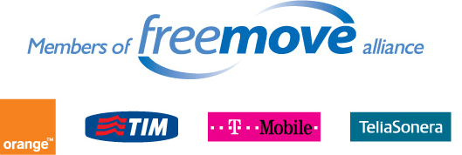
In order to offer its customers a customized mobile communications package abroad as well, T-Mobile International set up the FreeMove Alliance with other mobile communications companies in 2004. T-Mobile International's current partners include Orange, Telia Sonera and Telecom Italia Mobile.
The FreeMove alliance members are all highly-experienced, leading operators in their national markets, providing excellent coverage across Europe. Our alliance combines our coverage and individual strengths to bring superior and simplified services to multinational corporations. Our international reach enables you to standardize your procurement at an international level, improving both the management and efficiency of your mobile services. Our local expertise also enables us to provide you with the most relevant, tailored and cost-effective services for your business.
By working with T-Mobile (and FreeMove), you can consolidate your Europe-wide requirements within one organization, thus ensuring centralized and more streamlined mobile services.
Four leading operators. One simple idea. Discover mobility without complexity.
Simple cost-effective roaming. Centralised reporting. Single point of contact.
When your employees are based all over the world, efficient mobile communications are vital. FreeMove International Roaming offers predictable and transparent prices for roaming and international calls.
The FreeMove alliance members European footprint covers nearly 260 million customers across 31 countries. With worldwide member operations extending to 58 countries with over 390 million customers globally, FreeMove has the largest combined footprint.
About FreeMove
FreeMove was founded in 2003 by four of Europe’s leading mobile operators. We shared a vision that everyone in business should be free to travel without restriction or compromise. That mobile technology should either be invisible or a life-saver, never a nuisance or a hassle. Critically, this should go for the professionals that manage company mobile services just as much as it does for the employees who use those services.
We realised that international mobile services could be greatly improved and made even more affordable. So we established a cross-company association that we called FreeMove. In Europe FreeMove member operations extend to a total of 30 countries with over 360 million customers worldwide.
FreeMove is more than just a brand name. As an international alliance of leading mobile operators we combine global thinking with local understanding. This means you get products and services that suit your business, your employees and your location.
The alliance is a legally incorporated entity with a clearly defined corporate governance structure and is headed by board members of the four operators, namely:
Olaf Swantee (Orange), Carlos Lambarri (TIM), Philipp Humm (T-Mobile) and Kenneth Karlberg (Telia Sonera).
More importantly, we have a long-term strategy to develop services and capabilities that provide real benefits to our customers, whether they are global multinationals with complex business requirements or travellers trying to call home to say goodnight to their children.

ANALYSIS

12.

Orange is the key brand of France Telecom, one of the world's leading telecommunications operators.

The Group had consolated sales of 53.5 billion euros in 2008 and a customer base of 186 million customers in 30 countries at 2009, June 30. Orange, the Group's single brand for Internet, television and mobile services in the majority of countries where the company operates, now covers more than two-thirds of customers. At the end of June 2009, the Group had 125,5 million mobile customers worldwide and 13,4 million broadband internet (ADSL) customers in Europe.

France Telecom-Orange is the number three mobile operator and the number one provider of broadband internet services in Europe and, under the brand Orange Business Services, is one of the world leaders in providing telecommunication services to multinational companies.

The Group's strategy, which is characterized by a strong focus on innovation, convergence and effective cost management, aims to establish Orange as an integrated operator and benchmark for new telecommunications services in Europe. Today the Group remains focused on its core activities as a network operator, while working to develop its position in new growth activities. To meet customer expectations, the Group strives to provide products and services that are simple and user-friendly, while maintaining a sustainable and responsible business model that can be adapted to the requirements of a fast-paced and changing eco-system.

The Orange brand represents what we believe in and guides everything we do.

Technology continues to offer people new ways to share experiences as the borders between us are pushed away.
The world around us has become more connected, and we’re more empowered to change things for the better - together. While staying true to our values, this insight about the power of community and making it accessible to everyone, has given us the opportunity to capture the imagination and bring people together in simple and human ways. Over the coming months and years our brand will continue to expand into more markets across the globe as we take our customers on a journey into new services and media. Building a trusted brand is one of our five key strategic priorities alongside growth, innovation, efficiency and quality.

The achievement of the 2006-2008 NExT plan (New Experience in Telecoms) confirms the success of France Telecom-Orange's profound business transformation. Despite the rapidly changing environment, this has produces stronger growth, steady operating profitability and has demonstrated the Group's ability to reduce costs while respecting its values and without any reduction in its dynamism.

a strategy announced in 2005
The strategy announced in 2005 is based on: the convergence of networks and services, the migration to the internet and the associated services (such as VoIP and IPTV), the increased contribution of new growth activities (such as content, online advertising, e-health), the internationalisation of the Group under the Orange brand (123 million customers at the end of 2008 out of a total of more than 182 million worldwide).

achievements
Over the NExT period, the Group exceeded its targets for organic cash flow generation achieving 8 billion euros in 2008. At 1.85, the Group's debt-to-equity ratio is amongst the lowest in the sector today; during the same period its dividend increased by 39%.

Orange 2012 is a confirmed strategy and new action plans.

simplicity
To help customers address the profusion of technologies and provide accessible services to as many as possible, Group innovation will concentrate on simplicity, ergonomics and design, as well as quality of service both in terms of products and services and the "customer experience". In this way, France Telecom-Orange will open a new era of "pacified" or trouble-free technology for its customers.
The initiatives in this field include a particular focus on patents aimed at simplifying product usage, the creation of a dedicated, integrated design and ergonomics team, generalising usage tests, improving call centre procedures or launching customer care and backup products.

read more about innovation

agility
Against a backdrop of extremely rapid change, the Group will rationalise its offers so as to accelerate its time to market and seize new opportunities. This move to increase flexibility in the business will also entail initiatives to drive further the Group's transformation and optimise its cost structure.
Similarly, in light of the tecnological infrastructure developments (fibre optics, HSDPA and eventually LTE) expected to occur in the coming years, the Group will pursue a deployment strategy taking into account the regulatory environment and the speed of the adoption in the market.

read more about networks and IT
read more about finance

sustainable performance
Orange 2012 also aims to capitalise further on synergies available across the Group's geographic footprint and to complete the roll-out of the integrated operator model: this will include further sharing of networks, information systems and platforms, the extension of innovative initiatives to the greatest possible number of markets and the extension of the Orange brand.
With an acceleration in the number of employees retiring from the Group in France in the medium term, France Telecom-Orange intends to bring forward recruitment for key business areas by applying existing internal and external mobility programmes.

have a look on the join us section

France Telecom-Orange will reinforce its Corporate Social Responsibility activities in order to provide maximum access to the widest range of digital technologies, contribute to environmental protection (in particular by reducing the Group's energy consumption) and provide solutions to social questions such as the security of personal data and child protection.

organisation serving the strategy
In 2006, a new structure was implemented to support the group's transformation. This is based on two principles: make the customer the central priority of each and increase the group's efficacy by using a matrix structure.

a tight-knit and international organisation

Operating management
France
United Kingdom
Spain
Poland
Europe, Middle East and Caribbean
Africa, Middle East and Asia
Enterprise
Business segments
personal communication
services
home communication
services
enterprise communication
services
content
health
audience and advertising
Group functions
company secretariat
strategic marketing
finance
networks, operators and
information systems
human resources
group transformation
and purchasing
communication and brand

operating management
The group's operating activities are organised by geographic zones. These are composed either by country, by groups of countries, or worldwide for enterprise business customers. Their mission is to closely coordinate all customers’ activities and adapt the overall strategy to the requirements of the local markets.

business segments
The convergence of services accessible on fixed lines, mobiles and the Internet and the distribution of content on all platforms characterise the group's innovation and strategy. The personal communication services, home communication services and enterprise communication services are directing the group’s global strategy in terms of customer offers. Content and healthcare departments lead these new business territories.

Group functions
These are responsible for defining an overall strategy for the group and providing direction for each area (networks, operators and information systems, human resources, communication, etc.). In particular, they determine common rules of operation, combine the group's resources and expertise and centralise the strategic functions (finance, marketing, purchasing, etc.) Such an organisation promotes both synergy and cost reductions.

governance serving performance

Governance principles have an impact on all levels throughout the business, rallying all members of staff around an integrated approach.The values and principles guiding group's actions, expressed in the Code of Ethics, reflect its commitment to contributing to sustainable development through its present and future activities.

They express its corporate responsibility, looking beyond the group's legal and regulatory obligations, based on respect for all stakeholders.

the Group Management Committee In January 2006, a strengthened executive management committee, made up of nine members, including the Chairman-Chief Executive Officer, was put in place with clearly identified responsibilities. The executive management committee is responsible for implementing the group’s transformation programs and strategy, and overseeing efforts to monitor its operational and financial performance levels. It represents the management decisionmaking body for the group.

responsibility
message from Didier Lombard,
Chairman and Chief Executive Officer
In the current economic environment, our practice of corporate social responsibility is more than ever at the core of our business strategy.

Our priorities can be summarized in three words:
include, preserve, care.

Our approach to corporate social responsibility and sustainability greatly contributes to the Group's overall performance by promoting the creation of long-term value. This enables us to better manage our risks, it pushes us to innovate and allows us to seize the opportunities for growth linked to society's latest expectations. It also helps to optimize our internal operating methods, making us more efficient.

We have defined an ambitious strategy to become the leading telecommunications operator in terms of corporate social responsibility by 2012.

In more tangible terms, one of our priorities for 2009 will be to strengthen our offerings of “responsible” products and services, to help our customers meet sustainability challenges.

I invite you to read this report to learn more about our accomplishments and our goals for the upcoming years!

news:
Orange launches a phone particularly suitable for senior citizens (2009/09/21)
INSEAD and France Telecom-Orange establish ‘The INSEAD Orange Endowed Scholarship for Emerging Markets’ (2009/07/17)
Orange shows corporate responsibility with its new eco-citizen offers (2009/06/22)
Orange is launching the first mobile service in France aimed at beneficiaries of the Revenu de Solidarité Active (Earned Income Supplement) (2009/05/12)
Orange launches “Hello”, the multimedia IT pack dedicated to senior users (2009/04/29)

innovation
Didier Lombard
France Telecom-Orange CEO
“A long-term vision is vital for all innovations. Some of them, such as mobile telephony, voice over IP and Internet TV, have profoundly changed the business model of the telecom industry… Orange must always be attentive to and understand all the phenomena at work in the area of innovation. That’s why we have Orange Labs throughout the world, even in countries where Orange is not an operator. They allow us to spot innovations at the source, then facilitate and develop them for our clients at an increasingly fast pace. And, because we must also be attentive to and at the service of our users, simplicity is our watchword when it comes to our innovation DNA...”

The Orange Labs make up the France Telecom-Orange Group’s global innovation network. Created in 2006, they group together 5,000 employees (researchers, marketing experts, engineers). Each Orange Lab is integrated into its own regional ecosystem in order to anticipate technological advances and changes in uses around the world, delivering products and services that are easy to use at the right time and in the right country.
R&D represents the main source of innovation for the Group, with more than 8,500 patents in its portfolio and a presence spanning four continents. Its ambition is to supply the innovation pipeline for the next two years with strong value-added subjects, as well as to anticipate longer-term issues (5-6 years).
The Technocentre is shortening the time needed to move from a concept to its release on the market. It groups together around 30 “3P” (three-person) teams: overseen by a marketing expert, a researcher and a network engineer join forces to select, design, produce and release innovative products and services on the market.
Orange Vallée is a fast-track development unit focused on growing markets. It works with the Orange Labs, based on a startup approach, in order to respond very quickly to market requirements.

This system is completed by strategic partnerships with leading telecoms players and an open approach to the most innovative startups on the market

Trends for uses, trends for communication or trends for consumption, with Orange surprising its customers two or three times a year by unveiling what the “telecoms fashions” will be over the next few months. This represents an opportunity to take stock of the Group’s new offerings, as well as to discover uses or services that are still relatively unknown. In this way, the technocentre has produced more than two thirds of the solutions for the latest collections.

customer centric | time-to-market | creating value | sustainable development

The Group’s strategy is firmly built around the integrated operator model for telecommunications services.

The Group’s three year development plan – NExT (New Experience in Telecommunications) – is driving changes through innovation.
The key idea behind this plan is to move from network access logic to a service access logic, developing a new generation of converged telecommunications services which change our everyday lives. The innovation management is consumer focused to allow the best coordination between the clients' needs and launch of new products and services, wherever the Group is operating. Discover how innovation is a key to creating value and how the Group considers new technologies at the heart of sustainable growth.

http://www.orange-innovation.tv

