In LO ……….
1) Cell B1 & B2 are contains fixed date
2) select two cells then drag auto fill handler

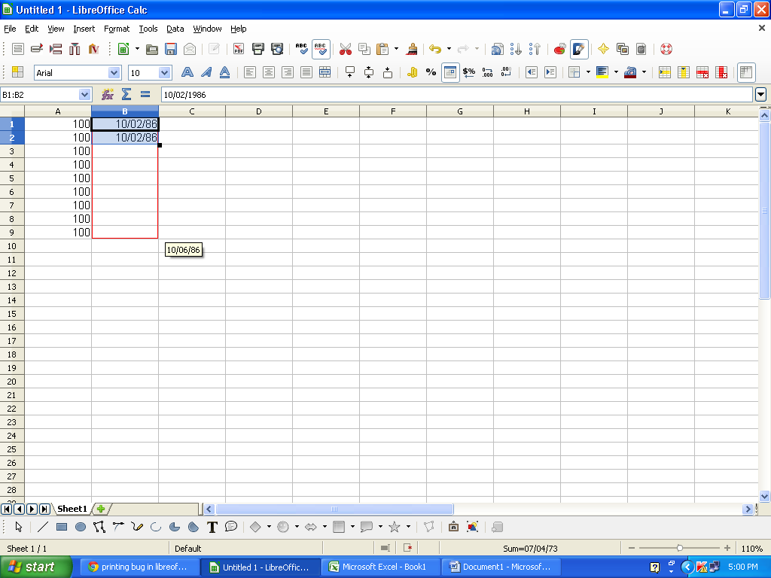

In MS-Office ……….
1) Cell A1 & A2 are contains fixed date
2) select two cells then drag auto fill handler

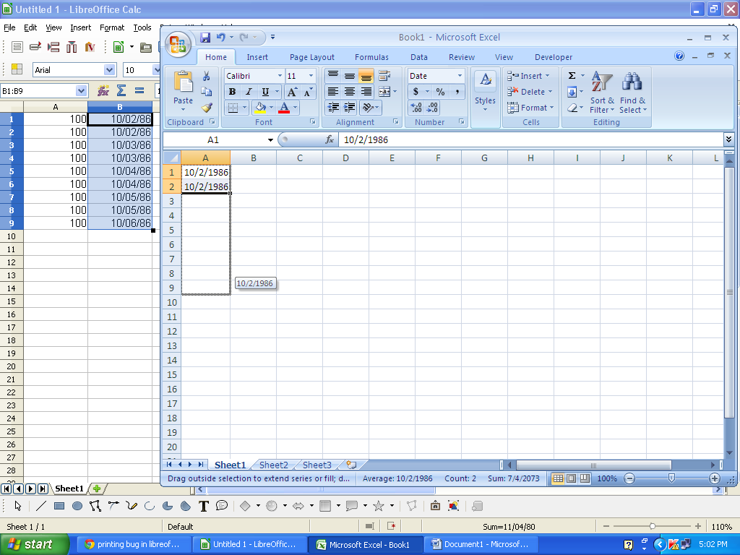

See the difference
Is it possible to get fixed date by dragging auto fill handler in LibreOffice?
I don’t want to use (Edit -> Fill ->Series / Copy & Paste / Ctrl + D)

