KWizCom Corporation

SharePoint Mobile Extensions
Admin Guide

Copyright © 2005-2013 KWizCom Corporation. All rights reserved.

Company Headquarters
95 Mural Street, Suite 600
Richmond Hill, ON
L4B 3G2 Canada
E-mail: info@KWizCom.com
Web site: http://www.KWizCom.com

Sales
E-mail: sales@KWizCom.com
Telephone: +1-905-370-0333

Contents
Contents 3
introduction 5
General 5
Product Overview 6
The Business Need 7
Who needs it? 9
Key Features 10
Installation Guide 11
Software Requirements 11
Server Requirements 11
Client Requirements 11
Installation Procedure 11
SharePoint 2007 11
SharePoint 2010 server 12
post Installation 13
SharePoint 2007 13
SharePoint 2010 14
Un-Installation Procedure 16
SharePoint 2007 16
SharePoint 2010 16
Administration Guide 17
Component Activation 17
Creating a mobile interface for your Shareoint site 23
General 23
Mobile interface terminology 23
Default behaviour after activating the mobile feature 25
Configuring your mobile solution 26
List-level mobile Settings 27
Site-level mobile Settings 30

introduction

General
This document provides all the information needed to install, evaluate and deploy this KWizCom product:
- Introduction
- Installation Guide
- Administrator Guide
- FAQ

Product Overview

SharePoint Mobile Extensions Feature is part of the Mobility Bundle
SharePoint Mobile Extensions Feature is part of the Forms Bundle

Smart, focused interface for productive mobile users!

In just a few minutes you can produce a custom-tailored, focused mobile solution that answers your mobile users’ specific needs!
With SharePoint Mobile Extensions You have FULL control over your SharePoint Mobile application:
- You define the exact layout – pages and what’s displayed on every page
- You define which menus and actions will be visible, according to dynamic conditions
- You define the exact logic

From now on you can provide then without any code development,
the exact mobile business solution that they need!

The Business Need
There are available solutions that enable you to connect to SharePoint sites using a mobile device (smartphone, Tablet). The problem with these solutions (including Microsoft’s list mobile views), is that they just render the basic SharePoint lists in a “thin” layout which matches the smart phone’s interface.
The result is too hard to use!
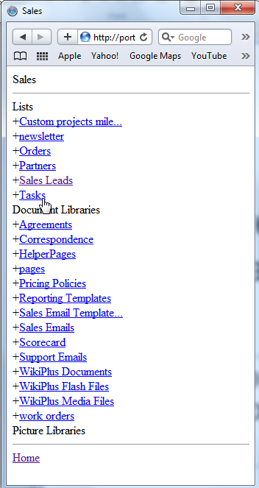
This is how the SharePoint’s mobile view looks like…

“Where is my sales dashboard??
All I see is a long list of lists and libraries..”

Smartphone/Tablet interface is much more limited than a PC or laptop; therefore you must provide mobile users with a smart interface that shows EXACTLY what the user needs.

A much more Focused, Task-Oriented interface is required.

You define which fields are visible
(depending on the user’s context)
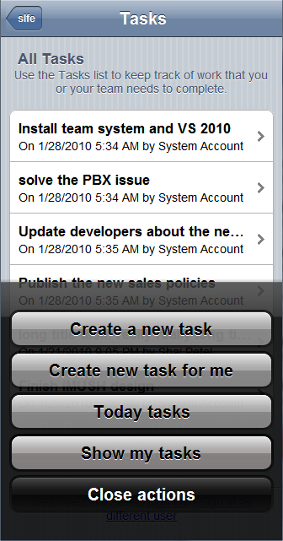
You define which menus are visible
(depending on the user’s context)

In contrary to the generic New-View-Edit SharePoint list pages that include too many irrelevant fields and menus, Users need Task-oriented custom screens that show exactly what the user needs, and include customized menus that enable the user perform the needed actions in minimum time.
No need to explain to your customers “how SharePoint works”…
From now on you can provide them the exact mobile business solution that they need, without any code development!

Who needs it?
- Field-engineers
- Sales agents
- Support/Help-Desk employees

and..
Anyone who needs the same level of SharePoint Workspace service
while being out of the office!

Key Features
Main key features of SharePoint Mobile Extensions are:
Feature | SharePoint Mobile Extensions | SharePoint 2007/2010  out-of-the-box
Supports Blackberry, iPhone, Android and Windows 8 based smartphones/Tablets | √
Enables further UI customization by using CSS files | √
BYOD support: Server-based deployment, no required installations on devices. | √
Enables creating Custom mobile pages with zero development | √
Support for various field types including graphic KPI’s and images | √
Advanced Forms capabilities*: Field-level security, View-level security, Custom default values, Field validation rules, View navigation, conditioned fields | √ | Static Field validation rules are available in SP2010
Custom item-level actions/menus ** | √
Custom list-level actions/menus ** | √
Context-sensitive/conditions menus ** | √
Attach a workflow to an action ** | √
Extensible by development | √ | √

* In order to have also advanced forms capabilities, you will need to install and activate the SharePoint List Forms extensions feature.
** In order to be able to create custom list and list-item actions, you will need to install and activate the SharePoint List Custom Actions feature.

Installation Guide

Software Requirements

Server Requirements
- WSS 3.0/SharePoint 2007 Server or SharePoint 2010 Foundation/Server
- .NET framework 3.5 SP2

Client Requirements
- Microsoft Internet Explorer 9 or later (just to access the Mobile Feature settings pages)
- Blackberry, iPhone/iPad, Android and Windows 8 devices

Installation Procedure

SharePoint 2007
- Log in using SharePoint administrator account to your SharePoint front-end server.
- Download the product’s latest evaluation version from KWizCom’s internet web site. This evaluation version is fully functional for 30 days. Further details about product activation can be found in the Administrator guide (next section).
- If you have a previous installed version of the product, then uninstall it before you install the new version.
- Unzip the product’s zip file on your SharePoint server.
- Double-click the .msi file in order to begin the web installation.
- The installation includes 2 additional optional products, that you can integrate with SharePoint List Custom Actions Feature:
- SharePoint List Forms Extensions Feature – Enables you to turn the out-of-the-box SharePoint list forms into powerful, feature-rich web forms.
- SharePoint List Custom Actions – Enables you to create custom menus at the list/item levels.
These 2 additional optional products are NOT part of the SharePoint Custom Actions Extensions Feature, and require separate licensing and payment.

- When the installation process is complete it will recycle all application pools automatically.

SharePoint 2010 server
- Log in as SharePoint administrator account to your SharePoint front-end server.
- Download the product’s latest evaluation version (zip file) from KWizCom’s internet web site. This evaluation version is fully functional for 30 days.
- Download the KWizCom SharePoint Foundation zip file:
http://www.kwizcom.com/objects/KWizCom%20SharePoint%202010%20Foundation/KWizCom%20SharePoint%20Foundation.zip
REMARK:
KWizCom SharePoint Foundation is a WSP package that includes all KWizCom’s shared utilities and licensing modules for SharePoint 2010.
- Extract both zip files’ content into the same folder on your SharePoint’s disk.
You will find the following .WSP files:
  - KWizCom SharePoint Foundation.wsp
This WSP file includes KWizCom’s shared modules and takes care of licensing and activation and therefore must be installed no matter which KWizCom product you’re using.
  - KWizCom SharePoint List Forms Extension Framework.wsp
This WSP file is an infrastructure package needed for the product.
  - KWizCom SharePoint Mobile Extension evaluation.wsp
This is the SharePoint Mobile Extensions product package.
  - 2 additional product packages (optional)
    - KWizCom SharePoint List Forms Extension evaluation.wsp
    - KWizCom SharePoint List Custom Actions evaluation.wsp
REMARK:
These 2 additional optional products are NOT part of the SharePoint List Forms Extensions Feature, and require separate licensing and payment. They are included in the product’s zip file only to enable you to check-out the features of the integrated solutions.
- You will need now to install and deploy these standard SharePoint WSP packages. This can be done by using SharePoint’s stsadm/Powershell tools, according to Microsoft’s guidelines for installing WSP packages.
- For a much quicker automatic installation, right-click the Powershell script file
“SP-WSPsInstaller.ps1” and select “Run with Powershell”. This will start the automatic installation and deployment process.
- At the end of the installation process, you should see all packages deployed in the Central Admin “Server Solutions” page, and the KWizCom SharePoint Foundation WSP package should be deployed also in the Central Admin web application.

post Installation

SharePoint 2007
- After completing the installation, you will see a new KWizCom entry in Windows Start -> All Programs -> KWizCom -> SharePoint Mobile Extensions

Under SharePoint Mobile Extensions entry you’ll see the following programs:
  - About SharePoint Mobile Extensions
Display General Information about the component.
  - Activate SharePoint Mobile Extensions
This utility enables you (the SharePoint Administrator) to activate the downloaded evaluation version.
- The installation adds a new feature in the farm level and in site collection level.
By default the Farm level feature should be active, enabling you to start using this feature immediately:
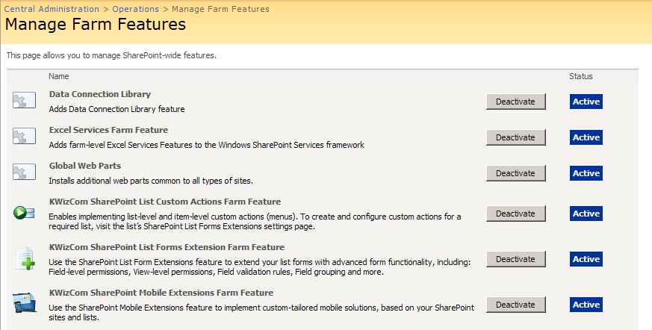

- In case you wish this feature to be available only in a specific site collection, disable the farm feature, and enable the site collection feature.
- If you had a previous version installed, and have been deploying the List Forms Extensions Feature is site collection level, you will need to deactivate the farm level feature (because it is automatically activated during installation). If you leave both the farm-level and the site collection-level features active, you will have duplicated links to the List Forms Extensions settings pages at the list settings pages.

SharePoint 2010
- After you have successfully deployed the required .WSP packages, a new feature is added both to the farm level and to site collection level. By default the Farm level feature should be active, enabling you to start using this feature immediately:
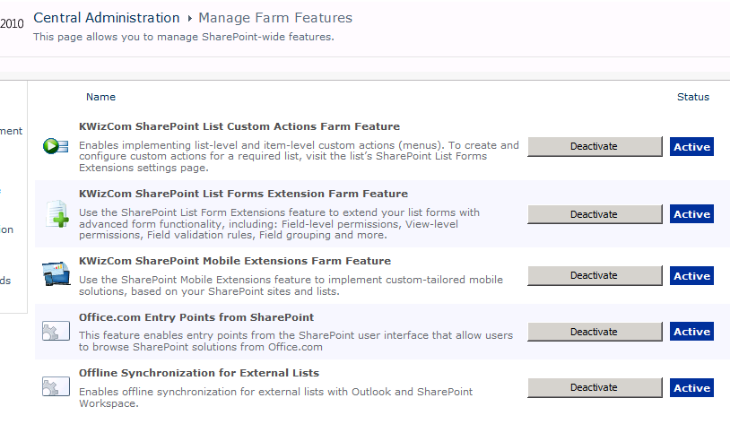

- If you had a previous version installed, and have been deploying the List Forms Extensions Feature is site collection level, you will need to deactivate the farm level feature (because it is automatically activated during installation). If you leave both the farm-level and the site collection-level features active, you will have duplicated links to the List Forms Extensions settings pages at the list settings pages.

Un-Installation Procedure

SharePoint 2007
- Log in as SharePoint administrator to your SharePoint front-end server.
- Go to Control Panel and double-click Add or Remove Programs.
- Select SharePoint List Custom Actions entry and click Remove button.
- Click Yes to approve the removal of the component.
- Once the product was un-installed, close the Add or Remove Programs screen.

SharePoint 2010
- Retract and delete the solution using SharePoint central admin or by using stsadm/powershell command line.

Administration Guide
This section describes all administration activities related to SharePoint Mobile Extensions, including: product localization, product configuration and customization.

Component Activation
KWizCom components are available for evaluation prior to purchase. This way you can try our components and verify that they indeed meet your needs. An evaluation version for each KWizCom component contains all features of the component's production version. The only difference is that an evaluation version is time-limited, and will operate for a period of one month.
Once you decide to order a KWizCom component, you will need to follow the following steps:

SharePoint 2007
- Order the component on the KWizCom website – www.KWizCom.com.
- Send us the installed evaluation version's product Code (you will see the product Code on the "About" product page:
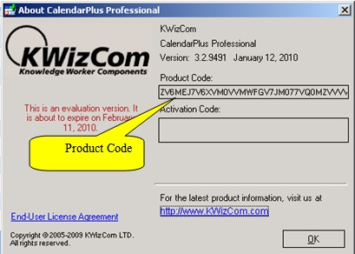
Please use the Activation Request web form, on KWizCom web site to send us your product code.
- Get the component activation key – this key will be sent to you by email once your order is processed.

- Activate your installed evaluation version -
click Start -> All Programs -> KWizCom -> SharePoint Mobile Extensions -> Activate SharePoint Mobile Extensions
SharePoint 2010
- Order the product on the KWizCom website – www.KWizCom.com, or contact our sales team at sales@kwizcom.com.
- After the order was made, you can activate your installed evaluation version. Activation is done by the following steps:
  - Open SharePoint Central Admin. On the main “Central Administration” page, you will see the “KWizCom Features Administration” icon:
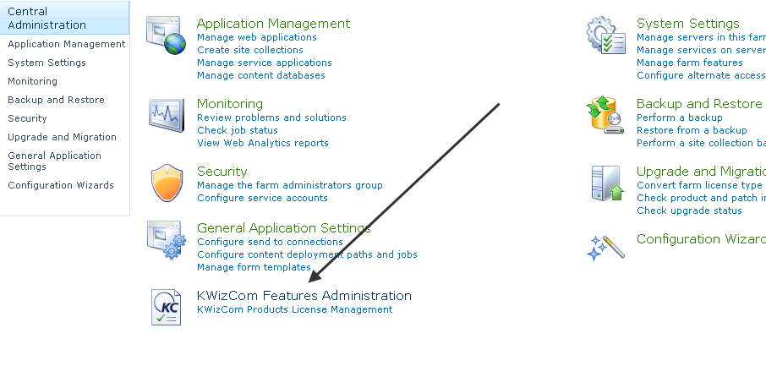
  - Click the KWizCom Features Administration icon. You will be redirected to a page that allows you to manage all your installed KWizCom products’ licenses:
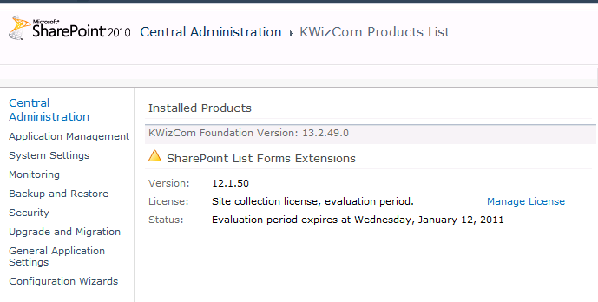
  - Click the “Manage License” link next to the product that you wish to activate. You will be redirected to that product’s license management page:
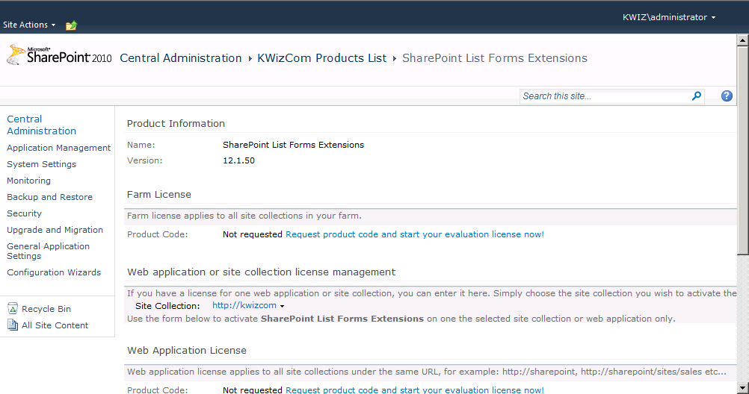
  - Click on the “Request product code and start your evaluation now” link, under the required license type (Farm, Web application, Site Collection).
A product code will be generated and displayed as in the following screenshot:
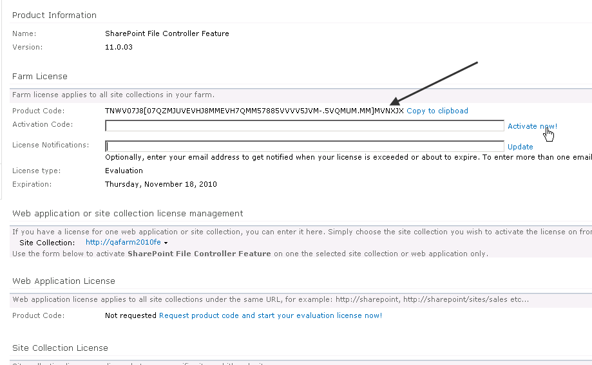
  - Copy the product code.
  - Browse the Product Activation Request page on KWizCom’s web site: http://www.kwizcom.com/ProductReg.
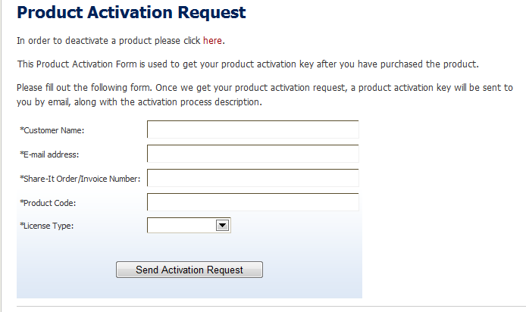
Copy your Product Code into the “Product Code” field, and after you fill-out all other form fields, click “Send Activation Request button.
  - Once your order is confirmed, you will receive the Activation Code for your product by email.
  - Copy the activation code into the “Activation Code” field in the product’s license management page and click “Activate now!” link.
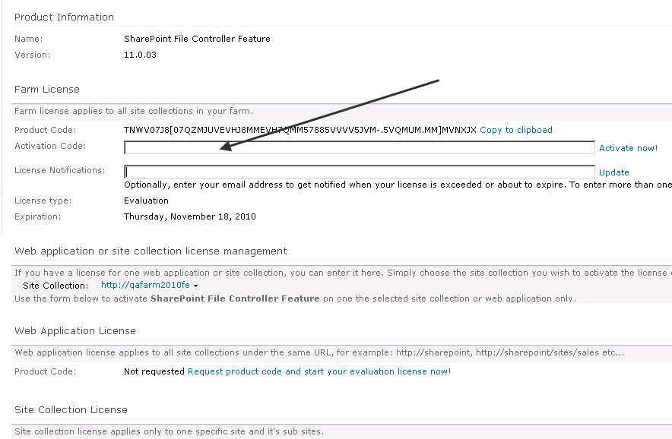
That’s it! Your product is now fully activated.

Creating a mobile interface for your Shareoint site

General
As a site administrator, you can create a custom mobile interface so that your mobile users will be able to keep using their workspace in a productive way while they are out of the office, by using their smartphones/tablets. This section guides you through the steps needed to create a custom mobile interface.

Mobile interface terminology
This section defines the basic terms used in the KWizCom SharePoint Mobile Extensions solution.
- Mobile solution – a solution consists of the mobile interface produced for a SharePoint site.
- Mobile pages – Every mobile solution includes mobile pages. Each page is accessible via URL.
- Page parts – Every mobile page includes one or more page parts (same as a SharePoint web part pages includes web parts).
- Action – this is a button/menu that when a user clicks it, it performs some action.
- Page part type – there are several types of page parts:
  - List View – This type of page part displays a list view. When you select this type, you then have to select the list name and view that you wish to display in the page part.
A list view renders the following display (this one for example shows a KPI list):
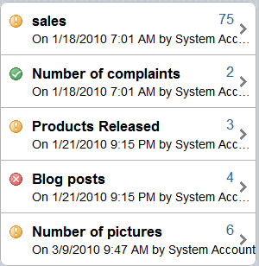
  - Actions List – This type of page part displays action buttons in a vertical layout.
An action list renders the following display:
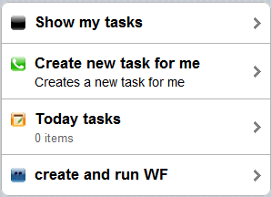
  - Actions Grid - This type of page part displays action buttons in a matrix layout (4 in a row).
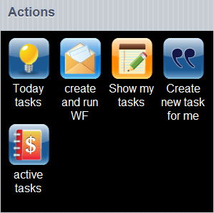

Default behaviour after activating the mobile feature
Once you install and activate the SharePoint Mobile Feature, you can start using the default mobile view without configuration needed.
This default mobile view simply gives you access to all of the lists and libraries in the site collection where you have activated the feature.
Once you browse your SharePoint site using a mobile device, you’ll get the following default mobile display:
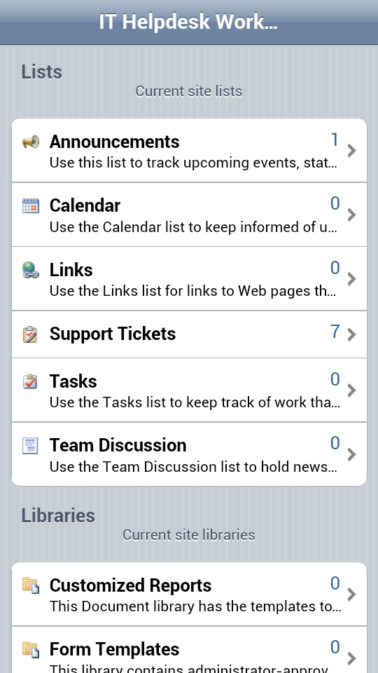

You can use the default mobile view to add/edit/delete items in your lists/libraries.
* If you have KWizCom List Forms Extensions Feature and/or KWizCom Custom Actions Feature installed, then you will be able to use them in the default mobile view (Enhanced forms, custom menus/buttons in lists).

Configuring your mobile solution
You can configure your mobile SharePoint solution in 2 levels:
- List/Library level
At this level you can configure which fields will be displayed in the mobile view (see next section for details)
- Site level
At this level you can create custom mobile pages.

The following sections describe the various configuration settings available at the List and Site levels.

List-level mobile Settings
To start configuring your list’s mobile settings, go to the list settings page and click the “KWizCom list mobile settings” link:
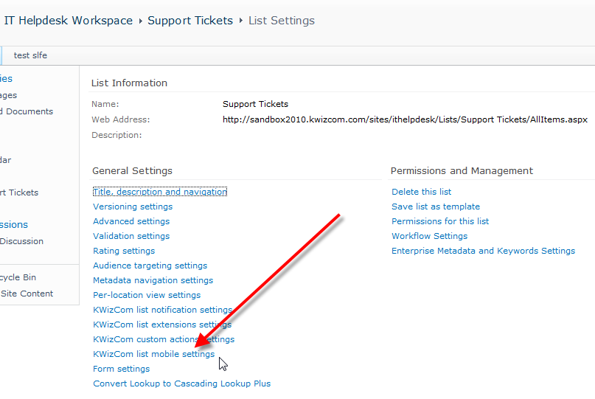

The following settings page will appear:
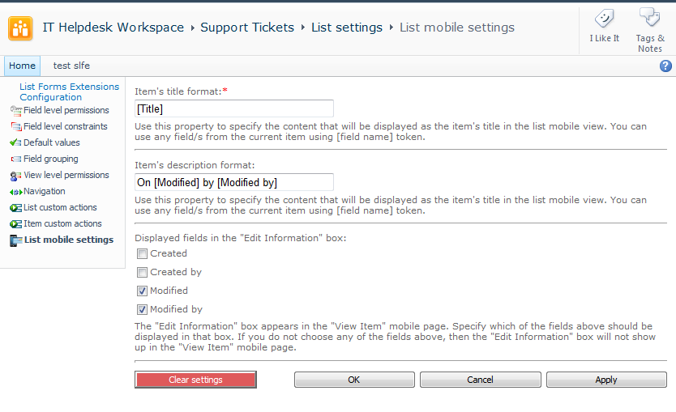
This page allows you to configure the following list mobile view settings:
Property | Description
Item’s title format | Use this property to specify the content that will be displayed as the item's title* in the list mobile view. You can use any field/s from the current item using [field name] token.
Item’s description format | Use this property to specify the content that will be displayed as the item's description* in the list mobile view. You can use any field/s from the current item using [field name] token.
Displayed fields in the  "Edit Information" box: | The "Edit Information" box** appears in the "View Item" mobile page. Specify which of the fields above should be displayed in that box. If you do not choose any of the fields above, then the "Edit Information" box will not show up in the "View Item" mobile page.

* When a list is displayed in the mobile view, you can display for each item a Title (appears bold) and Description (appears below the title):
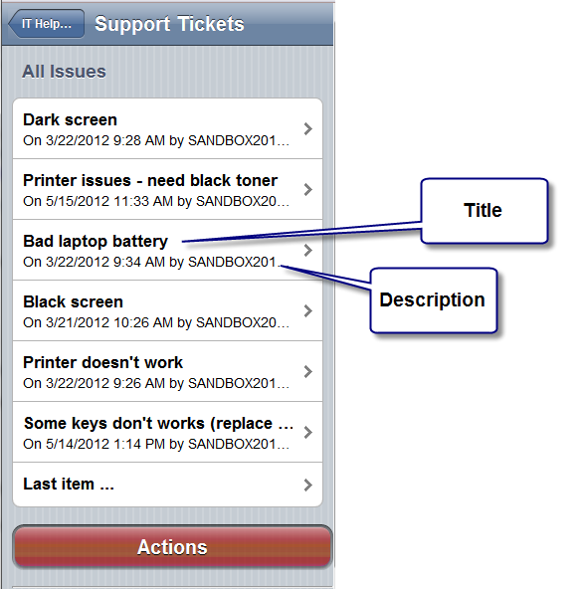

** In the item’s mobile view page you can see at the bottom part, the “Edit Information” box:
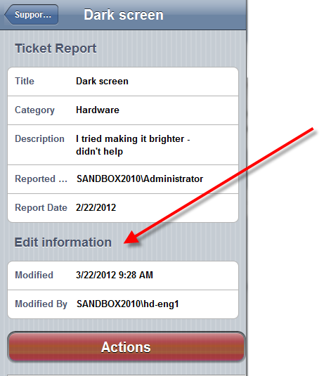

Site-level mobile Settings
To start creating your custom mobile pages, click the “SharePoint Mobile Extensions settings" menu below the “Site Actions” menu. The following settings page will be displayed:
