Contact
Michael Schwalm
Consultant
Direct +41 79 796 43 59
michael.schwalm@dbi-services.com

Virtual Box cloning tool manual

Customer dbi services

Creation 27.08.2012

History of changes
Version | Date | Updated by | Comments / Status
0.1 | 27.08.2012 | Michael Schwalm | Initial document
0.2 | 07.11.2012 | Michael Schwalm | Rewrite document
1.0 | 31.05.2013 | Michael Schwalm | Actual document

Document validation
Name | Department | Date
Prénom Nom | … | 24.04.2012
Prénom Nom | … | 24.04.2012
Prénom Nom | … | 24.04.2012

Document delivery
Name | Department | Date
Prénom Nom | … | 24.04.2012

Document review
Date | Reviewers | Next review
24.04.2012 | … | …

Table of contents

1. Introduction 4
2. Overview 5
2.1. Contents of the tool 5
3. Installation 6
3.1. Prerequisites 6
3.2. Installation 6
3.2.1. On host 6
3.2.2. On Guest template 9
4. First execution 14
4.1. Generate a new script plan 14
4.2. Edit the configuration file 16
4.3. Clone virtual machines 16
5. Directories structure 18
5.1. Structure of zip file 18
5.2. Structure of the scenario 18
5.3. Scripts 18
5.4. Configuration file specification 19
6. De-installation 20
7. Appendix 21
7.1. Create the Linux template for dbi’s cloning tool 21
7.1.1. System configuration 21
Network 21
Disable features 22
7.1.2. Pre requisites 22
Deploy the dbi’s cloning tool 22
Edit /etc/resolv.conf 22
Edit /etc/hosts 23
Download yum repository 23
Install Guest Addition Tools 23
Install oracle validated 24
Training shared folder 25
Partitioning 26
Tidy up 26
7.2. Create the Windows template for dbi’s cloning tool 26
7.2.1. System configuration 26
Network 26
7.2.2. Pre requisites 30
Deploy dbi’s cloning tool 31
Disable Windows firewall 31
Switch the remote access on 33
Install Guest Addition Tools 34
Training shared folder 35

- Introduction

This document describes the installation and the utilization of the dbi’s Virtual Box cloning tool. This tool is used to automatically clone and configure new virtual machines from a template using MS_DOS and/or shell scripts.

You will find in appendix an help to create virtual machine templates on Windows and Linux.
- Overview

  - Contents of the tool

The tool is shipped as a zip file, named cloning_tool.zip. It contains following items :

Item | Type | Definition
templates | Directory | Contains bootable scripts for guest operating system
scripts | Directory | Contains sub programs required for the duplication procedure
versions | Directory | Contains the history of the tool versions
newenv.cmd | Script | Script to generate a new scenario
README.txt | Text file | Contains help and how to about the tool

- Installation

  - Prerequisites

On Host

Oracle Virtual Box 4.0 or later must be installed. Previous versions have not been tested and are not supported.

The Virtual Box installation directory must be declared in the PATH variable of Windows.

On virtual machine template

Virtual Box Guest Addition Tools must be installed to enable some features used by dbi’s cloning tool.

  - Installation

    - On host

Configure the PATH variable

Click on Start, select Computer and Right click on Properties

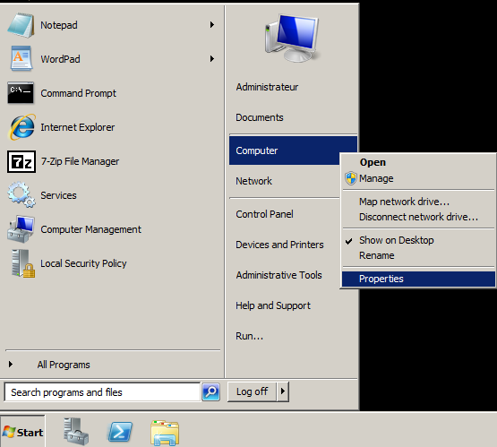

On the left panel, click on Advanced System Parameters

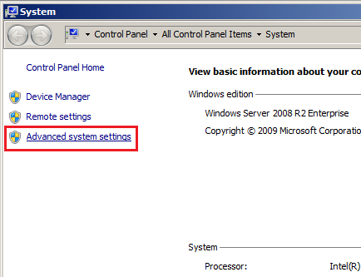

In the System Properties Windows, click on the Environment Variables button

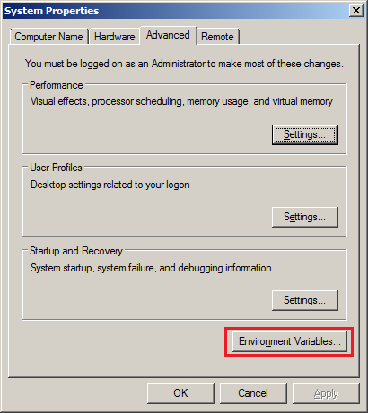

Find and edit the System variable named PATH

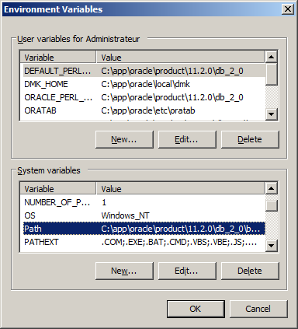

Add the Virtual Box directory in the PATH variable

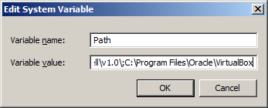

Extract zip file

Copy cloning_tool.zip file on your disk. Then, extract zip file in the directory of your choice. The cloning tool does not need to be extracted into a specific directory to work.

Once dbi’s cloning tool is copied it is ready to use.

    - On Guest template

Deploy the onboot script

The zip file contains a directory named templates. You can find on this directory two MS-Dos on boot scripts for Windows, and one KSH on boot script for Linux.

On Windows

Copy both scripts reconf.bat and replace_word.bat on the disk of the virtual machine. Use the directory of your choice, but both scripts must stay in the same directory.

Next, create a scheduled task to run the script at Windows startup.

Click on Start, select Administrative Tools and then click on Task Scheduler.

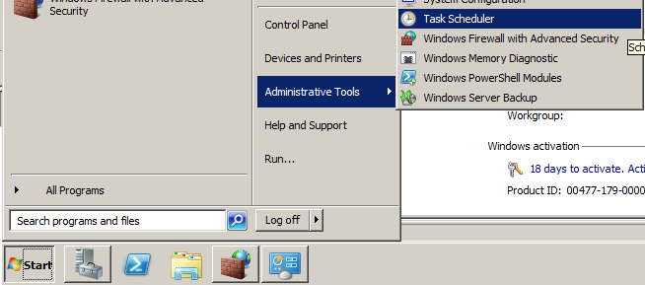

Right click on Task Scheduler and select Create Task…

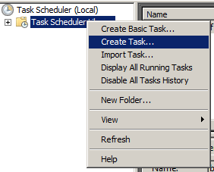

Type a name for the new task, and select option “Run whether user is logged on or not”

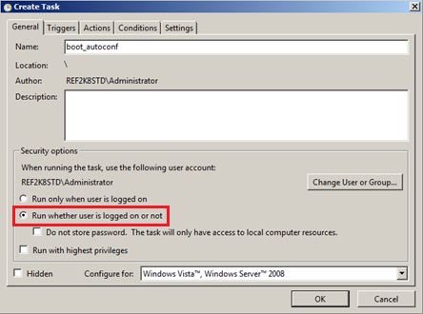

Access the “Triggers” tab and click on New button

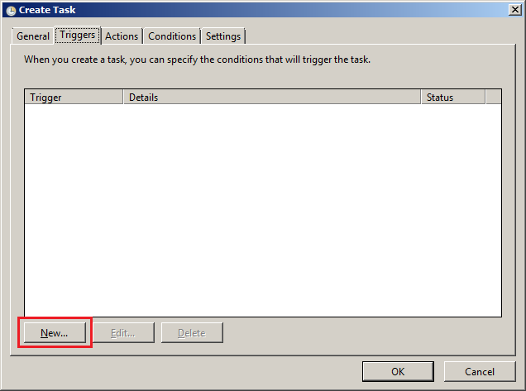

Select “At startup” in the list at the top, and keep all parameters by default. Click OK

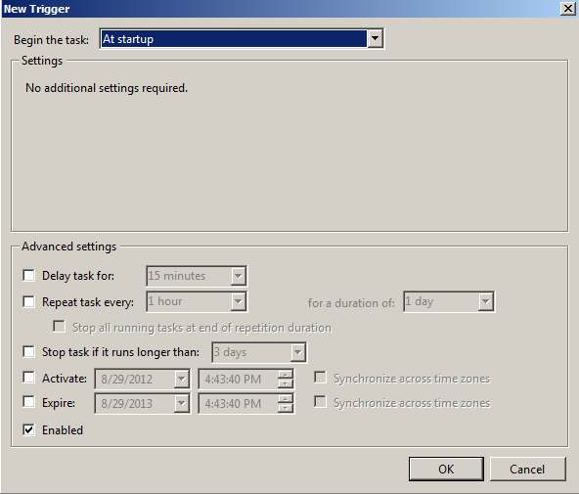

Access the “Actions” tab and clock on New button.

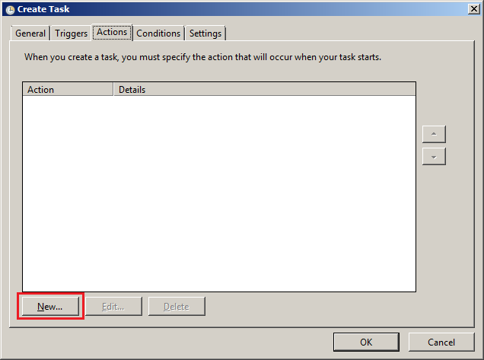

Select “Start a program” in the list, and put the script path in the Settings field. Click OK

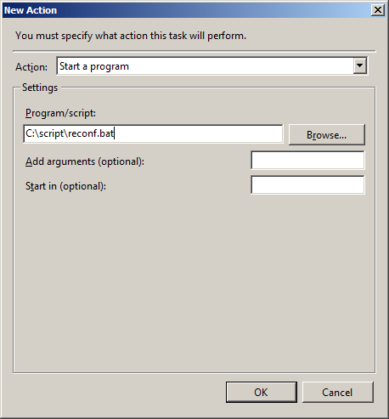

Leave default values for both Conditions and Settings tabs, and click OK.
Enter the credentials of the account running the script, and click OK.

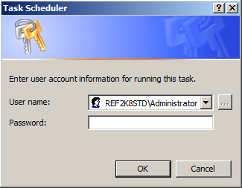

You can see the new task in the Task Scheduler summary:

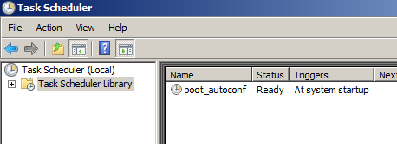

On Linux

As root, copy the reconf script on the disk of the virtual machine, in /etc/init.d. Check that execution permission is correct:

[root@vmtestora11g ~]# ls -altr /etc/init.d/reconf
-rwxr-xr-x. 1 root root 7401 Nov 6 17:47 /etc/init.d/reconf

If not, apply this command:

[root@vmtestora11g ~]# chmod 755 /etc/init.d/reconf

Make the script bootable by using the chkconfig utility, and check the new configuration:

[root@vmtestora11g ~]# chkconfig --add reconf
[root@vmtestora11g ~]# chkconfig --list reconf
reconf 0:off 1:off 2:off 3:on 4:off 5:on 6:off

Note: You can see that the script would be activated by default at runlevels 3 and 5. To change it, you can edit the header of the script in /etc/init.d and run the previous command again, or use the command chkconfig with --level option.

AJOUTER SCRIPT D’INSTALLATION AUTO SOUS LINUX ET WINDOWS POUR SIMPLIFIER LA PROCEDURE. EN COURS…
- First execution

  - Generate a new script plan

Before cloning virtual machines, you have to generate your scenario. A scenario consists in a configuration file and 3 scripts and corresponds to what your script is supposed to do. Each scenario has its own directory, allowing users to separate scripts in case of multiple environment creation on the same machine (i.e. Oracle workshops and SQL Server workshops are performed on the same host).

To create your scenario, navigate into the folder where you have extracted the cloning tool, and follow steps below.

Run the script newenv.cmd. Enter the name of your environment (i.e. “dbi training”, “oracle testing”, “workshop sql”…)

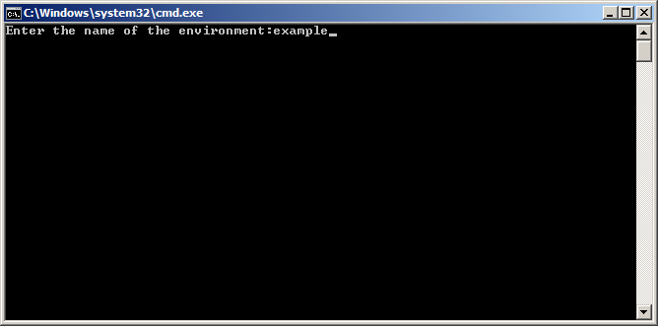

Enter a directory to store the files of your scenario

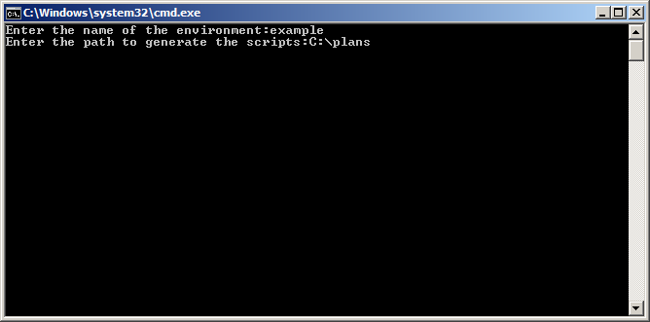

Confirm that you want to create a new scenario by typing Y, and then enter

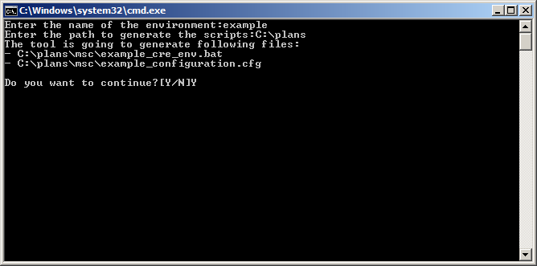

If the directory does not exist, the script will create it. Confirm that you authorize the script to create the new directory by typing Y, and then enter

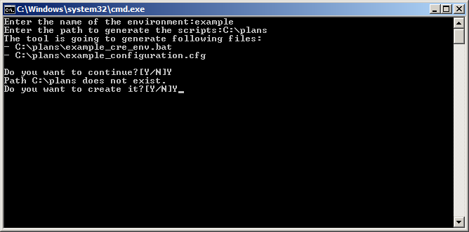

The next screen shows the execution status

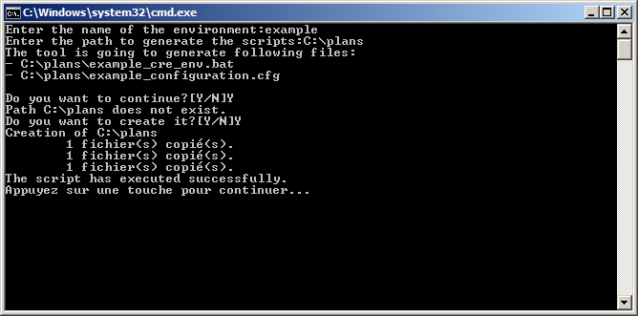
  - Edit the configuration file

The script has created a configuration file for your scenario, with only one line as an example. The file is generated in the path entered in the step 2 of the wizard (C:\plans in the example).

You must edit this file prior to execute the cloning procedure.

See Part 2 for more information.

  - Clone virtual machines

Once the scenario is created and the configuration file adapted, this is time to run the cloning procedure.

This step is quite simple: you just have to run the script 1_*_cre_env.bat (where * is the name of your environment.

Ex: 1_workshop_ora_cre_env.bat

Do not run any of the two other scripts (clone.bat and cre_env.bat), they are used by the first script and should not be run directly.

In the following example, we can see that two virtual machines were created. The script has cloned the template, added a shared folder, generated a parameter file, and started the new virtual machine, all automatically!

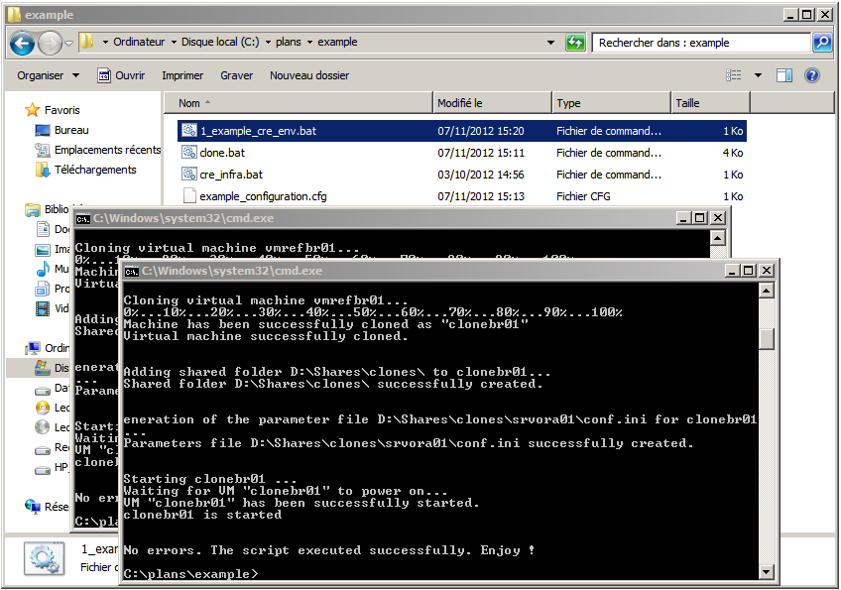

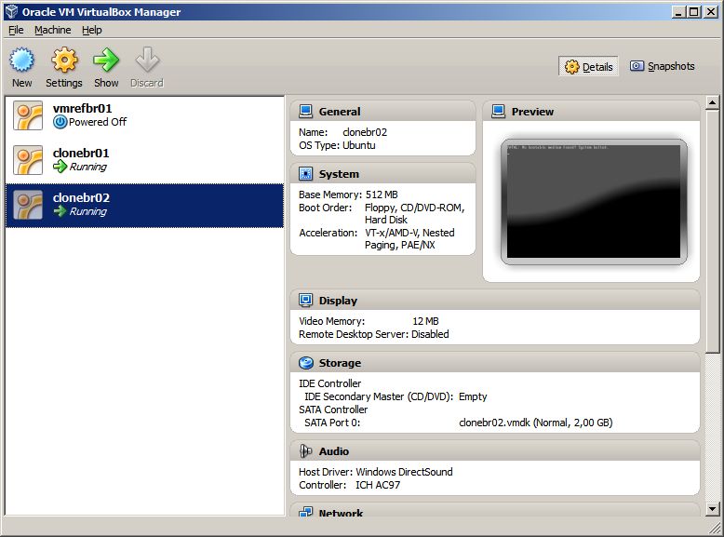
- Directories structure

  - Structure of zip file

This is the whole content of cloning_tool.zip:

Files contained in the zip file
\ | newenv.cmd  README.txt
scripts | clone.bat  cre_infra.bat
templates | configuration.template  Linux  Windows
templates\Linux | reconf
templates\Windows | reconf.bat  replace_word.bat
versions | *.zip

  - Structure of the scenario

This is the structure of the scenario generated from the section 4.1.

Files generated in the script plan
<env> (1) | 1_<env>_cre_env.bat  clone.bat  cre_infra.bat  <env>_configuration.cfg

  - Scripts

This is the list of all scripts and what they are used for.

newenv.cmd | Main script, it generate a new script to allow user to create a complete environment.
1_<env>_cre_env.bat (1) | Main script, il runs the cloning procedure executing cre_infra.bat and using configuration file
cre_infra.bat | Script run by 1_<env>_cre_env.bat, it runs clone.bat and read values registered in the configuration file (1)
clone.bat | Script run by cre_infra.bat, it gets values from cre_infra.bat and executes Virtual Box commands to create new virtual machines
reconf | On boot script for Linux, it runs at startup and performs many operation such as changing hostname, network configuration…
reconf.bat | On boot script for Windows, it runs at startup and performs many operation such as changing hostname, network configuration…
replace_word.bat | Script run by reconf.bat, contains a function to replace string in system files
<env>_configuration.cfg (1) | Configuration file, registers all required information about new virtual machine creation
- <env> corresponds to the name of the environment entered in step 1 of the wizard (see 4.1).

  - Configuration file specification

This configuration file registers all details about virtual machines to create from the template, each line corresponding to a virtual machine (see below).

The syntax on this file is as following:

<template_name>;<new_clone_vm_name1>;<destination_path>;<new_clone_os_hostname1>;<new_clone_IP_address1>;<new_clone_netmask>;<exec_flag>;<shared_folder_path>
<template_name>;<new_clone_vm_name2>;<destination_path>;<new_clone_os_hostname2>;<new_clone_IP_address2>;<new_clone_netmask>;<exec_flag>;<shared_folder_path>
…

Field | Definition
Template_name | Name of the virtual machine template as registered in Virtual Box summary  Ex: vmrefbr01
New_clone_vm_name | Name of the new virtual machine as it will be registered in Virtual Box summary  Ex: clonebr01
Destination_Path | Absolute path of the root directory containing new virtual machine files. A directory will automatically be created in this path for the current virtual machine.  Ex: D:\VirtualMachines
New_clone_os_hostname | Name of the new virtual machine at Operating System level  Ex: srvora01
New_clone_IP_address | New IP address of the new virtual machine  Ex: 192.168.22.101
New_clone_netmask | New netmask of the new virtual machine  Ex: 255.255.255.0
Exec_flag | Specify if the script has to configure the virtual machine at startup or not.  Boolean value, 0 or 1
Shared_folder_path | Absolute path of the root directory containing new virtual machine shared folder. A directory will automatically be created in this path for the current virtual machine  Ex: D:\SharedFolders

This is an example of a configuration file to create an heterogeneous environment with 5 virtual machines (2 Windows, 3 Linux) based on different templates:

vmrefwin;clone01;E:\VMs\;srvora01;192.168.22.101;255.255.255.0;1;D:\Shares
vmrefwin;clone02;E:\VMs\;srvora02;192.168.22.102;255.255.255.0;1;D:\Shares
vmreflinux;clone03;E:\VMs\;srvora03;192.168.22.103;255.255.255.0;1;D:\Shares
vmreflinux;clone04;E:\VMs\;srvora04;192.168.22.104;255.255.255.0;1;D:\Shares
vmreflinux;clone05;E:\VMs\;srvora05;192.168.22.105;255.255.255.0;1;D:\Shares

- De-installation

Remove all files extracted from the zip file. You can also delete scenarios, if you think they will not be required in the future.

- Appendix

  - Create the Linux template for dbi’s cloning tool

    - System configuration

Network

The Linux template needs first 2 network interfaces.

- The first one attached to “Bridged Adapter” allows the machine to exist on the Network.

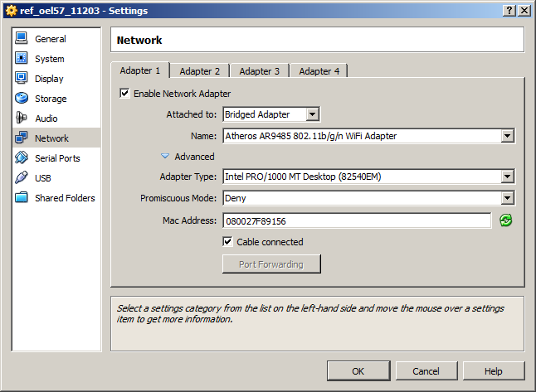

- The second one attached to “NAT”, for temporary usage only, to access the Internet to download packages, libraries or objects necessary for configuration. This interface must be deleted before deploying new clones from this template.

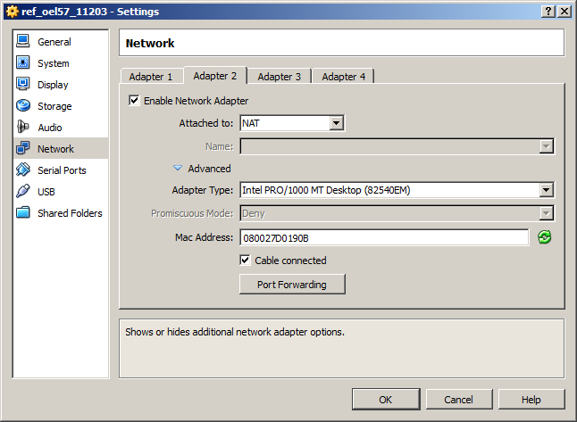

Disable features

Some Linux features could be disabled, such as firewall, kdump, X11…

    - Pre requisites

Deploy the dbi’s cloning tool

See the section 3 to know how to install the Linux guest component of this tool.

Edit /etc/resolv.conf

Add following lines into the resolv.conf file:

nameserver 8.8.8.8
nameserver 8.8.4.4

These servers are the name servers of Google. They will allow the virtual machine to communicate with the Internet to update the system.

Edit /etc/hosts

Add the following line into the hosts file:

<IP> <hostname>

(<IP> is the current IP address of the template, <hostname> is the hostname of the template)

Download yum repository

http://public-yum.oracle.com/

The repository is required to update many packages and libraries. It is also used to install Virtual Box Addition tools, and to download directly the oracle validated package, which allows to automatically deploying Oracle pre requisites.

To install it use the following command:

# cd /etc/yum.repos.d
# wget http://public-yum.oracle.com/public-yum-ol6.repo

Install Guest Addition Tools

Installation package for Additions tools is accessible from the Virtual Box console. Click on “Devices” and select “Install Guest Additions” from the virtual machine window.

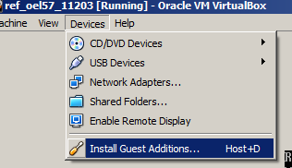

From the virtual machine terminal, access to the cdrom device and run the “VBoxLinuxAdditions.run”. Without addition tools, shared folders between host and virtual machines would not function.

Note that the install may fail the first time:

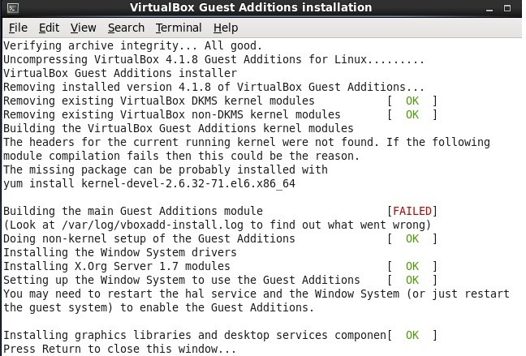

Use yum utility to download kernel sources, like advised to the wizard.

Install oracle validated

To simplify the Oracle installation procedure on Linux, Oracle provides a package called “oracle-validated” which automatically downloads required libraries, and create users and groups necessary for Oracle setup.

This tool is available on yum repository:

yum install oracle-rdbms-server-11gR2-preinstall.x86_64

The package is formerly known as “oracle-validated” on Oracle Linux 5.
Training shared folder

It could be useful to have a permanent shared folder between the host and virtual machines, to share documents or different setups for participants.

To add a shared folder:

- Access to “Devices” and select “Shared Folders”.

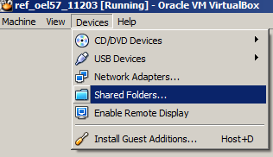

- Add a new share to a host directory, and select “Read-only”, “Auto-mount” and “Make Permanent”.

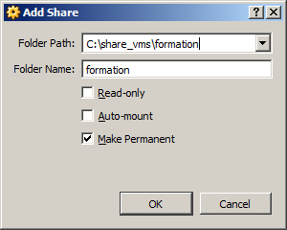

At Linux server startup, the share will be available on /dev directory.

Partitioning

This is an example of partitioning of a disk of 30 GB.

Partition /boot 250 MB
Root partition / 8 GB
Partition Swap 4 GB

Create a volgroup vgdata. On this volgroup, create a logical volume lvdata. Create on the logical volume the partition /oracle and assign it the rest amount of the disk (about 28 GB).

Tidy up

You can drop the NAT network interface configured at first step since no Internet connection is required now.

  - Create the Windows template for dbi’s cloning tool

    - System configuration

Network

The Windows template needs only one network interface.

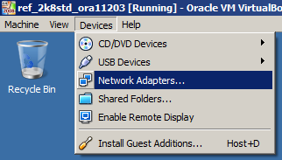

- Add an interface attached to “Bridged Adapter” to allow the machine to exist on the Network

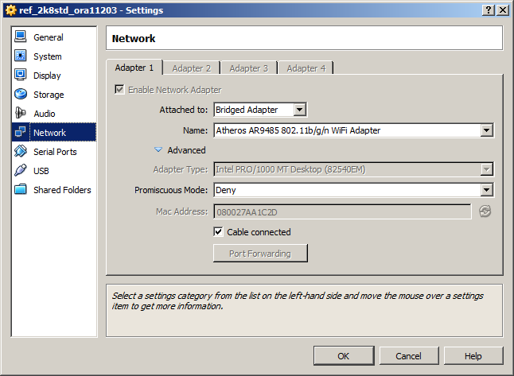

- On Windows “Network and sharing center”, rename the network adapter from “Local Network” to “LAN”.

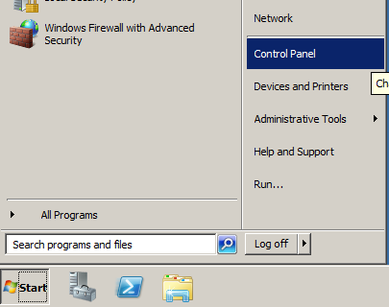

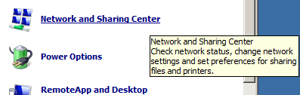

- Select link « Change adapter settings » in the top left panel.

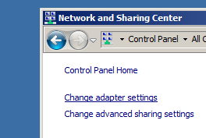

- Change the interface name to “LAN”, because this name is hard coded in the cloning script used to duplicate the virtual machine.

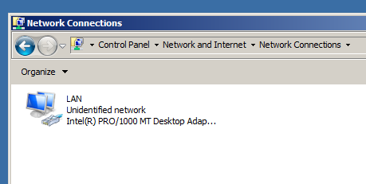

- Give a static IP address to the interface by editing interface properties.

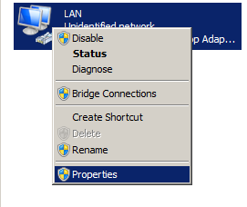
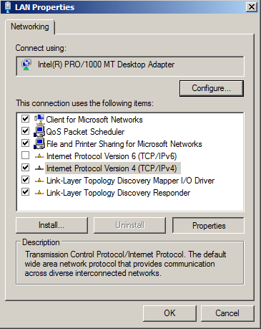

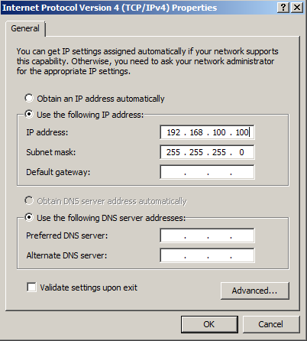

    - Pre requisites

Windows security policy

Some components can be disabled in the security policy of Windows, such as the server admin window…

Naming convention

Change the server hostname. Right click on Computer, select properties, and select Change settings in the Computer name section:

Click on Change on the new window and enter the hostname of the template.

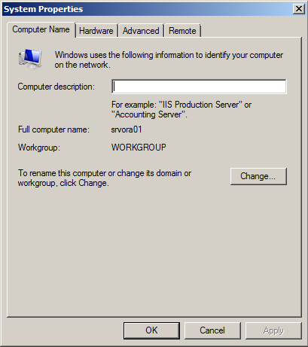

Edit the file C:\Windows\system32\drivers\etc\hosts and add the following entry:

# localhost name resolution is handled within DNS itself.
# 127.0.0.1 localhost
# ::1 localhost
<IP_ADDRESS> <HOSTNAME>

Replace <IP_ADDRESS> and <HOSTNAME> by the address and the name of the template.
Deploy dbi’s cloning tool

See section 3 to know how to install the Windows guest part of this tool.

Disable Windows firewall

Windows firewall may cause troubles to open sessions with RDP client. It must be powered off.

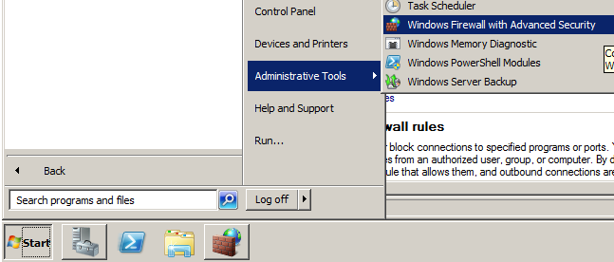

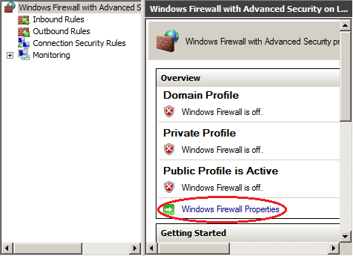

Put offline following profiles:

- Domain
- Public
- Private

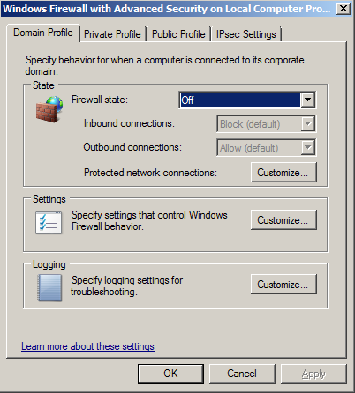

Switch the remote access on

Users access to the server with RDP client. Before, you must enable the remote access.

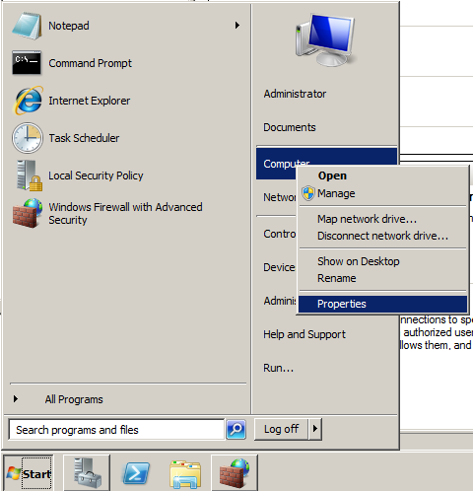

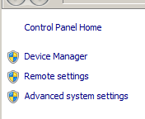

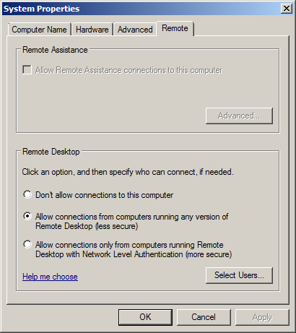

Install Guest Addition Tools

Installation package for Additions tools is accessible from the Virtual Box console. Click on “Devices” and select “Install Guest Additions” from the virtual machine window.

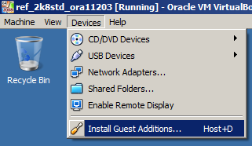

From the virtual machine, access to the cdrom device and run the “VBoxWindowsAdditions-x86.exe” or “VBoxWindowsAdditions-amd64.exe” according to the used platform.

Without addition tools, shared folders between host and virtual machines would not function.

Training shared folder

It could be useful to have a permanent shared folder between the host and virtual machines, to share documents or different setups for participants.

To add a shared folder :

- Access to “Devices” and select “Shared Folders”.

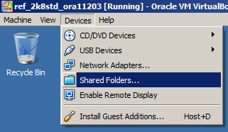

- Add a new share to a host directory, and select “Read-only”, and “Make Permanent”.

- On Windows, open a terminal and run the following comand to use a letter of your choice and make the network drive persistent:

# net use P: \\vboxsvr\formation /persistent:yes

