1. I wrote some text:
Some text Some text Some text Some text Some text Some text Some text Some text Some text Some text Some text Some text Some text Some text Some text Some text Some text Some text Some text Some text Some text Some text Some text Some text Some text Some text Some text

2. Set a highlight of its fragment:
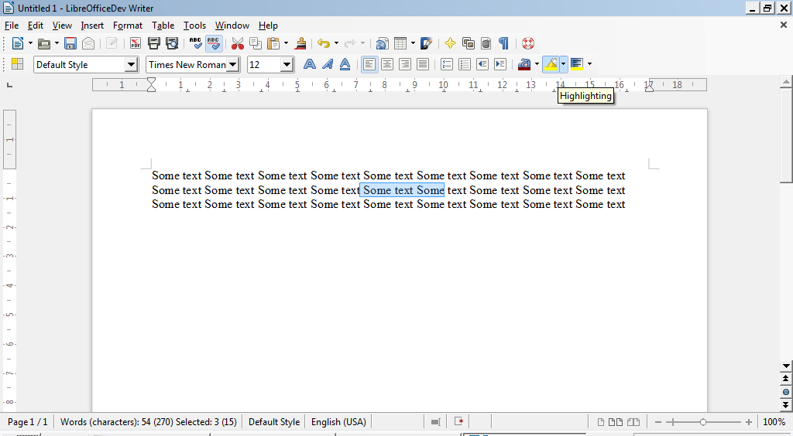
3. Got yellow highlight of selected fragment:
Some text Some text Some text Some text Some text Some text Some text Some text Some text Some text Some text Some text Some text Some text Some text Some text Some text Some text Some text Some text Some text Some text Some text Some text Some text Some text Some text

4. Saved this file as fdo64490.odt (Ctrl+S) and fdo64490.docx (Ctrl+Shift+S)

