Walk through on ICT Mark interface with schools
This walk through intends to show the way in which a school applies for the ICT Mark (first time) using the Naace SRF tool and how the Naace Administration team process their request.

Stage 1 – school applies
When a school has filled in all aspects at level 2, the School Admin account(s) is/are given a new button on the “overview” screen and their “Your settings” page. (Note that the text boxes do not have to be filled in to get this button.) The position of the buttons are shown below:
Overview screen:
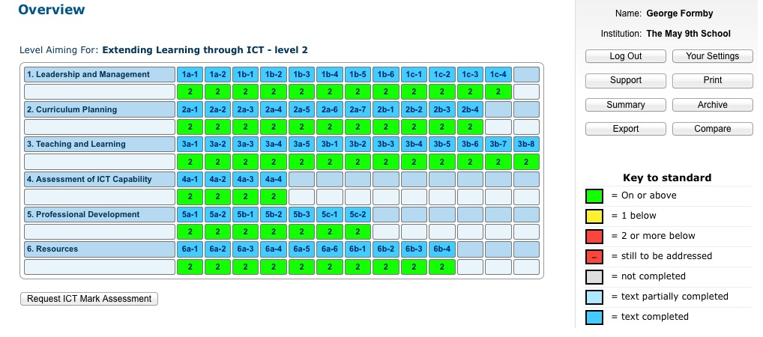
Your Settings screen:
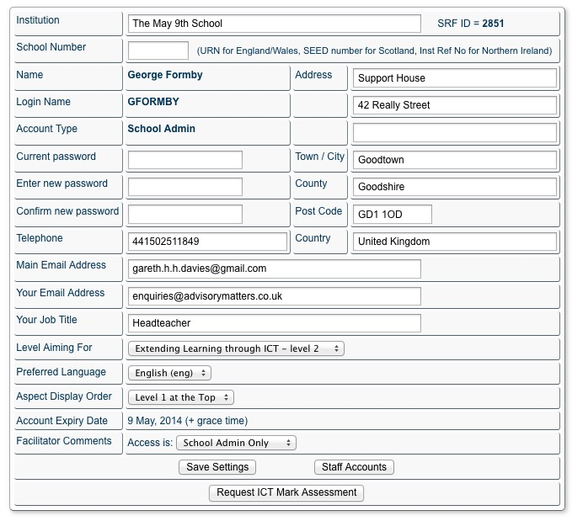
The school clicks on the “Request ICT Mark Assessment” button to generate the request.
Stage 2 – School fills in request form
On clicking on the button, the School Admin is taken to the request form.
The first part of the form confirms the schools details:
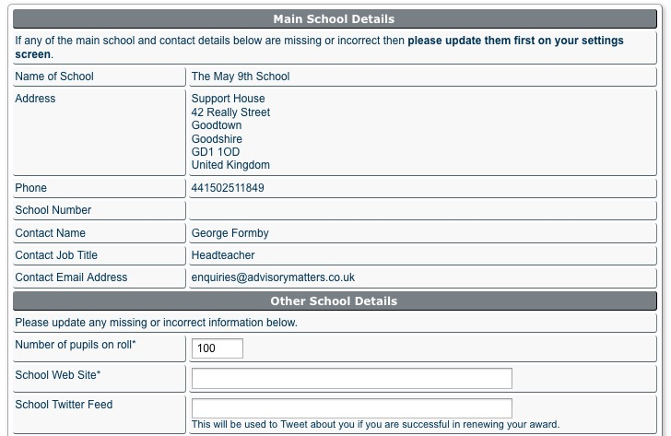
Note that should any of the filled in details be incorrect, the School Admin is requested to return to the “Your settings” screen and update their information.
“Other School details” refers to information that is either missing from the school record, or requires a checking ie. a check on pupils on roll for invoicing purposes. The school website field is compulsory.
The second part of the form provides information for administering the request:
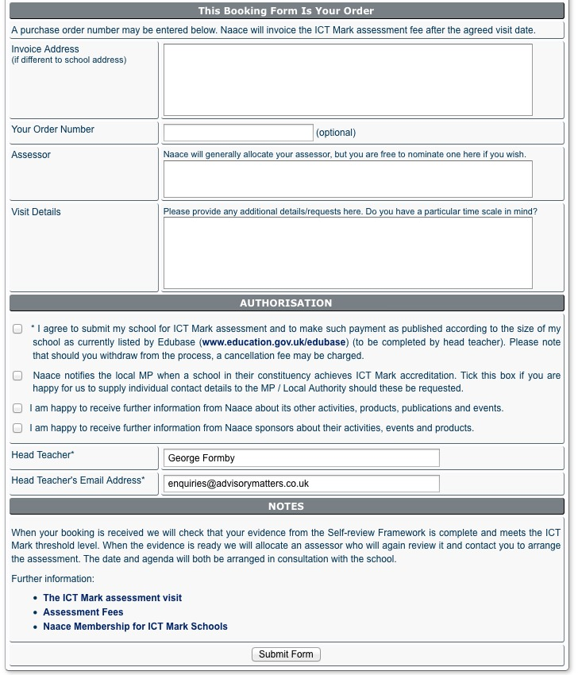

In these fields the Headteacher’s permission is required. If the School Admin is known to be the Headteacher this is automatically completed (but can be altered at this stage). The permission box (first) is compulsory.
Links to further information on the main Naace website is provided before the form is submitted.

The submission is accepted, and the school is presented with a ‘progress screen’:
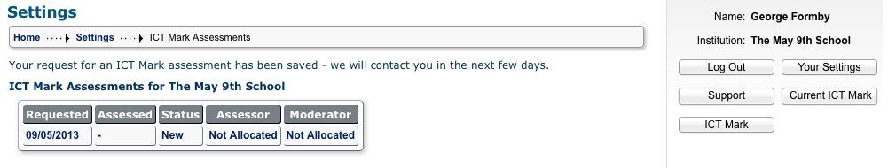
This screen is also shown under the “ICT Mark” button and MAY also contain details of previously successful ICT Mark submissions.
Clicking on the hyperlink against this submission ie. the date under requested will provide information about that submission. In this case there is only one submission so it is the same as clicking on the button “Current ICT Mark”. The “Current ICT Mark” takes the School Admin to most recent submission in progress.
The current ICT Mark screen looks like this:
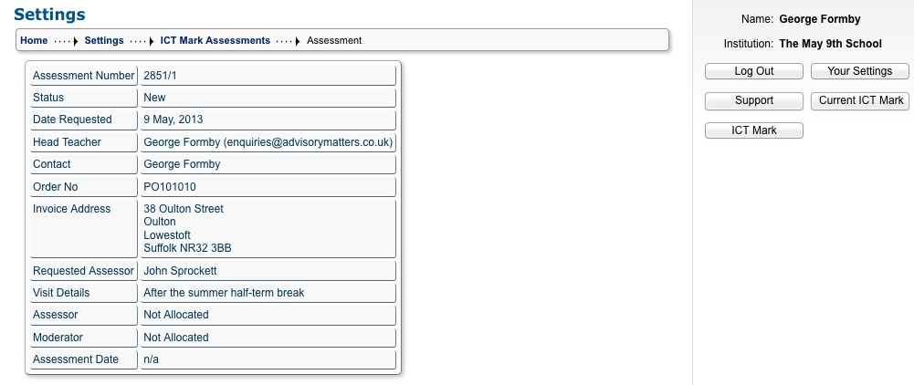
the screen contains all the information gathered from the form and is updated when an Assessor is appointed and a Moderator if applicable, as well as when an Assessment Date is agreed by the Assessor.
NB. Once a submission is made, the two new buttons, “ICT Mark” and “Current ICT Mark” appear on all screens when the School Admin is logged in.
Stage 3 – Handling a request in the Naace office.
Once a submission has been made it appears as a RED “Awaiting Attention” item on the main administration dashboard (note no email is sent as it is assumed that the Naace administrator is handling these requests frequently).
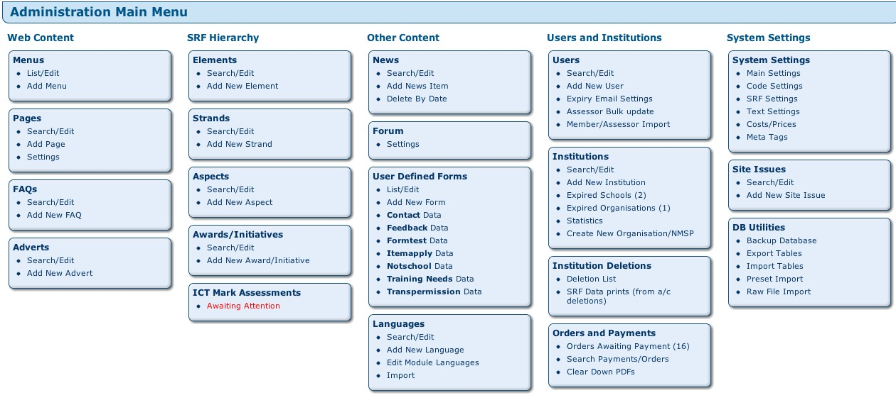
To deal with the request, click on the “Waiting Attention” link.
The screen shows a list of assessments and their status. Click on the school to handle the request or bring up details of that request eg:
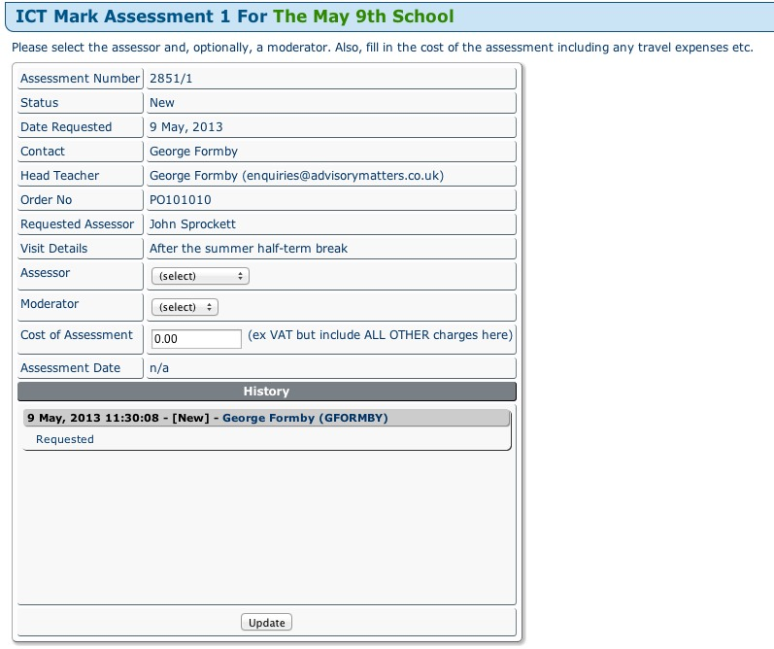
Here you can allocate an Assessor or Moderator from those active on the system via the dropdown box (this may be altered to cater for the number of potential assessors).
Enter the cost of the assessment. This should include all other charges if there are any.
At the bottom is a “History” pane of actions completed.

On clicking the “update” button, two emails are sent. One to the Headteacher email address, and one to the Assessor. The next screen reports this.
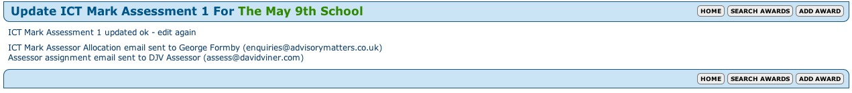
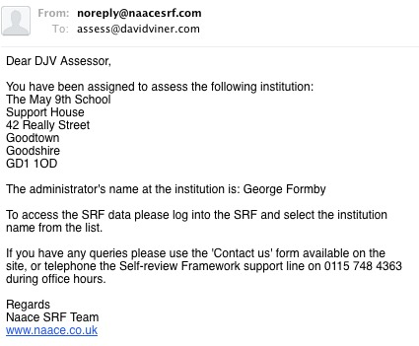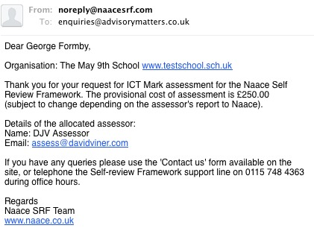
On returning to the entry a number of updates have taken place:
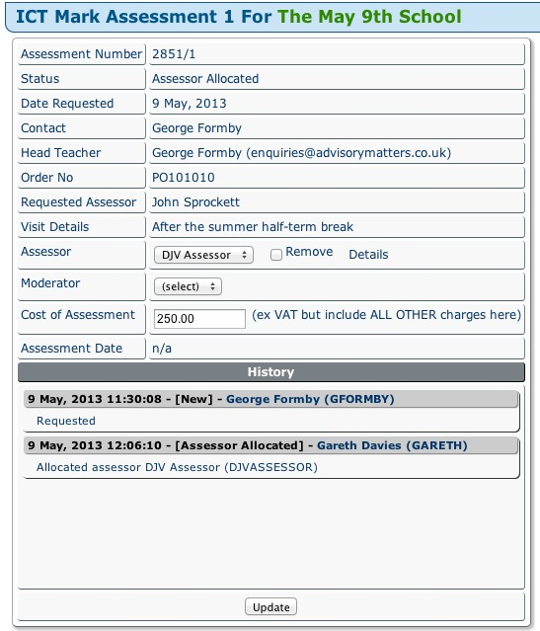
The Naace Admin can “Remove” the assessor (and allocate a new one). The assessor shown has a link to their record.

The History has been updated, showing which Admin account allocated the assessor, and who was allocated.

Stage 4 – assess by the Assessor and reviewing the school’s SRF
Having received the notification email, the Assessor logs onto the Naace DRF site. They have a new button on all screens, “ICT Mark”
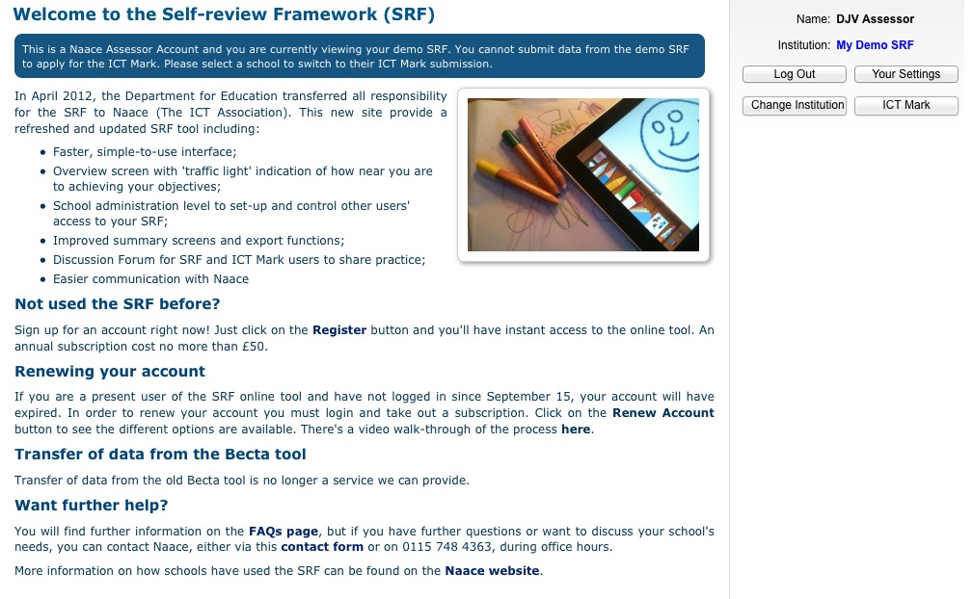
By clicking on the “ICT Mark” button, a list of schools they have been allocated is shown (Here there are two, The May 9th School is the one being used here for the walk through.)
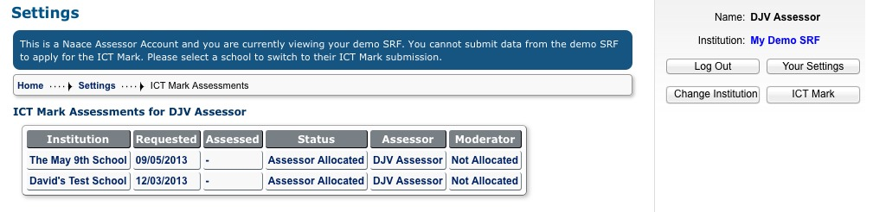
Note that the system warns the Assessor that they are on their “Demo SRF” at the moment. An assessor switches to the appropriate school’s SRF by clicking on name of the school (this can also be done through the “Change Institution” button.
Although the next screen shows the template ‘preparation for visit email’ to be sent to the School Admin, the Assessor, having switched to the school, needs to click on the “Self Review” top menu item to access the school’s SRF and review its contents. (We shall look at the ‘preparation for visit email’ as the next stage.)
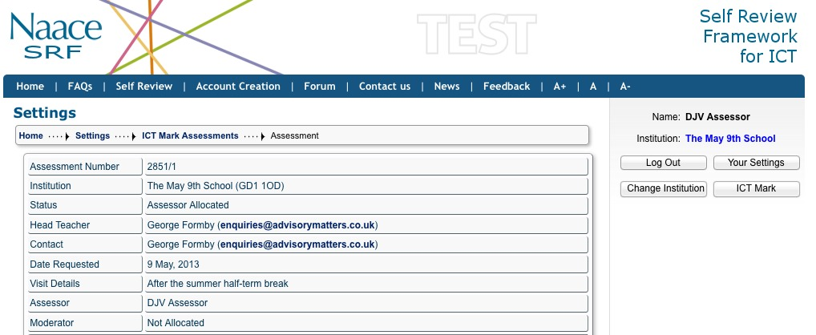
Drilling down to the aspect, the Assessor may individual comments and suggestions using the Assessor field:
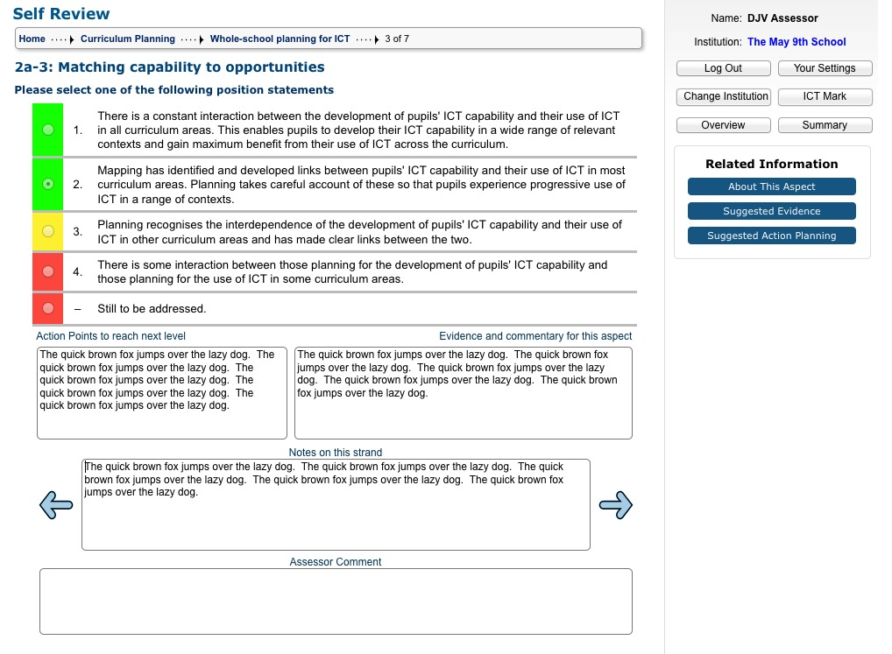
These comments can bee seen by the School Administrator. The Assessor should use these fields to elucidate points or ask for clarification. This should be summarised in the ‘email’ he/she will send to the School Admin to prepare the school for the visit.
Stage 5 – Sending the ‘preparation for visit email’
Once the Assessor has reviewed the SRF of the school he/she uses the ‘preparation for visit email’ template to communicate key information with the school as per the Assessor guidelines. To access this again, click on the “ICT Mark” button and the school concerned.
The template email can be used by the Assessor to provide different information to the school during the process of negotiation for a visit, by selecting different paragraphs during the process, although the intention is that the norm will be to send one email rather than more.
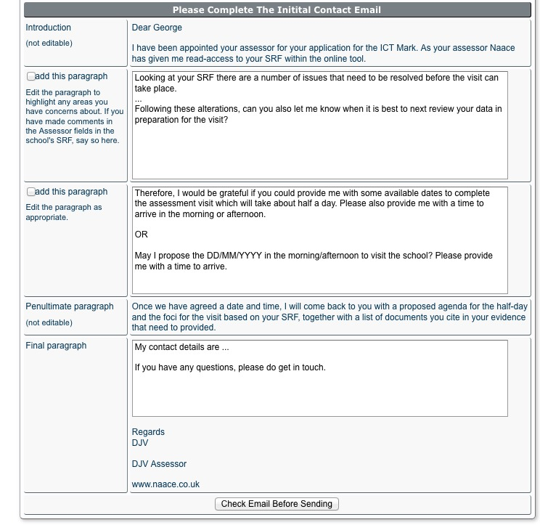
This first paragraph covers points you wish to make that may require a revision of the school’s SRF before the visit.
The second paragraph enables the Assessor or the school to suggest dates for the visit.
Note, the proposed agenda and foci are the subject of a second email.

Clicking on the “Check Email before Sending” button allows the Assessor to check the text, and return if necessary to edit, before sending the email.
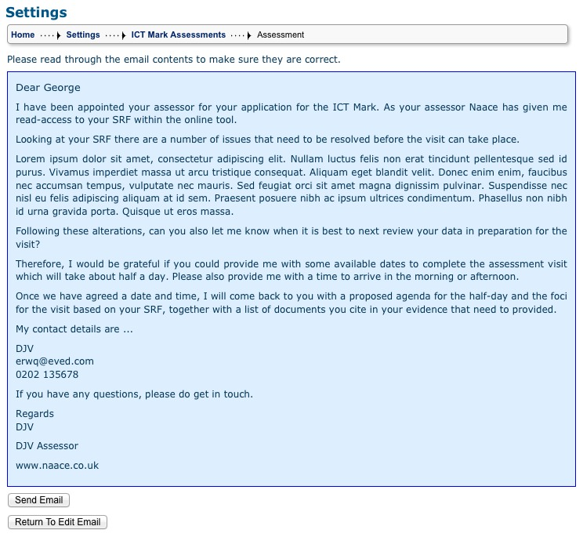
Stage 6 – recording the Assessment visit date, providing the agenda and foci
Assuming that the Assessor and school agree a date via email, the Assessor must record the agreed date on the system. To do this he/she should return to “ICT Mark” screen found under the button of the same name. Note on the screen the Status has changed to “Initial contact made”.
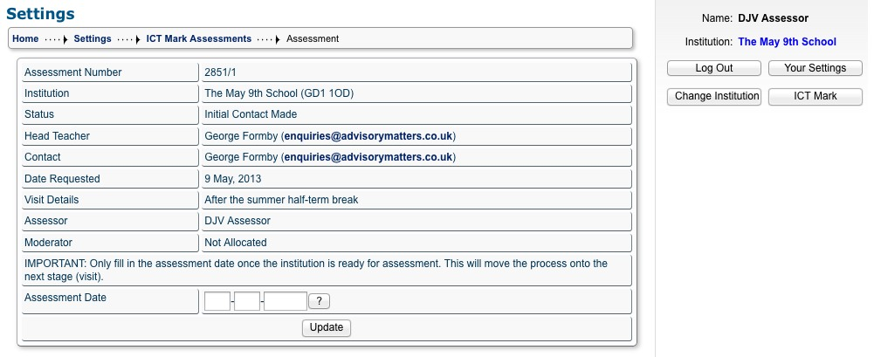
Note also that the Assessor should NOT complete this screen by filling in the Assessment Date unless he/she has deemed the school is ready, as this moves the process on to creating the proposed agenda and providing the foci.
To move that process on, the Assessor fills in the date and updates the record. An email from Naace is sent confirming the visit date:
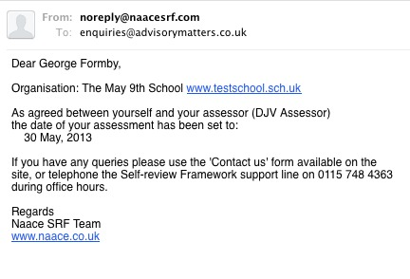
Clicking the “Update” button, provides a screen to provide the foci and proposed agenda for the visit. Guidance on this is found in the Assessor handbook.
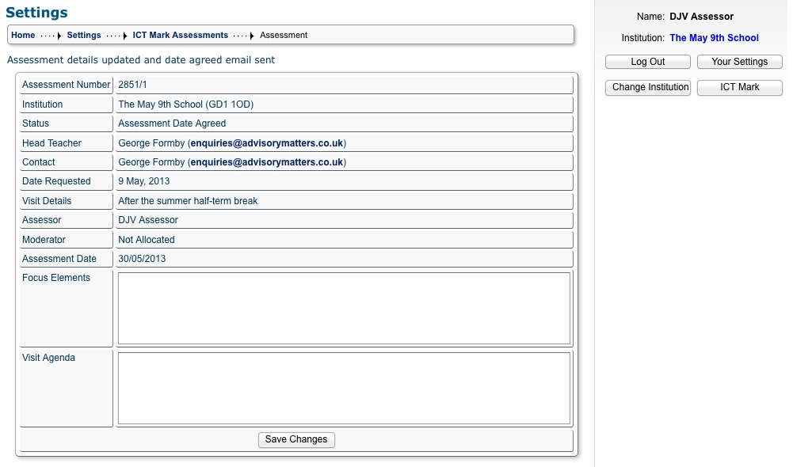
Clicking on “Save Changes” will save the text entered, although it can still be edited for being sent to the school.
The changed screen is shown below:
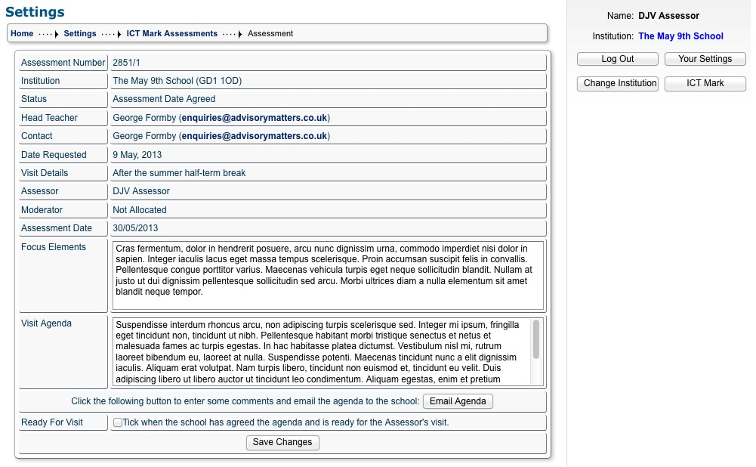

- Clicking on “Save Changes” will simply save any changes the Assessor has made to the text fields.
- Clicking on “Send Agenda” will provide an email with the Agenda, foci and allow some comment text to be added – it can be reviewed before sending using the “Back” button. See:
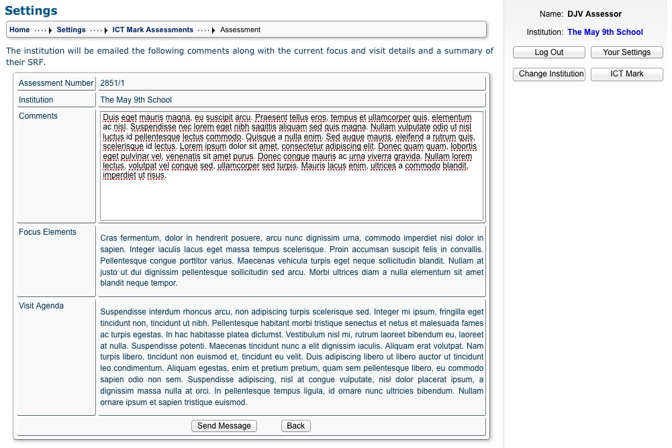
Provided the Assessor is happy, clicking “Send Message” will send the email to the School Admin.
- ONLY when the Agenda has been agreed, should the Assessor tick the “Ready for Visit” box, as this finalises all processes BEFORE the visit. For example, the School cannot alter their SRF text or statements. Click on “Save Changes” with the ““Ready for Visit” box ticked, carries out this act.

NEXT STAGE = ASSESSOR’S REPORT (Code to be completed)

Finally, the system records the History of actions so that the Naace Admin team can see where the Assessor has got with the school. This can be accessed from the School’s record (bottom of the screen – ICT Mark Assessments button):
