Libre Office Save As issue

Note: Below excel was generated using POI-3.8.20120326.jar in java program.
- Sheet having some columns are password protected hence the Libre office give alert that “Protected cells can not be modified”. Eg below screenshot column A, B, C, D, E, G and I are non-editable cause they are password protected and column F, H and J are editable.
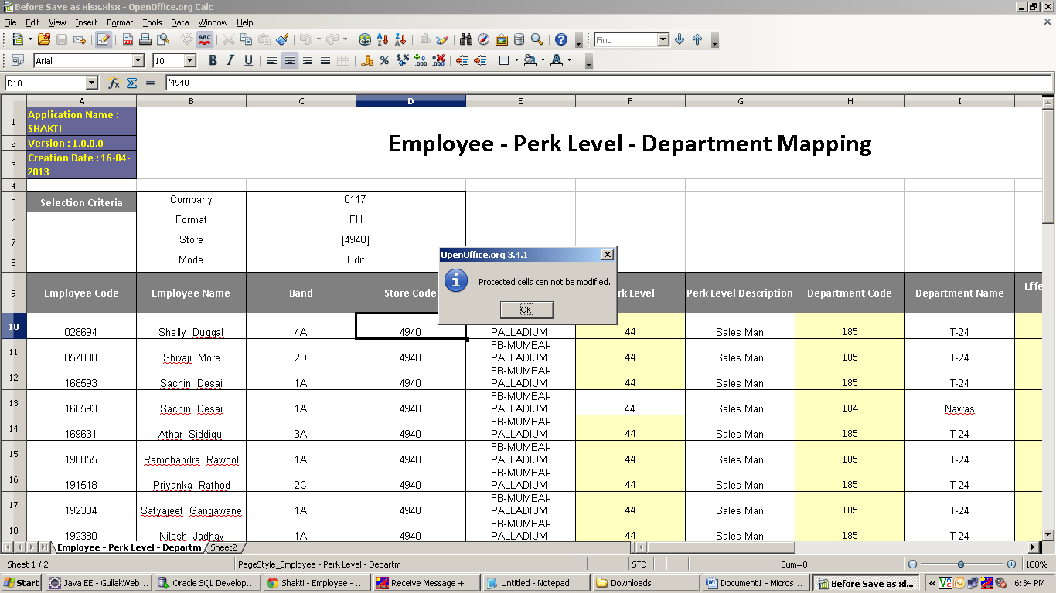

- Now I was trying to edit column F (Which is editable) and try to save file. An alert prompt was display as like below and was go with “Use Microsoft Excel 2007/2010 XML format).
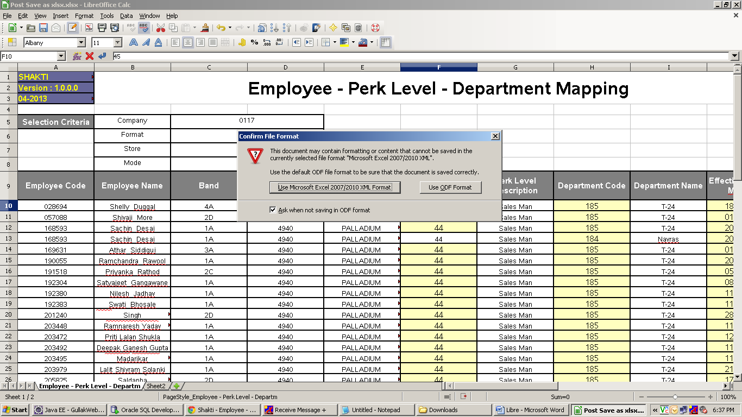

- Open saved file, It seems as like below. Issue with file like
  - All Non-Editable columns now get editable. Hence column A, B, C, D, E, G and I now get editable. It should be non-editable.
  - Cell Border width now get increased.

