

**MediTravel Solutions LLC**

**16516 El Camino Real # 220**

**Houston TX 77062-5723**

**Medical Tourism Provider Assessment**

**Name of Hospital/Clinic:** HOSPITAL MEXICO AMERICANO S.C.

**Date of Commencement:** 17-02-1958

**Address:** Calle Colomos 2110 Col. Ladrón de Guevara

**Website:** [www.hma.com.mx](http://www.hma.com.mx/)

**Clinic/Hospital Telephone:** 36 48 3333

**Main Contact Name:** Daniel Elí Henriquez Jaimes

**Telephone:** 36 48 3333 Ext. 231

**Email:** henriquezdaniel@hma.com.mx

**Do you use electronic records?** We are in the process of changing over (approximate time 6 months)

**What language is documented in medical forms?** Spanish

**What languages are available for client care?** Spanish and English

**Total number of Inpatient Beds:** 72

**Average number of inpatient beds occupied daily:** 40

**How many outpatients were serviced for the last full year?** Considering those attended in the emergency area, we service an average of 10,000 patients per year.

**Do you have an emergency department?** Yes. There is a stabilization area, and a doctor on duty 24 hours, 365 days/year who is accredited in ATLS and ACLS (Advanced Trauma and Cardiovascular Life Support), with prioritized patient attention procedures in place (Triage).

**If not, how close is the nearest emergency department?** NA

**How many surgical/operating room theaters are located at your facility?** 12 and a delivery room and a room for aquatic deliveries.

**What are the five top surgical, treatment procedures performed and how many were performed in the last full year:**

1. Laparoscopic cholecystectomy

2. Hernioplasty

3. Arthroplasties

4. Kidney transplants (an average of 1 or 2 per month)

5. Deliveries in general (aquatic, cesarean and natural)

**Does your facility own and operate a medical transport service that provides Medical Transport Services?** No, this is outsourced.

**What is the closest Airport to your facility?** 19.6 Miles (About 36 minutes).

**Does your facility provide care in homes or hotels?** No, but care is available through an agency specialized in this type of service.

**What are the 3 closest hotels to your facility:**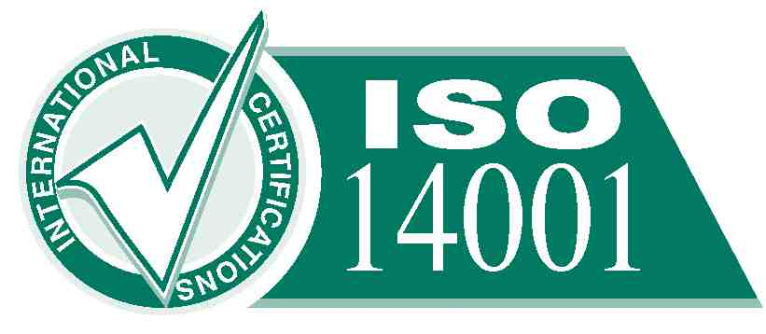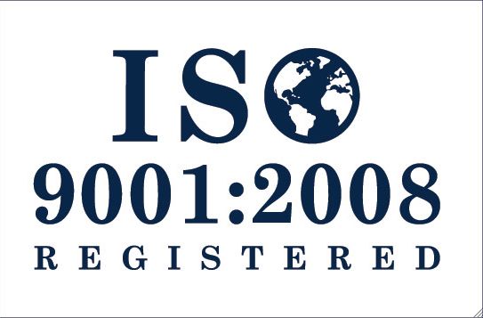

1. Country Plaza Hotel (2.8 miles, 11 minutes)

2. Hotel Fiesta Americana Grand Guadalajara Country Club (1.6 miles, 7 minutes)  
 3. Hotel Quinta Real (2.2 miles, 9 minutes)

**Do you have a preferred rate with these hotels? If so, please explain.** No

**What tourist attractions/ activities are available for medical tourism clients? Please list:**

We do not offer touristic activities, but the following are attractions in the city of Guadalajara.

1. Guadalajara Zoo

2. El trompo mágico (Interactive Museum)

3. The Parían plaza in Tlaquepaque (<http://en.wikipedia.org/wiki/Tlaquepaque>)

**Do you have preferred rates with any of these attractions/activities? If so, please explain.** No

**Does your facility have any certifications/accreditations? Please list.**

**Joint Commission International:** In March of 2010 we received the maximum international hospital accreditation for patient safety. To date we are the only hospital in the west of the country to obtain it.

**Certification by Mexico’s General Health Board:** In March of 2005 we received this certification, after meeting the requirements of the National Certification Program for Medical Establishments.

**Jalisco’s Quality a la Calidad:** In February of 2011 we obtained the Jalisco Prize for Quality, granted by the Government of the State of Jalisco

**ISO 9001:2008:** On July 30, 2007, we received the certificatation from Det Norske Veritas that we adhere to the international quality management system ISO 9001:2008. We were recertified in July of 2010 for a period of 3 years.

**Socially Responsible Company:** We obtained the distinctive “Socially Responsible Company” in February of 2011 from the Mexican Center for Philanthropy (CEMEFI) and the Alliance for Corporate Social Responsibility.

**Distinctive H:** We received the maximum recognition granted by the Boards of Health and Tourism in February of 2009, certifying trustworthiness, higiene and safety in handling of food.

**ISO 14001:2001:** In March of 2011 we received ISO 14001-2004 certification from Det Norske Veritas, endorsing the commitment Mexicano Americano Hospital has with the environment.

**The Best Mexican Companies:** In October of 2011 we received recognition from the Tecnológico de Monterrey, Banamex and Deloitte for companies with high standards of performance in their business practices.

**Additional Information:**