

**Medical Tourism Provider Assessment**

|  |
| --- |
| **Name of Hospital/Clinic:** HOSPITAL MEXICO AMERICANO S.C. |
| **Date of Commencement:** 17-02-1958 |
| **Address:** Calle Colomos 2110 Col. Ladrón de Guevara |
| **Website:** [www.hma.com.mx](http://www.hma.com.mx/) |
| **Clinic/Hospital Telephone:** 36 48 3333 |
| **Main Contact Name:** Daniel Elí Henriquez Jaimes |
| **Telephone:** 36 48 3333 Ext. 231 |
| **Email:** henriquezdaniel@hma.com.mx |
| **Do you use electronic records?** We are in the process of changing over (approximate time 6 months) |
| **What language is documented in medical forms?** Spanish |
| **What languages are available for client care?** Spanish and English |
| **Total number of Inpatient Beds:** 72 |
| **Average number of inpatient beds occupied daily:** 40 |
| **Do you have an emergency department?** Yes. There is a stabilization area, and a doctor on duty 24 hours, 365 days/year who is accredited in ATLS and ACLS (Advanced Trauma and Cardiovascular Life Support), with prioritized patient attention procedures in place (Triage). |
| **If not, how close is the nearest emergency department?** NA |
| **How many surgical/operating room theaters are located at your facility?** 12 and a delivery room and a room for aquatic deliveries. |
| **How many outpatients were serviced for the last full year?** Considering those attended in the emergency area, we service an average of 10,000 patients per year. |
| **What is the closest Airport to your facility?** 19.6 Miles (About 36 minutes). |
| **What are the five top surgical, treatment procedures performed and how many were performed in the last full year:**  1. Laparoscopic cholecystectomy  2. Hernioplasty  3. Arthroplasties  4. Kidney transplants (an average of 1 or 2 per month)  5. Deliveries in general (aquatic, cesarean and natural) |
| **Does your facility own and operate a medical transport service that provides Medical Transport Services?** No, this is outsourced. |
| **Does your facility provide care in homes or hotels?** No, but care is available through an agency specialized in this type of service. |
| **What are the 3 closest hotels to your facility:**  1. Country Plaza Hotel (2.8 miles, 11 minutes)  2. Hotel Fiesta Americana Grand Guadalajara Country Club (1.6 miles, 7 minutes) 3. Hotel Quinta Real (2.2 miles, 9 minutes) |
| **Do you have a preferred rate with these hotels? If so, please explain.** No |
| **What tourist attractions/ activities are available for medical tourism clients? Please list:**  We do not offer touristic activities, but the following are attractions in the city of Guadalajara.  1. Guadalajara Zoo  2. El trompo mágico (Interactive Museum)  3. The Parían plaza in Tlaquepaque (<http://en.wikipedia.org/wiki/Tlaquepaque>) |
| **Do you have preferred rates with any of these attractions/activities? If so, please explain.** No |

**Does your facility have any 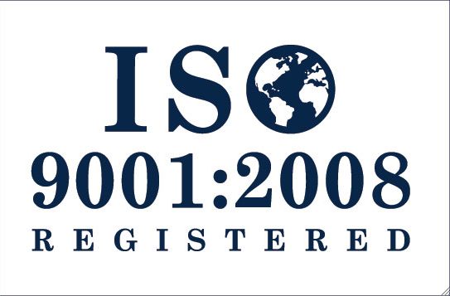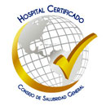certifications/accreditations? Please list.**

|  |  |  |  |  |  |  |  |  |
| --- | --- | --- | --- | --- | --- | --- | --- | --- |
| |  |  |  |  | | --- | --- | --- | --- | | **Joint Commission International**  In March of 2010 we received the maximum international hospital accreditation for patient safety. To date we are the only hospital in the west of the country to obtain it. | **Certification by Mexico’s General Health Board**  In March of 2005 we received this certification, after meeting the requirements of the National Certification Program for Medical Establishments. | **Jalisco’s Quality a la Calidad**  In February of 2011 we obtained the Jalisco Prize for Quality, granted by the Government of the State of Jalisco | **ISO 9001:2008**  On July 30, 2007, we received the certificatation from Det Norske Veritas that we adhere to the international quality management system ISO 9001:2008. We were recertified in July of 2010 for a period of 3 years. | | **Socially Responsible Company**  We obtained the distinctive “Socially Responsible Company” in February of 2011 from the Mexican Center for Philanthropy (CEMEFI) and the Alliance for Corporate Social Responsibility. | **Distinctive H**  We received the maximum recognition granted by the Boards of Health and Tourism in February of 2009, certifying trustworthiness, higiene and safety in handling of food. | **ISO 14001:2001**  In March of 2011 we received ISO 14001-2004 certification from Det Norske Veritas, endorsing the commitment Mexicano Americano Hospital has with the environment. | **The Best Mexican Companies**  In October of 2011 we received recognition from the Tecnológico de Monterrey, Banamex and Deloitte for companies with high standards of performance in their business practices. | |
| **Additional Information** |