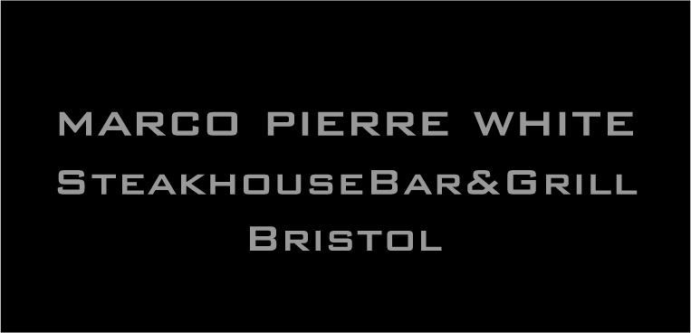

PRIVATE DINNER MENU
(choices to be pre-ordered in advance)
_______________________________________________
HORS D’OEUVRES
White Onion & Cider Soup
Crispy Duck, Watermelon and Beansprouts
Sautéed Chicken Livers, Button Mushrooms, Toasted Brioche
_______________________________________________
MAIN COURSES

Fish Pie, Duchess Potatoes, Creamed Spinach
Chicken Breast, Pomme Puree, Buttered Savoy, Mushroom & Tarragon Sauce
Leek and Wild Mushroom Pithivier
6oz Rib Eye Steak, Grilled Tomato, Triple Cooked Chips, Pepper Sauce - £3.00 Supplement
(all served with a selection of vegetables)
____________________________________________________________

PUDDINGS

Sticky Toffee Pudding
Mixed Berry Eton Mess
A Selection of Local Cheese

COFFEE

Service not included.
Please note that some of our dishes may contain nuts or traces of nuts.

