A picture should be under this string

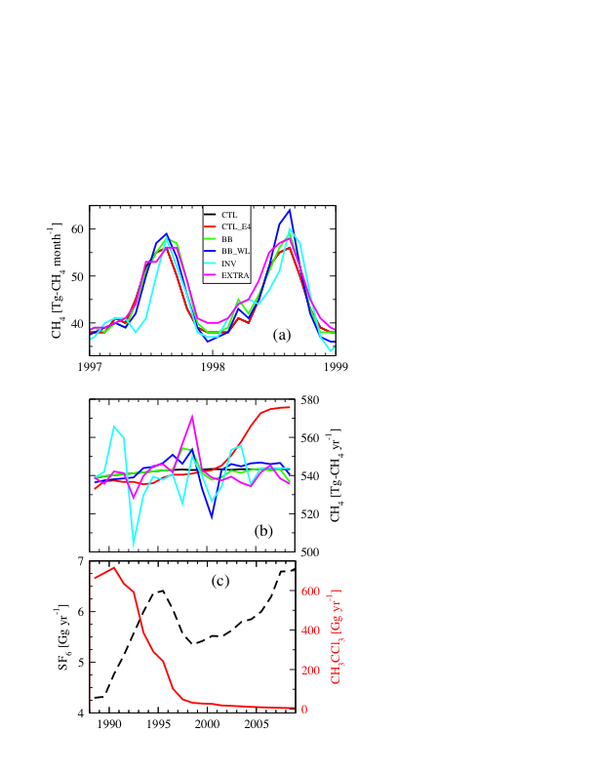

**Figure 2.** The average CH4