Images cropped in LO

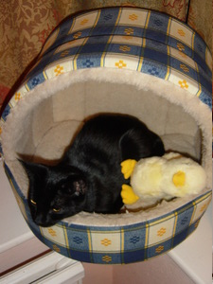
uncropped

cropped from top

Cropped from bottom

