Images cropped in LO

uncroppedA description...

cropped from top

A description...

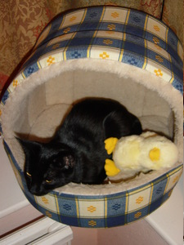

Cropped from bottom