PREDICTING THERMAL TRANSMITTANCE OF IGU SUBJECT TO DEFLECTION

Prepared by: Dr. Charlie Curcija, Simon Vidanovic
Lawrence Berkeley National Laboratory
Date: 7/16/2012

INTRODUCTION
Deflection of insulated glazing unit (IGU) can result in thermal performance degradation or improvement due to the reduction or increase of gap space width. Convection of the gas fill is affected by changed gap space and due to modified convection pattern and shorter or longer thermal path at the center of the glazing unit can result in increased or decreased thermal performance. For the most part, U-factor is mostly affected as a direct result of changed thermal performance; however note that solar heat gain through the window (SHGC) can also be affected because of the effect of inward flowing fraction of absorbed solar radiation, which is affected by thermal performance of the IGU.
Deflection in sealed IGU is caused by the difference in gas pressure in IGU gap vs. outdoor/indoor pressure. Indoor and outdoor pressure can be considered equal, since indoor building environment is in pretty good contact with outdoor environment. We will call this pressure an atmospheric pressure, P_{a}. The differences in pressure between atmospheric and gap pressure is due to several factors, listed here:
- Difference in atmospheric pressure between IGU fabrication location and end use location
- Difference in temperature during fabrication and actual operating conditions for the glazing. It should be noted that initial temperature can be higher than ambient temperature during fabrication process, due to elevated sealant temperatures, which can raise local temperatures within the IGU.
- Unbalanced gas fill leakage through the sealants, resulting in lower gap pressure and inward deflection.
- Wind or static load pressure
Effects 1 and 2 will be modeled using equations presented below, while effect 3 does not have credible mathematical model. However, cumulative deflection, resulting from all three effects can be measured in the field and its effect on thermal performance can be modeled by specifying center glazing deflection.
Wind or static load pressure effects on deflection is not included in this model at this time, but will be considered for future versions.
Recognizing that indoor and outdoor air pressure could be different, such as in hot box test environment, future plans for the extension of the model will include option to specify different values for indoor and outdoor pressure. Another future improvement to the model will also include linking certain air gaps with indoor or outdoor environment, meaning that respective pressures in linked spaces will be set to equal.

MATHEMATICAL MODEL
Mathematical model described in detail here is based on the research work by Bernier and Bourret (1997) and Timoshenko and Woinowsky-Krieger (1959). Bernier and Bourret (1997) of the Ecole Polytechnique Montréal adopted Timoshenko and Woinowsky-Krieger (1959) model for calculating flat plate deflection subjected to the differential pressure field (static), while their original contribution was to develop correlations for changes in thermal performance, based on IGU deflection at the center of glazing location. In addition to adopting Bernier and Bourret (1997) model here, we have also developed model for calculating change in thermal performance of deflected units when this deflection is measured in the field. Therefore, the mathematical formulation, presented here is divided into two sections; 1) calculation of the deflection and resulting thermal performance caused by pressure and temperature effects and 2) calculation of the thermal performance of the IGU when the deflection is measured.

Calculation of the Deflection and Resulting Thermal Performance caused by Pressure and Temperature Effects
If coordinate system is set as shown in Figure 1 and Figure 2,
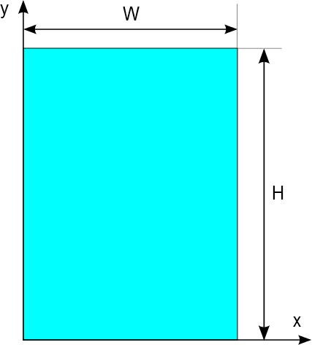
Figure 1. Deflection Coordinate System – 2D

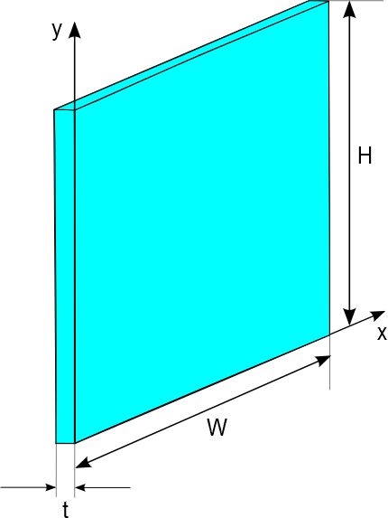
Figure 2. Deflection Coordinate System - 3D
it is possible to calculate deflection distribution at each point of pane by using following equation:
$L_{D(i)}\left(x,y\right)=\frac{16∙{∆P}_{(i)}}{π^{6}∙D_{(i)}}\sum_{m=1,3,5…}^{∞}{\sum_{n=1,3,5…}^{∞}{\frac{\sin{\frac{mπx}{W}}\sin{\frac{nπy}{H}}}{mn{\left({\left(\frac{m}{W}\right)}^{2}+{\left(\frac{n}{H}\right)}^{2}\right)}^{2}}}}$ | Eq.1
Where,
$D_{(i)}=\frac{E∙t_{(i)}^{3}}{12∙\left(1-ν^{2}\right)}$ | Eq.2
Where,
E = Young’s modulus (7.2 x 10¹⁰) [Force per unit Area; SI: Pa, IP: psi]
t = thickness of glazing pane [Length; SI: m, IP: in.]
ν = poison’s ratio (0.22 for glass) [Non-Dimensional]
ΔP_{i} = P_{gap(i)} - P_{gap(i-1)} (for i-th pane) [Force per unit Area; SI: Pa, IP: psi] | Eq.3
ΔP_{i} = P_{gap(1)} - P_{a} (first pane) [Force per unit Area; SI: Pa, IP: psi] | Eq.4
ΔP_{i} = P_{a} - P_{gap(n-1)} (last pane) [Force per unit Area; SI: Pa, IP: psi] | Eq.5
Where,
P_{a} = atmospheric pressure. [Force per unit Area; SI: Pa, IP: psi]
$P_{gap(i)}=\frac{P_{ini}V_{ini(i)}T_{gap(i)}}{T_{ini}V_{gap(i)}}$ | Eq.6
Where,
P_{ini} = Initial pressure. Applies to all gaps as a single value (input data - measured or otherwise) [Force per unit Area; SI: Pa, IP: psi]
T_{ini} = Initial temperature. Applies to all gaps as a single value (input data - measured or otherwise) [Degree Temperature; SI: K, IP: R]
V_{ini(i)} = Initial volume for i-th gap. [Lentgh*Length*Length; SI: m³, IP: in³]
$V_{ini(i)}=L_{i}∙W∙H$ | Eq.7
Where,
L_{i} = non-deflected glazing gap width (for i-th gap) [Length; SI: m, IP: in.]
W = IGU width [Length; SI: m, IP: in.]
H = IGU height [Length; SI: m, IP: in.]
T_{gap(i)} = temperature of the gap between two glass panes (calculated using center of glazing thermal calculation algorithm, as described in ISO 15099 (ISO 2003). This value is first calculated using non-deflected state and is recalculated after the resulting deflection is calculated. This process is repeated until temperature at next iteration does not differ by more than 0.1 ºC
V_{gap(i)} = volume of the IGU gap in deflected state [Lentgh*Length*Length; SI: m³, IP: in³]
$V_{gap(i)}=V_{ini(i)}+W∙H∙\left(\overline{L_{D,i}}-\overline{L_{D,i+1}}\right)$ | Eq.8
Where,
$\overline{L_{D,i}}$ is mean deflection value for i-th pane. [Length; SI: m, IP: in.]
Deflection of each pane can be positive or negative and is done solely to establish reference. Current frame of reference is that positive deflection means that pane is deflecting towards left side, while negative deflection means that pane is deflecting towards right side (Figure 3). Whether the deflection is in the direction of reducing the gap width or increasing it, it will be the result of pressure difference, as described in Eq.1. When pressure in the glazing unit is higher than surrounding environmental pressure, the deflection will be towards increasing gap width (i.e., ballooning), while the opposite situation will result in decreasing gap width (i.e., vacuuming)
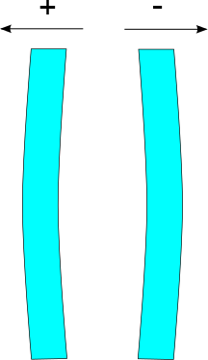
Figure 3. Deflection Direction Convention
Important part of calculating deflection of the IGU is to determine mean deflection value for each glazing pane. Mean deflection value is used to calculate gap volume in deflected state (Eq.8). Mean deflection of glazing pane can be calculated by integrating Eq.1:
$\overline{L_{D(i)}}=\int_{x=0}^{W}{\int_{y=0}^{H}{\frac{16∙{∆P}_{(i)}}{π^{6}∙D_{(i)}}\sum_{m=1,3,5…}^{∞}{\sum_{n=1,3,5…}^{∞}{\frac{\sin{\frac{mπx}{W}}\sin{\frac{nπy}{H}}}{mn{\left({\left(\frac{m}{W}\right)}^{2}+{\left(\frac{n}{H}\right)}^{2}\right)}^{2}}}}}}$ | Eq.9
Which is identical with the following expression:
$\overline{L_{D(i)}}=\frac{16∙{∆P}_{(i)}}{π^{6}∙D_{(i)}}\sum_{m=1,3,5…}^{∞}{\sum_{n=1,3,5…}^{∞}{\frac{\int_{x=0}^{W}{\int_{y=0}^{H}{\sin{\frac{mπx}{W}}\sin{\frac{nπy}{H}}}}}{mn{\left({\left(\frac{m}{W}\right)}^{2}+{\left(\frac{n}{H}\right)}^{2}\right)}^{2}}}}$ | Eq.10
and because integral of sin(x) is equal with –cos(x), above equation will become:
$\overline{L_{D(i)}}=\frac{16∙{∆P}_{(i)}}{π^{6}∙D_{(i)}}\sum_{m=1,3,5…}^{∞}{\sum_{n=1,3,5…}^{∞}{\frac{(1-cos\left(mπ\right))(1-cos\left(nπ\right))}{mn{\left({\left(\frac{m}{W}\right)}^{2}+{\left(\frac{n}{H}\right)}^{2}\right)}^{2}}}}$ | Eq.11
Finally, because $cos\left(mπ\right)$ and $cos\left(nπ\right)$ values are always equal to -1 for the given range of m and n, above equation will became:
$\overline{L_{D(i)}}=\frac{16∙{∆P}_{(i)}}{π^{6}∙D_{(i)}}\sum_{m=1,3,5…}^{∞}{\sum_{n=1,3,5…}^{∞}{\frac{4}{m^{2}n^{2}π^{2}{\left({\left(\frac{m}{W}\right)}^{2}+{\left(\frac{n}{H}\right)}^{2}\right)}^{2}}}}$ | Eq.12
After calculating mean pane deflection the following equation is used to calculate mean gap width:
$L_{r(i)}=L+\left(\overline{L_{D,(i)}}-\overline{L_{D,(i+1)}}\right)$ | Eq.13
Where,
L_{r(i)} = Mean gap “i” width after incorporating glazing deflection. This mean gap width is used to recalculate thermal performance of deflected IGU.
$\overline{L_{D,i}}$ = mean glazing deflection for each pane “i”.
Calculation of the deflection at the center of glazing and mean glazing deflection for each pane is an iterative process, where the initial temperature distribution is calculated for non-deflected state, then deflection is calculated based on this temperature distribution, new temperature distribution is calculated for this deflected state, then temperatures from previous iteration are compared to the current iteration and the process is repeated until the difference is no larger than 0.1 ºC.
At the end of calculations, program will calculate and return maximum deflection value for each pane (i.e., center of glazing deflection). If we label maximum deflection of each pane as L_{D(i),max}, we can calculate this value by substituting x=W/2 and y=H/2 in equation Eq.1 to determine deflection at the center point. Therefore,
$L_{D(i),max}=\frac{16∙{∆P}_{(i)}}{π^{6}∙D_{(i)}}\sum_{m=1,3,5…}^{∞}{\sum_{n=1,3,5…}^{∞}{\frac{\sin{\frac{mπ}{2}}\sin{\frac{nπ}{2}}}{mn{\left({\left(\frac{m}{2}\right)}^{2}+{\left(\frac{n}{2}\right)}^{2}\right)}^{2}}}}$ | Eq.14
For glazing systems with more than two glazing layers, meaning multiple gas filled gaps, the deflection will be calculated for each glazing pane assuming that the pressure in a gap is independent from each other and calculated separately, unless spaces are “linked” together (e.g., stretched film middle glazing that has hole for equalizing pressure).
Non-Linked Gaps in 3 or more glazing layer system:
The procedure shown above generally applies to the 3 or more layer glazing system, with the exception that neighboring pressures are no longer P_{a}, but rather could be P_{a} on one side and P_{gap} on the other, or have P_{gap} on both sides, as shown in Figure 6 for gap “i”. Center of glazing thermal calculation will determine new temperature distribution, after deflection is calculated for each glazing and will be used to determine new P_{gap}, as per the procedure above.
Linked Gaps in 3 or more glazing layer system:
When one or more gaps are linked together, their pressure is assumed to be identical (e.g., in triple glazing IGU P_{gap,1} = P_{gap,2}.) This pressure is calculated from temperatures of bounding glazing for linked gaps (e.g., for triple glazing IGU, glazing 1 and 3) and using neighboring pressures outside of those bounding glazing (e.g., for triple glazed IGU, P_{a} on both sides).
Note: This feature is not implemented in WINDOW 7.1. It is considered for future enhancements to the program.
Gap(s) Linked to Indoor or Outdoor Environment:
If one or more glazing gaps are linked to either indoor or outdoor environment its pressure is fixed to P_{a}. In combination situations, such as two or more gaps linked together with one of them being linked to indoor or outdoor environment, they will all have fixed pressure of P_{a}.
Note: This feature is not implemented in WINDOW 7.1. It is considered for future enhancements to the program.

Calculation of the Thermal Performance of the IGU When the Deflection is Measured
When deflection is measured, it is normally measured at the point of maximum deflection. Maximum deflection occurs at center of the IGU (at W/2 and H/2).
Measured value is typically gap width at the point of maximum deflection, which we can label L_{G(i)}. For i-th measured gap the width is equal to:
$L_{G(i)}=L_{(i)}+(L_{D(i),max}-L_{D(i+1),max})$ | Eq.15
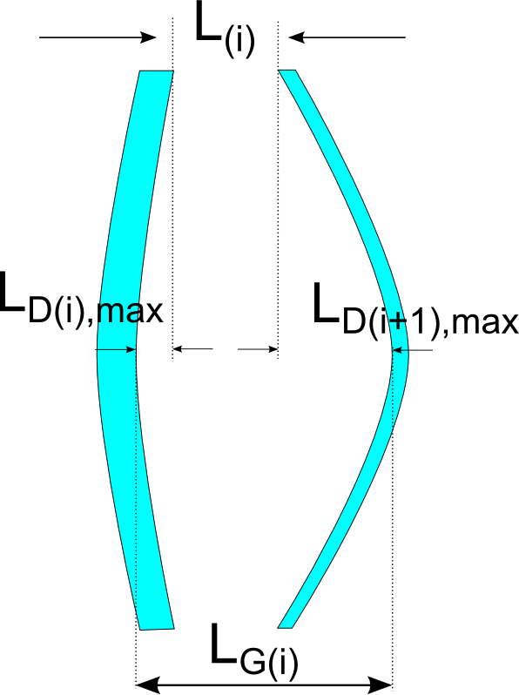
Figure 4. Sketch of the non-symetrically Deflected Glazing Panes
If we label ratio of mean deflection and maximum deflection as R_{(i)}, then:
$R_{(i)}=\frac{\overline{L_{D(i)}}}{L_{D(i),max}}=\frac{\sum_{m=1,3,5…}^{∞}{\sum_{n=1,3,5…}^{∞}{\frac{4}{m^{2}n^{2}π^{2}{\left({\left(\frac{m}{W}\right)}^{2}+{\left(\frac{n}{H}\right)}^{2}\right)}^{2}}}}}{\sum_{m=1,3,5…}^{∞}{\sum_{n=1,3,5…}^{∞}{\frac{\sin{\frac{mπ}{2}}\sin{\frac{nπ}{2}}}{mn{\left({\left(\frac{m}{2}\right)}^{2}+{\left(\frac{n}{2}\right)}^{2}\right)}^{2}}}}}$ | Eq.16
Important thing to note is that ratios ($R_{\left(i\right)}$) for all gaps in glazing system are equal.
$R_{(1)}=R_{(2)}=…=R_{\left(i\right)}=…=R_{\left(n-1\right)}=R$ | Eq.17
Replacing Eq.16 and Eq.17 into Eq.13 the following equation is obtained:
$L_{r(i)}=L_{(i)}+R\left(L_{D\left(i\right),max}-L_{D\left(i+1\right),max}\right)$ | Eq.18
Combining Eq.18 with Eq.15 we get the following expression for the mean gap width:
$L_{r(i)}=L_{(i)}+R\left(L_{G\left(i\right)}-L_{\left(i\right)}\right)$ | Eq.19
Number of equations given in expression Eq.15 is equal to n-1, where n is number of panes. Therefore, we need one more equation to complete the system of equations that would allow us to solve for all independent variables. To get the last equation we can rewrite Eq.14 in slightly different manner:
$L_{D(i),max}=\frac{{∆P}_{(i)}}{D_{(i)}}∙K$ | Eq.20
Where coefficient K combines all constant terms, while $D_{(i)}$ is given by Eq.2 and ${∆P}_{(i)}$ is calculated by Eq.3, Eq.4 and Eq.5. Summing over all deflections, $L_{D(i),max}$ the following equation is obtained:
${\sum_{i=1}^{n}{\frac{D_{(i)}}{K}}∙L}_{D(i),max}=\sum_{i=1}^{n}{{∆P}_{(i)}}=0$ | Eq.21
Note that sum of all ${∆P}_{(i)}$ is equal to zero since outside pressure is equal to inside. Therefore, the remaining equation that completes the set of equations is:
${\sum_{i=1}^{n}{D_{(i)}}∙L}_{D(i),max}=0$ | Eq.22

Solving System of Equations
In order to solve system of equations we will present Eq.15 in slightly different manner:
$0=L_{(i)}-L_{G\left(i\right)}+L_{D(i),max}-L_{D(i+1),max}$ | Eq.23
Which in developed form will look like this:
$0=L_{(1)}-L_{G\left(1\right)}+L_{D(1),max}-L_{D(2),max}$  $0=L_{(2)}-L_{G\left(2\right)}+L_{D(2),max}-L_{D(3),max}$  .  .  .  $0=L_{(i)}-L_{G\left(i\right)}+L_{D(i),max}-L_{D(i+1),max}$  .  .  .  $0=L_{(n-1)}-L_{G\left(n-1\right)}+L_{D(n-1),max}-L_{D(n),max}$ | Eq.24
In order to express each $L_{D(i),max}$ as dependence from $L_{D(n),max}$ (deflection of inside/last pane) we will need to make sum from first to last, then from second to last, third to last and so on. This procedure will create following set of equations:

$L_{D(1),max}=\sum_{k=1}^{k=n-1}{(L_{G(k)}-L_{(k)})}+L_{D(n),max}$  $L_{D(2),max}=\sum_{k=2}^{k=n-1}{(L_{G(k)}-L_{(k)})}+L_{D(n),max}$  .  .  .  $L_{D(i),max}=\sum_{k=i}^{k=n-1}{(L_{G(k)}-L_{(k)})}+L_{D(n),max}$  .  .  .  $L_{D(n-1),max}=\sum_{k=n-1}^{k=n-1}{(L_{G(k)}-L_{(k)})}+L_{D(n),max}$ | Eq.25
Now replacing this set of equations back to Eq.22:
$\sum_{i=1}^{n-1}{D_{(i)}∙(\sum_{k=i}^{k=n-1}{\left(L_{G\left(k\right)}-L_{\left(k\right)}\right)}+L_{D(n),max})} + D_{(n)}∙L_{D\left(n\right),max}=0$ | Eq.26
Which solving by $L_{D\left(n\right),max}$ leads to the following equation:
$L_{D\left(n\right),max}=\frac{\sum_{i=1}^{n-1}{{(D}_{(i)}∙\sum_{k=i}^{k=n-1}{\left(L_{\left(k\right)}-L_{G\left(k\right)}\right))}}}{\sum_{i=1}^{n}{D_{(i)}}}$ | Eq.27
Calculating $L_{D\left(n\right),max}$ value from this equation and substituting it in Eq.25 will enable calculation of the deflection of remaining panes.

REFERENCES
Bernier, M.A.; Bourret, B. 1997. “Effects of Glass Plate Curvature on the U-Factor of Sealed Insulated Glazing Units”. ASHRAE Transactions. Vol. 103, Pt. 1. American Society for Heating, Refrigerating and Air-Conditioning Engineers. Atlanta, GA. January 1997.
Timoshenko, S.; Kreiger-Woinowsky, S. 1959. Theory of Plates and Shells. McGraw-Hill Book Company. 2nd Edition.
ISO. 2003. “ISO 15099: Thermal performance of windows, doors and shading devices - Detailed calculations.” International Standards Organization, Geneva, Switzerland.

