

CITY OF KITCHENER – INFRASTRUCTURE SERVICES DEPARTMENT

Stormwater Utility Group

200 King Street West

Kitchener, Ontario

Canada, N2G 4G7

To whom it may concern,

Please find enclosed an introduction to the stormwater credit program, a printed version of the residential stormwater credit application form, terms and conditions to participate the program and a ‘How To’ insert to assist you in completing the application. Please return the competed application and ensure all mandatory fields are entered so that we are able to process your application.

For residential property owners we encourage the easy to use online application form ([http://app.kitchener.ca/wizard/](http://app.kitchener.ca/wizard/Start.aspx)). You may also print a version of the application from our website, pick up a copy from the front desk at City Hall or request the application be mailed to your house or workplace. Completed applications may be submitted in person to the Engineering department on the 9th floor of the Eby Tower at City Hall, or mailed into City hall at the address provided below. You may also submit your completed application or any inquiries to our email address at [stormwater@kitchener.ca](mailto:stormwater@kitchener.ca).

We have included a Frequently Asked Questions section for resolution to common problems and encourage you to visit our website at [www.kitchener.ca/stormwatercredits](http://www.kitchener.ca/stormwatercredits) for additional information. Do not hesitate to contact us if you have any remaining questions.

Sincerely,

Matt Wilson, M.Eng., P.Eng.

Stormwater Technologist

519-741-3400 ext.3255



# About the stormwater credit program

(Residential)

In March 2012, council approved the stormwater credit policy. These incentives are provided to property owners who use best management practices (BMPs) to reduce the quantity and improve the quality of stormwater runoff entering the municipal stormwater system. Encouraging the use of stormwater BMP’s supports the city’s stormwater management policies and water quality initiatives.

Property owners will be able to apply for stormwater credits of up to 45% of the stormwater portion of their utility bill beginning Oct. 1, 2012. If approved, credits will be applied to the stormwater portion of your regular utility bill starting in January 2013.

Eligible credits will be applied retroactively to either the date the BMP was installed or Jan. 1, 2011 (whichever is the most recent). The deadline to apply for retroactive credits is March, 1, 2013. After March 1, 2013, credits will be applied effective the date the application was received by the city. Retroactive credits will be processed as a one-time adjustment to your utility account.

## There are two different credit applications – residential and non-residential. Use this residential application if you own the following types of property:

* single detaches homes
* semi-detached homes
* townhomes
* condominiums
* duplex, triplex, four-plex and five-plex homes

Please apply using the non-residential application if you own the following types of property:

* industrial
* commercial
* retail
* institutional
* multi-residential buildings with more than five dwelling units

## About the Residential Credit Application

Please use this application (below) to tell us how you manage stormwater on your property. If you own multiple residential properties, you must complete a separate application for each property. Approved stormwater best management practices for residential properties include:

* Rain barrels
* Cisterns
* Infiltration galleries
* Rain gardens
* Permeable pavers

If eligible, you can receive up to 45% of the stormwater portion of your utility bill based on the amount of stormwater you are able to divert from the municipal stormwater system. In general, the more storage for stormwater that you provide using these methods the larger the rebate received (see table below).

Residential Quantity Control BMP Credit Values

|  |  |  |  |
| --- | --- | --- | --- |
| Credit Type | Volume Captured | Examples | Credit |
| Basic Residential Credit | 200 – 800 L | 1-4 rain barrels  small cistern | 20% |
| Normal Residential Credit | 801 – 3200 L | large cistern  combination of cisterns and rain barrels | 30% |
| Enhanced Residential Credit | 3201 L or more | large cistern  infiltration gallery | 45% |
| Note: The minimum volume eligible for a credit is 200 litres (L) | | | |

In order to complete this form you will need:

* a copy of your utility bill
* the measurements of the best management practices you use to manage stormwater or the volume of water stored.



**RESIDENTIAL STORMWATER CREDIT APPLICATION FORM**

Utility Account Number: ________________________________



(Please enter your 9 digit account number as it appears on your bill.)

Name: _________________________________________

(Please enter exactly as it appears on the bill.)

SEQ ID: ________________________________________

Contact Phone Number: __________________________

Email Address: _____________________________________________________________________________________

Address for which the stormwater credit applies:

_________________________________________________________________________________________________

*Why are we collecting this information?*

Any personal information collected herein, is collected for the administration for the stormwater management program pursuant to the Municipal Freedom of Information and Protection of Privacy Act (MFIPPA) and may be used by various divisions of The City of Kitchener under Sections 31 and 32 of MFIPPA. Your contact information required in case city staff need to clarify information collected on your credit application in order to process it. Where personal information provided on this application is inconsistent with existing city records, it may be used to update our internal records and could be used for various enforcement purposes. For any inquiries about the collection, use or disclosure of your personal information contained on this form please contact:

|  |  |
| --- | --- |
| **In person** | Kitchener City Hall is located at 200 King Street West.  Regular office hours are 8:30 a.m. to 5 p.m., Monday to Friday.  Visit the City of Kitchener's Welcome Centre on the first floor of City Hall. We'd be happy to assist you in finding the information and support you need. |
| **Phone** | City of Kitchener - Stormwater Utility Group  519-741-3400 ext. 3255 |
| **TTY** | TTY is a telephone system for deaf and hard of hearing callers 1-866-969-9994 |
| **Email** | [stormwater@kitchener.ca](mailto:stormwater@kitchener.ca) |
| **Mail** | City of Kitchener – Stormwater Utility Group PO Box 1118 Kitchener, ON Canada, N2G 4G7 |

Check all the stormwater best management practices that you use to control runoff from your property.

**Typical Best Management Practices:**

|  |  |
| --- | --- |
| Type | Details |
| Rain barrels | Barrels (1 to 4) Barrels (5 or more)  What is the volume of water your typical best management practice designed to accommodate?  Water Volume (minimum 200 Litres):_________________  *A **typical** rain barrel holds 200 Litres.  *See insert for help with entering this information |
|  |  |
| Cistern | What is the volume of water your typical best management practice designed to accommodate?  Water Volume (minimum 200 Litres): ________________  *See insert for help with entering this information |

**Enhanced Best Management Practices:**

|  |  |
| --- | --- |
| Type | Details |
| Infiltration Gallery | Installed by Home builder  Installed by Homeowner / Contractor  Length (In metres):_________ Width (In metres):_______  Depth (In metres):__________  *See insert for help with entering this information |
|  |  |
| Rain Garden | Collects runoff from driveway  Collects runoff from downspout  Length (In metres):_________ Width (In metres):_______  Depth of bioretention media (In metres):__________  Depth of gravel base (if applicable):___________  *See insert for help with entering this information |
|  |  |
| Permeable Pavers | Length (In metres):_________ Width (In metres):________  Depth of gravel base (In metres):_________  Depth of sub base(If applicable):__________  *See insert for help with entering this information |

When was the install date of the largest volume (most effective) stormwater best management practice on the property for which you are applying to receive stormwater credits? (mm/dd/yyyy): ____________________________________

Where did you hear about the stormwater credit program? Check as many as apply.

|  |  |  |  |  |  |
| --- | --- | --- | --- | --- | --- |
| Utility Bill Insert |  | Ad in Kitchener paper |  | Ad in Citizen |  |
| Facebook Ad |  | KW Review |  | Direct mail |  |
| Twitter |  | Through a friend |  | Newspaper |  |
| Website |  | REEP/RAIN |  | Other |  |

TERMS AND CONDITIONS

Residential property owners with single detached homes or multi-residential buildings with up to five units per building may qualify for rate credits when the Applicant can demonstrate that the property owned by the Applicant (the “Property”) contains impervious areas that are directed to approved, or in accordance with, stormwater quantity and/or quality best management practices (“BMP”). The BMP must provide the City with a cost savings that the City otherwise would incur as part of their efforts to manage stormwater.

Restrictions

1. No public or private property shall be eligible to receive credits for any condition or activity unrelated to the reduction of the City’s cost of providing stormwater management services, as determined by the Director of Engineering;
2. Credits will not apply to fees attributable to new development or redevelopment projects;
3. Any stormwater BMP off site or within a permanent easement maintained by the City shall not be eligible for a credit; and,
4. Credits shall only be given to the registered owner of the Property.

Conditions and Requirements

1. The Applicant shall complete a stormwater credit registration form (the “Form”). The Form may be printed or electronic, and may be submitted with supporting documentation (if required) by mail, fax or over the internet;
2. A signed Form shall constitute authority for the City to perform limited announced inspections of the Property to determine the eligibility of the on-site stormwater BMPs, and the accuracy of the credit calculation. The inspection shall be limited to stormwater BMPs and other elements described in the registration. The City shall schedule the inspections at a date and time that is mutually acceptable to both parties. The City will offer the Applicant at least one (1) opportunity to reschedule to a mutually agreeable date and time;
3. Credits will only be applied if requirements in this schedule are met, including but not limited to: completion of ongoing maintenance and guaranteed right-of-entry for inspections, on an annual basis, as at the discretion of the Director of Engineering;
4. Unless otherwise obligated by law, the City shall limit the use of the Form or other registration documents to activities required to administer stormwater credits;
5. Credits will be assigned up to a maximum of 45% of the assessed stormwater rate;
6. Credits will be defined as percent (%) reductions to the City’s stormwater portion of the utility bill;
7. Any BMP must comply with all applicable municipal, provincial and federal standards and guidelines;
8. As long as the BMP is functioning as approved and as demonstrated by City inspections, the credit will be applied to the stormwater portion of the utility bill. If the approved BMP is not functioning as approved or is terminated for any reason whatsoever, the reduction will be cancelled and the rate will be returned to the baseline calculation. In the circumstance that a BMP is no longer functioning as approved, the Applicant shall reimburse the City the entire amount of the credit received in respect of the Property since the last inspection by the City. Once the credit reduction has been cancelled, a customer may not reapply for a credit for a period of 12 months and only upon the deficiency being rectified as determined by the City inspection;
9. Credits will be applied retroactively to January 1, 2011 if the Form has been received prior to March 1, 2013, if such Form is approved. The retroactive credit is processed as a one time adjustment to an active customer utility account. If the Applicant took ownership of the Property and established a utility account after January 1, 2011 the credit will only be retroactive to the effective date of the utility account. Previous account holders are not eligible for the credit after moving out. Any Forms received after March 1, 2013, that are approved, will have the credits applied to a future billing cycle after receipt of the Form;
10. Only stormwater management facilities that serve the Property described on the Form shall be credited toward that Property’s bill. The Applicant cannot transfer credit eligibility from the Property to another property owned by the Applicant. Similarly, the credit eligibility of a Property does not transfer from the Applicant to a new owner of the Property, without a separate Form completed on behalf of the new owner of the Property;
11. All stormwater quantity control BMPs must be a municipality accepted practice. Accepted stormwater storage practices include:
    1. Infiltration galleries
    2. Storage devices (e.g. cisterns, rain barrels)
    3. Landscaping techniques (e.g. rain gardens, permeable pavers, depressed areas to collect rainwater)
    4. Combination of first three techniques

**HOW TO CALCULATE YOUR VOLUME OF STORMWATER**



This section contains all the information you should need to calculate the water volume for each of the approved stormwater best management practices (BMPs).

Rain Barrel and Cisterns

A typical rain barrel (similar to the ones purchased or received from the Region of Waterloo or other home and garden stores) can hold 200 litres (L) of stormwater. In general, rain barrels can range from 150-300 litres in size. Cisterns generally hold between 350-5,200 litres of water.

If you aren’t sure the size of your rain barrel or cistern, you can calculate the volume of water it can store using Table 1. If you have a cylinder shaped tank follow the example using the column on the left, and if you have a rectangular shaped tank follow the example using the column on the right.



Infiltration Gallery

An infiltration gallery is a dug out area, located near a house and connected to the downspout. Infiltration galleries are filled with gravel or similar material that temporarily holds water, allowing it to soak slowly into the ground instead of running off into the storm sewer. (see figure 1)

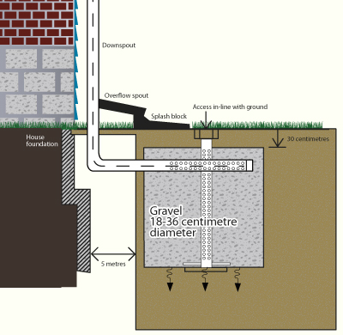

When filling out the application you will need to know the length, width and depth dimensions of the infiltration gallery (see figure 2).

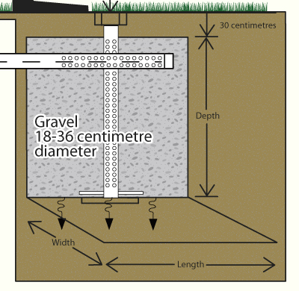

If you do not know the dimensions of your infiltration gallery, because it was installed at the time the house was constructed, select “installed by homebuilder” on the application. If you do not know the dimensions of your infiltration gallery for any other reason please call 519-741-3400 ext. 3355 to discuss your application with city staff.

Rain Gardens

Rain gardens are specifically designed gardens constructed to receive, filter, and absorb water runoff into the ground. Rain gardens differ from conventional gardens as they primarily serve a drainage purpose. These gardens are located so they are in line with where the water drains from the downspout of the home, and where rain water drains from the property. The have a specially designed base similar to an infiltration gallery that allows water to be slowly absorbed into the ground. (see figure 3).

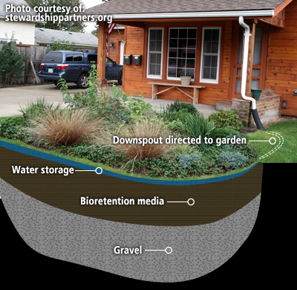

When filling out the application you will need to know the length and width dimensions of the rain garden and also the depth of the bioretention media and of the underlying gravel layer.

If your rain garden is complex in shape e.g. shaped as an oval, circular area etc. simply approximate the area as a square or as a rectangle and provide the distance from one edge of garden to the other edge along the length and width dimensions as illustrated in figure 4.

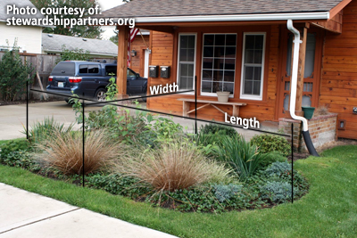

After entering the length and width of the rain garden into the form you must also enter the depth of the bioretention media beneath the rain garden and to enter the depth of the gravel layer located beneath the bioretention media. Typically, the bioretention media ranges in depth from 0.35m to 1m and the gravel layer, if present, is typically about 0.3m deep. If you do not know the depth dimensions enter 0.35 meters depth for bioretention media and 0.0 meters depth for the gravel layer.

Permeable Pavers

Permeable pavers are an alternative to traditional pavement or paving stones that allows water to drain between the stones. They are often interlocking pieces that are spaced for water to get through and be absorbed by an under-layer of gravel and sand. The difference between traditional paving stones and permeable pavers is there is slightly larger spacing between stones and rather than a fine sand mix between the stones, a looser, gravel mix is used that allows water to be absorbed rather than running off the hard surface. (see figure 5).

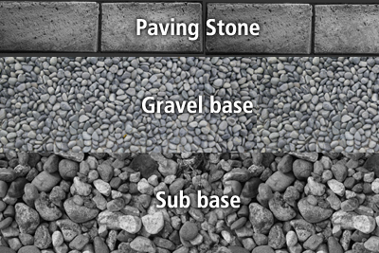

When filling out the application you will need to know the length and width dimensions of the driveway or patio area and also the depth of the gravel base and the depth of the gravel sub base layer if present.

If your driveway or patio area is complex in shape simply approximate the area as a square or as a rectangle and provide the distance from one edge to the other along the length and width dimensions as illustrated in figure 6.

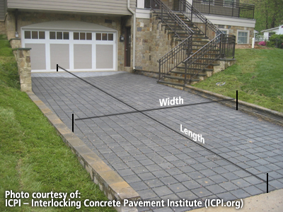

After entering the length and width of the permeable pavers into the form you must also enter the depth of the gavel base layer beneath the pavers and to enter the depth of the gravel sub base layer located beneath the gravel base (if present). Typically, the gravel layer ranges in depth from 0.3m to 0.6m and the gravel sub base layer, if present, is typically about 0.3m deep. If you do not know the depth dimensions enter 0.3 meters depth for gravel base layer and enter 0.0 meters depth for the gravel sub base layer.



**FAQ Sheet: Stormwater Utility Credit Applications**

1. **What are stormwater credits?**

In March 2012, council approved the stormwater credit policy. These incentives are provided to property owners who install best management practices (BMP) that reduce their individual contributions of stormwater runoff and pollutant loading to the municipal stormwater system. Applications to apply for stormwater credits were made available to the public on October 1, 2012. If approved to receive stormwater credits, you will see the credit appear against the stormwater portion of your regular utility bill starting in January 2013. Properties that have installed a BMP prior to October 1 are eligible to apply for a retroactive credit to the date that the BMP was installed or January 1, 2011, whichever is the most recent. Retroactive credit applications must be made by March 1, 2013. Encouraging such source controls supports the municipality’s stormwater management policies and water quality initiatives.

1. **What is a BMP?**

Best management practices are industry accepted standard practices to control the quantity and quality of stormwater runoff leaving any particular property.

For residential properties some examples include rain barrels, cisterns, infiltration galleries, rain gardens and permeable pavers. For additional BMP details and how to measure them please visit [www.kitchener.ca/stormwatercreditapplication](http://www.kitchener.ca/stormwatercreditapplication).

1. **Who is eligible to receive stormwater credits?**

Stormwater credits are available to all residential and non-residential property owners that currently receive a stormwater charge on their regular utility bill. Both residential and non-residential property owners are eligible for a maximum 45% credit on the stormwater portion of their utility bill. Residential credits are simply based on the volume of stormwater diverted.

**Residential Credit Types**

|  |  |  |  |
| --- | --- | --- | --- |
| **Credit Type** | **Volume Captured** | **Examples** | **Credit** |
| Basic Residential Credit | 200 – 800 L | 1-4 rain barrels  small cistern | 20% |
| Normal Residential Credit | 801 – 3200 L | large cistern  combination of cisterns and rain barrels | 30% |
| Enhanced Residential Credit | 3201 L or more | large cistern  infiltration gallery | 45% |

1. **How do I apply to receive credits?**

To receive stormwater credits there are two methods to apply. For residential properties an online application has been developed and can be found at the following location [http://app.kitchener.ca/wizard/](http://app.kitchener.ca/wizard/Start.aspx). Although we encourage the easy to use online application form however customers may also print the application from or website or request to be mailed a hard copy version that can be filled out by hand. Currently there is no online application form for non-residential property owners.

1. **How does the City ensure the Stormwater Credit Program is run in a fair and equitable way for all applicants?**

A completed application gives authority for The City of Kitchener to perform limited inspections of the property to determine the eligibility of the on-site stormwater BMP’s, and the accuracy of the credit calculation. The inspection shall be limited to stormwater BMPs and other elements described in the application. The city shall schedule the inspections at a date and time that is mutually acceptable to both parties. The city will offer the applicant at least one (1) opportunity to reschedule to a mutually agreeable date and time. If a site inspection reveals that reported BMP’s are not in place, functional and maintained then any credits that have been issued will be cancelled and the customer will be required to reimburse the amount of any credit received to date. Additionally, a one year probationary period where the applicant cannot reapply for stormwater credits will be applied to the utility account.