Bioresonance LaesEr
User Guide

Health Navigator LLC
2012

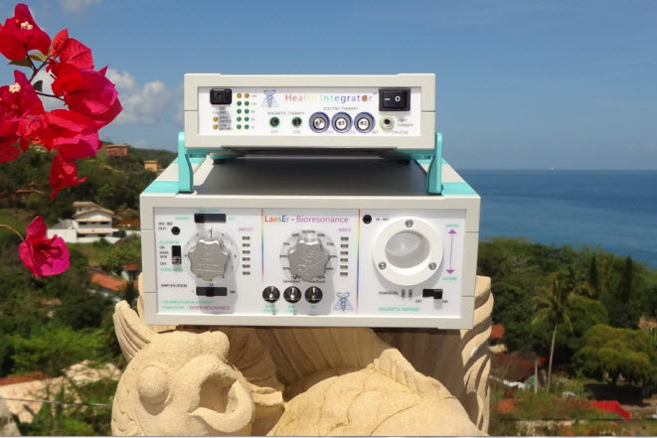

Table of Contents

1. Introduction 2
1.1 Eigen-Resonance 2
1.2 Disclaimer 4

2. Set-up 5
2.1 Session environment and record keeping 5
2.2 Overview of Bio-LaesEr functions 6
2.4 Setup for Bioresonance Therapy 12

3. Additional Functions 13
3.1 Make and Copy Information-carriers (remedies) 13
3.2 Demonstrate the Biofield 18
3.3 Heart-Rhythm 20
3.6 Using Music during Therapy 22

4. Frequently Asked Questions FAQ 24

5. Example of a Practice report 29

6. Disclaimer form for therapist 33

7. Disclaimer form for their client 34

8. Report Template (separate document) 35

9. Technical Data Health Integrator (separate document) 36

10. Technical Data Bio-LaesEr 36

- Introduction

  - Eigen-Resonance

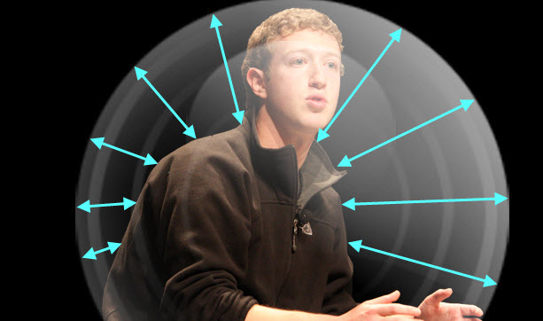

The Bioresonance-LaesEr addresses the most prominent issue of our time. Most people lead a sedentary life that misses the physical exercise that was naturally part of a life of farming or all crafts before the advent of machines. However even more importantly and generally overlooked, their lives are missing ways to make a sensual connection to themselves, which was a natural by-product of physical work and nature contact. We are living in mostly sterile environments, covering our own body with synthetic fabrics, cosmetics and odors. The sensual feedback contact with our own body is usually limited to washing hands or soaping us under the shower, there is very little awareness cultivated of our sensual self-awareness as for example of heartbeat and breath.
Sensual feedback to one’s own body is however a requirement for health and a feeling of contentment and security. Something that we can still see in abundance in less developed cultures where body and nature contact is common. In the “developed” world – “Physical workout” is promoted that generally is practiced on machines and leaves mostly a sense of exhaustion instead of an increased Sense-of-Self.
Nature attempts to force the Life-essential Self-awareness by all forms of restless that provide a rudimentary amount of Self-Sensing. Particularly in all places of mostly sedentary location like libraries, classrooms and offices one can observe most legs incessantly moving to create a minimal feedback. In children this has already become an epidemic called Attention deficit hyperactivity disorder (ADHD) or even worse leads to self-mutilation, bulimia or other masochistic behavior to create as sensual awareness of Self where our culture tries to make this as difficult as possible.
This uncertainty about Self-identity triggered by a lacking Sense-of-Self is of course most prominent in Adolescents who are forced by nature to disconnect from the family and become an individual. Instead of learning to have a natural sense of self it is replaced by Idol-worship that takes the sense of self or by over-involvement in social media where one is hungry to get feedback from visitors to one’s wall but still left hungry for the actually desired a sensual feedback.

Adults usually serve this need for self-sensing by cramping muscles, mostly in the shoulder, lower back and jaw region and sticking foreign objects in their mouth – also called smocking or eating. Commonly it has also become necessary to live in an environment with incessant background stimulation of TV or music to get a minimum of sensual energy stimulation that leads to a minute Eigen-Resonance. In more advanced, but exceedingly common, stages adults acquire all kinds of Status-symbols like cars, clothes and titles that are an artificial replacement for a sensory awareness of their Self, replacing this essential Self-feedback through the admiration of others.

Until recently the body’s own frequencies were exclusively used to monitor body function like in ECG or EEG. The Bioresonance-LaesEr fundamentally changes this by feeding those frequencies back to the body in an amplified form or transformed into light, sound or magnetic frequencies. This is what we call Eigen-frequency therapy, an energetic analog to Eigen-blood or Eigen-Urine therapy and most generally to the basic “Similimum” principle of Homeopathy, one’s own frequencies are the perfect energetic homeopathic remedy – the Panacea.
Experience shows that it creates an increased sense of relaxation, comfort and self-security in a very short time. It was always part of ways to promote health and healing to stimulate the senses, for example in walking bare-foot, hot and cold showers or compresses, needling or massage. In fact most so-called holistic techniques stimulate the senses, either with physical energies like light, electricity or sound or with strong tasting herbs or fragrances.
It is our Vision and Mission to bring this feeling of Self-Awareness to the people of the world that are starving for this most essential and necessary supplement in their life a Sense-of-Self.

  - Disclaimer

From the above it should be exceedingly clear that we understand the main working mechanism of the Bioresonance-LaesEr as supplying a remedy to a spiritual need. LaesEr stands for “Life Amplification by Energy Stimulated Eigen Resonance”, however the maximum Voltage applied is 14 Volt. We agree with the consensus of the scientific community that such minute voltages if applied to the skin cannot be the direct cause of physical healing or damages except in the case of people with extreme electro-sensitivity or pacemakers. Therefore also the prime remedy of the Bio-LaesEr system can only be understood as a “Spiritual Remedy”.
In the disclaimer (below), every person who wants to undergoes Bio-LaesEr treatment will have to agree that both, the working principle and treatment purpose are exclusively psychological/ spiritual and that all physiological effects that happen consecutively are not expected nor intended and considered purely coincidental.

Linguistically it is not possible to make a clear separation as our language does not use a separate vocabulary for mind and body phenomena. However herewith we want to make

clear that if we use words like remedy, therapy, diagnosis, treatment we only are referring to remedies, therapies, diagnosis and treatments for the informational realm which is also called psyche, spirit, emotion, mind.

- Set-up

  - Session environment and record keeping

As the primary purpose of the Bio-LaesEr is to stimulate Eigen-Resonance we advise to add many mirrors to the therapy room and to keep it otherwise free from unrelated information. Also discussion of experiences should not be held right after the treatment, because this is the time that the client has been turned inward and does not generally want to communicate, nor could this be of advantage.
Therefore all paperwork and questions should precede the actual treatment. Every client should sign the disclaimer below and at least the attached record template should be filled for every client.

  - Overview of Bio-LaesEr functions

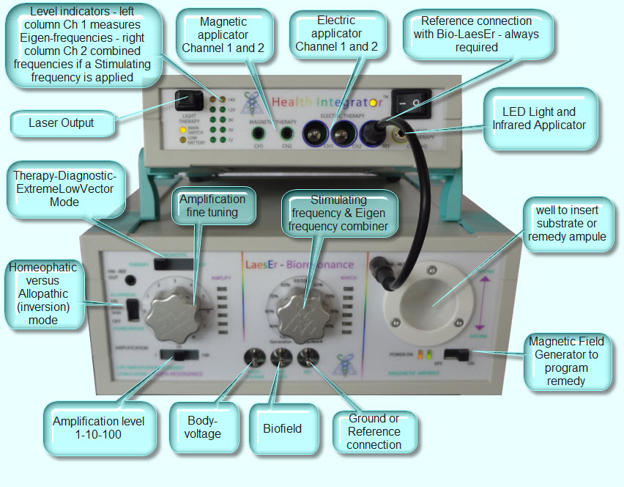

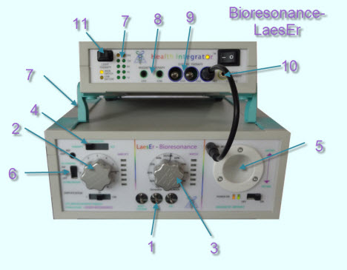
Bioresonance-LaesEr
Bioresonance has been has been used as complementary therapy since about 40 years. Traditional approaches had good results but lacked a working model that was acceptable to established science and was also not able to demonstrate any working energies with conventional measuring devices.
The Bioresonance-LaesEr works with the latest but nevertheless conventional measuring technology to read electrical signals from the body of the client, to amplify them and optionally to invert or modulate them with secondary information or frequencies and to send them back to the client’s body. The involved processes are measurable at any point and energies that are fed back are sensible. It is no longer necessary to use unproven and unverifiable concepts like “subtle energies” to explain the working mechanism.

Moreover the Bioresonance-LaesEr has the following useful additions:
1. Biofield detection – this allows to make the relative extension of the Biofield measurable. Never before has The Human Biofield has never been made verifiable by conventional technology before– reproducibly. This allows Biofields of different people to be compared or make possible to show the effect of different postures and gestures, as well as relative changes to momentary energetic states. Also the frequencies connected to the Biofield feedback can be
recorded or instantly distributed to connected patients (required additional software is in preparation ). http://energetic-medicine.com/modality/biofield/

2 .Signal-amplification : signals can be amplified selectively up to several hundred thousand times which makes it possible to read frequencies even from energetically very weak or insulated points, as for example the feet. Correct amplification can easily be checked via the left LED bar and adjusted with the left knob.

3. Client Eigen-Frequency Modulation is possible with an external signal that is generated by the CoRe software or a recorded mp3 file. This means the signal fed back to the client will in this case be composed of his own frequency pattern as the carrier and the healing information frequency. The proportion of the two signals is adjustable with the middle knob at any desired proportion. This combination of Frequency therapy and Biofeedback therapy is new and unique in that it increases receptivity of healing frequencies by magnitudes as the body's energetic system allows frequencies to enter without an energetic immune reaction. This is easily verifiable sensibly as even voltages of as little as 1 Volt are felt strongly.

4. Diagnostic Mode allows to study Electro-cardio as well as other electric signals of the clients body either on the LED part or via the monitor output of an attached computer (additional software in preparation) or by making them audible.

5. Substrate-information: it is possible via an integrated magnetic field generator that creates a measurable field, in the substance as well. Any substrate that contains magnetize-able particles can thus be used to store client and/or healing frequencies. For Liquids it is recommended to add a few drops of colloidal minerals for this purpose.

6. Inversion of client-signals: it is possible and thus creates what we call an allopathic energetic Bioresonance treatment. Just as with drug-based allopathic therapy this is often experienced as more violent, can however be curative if the patient´s pathology indicates stagnation or therapy resistance. The other mode of treatment, that is also unique to the Bioresonance-LaesEr, is the “energetic homeopathic” mode in which the client signal is returned simply amplified but otherwise unchanged. This mode is showing unparalleled potential as it is often sensibly
experienced as a self-affirmation and leads often to a meditative state with increased Self-awareness.

7. Monitoring: of the amplified signals that is used for treatment or for magnetic information is possible with an output at the back that allows its recording via any audio-recorder or display on a conventional oscilloscope.
The CoRe system is based on the concept of DLE, the Dynamic Labile Equilibrium, as its main principle. Life has to be lived between polarities – if we exclude polarity disease will set in – for the same reason we have two eyes and two halves of brains.
In the Bioresonance LaesEr this principle is integrated in and we can apply electric, magnetic and light signals always with 2 channels where the C1 (left bar and left knob) carries exclusively the signal of the client whereas C2 (right LED bar and middle knob) carries the client signal modulated with the signal from an external source.
(For Biofeedback therapy with client signal alone the middle knob functions as a fine tuner for the signal intensity if the feedback electrode is connected to Ch2 of the Health Integrator)

8. Magnetic therapy with client specific frequencies is possible if applicators are connected here. It is a new and unique approach to use magnetic frequencies in a feedback loop – which allows the person’ s own frequency pattern to be used for magnetic therapy instead of selective frequencies that have been found valuable in individual cases. Also here the Bioresonance

LaesEr has very new healing potential. We offer a wide selection of magnetic applicators: http://www.energy-medicine.info/magnetotherapy.html

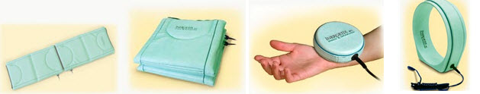

9. Rife therapy is now also possible with the Bioresonance LaesEr system adding the great improvement to this already successful therapy where the client’s own frequency pattern is used as carrier. This combines the central idea of homeopathy that the clients information system is made more open to receive information that is communicated in a personal language (frequency pattern) –“Similimum principle” – and will resist less with energetic immune reactions.

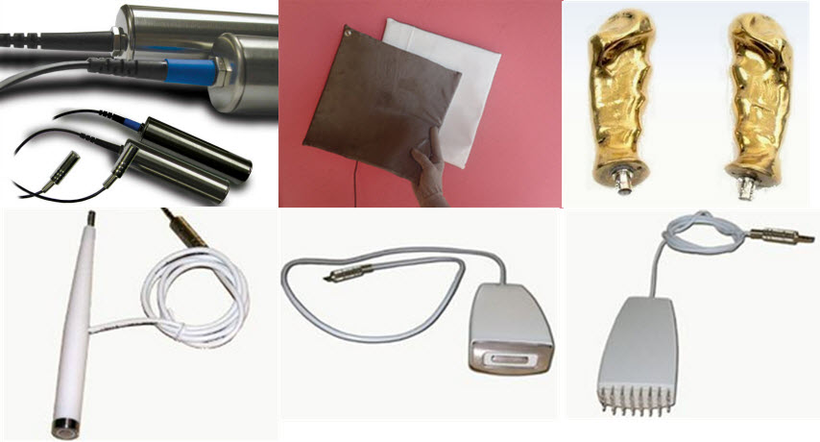

10. Light Therapy is possible with our LED visible red & infrared pad applicators:http://www.informationenergymedicine-academy.com/new-infrared-led-applicator/

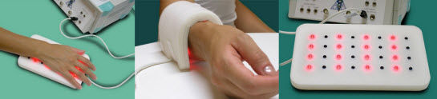

Light therapy is very effective to add to electric and light therapy particularly in skin problems as well as tension in superficial tissues.

11. The experience of mind-machines is increased exponentially if our Mind-Resonators are used as the light flashes with the heart-beat and other electric pattern in the body.

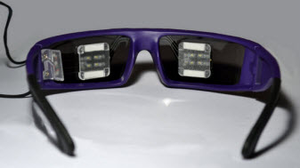

12. Laser-Light output – glass fiber applicator in development which will allow Bioresonance therapy with client specific frequencies via laser light on acupuncture points.

  - Initial Set-up and connections

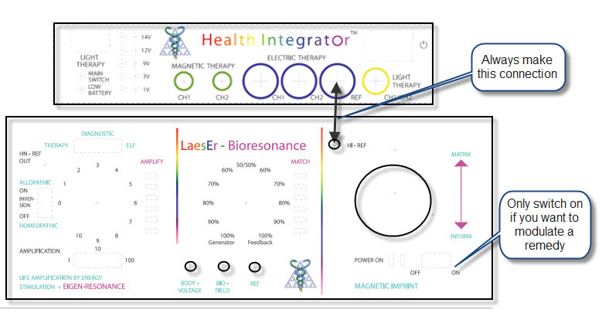

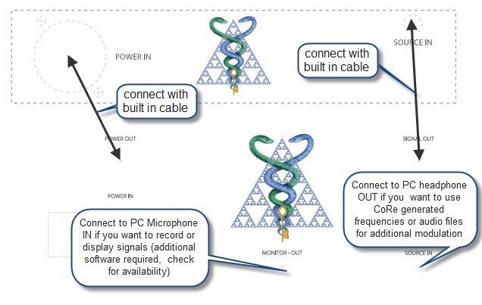

  - Setup for Bioresonance Therapy
2.4.1 standard setup

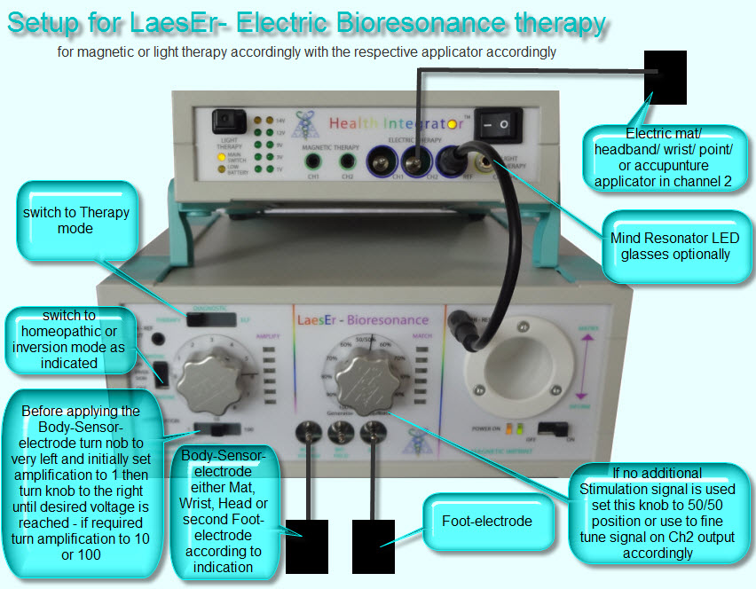

- Therapy can be applied while the client is either sitting or lying down

- The Mode is set to Homeopathic to feed-back client frequencies in sync with his own frequencies or Allopathic mode to re-introduce the client’s own frequencies mirror image with a 180 Degree phase difference. For now we are not able to provide general rules on which setting to use but is seems indicated in all more paralytic, passive and tired symptomatologies to use the activating Allopathic mode and in all situations of Inflammation, nervousness, high pressure indications to use the calming and relaxing homeopathic mode

- The Sensing electrodes can be applied anywhere on the clients body, generally it is most simple to use the two electrodes of the foot-electrode

- The applicator electrode should generally be connected to Ch2 of the Health Integrator as this channels can be fine-tuned for amplification and mixing with an external source with the middle knob, whereas Ch1 of the Health Integrator always exclusively monitors the client Eigen-Frequencies

- Instead or additionally to the Electric applicator also Magnetic, LED pad/ glasses, or Laser applicator can be used, however it is recommended to keep it simple and not overload the body with too many different stimuli and to use 2 applicators at most for every session

- The Amplitude that is being supplied to a given applicator is shown on the 2 bars of the Health Integrator labeled 1-14 Volt, it is recommended particularly with electric applicators to start low and increase the volume as the client feels best

- Amplification is first set with the slider switch under the left knob by moving from 1 to 10 to 100 while having the knob in approximately 3 position, when the green lights of the bars next to the knob turn on – fine tuning is possible with the knob such that the orange top LED not or only barely turns on

- Then with the middle knob the desired voltage on Ch2 of the Health Integrator is set as found most agreeable to the client

2.4.2 Biofield feedback setup

ANOTHER WAY TO CONNECT THE BIORESONANCE-LaesEr based on the experience with hundreds of clients at Marco Paulo’s Quadtrinity clinic Portugal
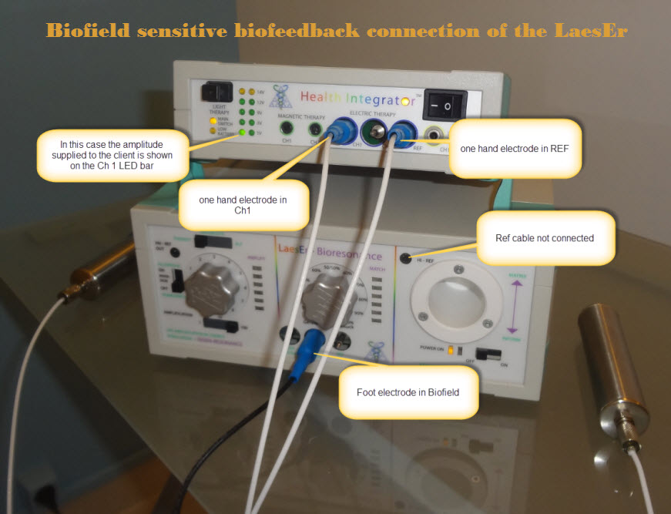

This is the result of a lot of experimenting with the standard set-up explained previously. At Quadtrinity clinic it was found that this set-up is more effective and even longer therapies and higher therapy signal amplitudes have always been tolerated well. Kiran could initially not believe that this scheme could work so, when he was in Portugal he tested himself
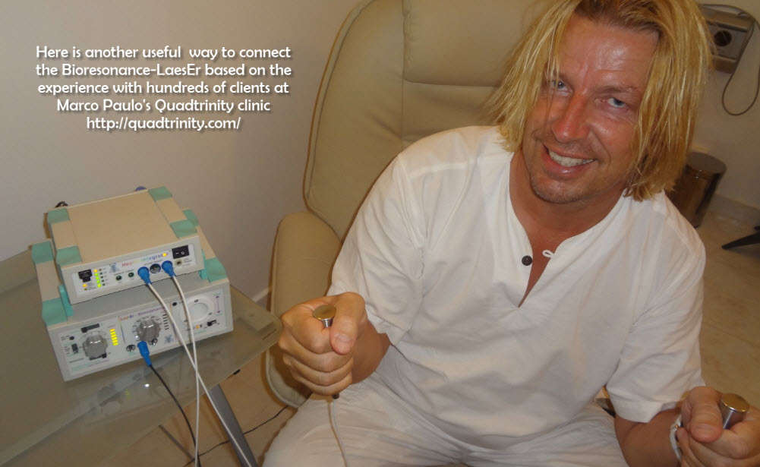

… and yes it works very well I cannot remember a session that was so centering – apparently because it uses the cannel that extracts particularly the Biofield frequencies, so it feeds back and amplifies the frequency field that is measurable close to the body and that has been called Aura in traditional scriptures – you feel as if you are coming home to your own bubble

AND …. Please take this as a great example to understand – there is much to learn with the LaesEr – it is a cutting edge technology and we know only few of its new possibilities and how to realize them – so experiment , and share with all of us your results

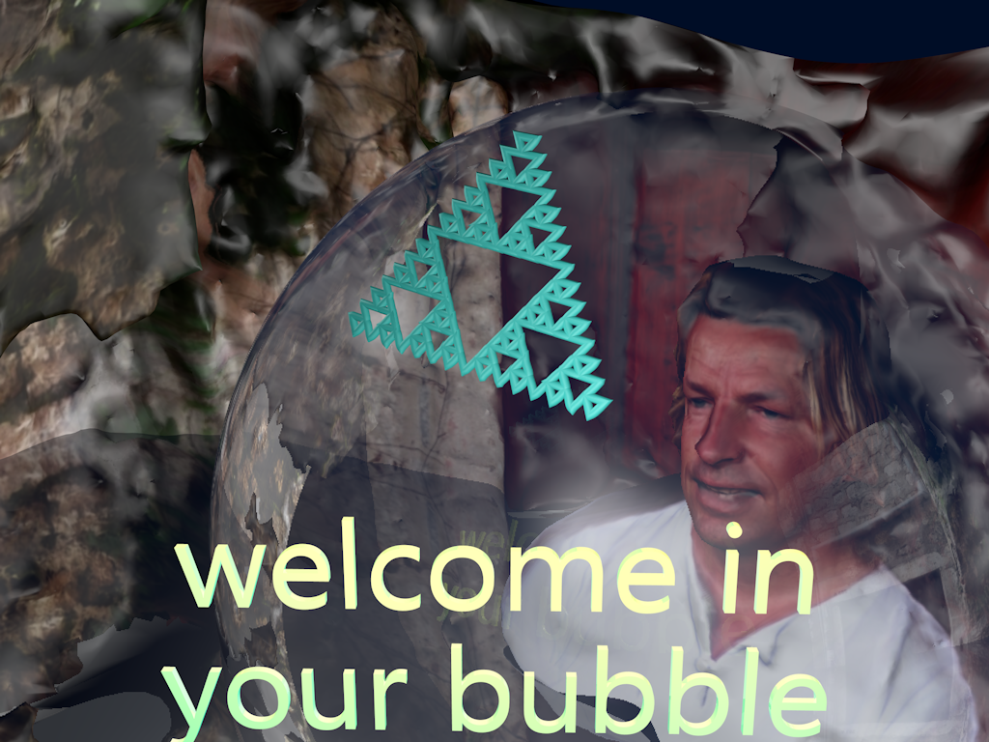

2.4.3 dual handelectrode with with body-signal application

IF you want to use the handelectrodes in the way you otherwise us the flexible mats – which means to tap into the electric body-signal that is conventionally measurable with ECG and EEG equipment please be aware that the connection have to be done as follows : | 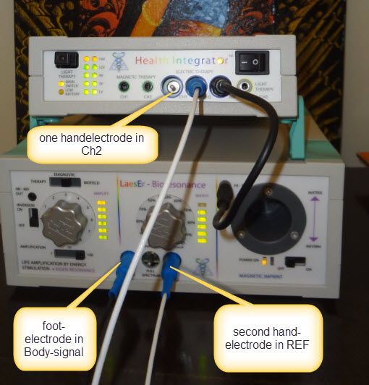

- Additional Functions

  - Make and Copy Information-carriers (remedies)

It has been known and used widely that certain aspects of remedies can be stored and copied. One of its currently most widely used aspects is the production of homeopathic remedies. Only a drop of a homeopathic preparation to produce more of that remedy in the homeopathic process. We consider the most potent part of any remedy to be its informational aspect and different then energy or chemical remedy information this is not reduced by the process or storage and reproduction.

The CoRe system allows 3 different forms of remedy-information transfer:

- With the CoRe software it is possible to transfer any information to a remedy holder that is labeled with a unique Locator code generated with the system – this is known as radionics “imprinting”.
- With the Bio-LaesEr it is possible to modulate any magnetically sensitive material with Remedy-information or frequencies. For this the Substance is placed in the tube of the Bio-LaesEr on the right side and the Magnetic Imprint switch is turned to ON. This will use any frequencies currently processed in the unit to be also converted to an analog measurable magnetic field in the tube.
- With the Health Navigator it is possible to transfer remedy information with an electric carrier -this feature will be added in the future.

Although most materials have a certain level of magnetic sensitivity it is recommended to use an alcohol-water mixture and add several drops of silver or gold colloidal – which will be the oscillator for the magnetic field applied – which in the following will be called SUBSTRATE. Informed substrates bring the advantage that the client can take

them home and use at any time he feels necessary – there is no need to limit the frequency of use.

There are 3 possibilities and for all an audio-cable has to be connected from the Bio-LaesEr SOURCE-OUT to the HEADPHONE-IN of the Computer :

A) A frequency is run from the Frequency panel of the CoRe system so the Substrate contains the information of the applied frequencies.

B) If the Communication/Information panel of the CoRe system is being used to communicate remedy information – this information can be modulated on the electric signal to the Bio-LaesEr if the “Switch Energetic Carrier” button on top of the communication screen is pressed.

In both of the above cases the remedy will be many times more effective if the substrate is also modulated at the same time with the client-Eigen-Frequencies. In this case the remedy information so to speak rides on the clients Eigen-Frequencies which make it pass the body’s immune barrier more easily. In order to facilitate it, the client has to be connected to the Ref and Body-voltage channel and the Match-Knob in the middle has to be turned to 50/50 – which mixes both the carrier signal and the clients Eigen-Frequencies.
http://www.youtube.com/watch?v=7tCyJICtBHM&feature=player_embedded

C) What follows is a report by users in Holland that found that it is also possible with the Bio-LaesEr to copy remedies between 2 substrates – this will need to be further evaluated.

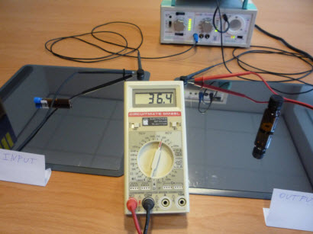

Yesterday we had a CoRe meeting/training with core/BiolaesEr-practitioners from Belgium and the Netherlands and one of the participants has found an AMAZING possibility for the BioLaesEr!
It's possible with the BioLaesEr to copy remedies (like with other devices), and not only copying but they are 'remarkable stronger' then when the remedy is copied by another device and they work and test even stronger than the original remedy! Cees den Braber has tried this many times.

The procedure that Cees followed is:
- You connect one foot plate to the body voltage on the BioLaesEr (here you place the remedy that needs to be copied – input)
- You connect one foot plate to the Health Integrator (here you put the bottle with granules on - the output)
- Amplification switch to 100 - and turn the knob to 10 (full power)
- 50%/50%
- that's all and the remedy is being copied.

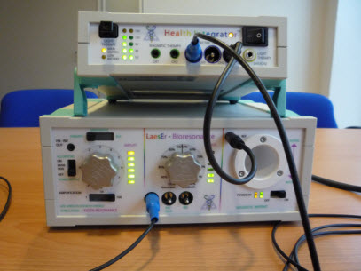
Maybe it's also possible with the inversion mode, we will try this and let you know asap about the results...

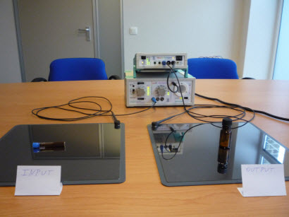

Another interesting example:

Stephan Maegh has tried this many times with brilliant success!!!

- You connect only one foot plate to the body voltage on the BioLaesEr, and put the client on it with his bare feet

- You connect the flex-headband to the Health Integrator CH1 or connect the two hand-electrodes to CH1 and CH2
- And then you will see that you already have at amplification Level 1 already a very good connection (you don't have to amplify with factor 10 or 100) and you can feel this much better then with the Ref also connected as we normally would do.

I also tried this myself ... don't ask me why it works, it just works and you really feel it.

Imagine what other possibilities we can find in time... such an amazing device!

We will keep in touch and update you with more news soon ...

Kind regards, Jerry

  - Demonstrate the Biofield

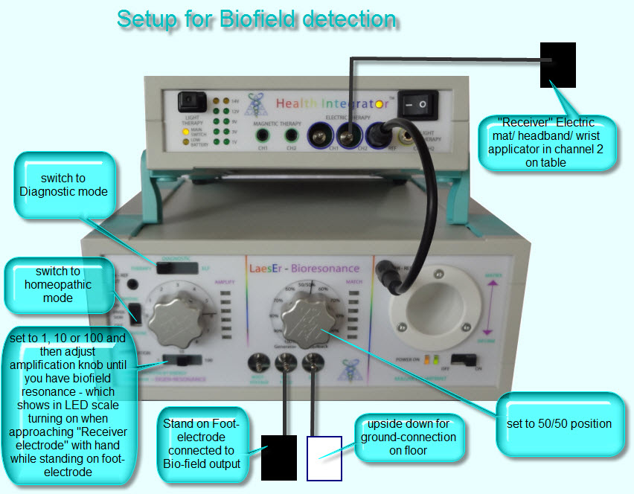

The Bio-LaesEr is the first device to be capable of demonstrating a field-component of living organisms. Different from for example Kirlian or Phase-contrast interference Photography where the observed Aura was mystified by claiming it was a manifestation of life-energy whereas in fact such Kirlian and Interference effects are equally observed for non-living matter and can well be explained with the standard concepts of physics – the effects of the Bio-LaesEr are not shown to be effects of capacitance or EMF reflection or any other electric phenomena.

What makes the effect so particular is that the electrically conducting mat or any other electrode connected to the Health Integrator that seems to work as an antenna and that makes the display LED to light up on approach is in fact no antenna or sensor but an output electrode of maximum 14 V and maximum frequency of 20 KHz. This low voltage and relatively low frequency would not be able to bridge the gap of sometimes up to several meters that is observed in some people with larger “Biofield” in order to close a circuit.

Even without such a set-up it is measurable with even a simple Voltmeter that every living organism also produces its own electric voltage, particularly know as EEG and ECG.
It is proposed as an explanation-model that the field of a living organism somehow senses the available energy at the mat and generates an increased Body-voltage proportional to its own field strength and inverse proportional to the distance from the electrode-source. In this way an Eigen-Resonance occurs that is comparable to a microphone that is brought close to a speaker leading to a high pitch sound with high volume as the result of Self-

Feedback – however with the difference that as stated above no actual energy is fed back from the electrode connected to the Health Integrator.

More closely this can be explained with an analogy that we all have experienced, we know the increase of energy that is measurably and sensibly produced on approaching a loved person or a special event - both leads to an exponentially increased body-voltage without physical energy feedback.

If we see this effect as a Resonance effect we can better understand also the process of setting up a Biofield demonstration.

The client has to stand with bare feet on the electrode connected to the Bio-field input, observing that he does not touch with parts of his feet or other parts of his body the floor or close by objects – which would lead to a short-circuit phenomenon.

Another mat or electrode connected to the Bio-LaesEr REF input is turned upside down to the floor and possibly weight down with some weight in order to make a good contact with the floor – it serves as a Ground-reference as the 3rd ground pin in common electric plugs is frequently not a reliable grounding pole.

Another electrode – preferably the conducting mat – is connected to the Ch2 of the Health Integrator and placed on a table in about 1 m distance from the person standing on the foot-electrode.

The operator asks the person to hold his hands in about 30 cm distance from the mat, turns the middle Matching-knob to position 50/50 and then tries to get the LED light in Diagnostic/ homeopathic mode and by consecutively switching amplification from 1 to 10 to 100 and in between always turning up the above amplification-knob. When LED come on in any position – resonance has occurred, then the client can be asked to remove the hands maybe to 50 cm distance and the operator can attempt to fine-tune the amplification knob and while still getting resonance.

This process is comparable to the tuning of an instrument and therefore needs initially some experimenting and the development of sensitivity but easily become routine after a short time. Also from this process it is clear that no absolute Bio-field-extension is possible as it is always to some degree depending on how sensitive the resonance point was set. However once set different people can be compared as to their relative Biofield-expansion.

Biofield resonance setting is demonstrated in this video :
http://www.youtube.com/watch?v=i8wnt5GIEXA&feature=player_embedded

  - Heart-Rhythm

This is a new function that needs dedicated software to be shown and recorded which is currently under development – we will inform you when it is available for general use on our www.InergetixForum.com so make sure you receive our monthly news-email

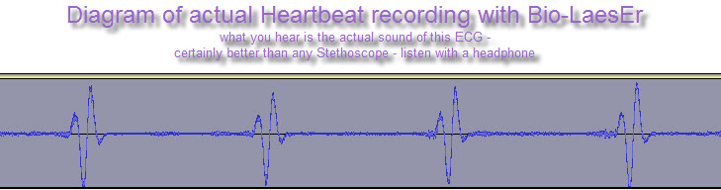
also what you can see in this ECG recorded by the Bio-LaesEr on Kiran that :

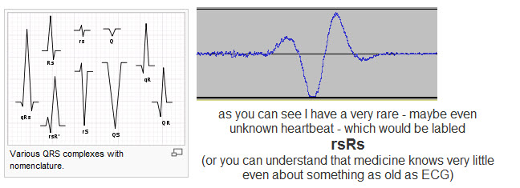
from : http://en.wikipedia.org/wiki/QRS_complex
but that my heartbeat is missing the very standard P wave which may indicate according to http://en.wikipedia.org/wiki/P_wave_(electrocardiography) :
- Atrial fibrillation[1]
- Sinoatrial block[1]
- Junctional rhythm[1]
AND worse even I am lacking the T wave also which would mean :
coronary ischemia or hypokalemia[3]
according to : http://en.wikipedia.org/wiki/T_wave
but really what you can see in this most simple aspect of medicine – 100 years of study have just given income and reputation to some “scientists” who are really “Haarspalter” (Hair-splitter) without creating something useful.

In comparison we can use the Heartbeat and transform it with the Bio-LaesEr into sound, light, magnetic and electric signatures that are being fed back to the client and allow a multi-dimensional experience of the SELF – which will be proven to be the most effective way towards health and happiness.

  - Connecting an external Generator

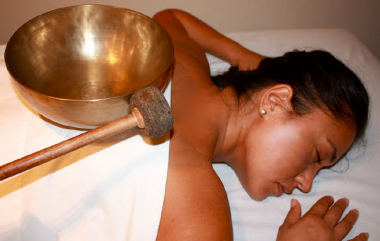

- This video shows another revolutionary aspect of the LaesEr in that it can sync the Eigen-Frequencies with an external source. Attempting to create this coherence is the essence of music or general frequency therapy or healing and inducing meditative states with Tibetan bowls
http://en.wikipedia.org/wiki/Singing_bowl in a far more direct and effective way then was ever been possible before.

- This was achieved by being able to mix the body-own electrical frequencies with that of an external source like an audio source or a frequency generator output and applying the combination in electric, magnetic or light form to the client with Bio-LaesEr in conjunction with the Health-integrator.

- Try it and you will never want to go back to the old ways – not only has it so much healing potential it also will open new forms of spiritual practice.

http://www.youtube.com/watch?v=TTcAVN1Cf5k&feature=player_embedded

3.5 Using Music during Therapy

During the therapy it is also sometimes beneficial to use music or the following CD with affirmations. However this will usually only be indicated for the first sessions and should be discontinued when the client has become able to go through 30-45 min of session time without this diverting media.

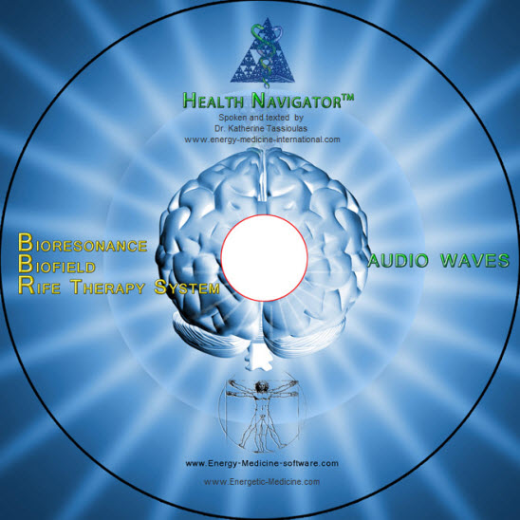

Here is what a user has to say about it:
“I have just listened to the sample of relaxation / healing that you have made for the CoRe new bit…..and I must say I am very impressed…. This is probably the best relaxing healing voiced cd I have come across…..and I have trialed quite a few over the years ( often with disappointments, due to armatures masquerading as professionals)..
Really excellent ……..and the DNA healing 528 Hz music frequencies behind it are a clever addition…. So, take a bow and feel valued even more by the collective consciousness for what will show up as individual yet collective benefits across the planet as we continue on.”

With every BBR system we ship one of these CD with text spoken and created by Katherine, her magical tone of voice. You can let the client just listen, while he/she is on Eigen-Frequency treatment or you can even add this music and text by connecting your headphone out – with the “SOURCE IN” of the Bio-LaesEr and then setting the “middle knob” that combines Eigen-frequencies and any additional source, as like this one – at any desired ratio. This then uses the Eigen-frequencies of the client as carrier wave for the information – subliminals are nothing in comparison – please try it.

Content :
1. Healing 5 min
2. Addiction 6 min
3. Addiction 8 min
4. Pain relief 8 min
5. Stress relief 8 min
6. Chakra balancing 22 min

We have put especial focus on “Addiction” as the life of most of us is based on addictions (work, media, cell-phone, eating, alcohol, sex, security, prestige, …..) which are all symptoms of stagnation based on a lack of “sense of SELF” that would naturally give the certainty that these placeholders will never be able to supply consistently.

- Frequently Asked Questions FAQ

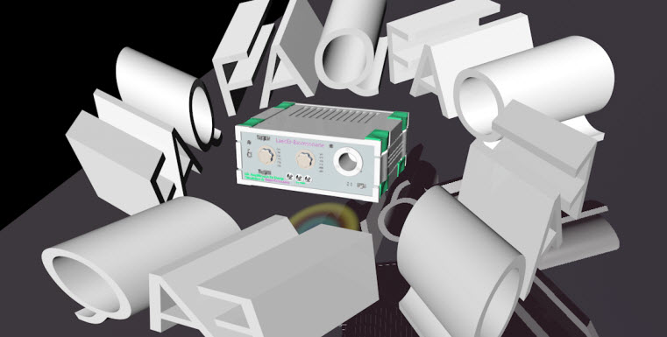

From Nirlepa in India :

- How can I send frequencies indicated in CoRe, to a patient through Bio Laser?
K: You make the connection as explained in chapter 3.1 : If the Communication/Information panel of the CoRe system is being used to communicate remedy information – this information can be modulated on the electric signal to the Bio-LaesEr if the “Switch Energetic Carrier” button on top of the communication screen is pressed.

2. How can I use allopathic mode in Bio Laser?
K: Just by switching on the Allopathic mode switch – but I guess you mean “when to use it” for this please see my answer 5 at the bottom

3. How to prepare homeopathic medicines with specific potencies in CoRe through Bio Laser? As I want to prepare and give some homeopathic medicines which are not available in Regional Research Institute of Homeopathy in Andhra Pradesh.
K: First you create the Informational Homeopathic in the CoRe software and then you modulate this information on an energetic carrier from the Communication/ Information screen and then send it to the Bio-LaesEr. To do this you apply the set-up as described in answer to question 1 but of course here you do not need a client connected. Then run the desired frequencies for a few minutes with the MAGNETIC GENERATOR switch in ON position. These are a new type of
homeopathics and in how far the concept of “potency” might be applicable is to be investigated – probably by doing the modulation longer – you get higher potencies, because modulation by manual agitation is the basis of succession.

from Bob Shane / USA:

1. How get the CoRe informational resonances to modulate the Eigen-Frequencies of the LaesEr and to also be included in the magnetic imprinted remedy of the LaesEr ?
Kiran : First some clarification – the LaesEr does not have “Eigen-Frequencies” but your client. The LaesEr only picks them up and amplifies them. - SO NOW LET’S GET PRACTICAL :
A) Just connect the Headphone out of your Lab-top with the Source-IN of the LaesEr back. For magnetic information you need only the LaesEr and a Frequency source – like the CoRe program on a Computer or an audio-file on a MP3 player – You do not need the Health Integrator as it is only used for therapy – just leave it connected as usually
B) Then switch the Magnetic Inform button so the LED comes on
C) Now you have two possibilities – you can modulate the substrate either with frequencies that you create with your Frequency source alone – this is the conventional and old way of adding frequency-information to some remedy. Or you can modulate the liquid with the Frequencies carried on the Eigen-frequencies of the client – this means you really make a client-specific remedy and not a generic one and you will see the receptivity and effect is so much better. In the latter case you move the middle knob to the 50/50 position which means the Eigen-Frequencies of the client (of course he has to be currently connected) and the frequencies from your audio-source are mixed at a 50/50 ratio – and this is no magic this is measurable and audible also at the Monitor – Out of the LaesEr
D) At the magnetic field generator (if the switch is on) you always have a signal no matter if in Therapy/ Diagnostic or ELF mode – put the vial with the alcohol water mixture and a few drops of Silver-colloid – please for this also see http://energetic-medicine.com/magnetic-information-of-substrates-with-the-bioresonance-laeser/
E) and if you turn the middle knob to 100 % Feedback you only use the Eigen-Frequencies of the client for modulation of the substrate – in this way you can make perfect Isodes of the client – a homeopathic concept that has never been used properly – it does not work by making Isodes of poisons but Isodes of the person’s frequencies – which I call Eigen-Frequencies will be a new step in energy medicine – try it and give me your feedback.

2. On Bio-LaesEr what are the following functions:
A. What is the function of HN – REF OUT on left top
K: This is the REF connection for those who want to use the Health Navigator instead of the Health Integrator for amplification of the signal – which however is not recommended as the amplification of the Health Navigator is usually not sufficient for the very small Bio-LaesEr output – the Health Integrator amplification range is made specifically for this purpose

B. What is the function of Switch position of ELF on left top
K: The ELF refers to “Extreme low Field” this will be used for some specific applicators that we are developing and testing right now.

C. When use MATCH LEDs on right side of Bioresonance knob
K: You use them always for seeing what signal strength you are sending to the client – they should be approximately analog to the reading on channel 2 (right LED bar) of the Health Integrator. If you have no external frequency source connected, apart from the client, and you turn the middle (match) knob to 100% Generator, the LED should go out. If you turn it to 100% Feedback they should be identical to the one on the “Amplify” scale – so they are meant to give you a sense of the signal strength when you use both Eigen-Frequencies of the client and adding an external Frequency-source signal

D. Are the Body–Voltage and Bio-Field both inputs in Diagnostic and in Therapy modes?
K: Yes, but for Biofield demonstration you will use generally only the Diagnostic setting.

E. If so where is the output of Eigen-Frequencies coming from if only use LaesEr without Health Integrator?
K: It is coming from the SIGNAL-OUT on the back of the LaesEr – however only in a very low amplitude AND from the Monitor-OUT plug in audio-quality. This is the traditional Bioresonance device, it generates a signal that is not sensible and cannot drive any magnetic or light applicators.

3. On Health Integrator – what is function of the following:
A. The first column of LEDs indicates output level to client. What does second column measure?
K: Left and right channel show the output level on Ch1 or Ch2 respectively – 1 is always the unmixed signal CH 2 is the mixed signal if you connected an external Frequency-source at the Source-In at the back of the LaesEr

B. Is there a cold laser that plugs into the Light Therapy output of the Health Integrator on top left corner?
K: No the Laser is already built in – you see it if you open the cap – just don’t look in too close! We will have an acupuncture applicator that plugs into this port soon – so you can do Acupuncture with Laser Light that is Eigen-frequency modulated

- When measuring the Biofield:
A. Soft footpad connected to HI Ch1 and other foot electrode connected to Biofield on LaesEr with no ref connected…..seems to work ok…. The floor is carpeted so ref is not grounded so I did not plug anything in.
K: For proper use you should use a REF electrode – but maybe in your condition it even works without

  - However if I keep everything the same but plug soft footpad into HI Ch2 instead of Ch1 it does not work. The voltage level does not increase when approaching the mat like it does when plugged into Ch1.
K: That is why we recommend doing it exactly as outlined in my post with the “receiver” pad in Ch2 but then you need the REF electrode also

- Connection between LaesEr and Health Integrator:
  - In the Biofield / Mesmer video the connection is from HN-Ref Out to Ref on HI
K: Good observation both HI-Ref and HN-Ref-Out are identical we placed only 2 so cable length is short no matter if you use HI or HN

  - In the figures on the website for Biofield detection it goes from HI-Ref out to Ref on HI
K: That is the way to do it – and you need to make this connection always no matter what you do with the LaesEr – Health Integrator combination

  - Also sometimes the footpad is plugged into the Biofield input of the LaesEr and sometimes into the Body Voltage input. Is this just a matter of sensitivity….the Biofield input is more sensitive than LaesEr?
K: If so this was a mistake – but you are right it works either way – but the Biofield input is the one which is specially filtered for Biofield and therefor more sensitive

- Part of the package was a magnetic field tester – what is it used for?
K: Just that you can show your clients that the magnetic applicators really produce a measurable field – although magnetic field is not sensible by humans it has enormous healing potential.

from various other users :

- I am just trying out something for a patient. He is lying down, can you tell me which electrodes to use as he can only use one on his feet connected to ref on the LaesEr.
K: Where you place the 2 electrodes plugged into REF and Body-Voltage is completely up to you, use your intuition and use common sense. Maybe over time we will collect more observations to derive some rules – but hopefully it will always remain a client and situation specific choice. However we recommend as one standard to tap into the potential that exists between the right and the left side of the body either by using two hand-electrodes, two wrist electrodes, the new dual electrode for both feet or just as The Feedback-electrode that come from the Health Integrator can be applied anywhere or where it hurts or at key chakra points.

- If I connect the steel mat to body voltage and the hand electrodes to ch1 and ch2 on the electric therapy will that be enough without the soft mat?
K: With the LaesEr connected you use only one of the 2 Health Integrator channels because without any external Frequency Generator connected both channels are identically producing the amplified client Eigen-frequencies – so this will not work

- I have set the amplification to 10 and the fine tuning to 4 and the frequency combiner is fully to the right and the lights on the integrator are on 12v. He still feels nothing and neither do I when I try it. Are we doing something wrong?
K: As described in 2 both channels are the same so there is no potential difference between them and therefore he will not feel anything nor does it have any effect – never just connect only 2 electrodes on Ch1 and Ch2 but always to one and the REF output

- How long to do treatments?
K: This is the old and always first question and the answer is always the same “As long as the patient feels that he wants it”

- I am in need of help with features of the LaesEr operation. Are you able to help with descriptions of the difference between homeopathic and allopathic in use of the LaesEr.

K: The Inversion mode follows the traditional concept of feeding patient frequencies back with a phase inversion (although no other Bioresonance device manufacturer actually did it or was able to show it on an oscilloscope) – with the Bio-LaesEr we can demonstrate how different it feels if the Frequency is returned with Phase-inversion (Allopathic mode) or without (Homeopathic mode). From the first feedback I got and my personal experiments it has shown that the inversion mode feels much stronger and even sometimes too violent at only 1-6 V – but energizing.
The homeopathic mode is generally felt as very soothing and relaxing – however also in this mode some people got little burns at only 1 or 2 Volt.
So if you want to make any conclusion and get any suggestion, I would recommend that in cases where there is paralysis, stiffness, dullness, exhaustion, acute disease use the allopathic mode – but remember that this is only a “rule of thumb” and never let this overshadow your common sense, intuition and feedback from the client – keep being a learner.
The Bio-LaesEr possibly more than any other holistic device before shows how different people are in the way they react – because it is truly a gentle energetic homeopathic device and it is able to truly deliver the healing Similimum.

- WHEN USING THE SYSTEM FOR A LONG PERIOD THAT YOU ADVISED (EVEN SEVERAL HOURS) WHAT IS THE BEST WAY TO DEAL WITH THE TOXICITY CREATED BY THE

DEAD CANCER CELLS?, BECAUSE I HAVE READ (ALTHOUGH NOT SPECIFICALLY IN RELATION TO YOUR SYSTEM) THAT PEOPLE HAVE DIED BECAUSE THE BODY CANNOT COPE WITH THE BUILD UP OF TOXINS. IS THIS RELEVANT HERE? OR DOES IT WORK ON A DIFFERENT METHOD?
PLEASE LET ME KNOW BECAUSE I WOULD LIKE MY PATIENT TO USE IT FOR AS LONG AS IS COMFORTABLE BUT I REALLY NEED TO KNOW WHAT HAPPENS TO THE DEAD CANCER CELLS.
K: I cannot imagine anybody who has been able to verify at the death of someone that he has died at an overload of DEAD CELLS – so I cannot comment on that but I know that many people have died of FEAR and of EXCESS – so use all the senses that the creator has given you to make the best decisions – knowing that it is more safe to be honest to your SELF then to be faithful in a want-to-be AUTHORITY

7. I want to have an understanding of the differences between Therapy, Diagnostic and ELF use.
K: You use the Therapy setting when you actually have the applicator electrode, which is the one plugging into the Health Integrator, connected to the client. You use the Diagnostic setting if only the 2 electrodes that read the frequencies from the client body, that are connect to the LaesEr, are
in contact with the client – for example if you want to make the heartbeat or other body frequencies audible or recordable. The ELF setting is for future Extreme Low Field application and not used at present.

- Example of a Practice report

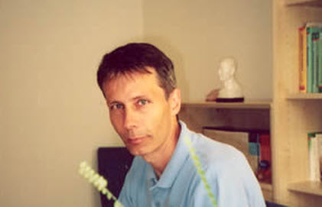

Andreas Lederman has a natural therapy clinic in Switzerland
He has send me this informal list of observations after the first month working with the Bioresonance LaesEr .

Andreas has his clients lying down, two flex electrode mats under the knees, one connected to Body voltage and the other to the LaesEr REF input – application of feedback is from the Health Integrator Channel 2 through the flexible Forehead-electrode.

Also he has one local magnetic disc applicator on the chest or lower abdomen and the full body magnetic applicator to lie on. Second visit can be anywhere between 3 and 6 days after the first one.

He adjusts the Voltage of the Bio-LaesEr according to the clients preferences and treatment time can be anywhere between 20 and 50 min
Thank you Andreas for taking the time to make this list and to send it to me – I am getting so many reports of “miracle healings” with the Bio-LaesEr but despite we have already delivered 80 – nobody has send me a simple report like this.

Dear All – we have to work together – and despite the fact that in our times it seems almost impossible to keep consistent notes and not just doing one line blogging – this is the only way that we can learn and share some substantial observations.

Observations with the Bio LaesEr 9. – 30. Nov. 2011

Patient / Datum | Symptom |  |  | Observations during the treatment | Observations at the next visit
001 / 9.11 | Nausea, Energy-Low, r  racing heartbeat, tendency for collapse |  |  | none | Significantly better  after 2 days – no Energy-low anymore
002 / 9.11 | Back pain |  |  | Sense of warmth and relaxation | none
003 / 9.11 | Head pain |  |  | Deep relaxation | none
004 / 9.11. | Hip pain |  |  | none | none
005 / 10.11 | Tiredness |  |  | Light tickling – feeling relaxed | Burning on forehead 3 hours after treatment
006 / 10.11. | Eczema |  |  | Very relaxed | Slightly better
001 / 11.11. | Back pain |  |  | none | Pain free
007 / 11.11. | stress |  |  | Very relaxed | Feels even 1 week after the therapy very comfortable
008 / 11.11. | Knee pain |  |  | Sees vibrating light | none
009 / 11.11 | Spastic paralysis |  |  | none | For some days significantly less shoulder pain
010 / 11.11. | depression |  |  | none | Emotionally I feel much better
011 / 11.11. | M.Crohn |  |  | Afterwards very relaxed | none
012 / 14.11 | Joint pain |  |  | Sees waves of orange light with closed eyes | Less pain
013 / 14.11. | Depression, digestion, beginning cold |  |  | Feels very good after the therapy | none
014 / 14.11. | depression |  |  | Feels subtle warmth from magnet on the chest | Relaxed, emotionally significantly better
015 / 15.11. | Breathing problem |  |  | none | none
016 / 15.11. | Eye inflammation |  |  | none | none
017 / 15.11. | Bruxismus |  |  | Very relaxed | none
018 / 15.11. | Cluster headache |  |  | Very relaxed | Increased headache during one week
019 / 15.11. | Pressure on heart |  |  | Slight tingling under the head electrodes | none
020 /16.11. | Burn out |  |  | After a few minutes waves of dark matter, surrounded with light that flows towards the eyes, very relaxed | Slight improvement
021 / 16.11. | Psoriasis, stress |  |  | Very deep relaxation | Skin 40% better, significantly more relaxed
022 / 16.11. |  | Digestive Problems | A fine layer over the skin, heaviness of extremities, feels euphoric |  | Feeling of well being continued for another day
023 / 17.11. |  | Stutter | Small burn on the forehead at only 2V. Afterwards no more sensations |  | More courageous
008 / 17.11. |  | Knee pain | none |  | none
024 / 17.11. |  | Sorrow and fatigue | Feels great happiness |  | New insight
025 / 18.11. |  | Blood high pressure | Waves of Energy first in the kidney region rises to the upper body and whole body |  | none
026 / 18.11. |  | Back pain | First pressure on the head , well relaxed |  | A few days better

- Disclaimer form for therapist

Therapist informed consent form for the Health Navigator, Health Integrator, Bio-LaesEr and the Inergetix-CoRe system in general (collectively referred to as HN-Products)

I _____________________________ understand that HN-products are powerful and potentially life changing systems, therefore every one of my clients needs to sign the “HN-Disclaimer for clients” .
I understand that only the Health Navigator is approved as a medical device in the European Union and that its use as such is limited to Wound-healing, Depression and Pain Therapy. Furthermore its use as such requires that I am qualified to use medical devices.
Optionally the Health Navigator as well as all other HN-products come with a Wellness CE that certifies their technical safety which however does not allow me to make any medical claims. Therefore I will promote my services exclusively either as “Wellness body and mind education” or as “Spiritual Healing work”. In both cases I will make it known to my clients, in advance, that any possible physical or energetic health changes are purely coincidental and are neither expected nor intended.
I understand that particularly the Bio-LaesEr is a potentially very powerful healing tool, despite the very minute energies applied. The Bio-LaesEr is the first device that uses client-Eigen-Frequencies for therapy and it is therefore necessary to make sure that the client has no implants and acknowledges that he needs to confirm that he has no hypersensitivities to light, magnetism or electricity and, if in doubt, consults another health care professional before undertaking any treatment.
In some cases the body might display little points of irritation, at the points where the electrodes were applied – these might resemble little burns – which however never have been experienced as such and are a form of initial healing aggravation. These signs may occur at voltages as little as 1 Volt and therefore cannot be the result of any physical burn nor has ever any sensation of burn been reported – but it is necessary to state the appearance of such symptoms before starting the treatment.
I understand that for some clients the significant health-changes that are possible with HN-Products, although positive, will be experiences as a threat to stagnant life pattern that have developed over many years and thus have established a sense of security. Healing can thus be perceived wrongly as a deprivation of that security and as a too unexpected impulse for change that trigger new and possibly violent symptoms of resistance - frequently will be blamed on the therapist.
Therefore I understand and accept the above as well as the need for proper education of my clients and that the disclaimer that is provided by Health Navigator LLC is signed before any treatment is commenced.

_________________________________________________________________________
Signature/ Date/ Place

- Disclaimer form for their client
Informed Consent for clients that want to be treated with the Health Navigator, Health Integrator, Bio-LaesEr and the Inergetix-CoRe System in general (Here collectively called HN-Devices)

I have been informed that my Therapist, __________________________________________
(Your business information here)

Is using HN-Devices as: (please circle only one)
A - Medical device
B - Wellness device that re-educates my mind and/or body
C - Spiritual healing device

I understand that in case of B or C any physical or energetic changes that occur during or after the therapy were neither intended nor could they be expected. I agree with the consensus of contemporary science that with the minute energies applied by HN-Products such changes can only be coincidental or the result of hyper-sensibility.

To exclude the possibility for the latter I confirm that I:
DO NOT SUFFER FROM ELECTROMAGNETIC SENSITIVITY
- do not have a pacemaker
- do not have any metal implants
- am not pregnant
- do not have an inflammation of the skin
- do not have an eczema or a wound in the area of the electrodes
- have not had or have a seizure disorder
- do not suffer from long-lasting pains with unclear reason
- do not have any other indications of a particular sensitivity to electromagnetic energy
- And in case of therapy that involves a light applicator I confirm that I do not have:
- allergy to sunlight or a lack of pigment,
- been taking any drugs which increase the responsiveness of light
- any inflammations
- hyper function of thyroid
- any urgent infectious disease
- any other symptoms of light-hypersensitivity

Regarding all the above I was not confident to confirm myself, I have first consulted a qualified professional health practitioner for advice.

Date Print Name
Signature

- Report Template (separate document)

Please take the 5 minutes that it takes for every client to fill in one row on the attached Report-Template. This is of crucial importance for all of us to learn what works and what works better, this is impossible without proper record-keeping. As I like bookkeeping as little as anyone I have distilled the essential information to a minimum:

- Patient No / Date : in order that you can send us the records from time to time you might want to replace the actual Patient name with a number that confidentiality is preserved
- Symptom: best in the clients words, medical terminology can be additionally
- Observations during the treatment: what the client felt, either physically or emotionally during the treatment – in his own words
- Observations at the next visit: how symptoms or emotional issues changed – it is fine to simply state “none” – if there was no particular observation
- Sensors (FF or FH): The sensors are the electrodes connected to the Bio-LaesEr input “Body-Voltage” and “REF” if one is connected to one FOOT and the other connected to the other FOOT, for example by standing or lying on the Dual-Footplate – please enter FF. This is the preferred access to Body-Frequencies if the person appears not to be lacking balance between the left and right side of his body, expressed either in physical asymmetries, struggle between male and female aspects, discomfort between personal and public appearance or other YIN YANG aspects. FH stands for applying one sensor to the feet and the other to the forehead this is to be preferred it the person seems not very grounded, has too many worries or frequent headache
- Mode (HM or AM): In the Homeopathic mode HM the signal from the client is returned to the client in phase and only amplified. This way the signal serves as a perfect Similimum, a mirror of the person’s energy signature. Just like in Homeopathy this is usually felt as a more gentle healing stimulant. AM stands for Allopathic mode in which the body signal is fed back with a 180 degree phase difference, theoretically cancelling the original signal (which in practice however rarely happens). This is the principle of allopathic medicine where symptoms are generally attempted to be neutralized by an opposing drug. This will also be sometimes the right approach energetically with the Bio-LaesEr but the effect of voltages will be felt stronger as the body generally resists to an inverse signal. The Allopathic mode has an activating effect especially when the symptomatology is in a stagnant phase.
- Intensity (Volt) : With the Bio-LaesEr intensities as low as 1 Volt can sometimes be felt very strongly – something that has never been observed before with any other biofeedback or TENS device – this shows particularly the potential of this new form of treatment. Also the client should be also made aware of the possibility that even such low voltage can create little “burn-like” reactions on the skin, which however will occur only for the more sensible and will disappear in a few days’ time. Generally it is the patient that should determine with which voltage he feels best. Voltage is

read on the LED bar of the channel that the applicator is connected to the Health Integrator, which will usually be the right bar indicating channel 2.
- Duration (min): There is no limit or general rule for Bio-LaesEr treatment – again it is the client that should decide what feels good for him or the time restrictions in your clinic. Usually 15 min is the minimum and 30 min a good average. It is important that especially initially the treatment should be repeated every 2-3 days.
- Applicator & position (E, M, L, G): We can apply Frequencies either with the Electric, Magnetic, Light applicators or Glasses (Mind-Resonator). You would generally apply applicators where there is pain or on an indicated chakra or Acupuncture area – just state for example: E-forehead, M-Back, L-chest, G

- Technical Data Health Integrator (separate document)

- Technical Data Bio-LaesEr

Storage/Usage Requirements
Ambient conditions are required for the HI’s operation and storage. These are defined within the table below:

Storage Temperature | 5 °C | - | 50 °C
Operating Environment Temperature | 10 °C | - | 40 °C
Relative Humidity Storage | 10 % | - | 90 %
Relative Humidity Operating Environment | 30 % | - | 50 %
Atmospheric Pressure Storage | 500 hPa | - | 1060 hPa
Atmospheric Pressure Operating Environment | 795 hPa | - | 1060 h

Labelling

LABELLING | EXPLANATION
Body Field | Input only AC max. +/15V. Over-voltage protected  3.5mm jack plug,
Bio-Field | Input only AC max. +/15V. Over-voltage protected  3.5mm jack plug,
REF | ground wire  3.5mm jack plug
HI-REF/HN-REF | ground wire to HI/HN  3.5mm jack plug,
Magnetic Imprint | Green LED – Magnetic field is generated
Amplification Switch | Amplification range 1, 10 and 100
Left Turn Knob | Amplification fine tuning factor 1 to 17
Inversion ON/OFF | Phase shift of Input signal 180 deg
Right Turn Knob | Mixing of Body-voltage input (Front) and Source-IN (Back) Turned to left “Generator” only 100% Source-IN is delivered to “Signal-Out” (Back). Turned all the way to right “Feedback” “Signal-Out” is 100% the signal received at the Body-voltage input
 | On back – front Orange LED indicator
  Main Switch | LED for main switch
 | 0-20KHz and 400 mV max  Over-voltage protected
  SOURCE IN | Input of frequency source  3.5mm jack, stereo
POWER IN | Input for power supply FW7405M/05
Signal Out | Signal matching Health Integrator Source IN
Monitor Out | Signal matching MIC input for PC

Specifications
No Protective Conductor | Input  Body Field  Full Spectrum | Monitor Out |  | Signal Out | Source IN
max. current output (at 1kΩ real) | --- | 20mA |  | 20mA | ---
frequency range | 0-20kHz  Sinus | 5Hz - 20kHz  Sinus |  | 0-20kHz  Sinus | 0-20kHz Sinus
Max. voltage output |  | 0,5V |  | 0,5V | ---
Min. voltage input | -15V | --- |  | --- | 0,02V
Max. voltage input | +15V | --- |  | --- | 0,5V
connection of mains adapter FW7405M/05 |  |  | Voltage Range: 100 - 240VAC  Frequency Range: 50 - 60 Hz
power supply Health Integrator "Power In" |  |  | 5V/4A/DC
current consumption |  |  | AC current (Typ.) 0.6/115VAC, 0.4/230VAC

