Test

test

test

test

Test

test

test

testTest

test

test

testTest

test

test

testTest

test

test

testTest

test

test

testTest

test

test

testTest

test

test

testTest

test

test

testTest

test

test

testTest

test

test

testTest

test

test

testTest

test

test

testTest

test

test

testTest

test

test

testTest

test

test

testTest

test

test

testTestA description...

test

test

testTest

test

test

test

oak branch is page anchored

Test

test

test

testTest

test

test

testTest

test

test

testTest

test

test

testTest

test

test

Stomata are paragraphe anchored

A description...

Pedonculate oak flowers 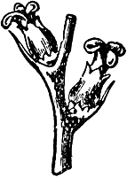are anchored at a letter

Test

test

test

test

The starch grain is achored as a letter. 