 | nutritionwellness  discover the healing power of food  Melissa Mouton, MS, RD, LD  Registered Dietitian & Holistic Nutrition Counselor

this is the screencapture of what I see when opening this doc
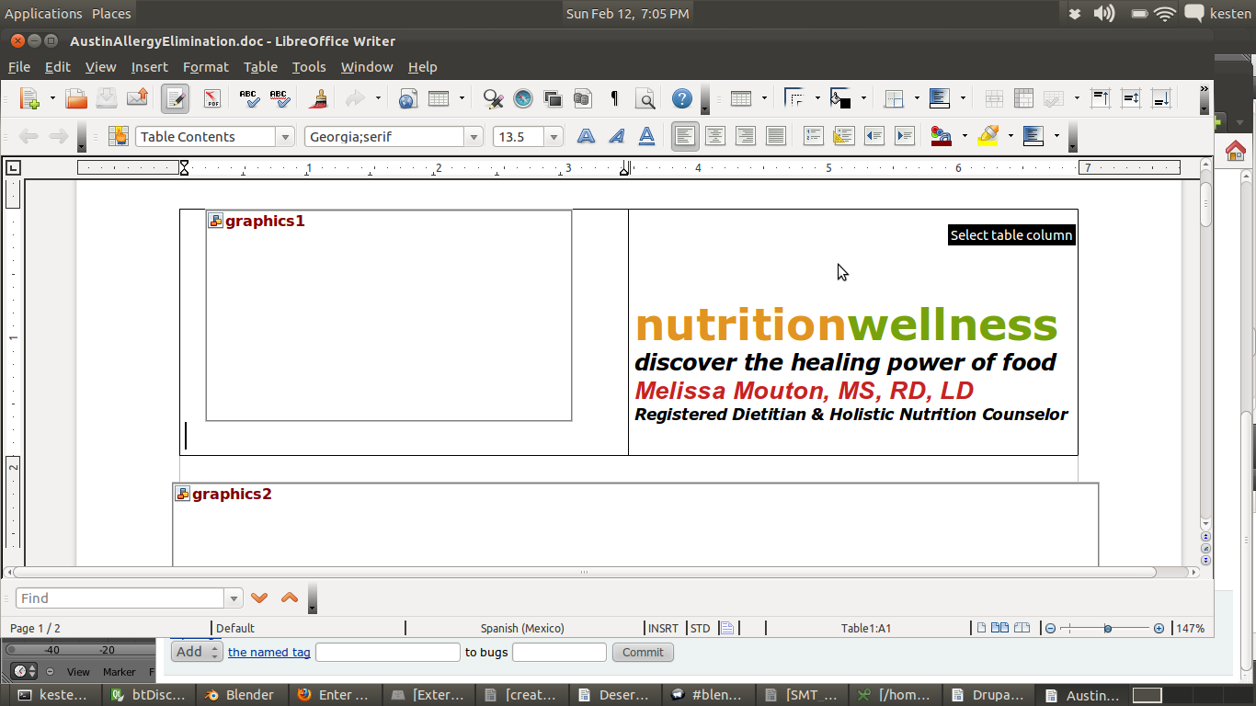


Sun Farm Kitchens Coop and Nutrition Wellness present
Austin Allergy Elimination Diet, Summer 2011
Many chronic conditions can often be relieved and sometimes enter remission when certain items are removed from the diet. Find out if our summer allergy elimination diet is right for you.

Registered Dietitian & Holistic Nutrition Counselor Melissa Mouton will provide nutritional guidance while Sun Farm Kitchens will offer meals to go and cooking classes in support of the quest: eating your way to a healthier you.
Already know your allergies? This diet can help you fine tune your diagnosis to give you the maximum variety of dietary choices and show you how to prepare delicious meals that meet your restrictions. Haven`t got a handle on what`s causing your problems? This is definitely for you.
Course cost is $50. Exchanges will be considered. Includes 4 lectures and 4 cooking classes.

What is the Elimination Diet?

The standard Elimination Diet consists of most fruits and vegetables, nuts, nut butters, beans, seeds, gluten free grains like rice and quinoa, fish, lamb, wild game meats, organic turkey, and lots of water. It actually sounds more restrictive than it is since there are hundreds of foods to choose from -- they're just foods you're probably not used to making the mainstay of your diet.
How long does it last?
The Elimination Diet can take anywhere from 8 to 10 weeks to complete
Weeks 1-3: all potentially allergenic foods are removed.

Weeks 4-10: reintroducing foods back in one at a time to see how you respond
Find out more by contacting kesten@sunfarmkitchens.ca or melissa@nutritionwell.com or search #austinEliminationDiet @sunfarmkitchens
The standard Elimination Diet consists of most fruits and vegetables, nuts, nut butters, beans, seeds, gluten free grains like rice and quinoa, fish, lamb, wild game meats, organic turkey, and lots of water.

The Benefits
* About 90% of the hundreds of clients experience a significant improvement in their symptoms.
* Weight loss is a common side benefit to the diet
* Once they adapt to the diet, people love the food, and many adopt the principles of the diet long after the Elimination Diet is over.
* The diet fully throws you into a 100% healthy, all natural, diet. You can make it work for yourself, despite your busy schedule
* Emotional eating often reduces or disappears.
* You feel amazing, your symptoms often subside and you learn a new way of eating. It's a wonderful way to change your way of eating.

What is a food sensitivity?
A food sensitivity is kind of like a food allergy, only different. A food allergy is a reaction that happens within the first two hours after eating a particular food It's more immediate, and more obvious. Food sensitivities are different. They're more delayed in nature. They have to do with the amount and frequency that you eat a particular food. You may be fine with eating small amounts of that food, but the more you eat it, the more you're building that food protein up in your system, and once you reach your own individual threshold, you react.

Reactions can show themselves in any number of ways: Joint pain, digestive issues, migraines, asthma, fatigue, depression, anxiety, skin issues, or unexplained weight gain or weight loss, emotional eating -- all of these can be results of food sensitivities.


