A standard bullet list:
- Apple
- Pear
- Orange

Below: A screenshot showing how this renders in LibreOffice 3.4.5 on OS X

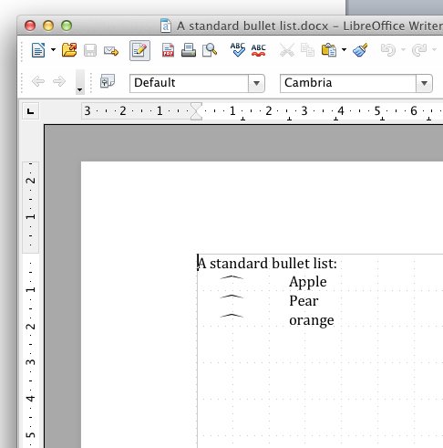

Below: How it looks in Word 2011

