Circuit 1
Unidirectional link – no other pins connected (model does simulate effect of internal receiver in the IOB for the TX i.e. representative of how 2-pin bi-dir LVDS would look like)
Cable model is 50ohm cable @50inches (consistent for both scenario’s so ok for comparative sims)
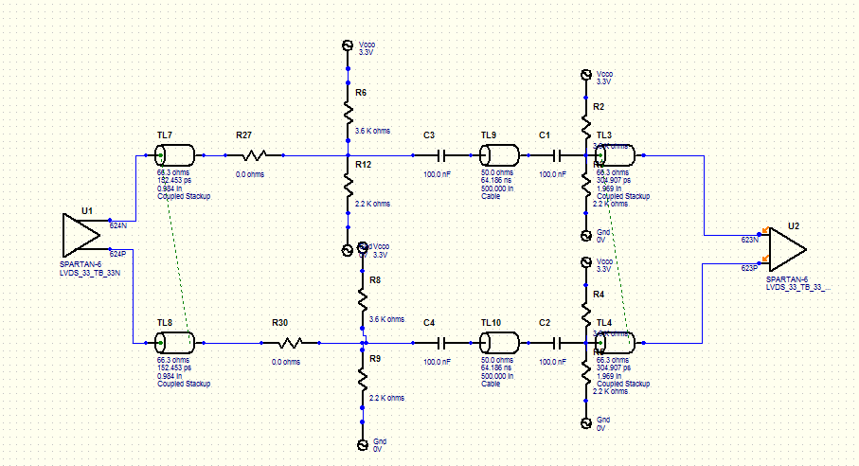

Sim settings
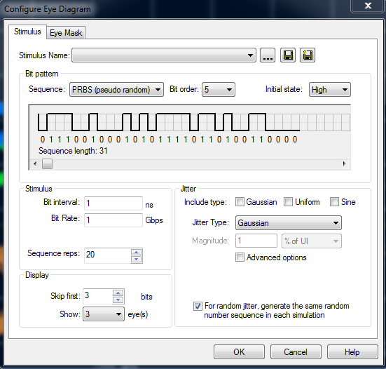

1000Mbps
Eye Height: 597mV
Eye Width: 846ps (of 1000ps) 85%

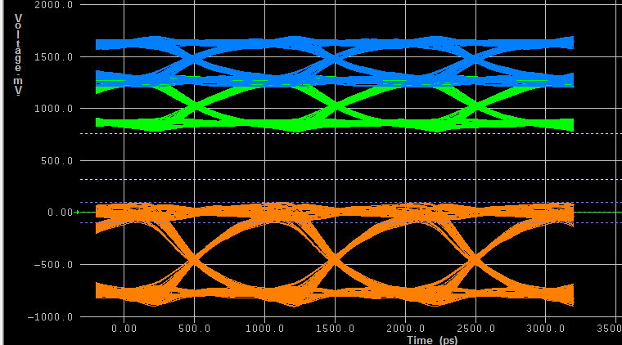

Circuit 2
Simulating the effect of tying another set of pins to transmitter (emulates RX for other direction) . RX IO in tri-state.
Each pin has CRLC network (pulled from S6 model for FGG484 pkg)
Eg C10 -> C_comp , L2 -> L_pkg, R32 -> R_pkg, C9 -> C-pkg
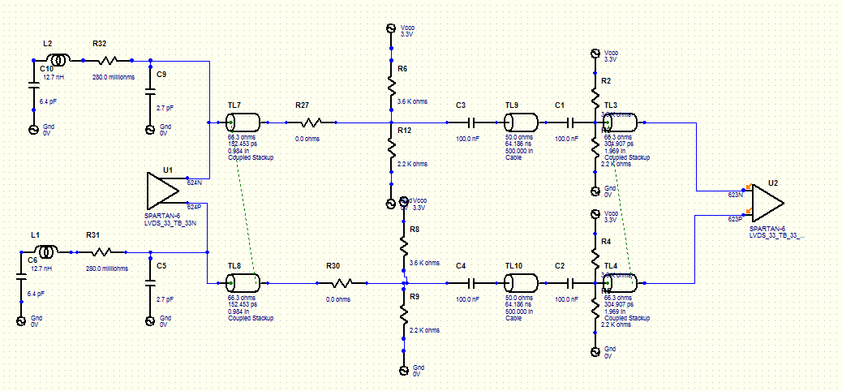
Sim settings
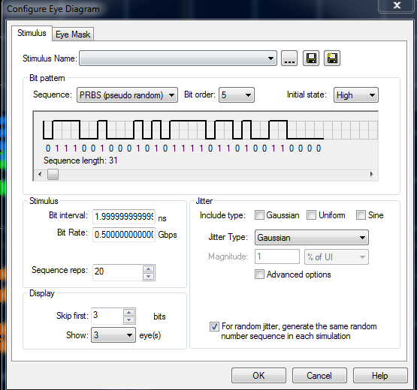

500Mbps
Eye Height: 440mV
Eye Width: 1779ps (of 2000ps) 88%
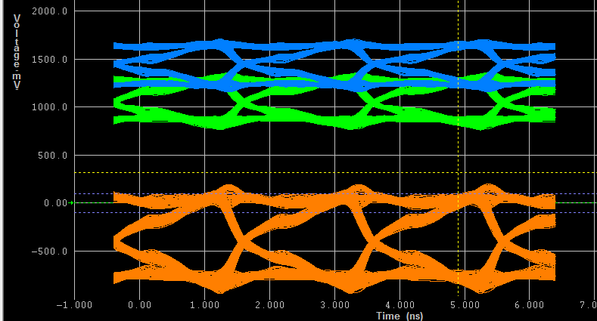

600Mbps
Eye Height: 405mV
Eye Width: 1254ps (of 1666ps) 75%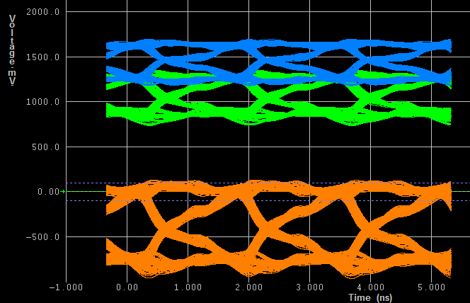

700Mbps
Eye Height: 269mV
Eye Width: 835ps (of 1428ps) 58%
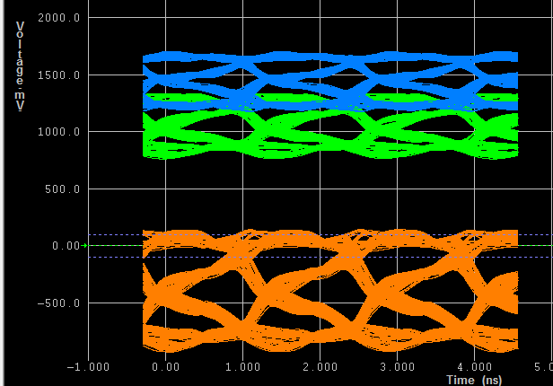
800Mbps
Eye Height: 143mV
Eye Width: 508ps (of 1025ps) 49.5%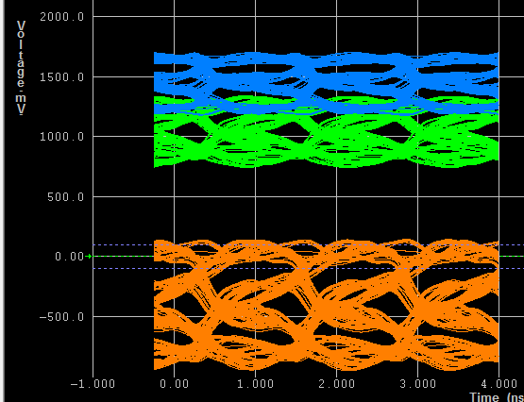
900Mbps
Eye closed!

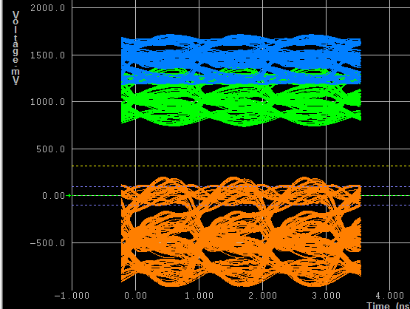

Circuit 3
Adding same at RX end to emulate our system accurately

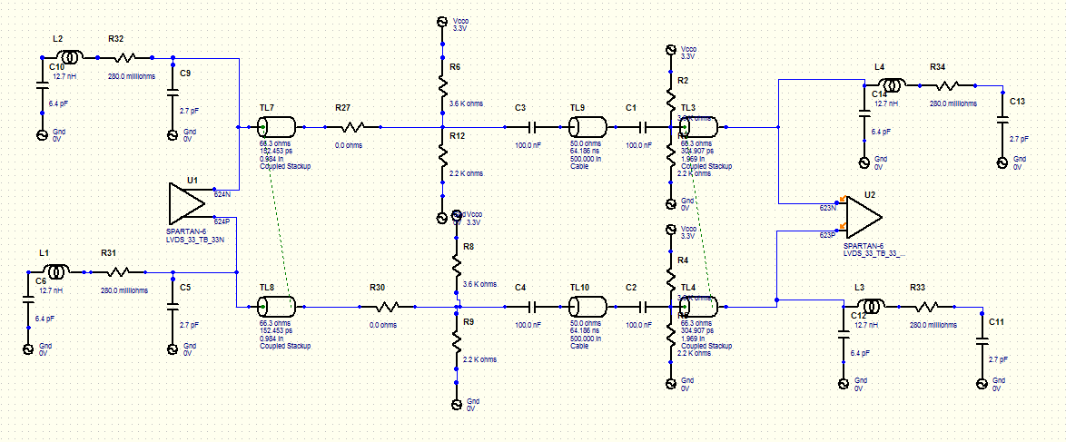

500Mbps
Eye Height: 421mV
Eye Width: 1791ps (of 2000ps) 90%
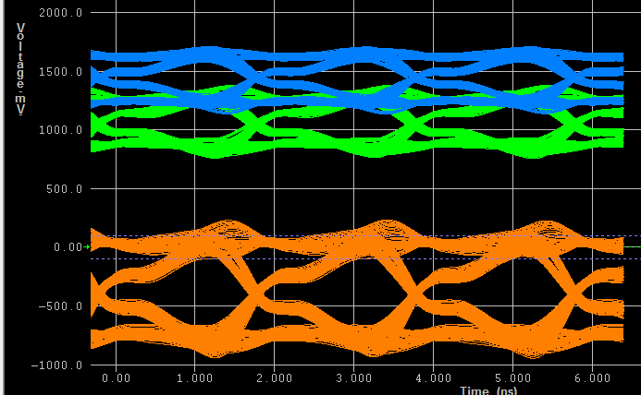

600Mbps
Eye Height: 320mV
Eye Width: 1302ps (of 1666ps) 78%
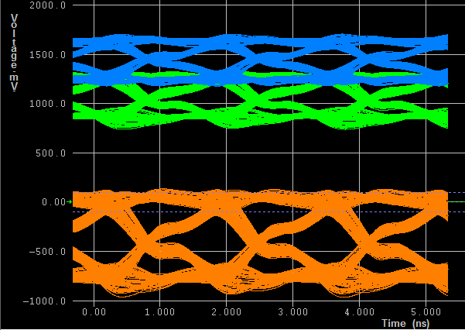

700Mbps
Eye Height: 195mV
Eye Width: 935ps (of 1428ps) 65%

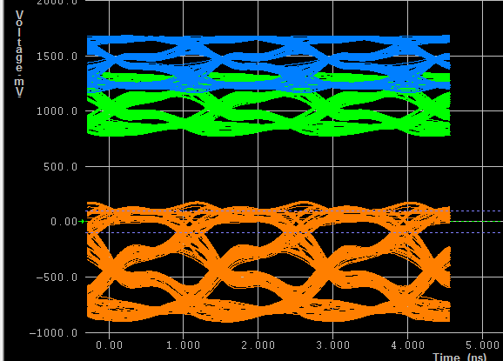
800Mbps
Eye Height: 39mV
Eye Width: 308ps (of 1025ps) 30%
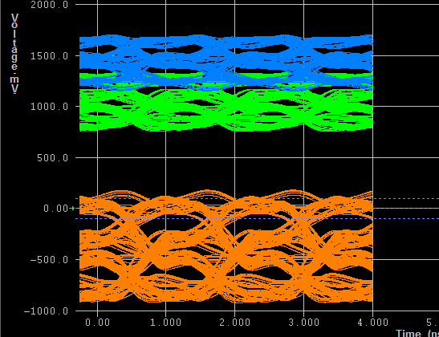
Results Summary

Table below shows Eye height/width versus datarate when modelled with extra pins

