F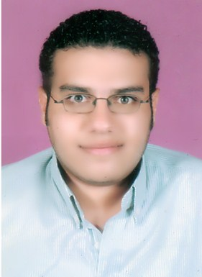ady Mohsen Andrawis
30 Hamdy st., Elzaher, Cairo, Egypt
Tel: (0225906408)
Mob: (01121050630)
E-mail: fadymohsenandrawis@gmail.com
Personal Data
Date of birth: April 5th, 1986.
Place of birth: Cairo, Egypt.
Nationality: Egyptian.
Marital Status: Single.
Military service: Exempted.
Objectives
Seeking a job opportunity with more responsibilities in a highly competitive place that enhances my skills, make use of my personality and be useful for people.

Education
- University:
- Graduated from: Faculty of Commerce Ain Shams University
- Date of graduation: June 2009
- Section: Arabic Section
- Major: Accounting
- Grade: Fair
- School:
- Graduated from: St. Joseph Maronite School
- Date of graduation: June 2003
- Certificate: Thanawia Amma- Literary Section
- Grade: 84.1%
Special Skills
- Computer skills:
- Good knowledge of Windows Me, Windows XP, Windows Vista, Windows 7.
- Good knowledge of Microsoft Office 2003, 2007, 2010 (Word, Excel and Power point).
- Good knowledge of VM Ware Workstation.
- Good knowledge of different Internet applications and Email.
- Language skills:
- Arabic: Mother Tongue.
- English: Fluent on spoken, writing, reading and understanding.

Communication & other skills
- Highly energetic & able to work under pressure in a dynamic environment.
- Excellent communication, listening & interpersonal skills.
- Self-confident with professional behavior & attitude.
- Flexibility & ability to work in a team.
Hobbies, interests & activities
- Surfing the net.
- Listening to music.
- Playing sport.
- Going to the cinema.
Professional training courses
- Attended training courses in A+, N+, MCSE (Vision Academy).
- Microsoft Certified Professional (MCP).
Job experience
Worked as a cashier in Radisson Blu Hotel, Heliopolis from May 2010 till November 2010.
Worked in Mobinil as a customer service representative from November 2010 till September 2011 (Enterprise call center from November 2010 till April 2011 and Personal call center from April 2011 till September 2011).

