09/08/15

09/08/15

Figure 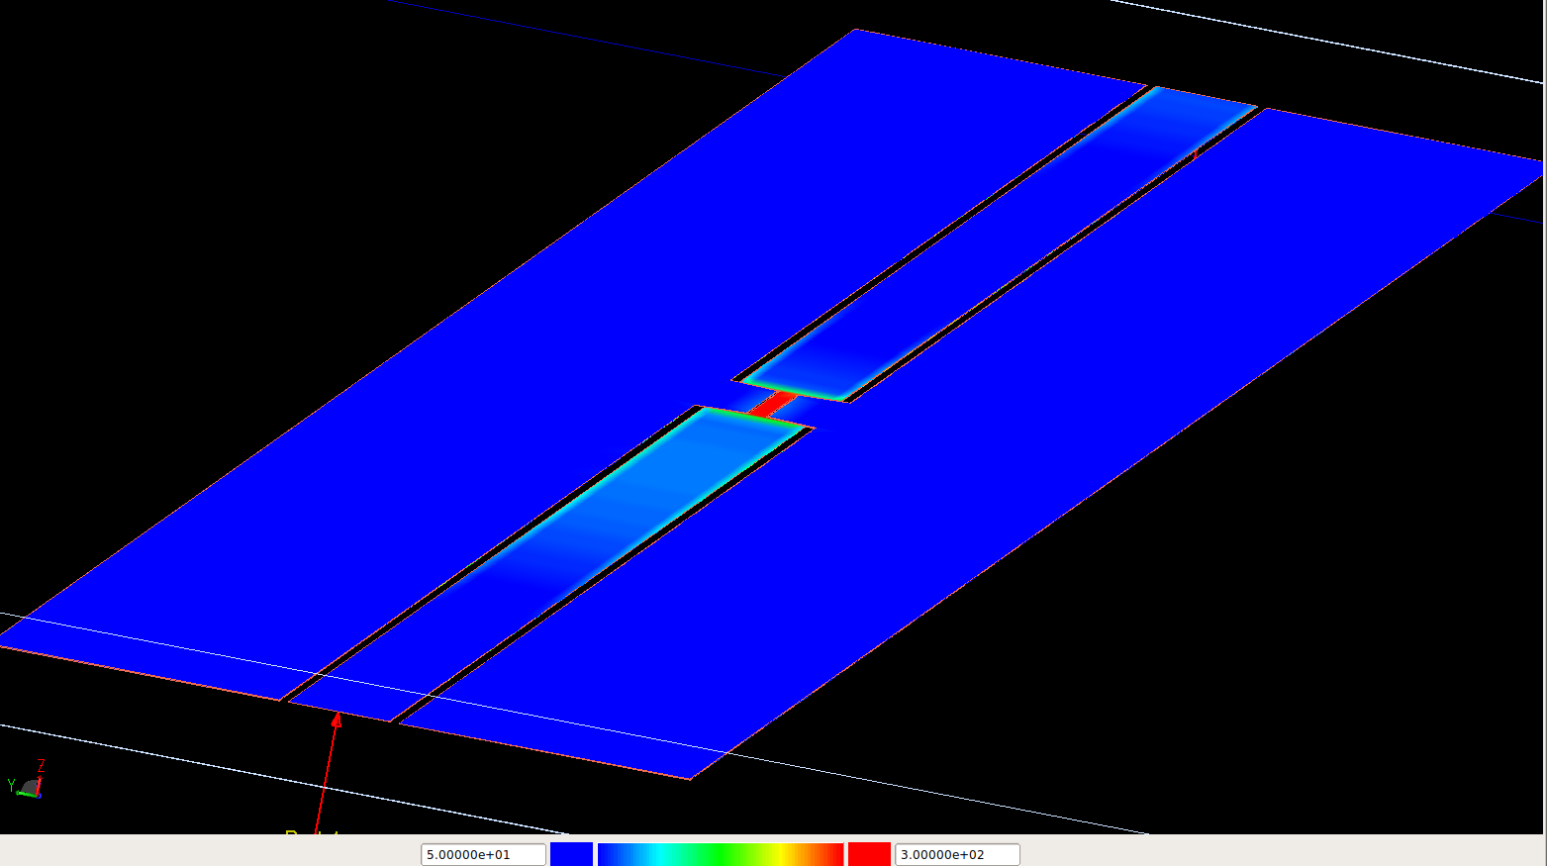1: Figure aaa

Figure 2: sadf