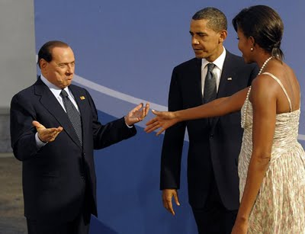
Image without frame (text box) should be here ^^^^^^
Image in textbox should be here ^^^^^^
( paragraph anchor)

Image in textbox should be here ^^^^^^
(character anchor, inline)

