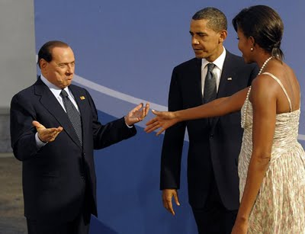

Image should be presend here ^^^^^^

This is a label example