- Very broad experience, wide background
- Strong analytical and problem-solving skills

Screenshot:
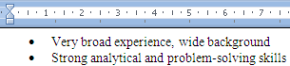
Screenshot or paragraph properties or first line:
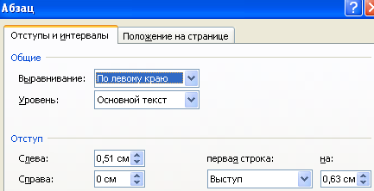
Text variant:
Paragraph
Indents and intervals
Common
Allign: by left margin
Level: main text
Indent
From left: 0,51 cm
From right: 0 cm
First line: Outdent
To: 0,63 cm

