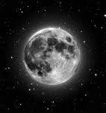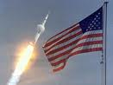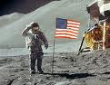

## Contents:

Contents: 2

Apollo 11 3

The Kennedy Speech 4

Yuri Gagarin 5

# Apollo 11

The *Apollo 11* mission was the first manned mission to land on the Moon. It was the fifth human spaceflight of Project Apollo and the third human voyage to the Moon or Moon orbit. Launched on July 16, 1969, it carried Mission Commander Neil Alden Armstrong, Command Module Pilot Michael Collins, and Lunar Module Pilot Edwin Eugene 'Buzz' Aldrin, Jr. On July 20, Armstrong and Aldrin became the first humans to land on the Moon, while Collins orbited above.

The mission fulfilled President John F. Kennedy's goal of reaching the moon by the end of the 1960s, which he had expressed during a speech given before a joint session of Congress on May 25, 1961: "I believe that this nation should commit itself to achieving the goal, before this decade is out, of landing a man on the Moon and returning him safely to the Earth."[1]

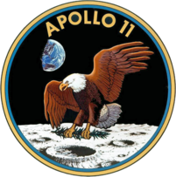

# The Kennedy Speech

On 25th May 1961 President John F. Kennedy presented a bold challenge before a joint session of Congress: Send a man to the moon by the end of the decade.

Some derided the dream as lunacy. Others viewed it as just another strategic move in the Cold War chess match between the United States and the Soviet Union.

Kennedy had just been humiliated in the Bay of Pigs fiasco in Cuba, a communist ally of Moscow. In his speech, he called for many measures to combat communism, requesting billions, for example, to stop red insurgencies in Southeast Asia. But in his address, Kennedy chose space as the main Cold War battleground on which to marshal his forces. The Soviet Union opened the final frontier when it sent the Sputnik satellite into orbit in 1957.

Four years later, cosmonaut Yuri Gagarin became the first man in space. The Soviets were beating the Americans to every milestone off the planet.[2]

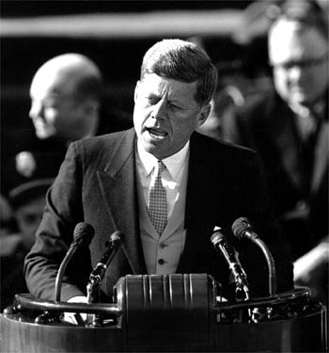

# Yuri Gagarin

Yuri Gagarin was born in the village of Klushino near Gzhatsk (now in Smolensk Oblast, Russia), on 9 March 1934. The adjacent town of Gzhatsk was renamed Gagarin in 1968 in his honour. His parents, Alexey Ivanovich Gagarin and Anna Timofeyevna Gagarina, worked on a collective farm. While manual labourers are described in official reports as "peasants", this may be an oversimplification if applied to his parents — his mother was reportedly a voracious reader, and his father a skilled carpenter. Yuri was the third of four children, and his elder sister helped raise him while his parents worked. Like millions of people in the Soviet Union, the Gagarin family suffered during Nazi occupation in World War II. His two elder siblings were sent to Germany as slave labourers in 1943, and did not return until after the war. While a youth, Yuri became interested in space and planets, and began to dream about his space tour which became true one day. Yuri was described by his teachers in the Moscow satellite town of Lyubertsy as intelligent and hard-working, if occasionally mischievous. His mathematics and scyence teacher had flown in the Soviet Air Forces during the war, which presumably made some substantial impression on young Gagarin.

In 1960, after the search and selection process, Yuri Gagarin (then an excellent pilot in the Soviet Air Force) was selected with 19 other cosmonauts for the Soviet space program.

On 12 April 1961, Gagarin became the first human to travel into space, launching to orbit aboard the Vostok 3KA-2 (Vostok 1). His call sign in this flight was Kedr (Cedar). During his flight, Gagarin famously whistled the tune "The Motherland Hears, The Motherland Knows”. The first two lines of the song are: "The Motherland hears, the Motherland knows/Where her son flies in the sky". This patriotic song was written by Dmitri Shostakovich in 1951, with words by Yevgeniy Dolmatovsky.

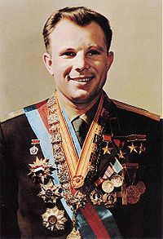

1. Source Wikipedia article on Apollo 11
2. Source: CNN.com