Insert->picture tools ->rotate right 90
----------------------------------------------------------------------------------------------------
Picture tools ->shadow effects->drop shadow
Picture tools ->shadow effects->shadow style 3
----------------------------------------------------------------------------------------------------

Picture tools->borders and shading->borders box,color->green
----------------------------------------------------------------------------------------------------

Picture tools ->borders and shading->shadow ,color->blue

Picture tools ->crop height 0.79 width 1.3

Picture tools ->brightness -20%
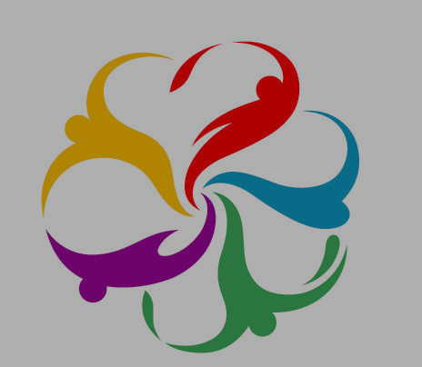
----------------------------------------------------------------------------------------------------
Picture tools->brightness +30%
----------------------------------------------------------------------------------------------------

Picture tools->arrange ->wrap text->behind text

Picture with brightness and contrast

Picture tools->arrange ->wrap text,border->picture border color

Picturetoolsshadow effects ->shadow colorgreen

