|  |  |  |  |  |
| --- | --- | --- | --- | --- |
| **Sensor Kontakte** | | |  | **Logik** |
|  |  |  |  |  |
| A | B | C |  | A |
|  |  |  |  |  |
| D | E | F |  | B |

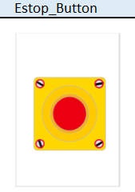

|  |  |  |  |  |  |
| --- | --- | --- | --- | --- | --- |
| **Aktor Verbindung** | | |  | **Aktor** | |
|  |  |  |  |  |  |
| A | B | C |  | A | B |
|  |  |  |  |  | |
| D | E | F |  | C | |



          
          
          