Admitted to regional hospital with progressive severe cognitive impairment (FAB 20), 20Kg weight loss and incontinence. Diagnosed with HIV.

No prior personal or familial medical history.

2015

May

Truvada, Darunavir and ritonavir commenced

 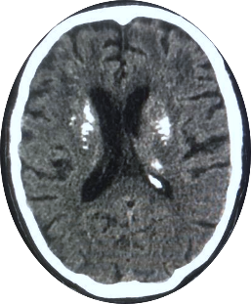

Truvada switched to Kivexa

July

Transferred to tertiary hospital for specialist input.

CD4: 6 cells/mm3

HIV viral load: 1,700,000 copies/mL

Opportunistic infections out ruled.

Fahr’s-type calcification noted on CT.

CSF HIV viral load was 85,000 copies/mL

MOCA 17/30

MOCA 26/30



Currently at home with his parents, wheelchair bound and aphasic.

Transfer to a dedicated neurorehabilitation unit.

CD4: 298 cells/mm3

Oct

Apr

July