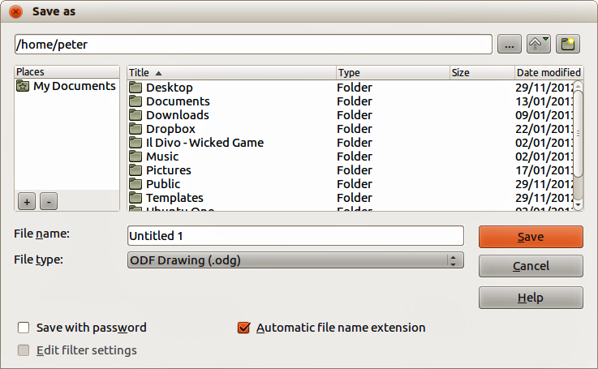
Figure 1: Example of LibreOffice Save As dialog

Click the marker (+ or triangle) by any of the categories to display the list of objects in that category.
The Navigator provides several convenient ways to move around a document and find items in it:
- When a category is showing the list of objects in it, double-click on an object to jump directly to that object’s location in the document.
- Objects are much easier to find if you have given them recognizable names when creating them, instead of keeping the default names, for example Sheet1, Table1, Table2, and so on. The default names may not correspond to the actual position of the object in the document.
- Each Navigator in the individual LibreOffice components has a different range of functions. These functions are further explained in the user guide for each LibreOffice component.
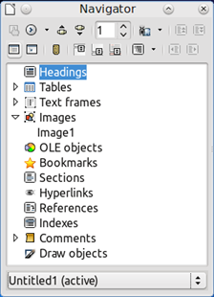
Figure 2: Navigator in Writer

Undoing and redoing changes
To undo the most recent change in a document, use the keyboard shortcut Ctrl+Z, or click the Undo icon on the Standard toolbar, or go to Edit > Undo on the Menu bar. Click the small triangle to the right of the Undo icon to get a list of all the changes that can be undone. You can select multiple changes and undo them at the same time.
After changes have been undone, you can redo changes. To redo a change use the keyboard shortcut Ctrl+Y, or click the Redo icon, or go to Edit > Redo on the Menu bar. As with Undo, click on the triangle to the right of the arrow to get a list of the changes that can be reapplied.
To modify the number of changes LibreOffice remembers, go to Tools > Options > LibreOffice > Memory on the Menu bar. In the Undo section increase or decrease the Number of steps. Be aware that asking LibreOffice to remember more changes consumes more computer memory.

Closing a document
If only one document is open and you want to close that document, go to File > Close on the Menu bar or click on the X on the right or left end of the Menu bar. On Windows and Linux, the document closes and the LibreOffice Start Center opens. On Mac OS X, the document closes and only the Menu bar remains at the top of the screen.
If more than one document is open and you want to close one of them, go to File > Close on the Menu bar or click on the X on the title bar of that document’s window. The X may be located on either the right or left end of the title bar.
If the document has not been saved since the last change, a message box is displayed. Choose whether to save or discard your changes.
- Caution
Not saving your document could result in the loss of recently made changes, or worse still, the entire file.

Closing LibreOffice
To close LibreOffice completely, go to File > Exit on the Menu bar in Windows and Linux operating systems. In a Mac operating system, go to LibreOffice > Quit LibreOffice on the Menu bar.
When you close the last document using the X on the title bar of the window, then LibreOffice will close completely. A Mac operating system does not have this function; instead, you need to use to LibreOffice > Quit LibreOffice.
You can also use a keyboard shortcut as follows:
- In Windows and Linux – Ctrl+Q
- In Mac OS X – Command ⌘+Q
If any documents have not been saved since the last change, a message box is displayed. Choose whether to save or discard your changes.

