Table with Alt Text

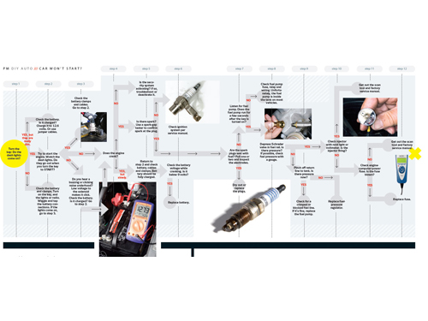
Picture with Alt Text

Chart with Alt Text

MSO 2016 created DOCX

